Chemistry 题库+extension

2024

10/06

**1a: How to functionalize a graphene substrate with alkyl thiols? Draw the outcoming structure.**

You basically add graphene to the alkyl thiol solution and the alkyl thiols lie flat on the graphene surface.

1. If modified the structure is allowed, then first oxidize the graphene, and use the Oxygen to connect with the alkyl thiols. There are a few examples in the book. Draw a similar one. we can see (C20, p26), the modification of graphene and make the bonding.

2. utilize the Vdw interactions to do the molecular nanopatterns. And the result will be like (C15, p16)? I guess.

**1b: How to functionalize a gold substrate with alkyl thiols and five islands with alkyl thiols of a greater chain length (diameter of the islands *10nm* or something)?**

SAM of alkyl thiols with subsequent **nano grafting（C13,P44）**and addition of alkyl thiols of greater chain length

**1c: How to achieve a stripe patterned substrate of gold with alkyl thiol stripes of *5μm* width?**

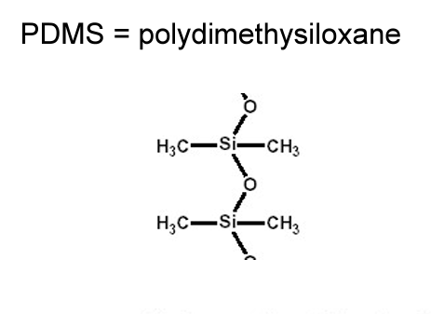**Microcontact printing(C14,P19)**. He ALWAYS asks to draw the PDMS molecule of the stamp so learn how to.

**1d: How to functionalize a gold substrate in a patterned fashion with alkyl thiol islands of 1nm diameter and spaced 3nm between each other? Explain challenges and risks.**

SAMN with pores and subsequent addition of alkyl thiols. The problems are kinetics and the fact that alkyl thiols could replace the SAMN resulting in a shitty pattern.

Templating, create pores on the substrate with the given diameter and spacing, make the alkyl binding to the substrate (C15, p38).

**1e: How to realize ONE single feature which is a drawing of *70nm* wide lines? (Alkyl thiols on gold of course)**

Dip-pen nanolithography. **(C13,P47)**

**1f: How to realize a substrate of silicon with gold nanoparticles (*10 nm*) that are arranged in a pattern, but are not crystallized and exposed (no ligand shell)?**

Block copolymer thin film**(C16,P36)** to make a template and electrodeposition of Au. Synthesis of gold NP with block copolymer shell or whatever. Transfer on substrate and burning or plasma etching of the shells.

**1g: How to characterize the height differences of 1d? Explain the microscopy technique.**

AFM intermittent contact. He ALWAYS asks for the frequency range of the oscillation (MHz) 50kHz to 500kHz**(C10,P47)** and the diagram of the forces on the AFM tip as it gets closer to the substrate. 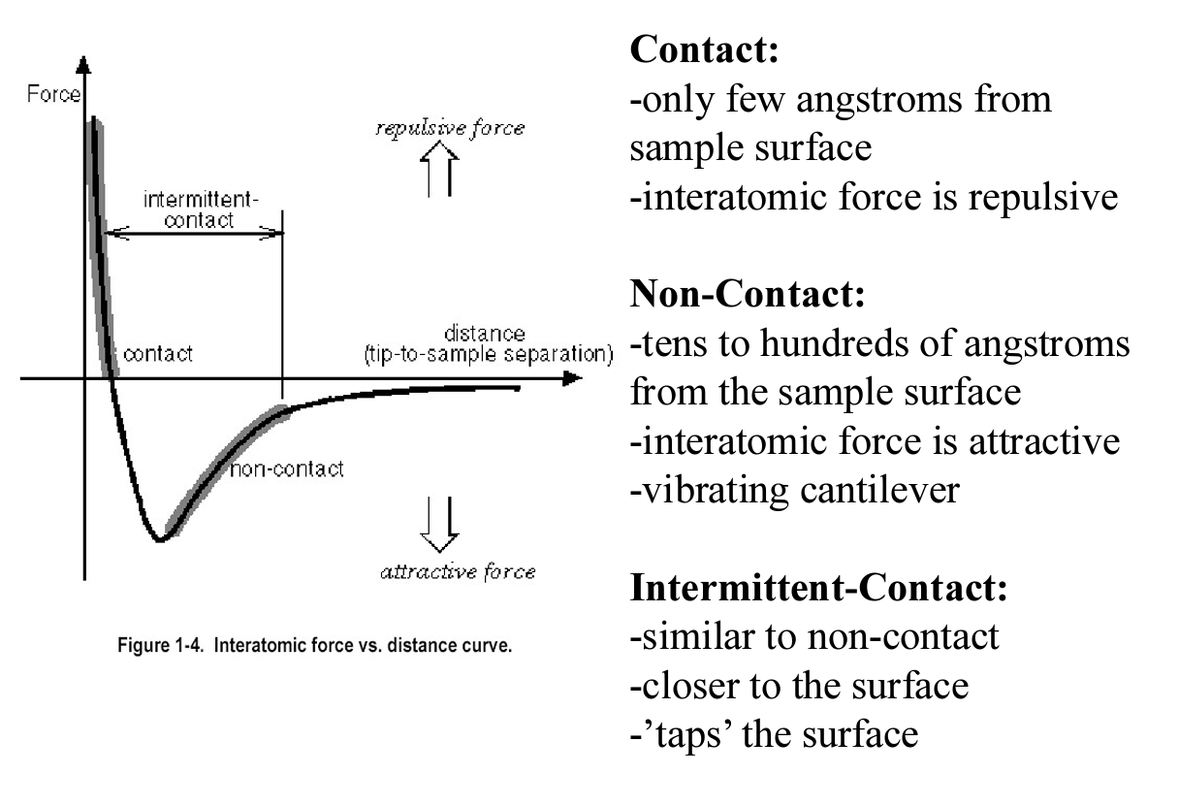

**2a: Is it trivial to use SWCNT in electronics? (right/wrong and why)**

It’s NOT trivial to use SWCNT in electronics. For the synthesis aspect, SWCNTs can be either metallic or semiconductor, not easy to separate them. There are lots of potential defects in the structure. For alignment, can use DNA-guided assembly but they are hard and not scalable. (can stick to the C19, p81-108, make an abstract upon that)

10/06

1. **A n-doped silicon nanowire functionalized with DNA is used as a biosensor for the detection of positively charged proteins. The surface was functionalized with a chain ending in CH=CH2.**

**How is this NW made?** (Vapor-liquid-deposition, Chapter 19, Nanowire)

**Draw the reagent needed to put CH=CH2 on the surface (i.e., give meaning to the chain in the given image) + provide the reaction mechanism?**

An alkyl chain with CH=CH2 at one end and SiCl3 at the other end, where SiCl3 can react with the OH groups on the surface.

**How can you prevent non-specific adsorption by applying a coating?**

Add PEG since PEG stabilized the nanocluster, be able to draw it **(C18,P85)**

**Explain why a ligand with a double bond can sometimes be more stabilizing than a linear ligand?**

A double bond creates a kink -> better interaction between ligand & solvent was correct; the explanation was that kinked ligands can sit on the facets of the surface and thus shield the corners of the surface; **electron delocalization can form stronger bond.**

1. **Right/wrong, why:**

**Gold nanoparticles of 20 nm have the major drawback of having a much smaller quantum yield than semiconducting nanoparticles and are thus not good for fluorescent tagging.**

Right, Gold nanoparticles (AuNPs) generally have very low quantum yields because they tend to dissipate absorbed energy as heat rather than re-emitting it as light. This contrasts with semiconductor nanoparticles (quantum dots), which have much higher quantum yields and can re-emit absorbed light efficiently.

1. **Which situation gives the thickest shell: polycation & polyanion given with pKa, dipping solutions pH given?**

**very similar to the practice session.**

06/06

**1.A PAMAM dendrimer with a Na* sensitive nanoprobe.**

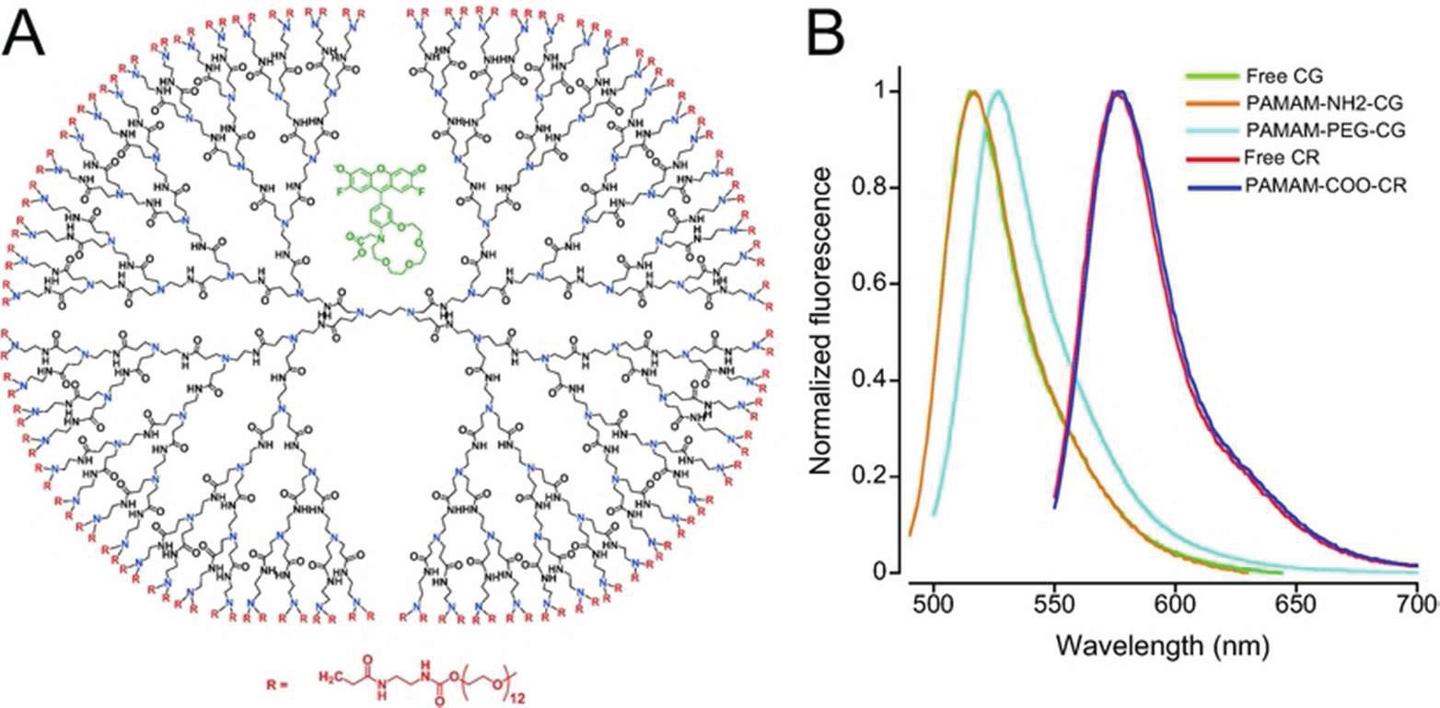**a)Why/ How selective adsorption of Na"?（**<https://doi.org/10.1021/nn203822t>**）**

-Porosity of dendrimer

-Crown ether of nanoprobe

-Selectivity by size of Na*-ion

**b) How to synthesize dendrimer?** what the (dis)advantages of each method are

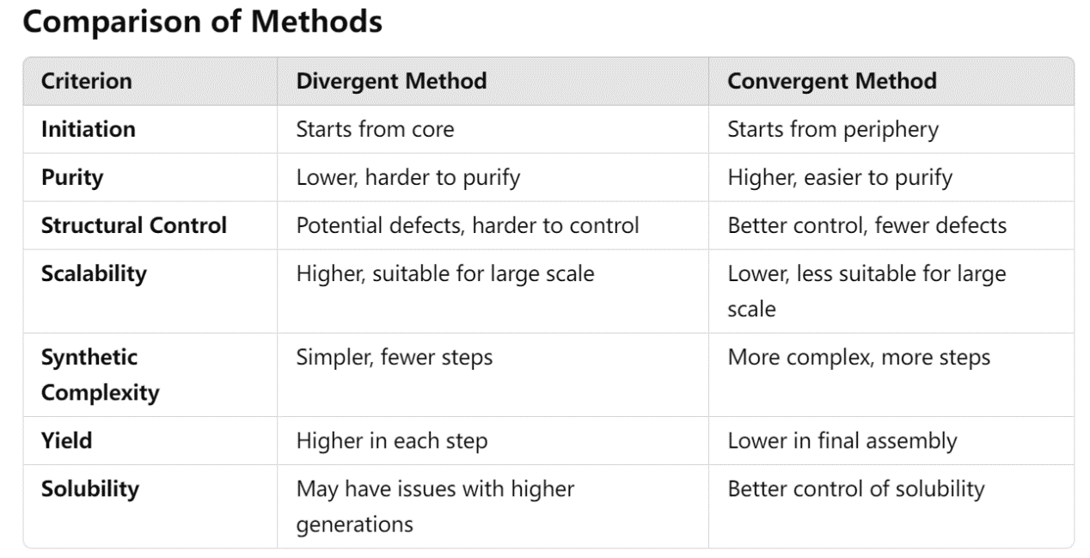-Convergent vs. divergent approach **(C5,P19)**

**C)Explain viscosity of dendrimer.**

* viscosity increases with the **generation number** due to the increased size and complexity of the molecules, reaches maximum and decrease for higher molecular weight**WHY? Solvent molecules are gradually repulsed from the interior of the globules with the increase in branching density.**
* Higher **molecular weight** dendrimers exhibit higher viscosity due to the increased intermolecular interactions and entanglement.
* **Concentration**
* **Temperature**
* **画个极值**

**2.What are the electronic disadvantages of graphene and CNTs?**

-Mainly Dirac-point -->low density of states:

-For CNTs: CNTs can be either metallic or semiconducting depending on their chirality and diameter. This variability makes it difficult to produce CNTs with uniform electronic properties, no control over chirality and metal vs. semiconductor behavior**. (C19,P87)**

**3.** **Why is it sometimes observed that upon diluting a solution of ligand-shell protected NPs, based on non-covalent chemistry, the particles aggregate?**

-I still don't really know, but somehow ligand might detach and “naked nanoparticles are not stable...?

The non-covalent interaction for the ligand-shell protected NPs is reversible, that gives a possibility to dis-engage with ligands.

* There might be a critical concentration of the ligand does not reach in a certain position, assuming the ligand distribution is not uniform.
* The kinetic barrier has been overcome by some external factors (temperature).
* Solvent quality: Upon dilution, the quality of the solvent surrounding the nanoparticles changes. A good solvent effectively solvates the ligands, promoting their extension away from the nanoparticle surface and enhancing steric repulsion among nanoparticles. As the concentration of NPs decreases, there might be insufficient solvent molecules to effectively solvate all the ligand chains. (This answer is from GPT, I think it makes sense though it’s not mentioned in the lecture)

**4.** 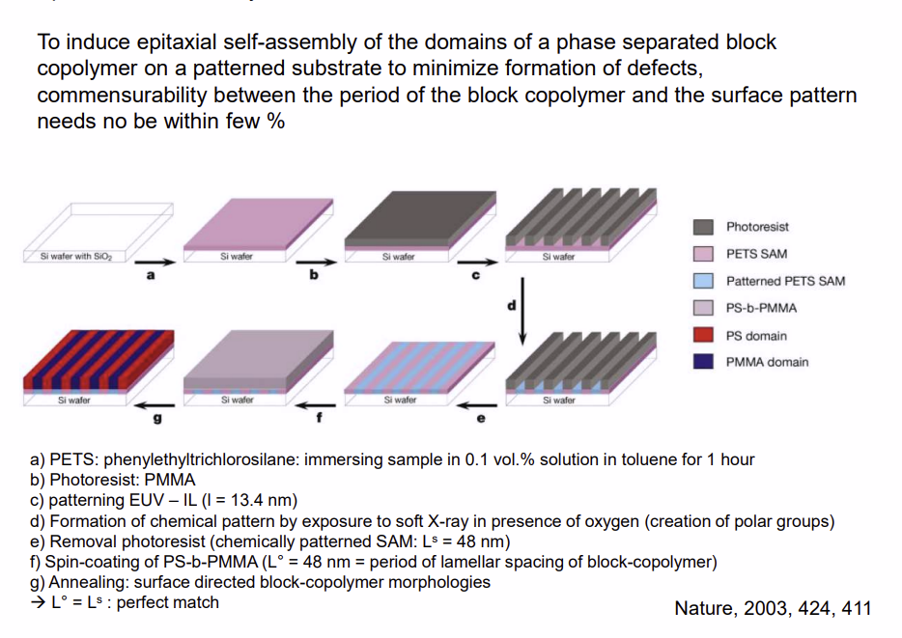

**A contact layer is patterned with parallel stripes. On top of it, PMMA-PS block copolymer self assembles into stripes, too (of higher periodicity!).**

**a) How to functionalize this contact layer?**

-Use silane chemistry to grow monolayer (explain this chemistry in detail!), then apply a mask and EUV to locally form polar headgroups

**b) Which functionalization of the contact layer is needed for PMMA?**

Polar (e.g., hydroxyl), the PMMA blocks of the PMMA-PS block-copolymer preferentially absorb. Finally with the topology like (C16, p30, vertical cylinders)

**c)How to examine topography and nanostructure?**

-Topography: AFM, intermittent contact mode, explain phase shift (time delay between excitation resonance and resonance of cantilever, eigenfrequency of cantilever in the order of MHz) **C10,P47**

I think the basic contact AFM could also finish this job

-Nanostructure: Chemical force microscope Lateral force microscope

2023

**1. A SiO2 surface with a graphene layer on top are functionalized with aryl-COOH and aryl-NO2 in a chess board pattern (but with some spacing in between the squares, so small lines of unfunctionalized surface), with squares of size 5 µm.**

1. **Explain how you can functionalize covalently it without using SPM or soft lithography. It is top-down. Explain the chemistry used.**

photolithography combined with diazonium chemistry

1. **Which technique can you use to determine whether graphene is covalently functionalized or if the molecules are just adsorpted?**

C20,P51, Raman. Sp2=>Sp3. To find determine the existence of sp2 bonds.

1. **How do you find out which type of aryl functionalization is on which square, explain in detail how it works?**

**SPM**

1. **How to measure the thickness of a square (so the length of the functionalized molecules) if you would have a full chess-board pattern, without unfunctionalized parts in between (so no spacings between the tiles)?**

AFM and subtract the base thickness

**e. If you had a gold substrate and you had to functionalize it with a phenyl group with -NO2 attached. How would you do that? Explain the chemistry. Here there was no space between the squares (so as in 1d, but with half of the squares nonfunctionalized)**

absorption of alkanethiol on Au. C13, p16 + Microprinting

**2. Right or wrong**

**a. Is starting from CNT, a good way of making high-quality graphene?**

Wrong, brings defects.

**b. Fast addition of reducing agent to thiol-gold NPs gives a narrow absorbance spectrum?**

Wrong, leads to rapid nucleation and growth broad distribution of NP.

Some explanations from GPT to complete the answer:

* Uncontrolled Growth: After the nuclei are formed, they begin to grow as more gold atoms are reduced and added to the existing clusters. If the addition of the reducing agent is fast, the supply of gold atoms is not only quick but also inconsistent, leading to uncontrolled growth rates of these nuclei.

**c. Catanene: multifunctional stations. Are they unidirectional?**

Wrong, rotaxanes are unidirectional

1. **Is it easy to disperse graphene and 2D materials in H2O?**

Wrong, Graphene and many other 2D materials are hydrophobic and do not disperse easily in water. (C20, p28)

**3. In a solution containing compound-P and ZnP-8, adding SWNTs decreases the fluorescence emission spectrum. If you do the same for compound-P ZnP+8, nothing happens. (this paper "Integrating Single-Wall Carbon Nanotubes into Donor–Acceptor Nanohybrids" contains the info given. ZnP-8 and ZnP+8 are given in image 1 alongside compound-P which here is called pyrene+, the emission spectrum given on the exam is** 图示
**figure 3b). Image shown below as well.**

**a. What can be the role of the compound P with ZnP8- and the CNT?**

ZnP8- :electron donor, CNT & P electron acceptor.

P-CNT: pi-pi stacking (delocalized π-electron)

**b. Why is the fluorescence of the CNT decreasing?**

quenching effect

**c. What is the mechanism in which this is happening. (I think he was referring to energy transfer)**

the excited electron from the donor (pyrene+ or ZnP-8) is transferred to the acceptor (SWNTs), resulting in non-radiative relaxation and a decrease in fluorescence.

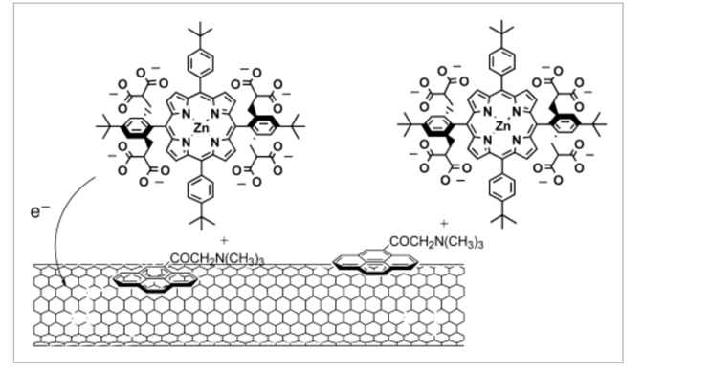**d. Draw the structure that you see for the entire hybrid structure**

**4. LbL approach, but for different polymers (not PAA and PAH). pKa's given en pH's of solutions is well. Say which one is thicker.**

Skip.

**5. Some siloxane structure (APTMS, but it was just given as '3-Aminopropyl-trimethoxysilan') --> make surface of Si hydrophobic. What's correct and what is wrong in this recipe? Explain.**Wrong, the amino group is polar so that is hydrophilic.

APTMS is a silane coupling agent with the formula H2N(CH2)3Si(OCH3)3. This molecule features:

* An amino group (–NH2) attached to a propyl linker, which provides a functional group that can react with various substrates and materials.
* Three methoxy groups (–OCH3) attached to a silicon (Si) atom, which are hydrolyzable and allow the molecule to bond with hydroxyl (–OH) groups present on surfaces like glass, ceramics, and silicon.

Methoxy groups are correct since it can anchor to the substrate.

题目好像没给完整？

**1. Add block co-polymer with Si wafer**

**2. Mix APTMS in high concentration of octane(apolar) in other glass beaker.**

**Use ethanol(polar)**

**3. Put this solution on Si wafer with the block co-polymer, just for a few seconds.**

**Few seconds are too short**

2022

1.**a. Why graphene can be used as a lubricant?**

layers can easily slide over each other; high mechanical strength; Chemical Inertness; thermal conductivity-- reduces the likelihood of thermal degradation; Thinness and Flexibility

**b. How to make graphene chiral and how to characterize that?**

Covalent functionalization with chiral components

CD (circular dichroism, C3, p9)

**c. How to prepare a graphene sheet on silicon oxide substrate? Given that mechanical exfoliation is not available.**

CVD

* Growing monolayer graphene on copper foil
* Depositing onto SiO2 via PMMA
* Curing
* Removing Cu by etching process
* Washing PMMA/graphene in DI water
* Redepositing PMMA/graphene onto silicon dioxide substrate followed by curing
* Removing PMMA with acetone

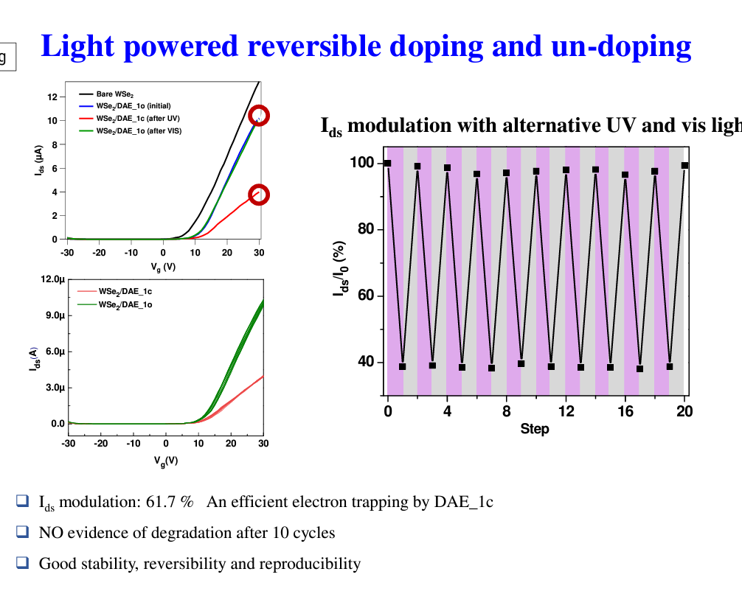**d. How to n-dope or p-dope graphene? Given that the doping process is reversible.**

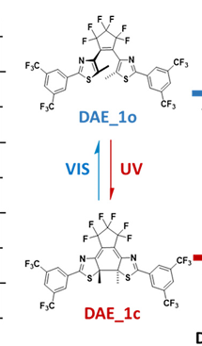**2. A FET sensor based on single-wall CNT (SWNT) with Pd as electrodes is built on SiO2 on Si substrate. Some adamantane金刚烷C10H16 compounds are given. Transfer characteristic (Ids vs Vg) curves of FET under bare-SWNT, host-guest complex on SWNT are also given.**

1. **How to build the SWNT FET on SiO2 on Si substrate?**

**C19,P99** metallic CNT and semiconducting CNT separation

evaporation induced self-assembly, hydrophilic modification on the substrate by surface energy **C19,P106**

**b. Design host for adamantane compounds (same host for all compounds). Explain the host-guest interactions.**

**c. How to ensure "contact" between host-guest and SWNT? Which characterisation technique to visualise this adsorption?**

Raman, X-ray photoelectron spectroscopy

**d. When host-guest complexes interact with SWNT, explain why the threshold voltage is more negative and conductance is reduced?**

If the host-guest complex donates electrons to the SWNTs (n-doping), it would shift the threshold voltage towards more negative values because more negative gate voltage is required to turn the device on.

scattering centers；introduce surface states that trap charge carriers

(C19, p105) Host-guest complex gives some degree of charge transfer.

Scattering and Trapping: Interaction with host-guest complexes can introduce new scattering centers or trapping sites along the SWNT. These centers can interrupt the delocalized π-electron system that facilitates conductivity in carbon nanotubes. Electrons traveling along the tube may be scattered or temporarily trapped by these new sites, effectively increasing the electrical resistance.

**Statement (right/wrong and why): we can use alkyl thiol terminated PEG as a protective coating for SWNT.**

Wrong, Alkyl thiol groups (R-SH) typically have a strong affinity for gold surfaces (due to the formation of Au-S bonds), not carbon-based materials like SWNTs.

Better Approach: Pyrene-PEG, Phenyl-PEG (pi-pi stacking)

**3. Statement (right/wrong and why): Quantum confinement can be used to explain the shift of UV/Vis and fluorescence spectra of CdSe NPs to shorter wavelength upon the evaporation of solvent.**

Wrong, Uv/vis and fluorescence redshift when solvent evaporated, explain by weak coupling?

Incorrect, Refer to (C18, p170).

Quantum confinement effects occur when the size of the nanoparticle is reduced to a dimension that is smaller than the Bohr exciton radius (the effective radius in which an electron-hole pair can exist). In CdSe nanoparticles, this results in discrete, quantized energy levels for the electrons and holes. So, the shift of the spectral is strongly related to the wavelength.

Should be towards to the longer wavelength.

2021

**1.Give the optimal way to make a gold surface:**

a. Hydrophobic

SAMs of long-chain alkylthiols (e.g., octadecanethiol十八烷) on gold surfaces are a popular method. The thiol group (-SH) binds strongly to the gold, and the long carbon chains present a hydrophobic exterior that repels water.

1. Hydrophilic

Thiol-based SAMs: Gold surfaces can be modified to be hydrophilic through the formation of self-assembled monolayers (SAMs) using thiol (–SH) groups, which strongly bind to gold. Compounds like mercaptoalkanoic acids (e.g., mercaptopropionic acid) can be used to form a SAM that presents carboxylic acid (–COOH) groups on the surface, enhancing hydrophilicity.

1. To tune hydrophobicity and hydrophilicity

Hydrophobic groups: Methyl (-CH3), fluoroalkyl groups

Hydrophilic groups: Hydroxyl (-OH), carboxyl (-COOH), amine (-NH2)

Co-adsorption: By co-adsorbing different thiols in a controlled ratio, you can tune the surface properties. For example, increasing the proportion of hydrophobic thiols will make the surface more hydrophobic and vice versa.

Given a certain ratio in the solvent and obtain almost identical (C13, p28)

1. What kind of technique would you use to measure the thickness

AFM

1. Explain this technique

Refer to Chapter 10

f. Right/Wrong: I don't remember

Give the optimal way to create:

重复问题(a) (b) (c) (d) (e)

1. **A thiol monolayer on a graphene substrate (extra question: what does this layer look like?)**
2. **A thiol layer on a gold substrate with a certain alkyn chain length but at five locations at positions you can control with a diameter of a couple tens of nanometers, place thiols with a longer chain**
3. **A thiol layer on a gold substrate in a regular band structure, bands have a width of several micrometer (extra questions: what is PDMS? what is the ink composed of?** micro printing
4. **A thiol layer on a gold substrate with the thiol in an array of regular sized dots (about 3 nm in diameter) spaced 1.5 - 2 nm apart**
5. **A thiol "drawing" on gold substrate, the drawing lines have a width of about 70 nm**
6. **Gold nanoparticles (d = 10 nm) on a silicon substrate in a regular but non-crystalline array, spaced 60 nm apart**

It’s also available to utilize the templating to pre-define the gap and porous of the structure. Refer to (C15, p48)

1. What probing method would you use to visualise d)? Can you use the same method to visualise f)? (extra questions: how does feedback work in AFM? what is the resonant frequency of the tip?)

动态模式（也称为振动模式或交流模式）：在这种模式下，探针悬臂在其共振频率附近振动。当悬臂接近样品表面时，表面的作用力会改变悬臂的振动状态（如幅度、相位和频率的改变）。通过测量这些变化，AFM可以高度敏感地探测表面的特性。这种模式尤其适合测量软材料或生物样品，因为它可以减少对样品的机械损伤。

The feedback is obtained by the mirror on the cantilever, which reflects the laser to a detector.

后面有解答 一样的问题

**2. A silicon nanowire bind a negative charged protein.**

a. How would you make the silicon nanowire

b. the principle of an N-type silicon nanowire and the set-up

Electron donating?

1. How can you read out the binding of the negative charged protein

d. How can you improve the binding of the protein

e. Right/Wrong: a larger diameter gives a better readout

**3. Something with gold nanoparticles and iron-oxide that bind in ordered structure or layer**

**a. How would you produce a gold NP, which is soluble in H2O**

**b. Draw the structure of iron in n-octylamine and ethyleenglycol**

**c. Draw the structure and explain the chemistry of b) in APTMS and methanol**

**d. Right/Wrong: chemical force microscopy is designed to measure these structures and is the best technique**

**4. The UV-Vis and fluorescence spectra of a semiconductor NP of 6 nm with a 1.2 nm organic coat in solution shifts (I don't remember to which side) upon evaporation of the solvent. Comment on al the concepts and explain (right/wrong)**

2020

1. **Right/wrong/why: The chemical composition of NP determines toxicity**

Wrong，Size and Shape: Smaller nanoparticles can penetrate cells and tissues more easily, potentially leading to higher toxicity. The shape of nanoparticles can influence how they interact with biological membranes and proteins.

Surface Charge: The surface charge of nanoparticles affects their interaction with cellular membranes and can influence uptake and distribution within the body.

Aggregation State: Whether nanoparticles are dispersed or aggregated can affect their biological interactions and toxicity.

Dose and Exposure Duration: The amount of nanoparticles and the length of exposure are critical factors in determining toxicity.

Environmental and Biological Conditions: The medium in which nanoparticles are dispersed (e.g., water, blood) and the presence of other chemicals or proteins can influence toxicity.

1. **Why are MWCNTs sometimes used in Li-ion batteries.**

High Electrical Conductivity； Large Surface Area； Mechanical Strength； Improved Ion Transport； Thermal Stability； Enhanced Cycling Stability

1. **Right/wrong/why: one of the best methods to make high-quality graphene is from graphene oxide**

Wrong, bring defects

**4. Right/wrong/why: NMP (N-methyl pyridine or something) is popularly used to solubilize graphene sheets (exfoliation)**

**5. A molecule was given that allows to disperse(solubilize) SWCNTs (molecule had long alkyl chain and two rings with some oxygens and nitrogen) in many organic solvents.**

a. Why is it not trivial to disperse CNTs?

Aggregation: Carbon nanotubes tend to aggregate due to strong van der Waals forces between them.

Hydrophobic Nature: CNTs are highly hydrophobic due to their all-carbon composition.

High Aspect Ratio: Carbon nanotubes have a high aspect ratio (length-to-diameter), which means they are long and thin.

Limited Reactivity: The carbon-carbon bonds in CNTs are extremely strong, rendering the nanotubes chemically inert and resistant to many types of chemical modification that could otherwise aid dispersion by attaching functional groups to their surfaces.

b. How does this molecule help in making the dispersion?

Once adsorbed onto the SWCNTs, the long alkyl chains of the dispersant provide a compatible interface with the organic solvent. This interaction helps to solubilize the otherwise hydrophobic and poorly soluble SWCNTs in the solvent.

**6. Right/wrong/why: Slowly adding reducing agent leads to NPs that give a broad fluorescence spectrum.**

**1. **It is often important to modify the polarity of a surface.\*\***

1. **How can you make a gold surface hydrophilic using a solution-based approach?**

(SAM of alkylthiols with hydroxyl end group)

1. **How can you make it hydrophobic? If you use the same method as in (a), only describe the differences.**

(SAM of alkylthiols with methyl end group)

1. **How can you tune the polarity of the surface?**

(mixed SAM) nanografting

**d. How can you macroscopically observe the polarity of the surface?**

(contact angle of a liquid droplet)

1. **What method is best used to visualize the surface?**

(AFM)

**2. **An n-doped silicon nanowire functionalized with DNA is used as a biosensor for detecting positively charged proteins.\*\***

1. **Explain how this works in detail.**

(C19,P54)

1. **If the diameter of the nanowire increases, is the sensor better?**

(No, it would have lower sensitivity because the effect of the charge shell on conductivity would be less significant).

1. **The researchers also functionalized the nanowire with a SAM of oligo ethylene glycol (OEG), why?**

Prevent Non-Specific Binding；Improve Selectivity； Stability and Biocompatibility

**d. What is the best way to visualize the binding of the nanowire with proteins? Which technique should not be used?**

**Fluorescence Microscopy**: This is one of the best techniques to visualize the binding of proteins to the nanowire. The proteins can be tagged with fluorescent markers

**Prevent：**Electron Microscopy：These techniques require vacuum conditions and can be destructive to biological samples.

3. **You have iron oxide nanocrystals and gold nanocrystals.**

1. **Provide a simple method to separate them.**

(magnetism, iron oxide NPs become magnetic only in the presence of a magnetic field).

1. **Describe the synthesis of gold NPs in water.**

Same as the lab

**c. The iron oxide nanocrystals are mixed with n-octylamine.**

- Draw what the structure looks like.

(iron oxide particle stabilized by a shell of octylamine, with the amine group covalently bonded to the surface).

- Then (3-aminooctyl) triethoxysilane is added with trace amounts of acetic acid. What happens now?

(place exchange and then polycondensation of the ethoxy groups leading to interlinked aggregates).

1. **Why is there a red shift in the SPR absorption peak in the final structure?**

(due to aggregation, larger particles cause a red shift, Mie theory).

**4. **True or False**: Mie theory explains why semiconductor nanoparticles exhibit a red shift in fluorescence as the particles become larger.**

Wrong, for metallic NPs

**2018**

18 June 8:00

重复的问题(1)(2)(3)(4)

1. Dendrimers PAMAM(chap 5) take me a lot of time to find where it is...

(1) Na+ is adsorpted selectively by the dendrimer. Why?

(2) Discuss the structure (shape).

(3) Discuss approaches to synthesize this dendrimer.

(4) Discuss the viscosity change with higher generation.

(5) difference between dendrimer and micelle is dendrimer needs lower concentration, right?

The statement that "dendrimers need a lower concentration" is not quite accurate in the context of comparing them with micelles, as the formation and stability of dendrimers do not depend on achieving a particular concentration threshold like micelles do with their CMC. Instead, dendrimers and micelles differ fundamentally in their structural complexity, formation mechanisms, and uses.

一样

2. Why is it sometimes observed that upon diluting a solution of ligand-shell protected nanoparticles, based on non-covalent chemistry, particles aggregate?

Skip, 有类似题目

3. **copolymer, epitaxial SA on Si(chap 15) only two slides but you need to know the whole process and the mechanism. also about AFM i think so go over chap 19 AFM!**

**(1) how to make chemical contrast?**

**(2) how copolymer ordered on that?**

**(3) how to characterise this pattern?**

一样

4. LbL question, given the pKa of polymer X and polymer Y, fill the table and discuss which set of conditions give the thinner outermost layer.

**2016=2015**

Correct/wrong and why?

1. It does not matter what type of amphiphiles you add to a solution (positively charged, negatively charged or neutral), the surface tension decreases at increasing concentration

Correct

b) Gold nanoparticles have the major drawback of having a much smaller quantum yield than semiconducting nanoparticles for fluorescence spectroscopy purposes

Correct

2. True/False

a) the surface energy is independent of the amphiphile you use: positively charged, negatively charged or neutral. (it was something a little bit different but more or less)

not entirely correct, depend on the substrate. If this is air, then it’s correct.

1. GNPs are not really used as bio-labels because they have low quantum yield in comparison to QDs of the same size.

Correct, bio-labels due to their inherently low (or nonexistent) quantum yield for fluorescence when compared to quantum dots (QDs) of similar size.

1. Diagram of a DNA functionalised gold NP designed to detect Ascorbic acid. An explanation of how the device work is provided. Basically It fluoresces after the DNA gets cleaved because of a radical produced by the ascorbic acid.

a) describe how one can prepare gold nanoparticles

skip, same as the lab.

b) describe how one can functionalize the NPs with the DNA strand.

Utilize the complementary sequence of DNA, make a linker to the nanoparticle via thiols or other chemical groups.

c) which spectroscopic technique would you use to determine the concentration of gold NP

UV visible spectral, look at the absorbance.

d) What do you think is the reason why the sensitivity is 100x better with the Gold NP than in a device without gold NPs?

This resonance leads to strong absorption and scattering of light at specific wavelengths, which can be finely tuned by varying the size, shape, and composition of the nanoparticles.

2. True or false and why: Keeping a low precursor concentration when synthesising gold NPs results in a broad spectrum of the fluorescence curve 3. He gives you a diagram of a molecule with three fused aromaticc rings, a number of C=O bonds, some N atoms and an alkyl chain. He says some researchers showed this can be useful for dispersing SWCNTS.

a) why is it hard to disperse SWCNTS?

This structure leads to strong van der Waals interactions between individual nanotubes. These interactions cause the nanotubes to aggregate or form bundles, making them difficult to separate into individual tubes.

b) Describe a possible mechanism of how this molecule achieves dispersion

**5 June 10:00**

For a given application it is necessary to make a silicon wafer, with its natural oxide layer, hypdrophobic. Looking into the scientific literature, I found the following recipe:

"After dissolving trichlorooctylsilane molecule in a new glass beaker with ethanol, at rather low concentrations, a gold substrate is dipped into the solution for a few seconds, followed by a rinsing step with water.'"'

Analyse this statement, and discuss in terms of chemistry, indicating what's correct/wrong/nonsense and why.

Comment on this statement (correct/wrong and why?):

"Metal nanoparticle synthesis is governed by kinetics, rather than thermodynamics."

By kinetics mostly

On top of this multilayered substrate, shown below (so with the chromium top layers), a photoresist polymer is coated. The sample is irradiated through a square-shaped mask, and the irradiated area (so having the shape of a square) is washed away. Then the following manipulations were done: gold is deposited via electrodeposition on top of the substrate; a chromium layer is deposited; then the sample is subsequently treated with 1) acetone, 2) nitric acid (dissolves the silver layer), 3) sonicated in a hexadecanethiol solution, though not necessarily in the order indicated.

Figure with this top-to-down structure: chromium-silver-chromium-Si/SiO2

Draw the object formed and describe its chemical nature (bulk and surface)

What is the role of acetone, an organic solvent

sonication in hexadecanethiol solution in ethanol

Define the order of the different steps in the treatment

* Describe two methods you would use to evaluate the degree of polarity of surfaces:

a macroscopic technique: droplet and contact angle

a technique which operates at the nano to micro scale: make use of AFM to get the value of adhesion.

A mixture of oppositely charged spheres (diameter not defined) forms a highly ordered phase (see figure below). The red particles are negatively charged and the green ones positively charged.

Discuss the different aspects of the energetics involved in this self-assembly process (in terms of Gibbs free energy)

Alt

+/- Charged spheres assembled lattice

In another experiment, rod like objects of identical length, carrying no charge, and with only minimal interrod interactions, were found to self-assemble. Draw the outcome of the self-assembly process. Explain in terms of the energetics of the process.

# Extension: different size pattern technique

Scanning probe lithography: in nanometer scale，可以动1nm的molecule

Soft lithography: (C14, p17)