ASSIGNMENT 1

Nonlinear least squares method

Problem description: The goal of this assignment is to find the position of the mobile phone that was lost by person X. The mobile phone is somewhere inside the coordinate system presented in Figure 1. Mobile phone was detected by three base stations. The locations of the stations are given in table Table1:

Table 1: Base station positions

|  |  |  |  |
| --- | --- | --- | --- |
|  | Base station 1 | Base station 2 | Base station 3 |
| X coordinate | 1 | 10 | 2 |
| Y coordinate | 1 | 5 | 4 |

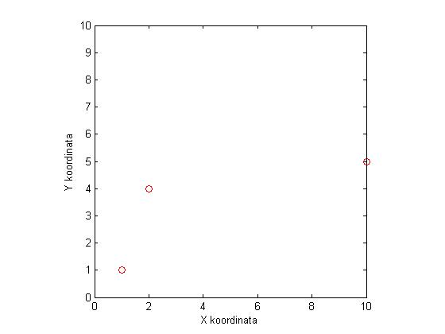

Figure 1: Position of base stations.

In the folder there are three Matlab functions (*ping_stolp_1, ping_stolp_2, ping_stolp_3*). Each of these functions returns the distance to the mobile phone corrupted by noise. Each station has different noise levels.

Your task is to get the position of the mobile phone with means of optimization. You have to program the nonlinear least squares method or Levenberg-Marquad optimization method to solve the problem. Test also how number of measured values affects the accuracy and consistency of the results. Does considering the variance in the optimization method (weighted nonlinear least squares) improves the results?

Write the report in which the basic theory of used methodology is described and results are presented together with your observations and comments.