ASSIGNEMENT 5

Nonlinear dynamical model

In script primer_uporabe_helicrane you have an example of useage for simplified model of heliocrane presented in fig 1.

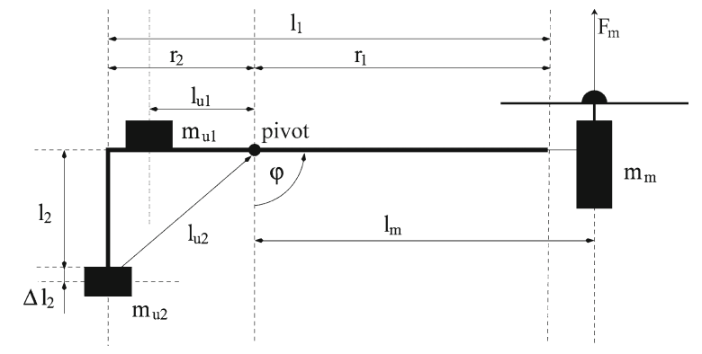

Slika : Helio crane, shematski prikaz.

In your assignement you have to:

1. Make simulation model:
   1. Use of neural network toolbox to get the simulation model of the heliocrane. Compare the output of the neural network model with the model in script. Thest the model through out the whole operating range.
   2. Repeat the modeling with the fuzzy logic. Write the identification algorithm for takagi sugeno fuzzy model. Compare the obtained results with.
2. Compare also both models and comment the results.

The process sampling time is 0.01 s. You have to generate proper signals for identification and validation of the model. If the sampling time is too smal for you you can resample the signals.