Assignement 6

Predictive functional controller

In Figure 1. a heliocrane model is represented, that is implemented in the attached matlab script.

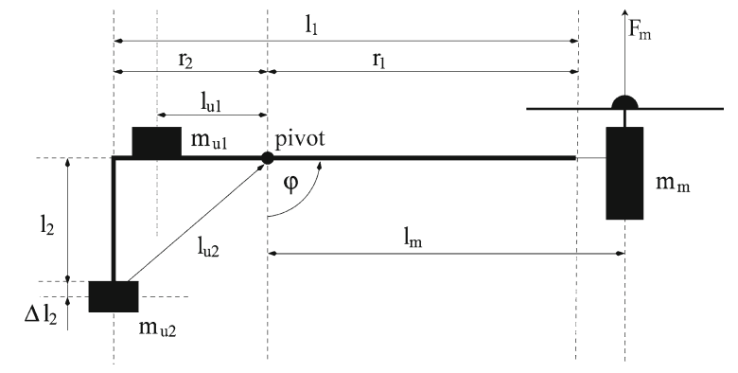

Figure 1: Helio crane

In previous assignement you made a model of the system using fuzzy model. Use this model to make predictive functional controller that will control the process troughout the operating range of the system.

You will have to transform the local models to state space. Here are some equations that might help you:

Local model:

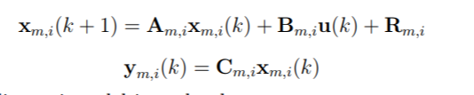

Globalni model (fuzzy model):

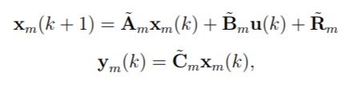

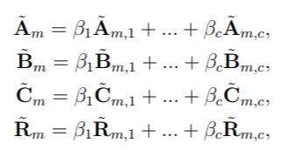

Reference model (for reference model you can choose 1. order model):

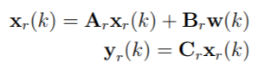

Control law:



