Noah James

Stat 217

Homework 1 Write up

1. Code: stress

Output:

Subject Group PSSbefore PSSafter

1 A1 Sport 25 13

2 A3 Sport 17 15

3 A4 Sport 12 13

4 A5 Sport 21 22

5 A6 Sport 29 25

6 A7 Sport 28 24

7 A8 Sport 21 19

8 B1 Sport 18 19

9 B2 Sport 20 24

10 B3 Sport 29 21

11 B4 Sport 27 22

12 B5 Sport 44 33

13 B6 Sport 23 8

14 B7 Sport 18 12

15 B8 Sport 27 30

16 A2 Control 0 16

17 C1 Control 30 27

18 C2 Control 12 31

19 C3 Control 29 21

20 C4 Control 25 33

21 C6 Control 2 9

22 C7 Control 6 26

23 C8 Control 20 20

24 C9 Control 27 28

25 C10 Control 14 21

26 C11 Control 15 29

1. Code: head(stress)

Output:

Subject Group PSSbefore PSSafter

1 A1 Sport 25 13

2 A3 Sport 17 15

3 A4 Sport 12 13

4 A5 Sport 21 22

5 A6 Sport 29 25

6 A7 Sport 28 24

1. Code: tail(stress)

Output:

Subject Group PSSbefore PSSafter

21 C6 Control 2 9

22 C7 Control 6 26

23 C8 Control 20 20

24 C9 Control 27 28

25 C10 Control 14 21

26 C11 Control 15 29

1. Code: stress$Differences<-stress$PSSafter-stress$PSSbefore

Output:

Subject Group PSSbefore PSSafter

1 A1 Sport 25 13

2 A3 Sport 17 15

3 A4 Sport 12 13

4 A5 Sport 21 22

5 A6 Sport 29 25

6 A7 Sport 28 24

7 A8 Sport 21 19

8 B1 Sport 18 19

9 B2 Sport 20 24

10 B3 Sport 29 21

11 B4 Sport 27 22

12 B5 Sport 44 33

13 B6 Sport 23 8

14 B7 Sport 18 12

15 B8 Sport 27 30

16 A2 Control 0 16

17 C1 Control 30 27

18 C2 Control 12 31

19 C3 Control 29 21

20 C4 Control 25 33

21 C6 Control 2 9

22 C7 Control 6 26

23 C8 Control 20 20

24 C9 Control 27 28

25 C10 Control 14 21

26 C11 Control 15 29

Differences

1 -12

2 -2

3 1

4 1

5 -4

6 -4

7 -2

8 1

9 4

10 -8

11 -5

12 -11

13 -15

14 -6

15 3

16 16

17 -3

18 19

19 -8

20 8

21 7

22 20

23 0

24 1

25 7

26 14

E) i: Code: stress$Differences

Output:

[1] -12 -2 1 1 -4 -4 -2 1 4

[10] -8 -5 -11 -15 -6 3 16 -3 19

[19] -8 8 7 20 0 1 7 14

ii: Code: mean(stress$Differences)

sd(stress$Differences)

Output:

Mean: [1] 0.8461538

Standard Deviation: [1] 9.194313

iii: Code: summary(stress$Differences)

Output: Min. 1st Qu. Median Mean

15.0000 -4.7500 0.5000 0.8462

3rd Qu. Max.

6.2500 20.0000

iv: Code: hist(stress$Differences)

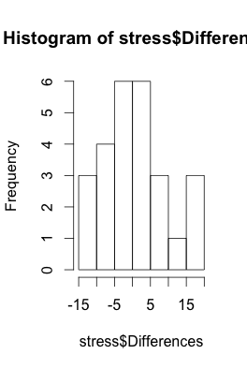 Output:

v: Code: boxplot(stress$Differences)

Output:

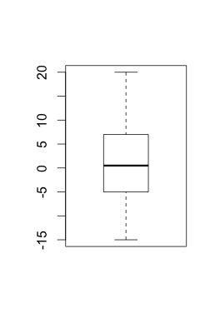

As we can see in the histogram there is a relatively normal distribution. Also, as demonstrated in the box plot the distribution is clearly centered around 0 which implies that for most cases there was little or no change in stress before and after.