Shane Connors

Stat 217

HW #1

1a.

**Code: stress**

output:

Subject Group PSSbefore PSSafter

1 A1 Sport 25 13

2 A3 Sport 17 15

3 A4 Sport 12 13

4 A5 Sport 21 22

5 A6 Sport 29 25

6 A7 Sport 28 24

7 A8 Sport 21 19

8 B1 Sport 18 19

9 B2 Sport 20 24

10 B3 Sport 29 21

11 B4 Sport 27 22

12 B5 Sport 44 33

13 B6 Sport 23 8

14 B7 Sport 18 12

15 B8 Sport 27 30

16 A2 Control 0 16

17 C1 Control 30 27

18 C2 Control 12 31

19 C3 Control 29 21

20 C4 Control 25 33

21 C6 Control 2 9

22 C7 Control 6 26

23 C8 Control 20 20

24 C9 Control 27 28

25 C10 Control 14 21

26 C11 Control 15 29

1b.

**Code: head(stress)**

Output:

Subject Group PSSbefore PSSafter

1 A1 Sport 25 13

2 A3 Sport 17 15

3 A4 Sport 12 13

4 A5 Sport 21 22

5 A6 Sport 29 25

6 A7 Sport 28 24

1c.

**Code: tail(stress)**

Output:

Subject Group PSSbefore PSSafter

21 C6 Control 2 9

22 C7 Control 6 26

23 C8 Control 20 20

24 C9 Control 27 28

25 C10 Control 14 21

26 C11 Control 15 29

1d.

**Code :stress$Differences<-stress$PSSafter-stress$PSSbefore**

Output: stress$Differences<-stress$PSSafter-stress$PSSbefore

1e.

1. **Code: stress$Differences**

Output: [1] -12 -2 1 1 -4 -4 -2 1 4 -8 -5 -11

[13] -15 -6 3 16 -3 19 -8 8 7 20 0 1

[25] 7 14

ii) **Code: mean(stress$Differences)**

**sd(stress$Differences)**

output:

[1] 0.8461538

[1] 9.194313

1. **Code: summary(stress$Differences)**

Output:

Min. 1st Qu. Median Mean 3rd Qu. Max.

-15.0000 -4.7500 0.5000 0.8462 6.2500 20.0000

1. **Code : hist(stress$Differences)**

Output:

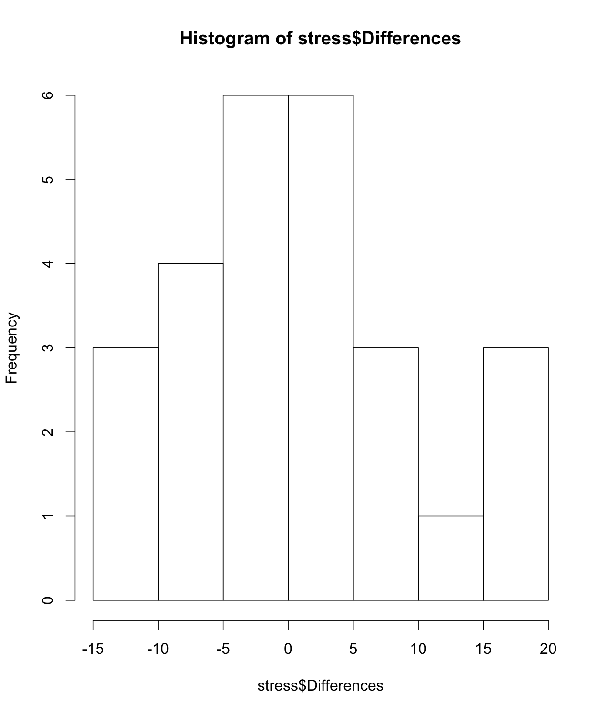

1. **Code : boxplot(stress$differences)**

Output:

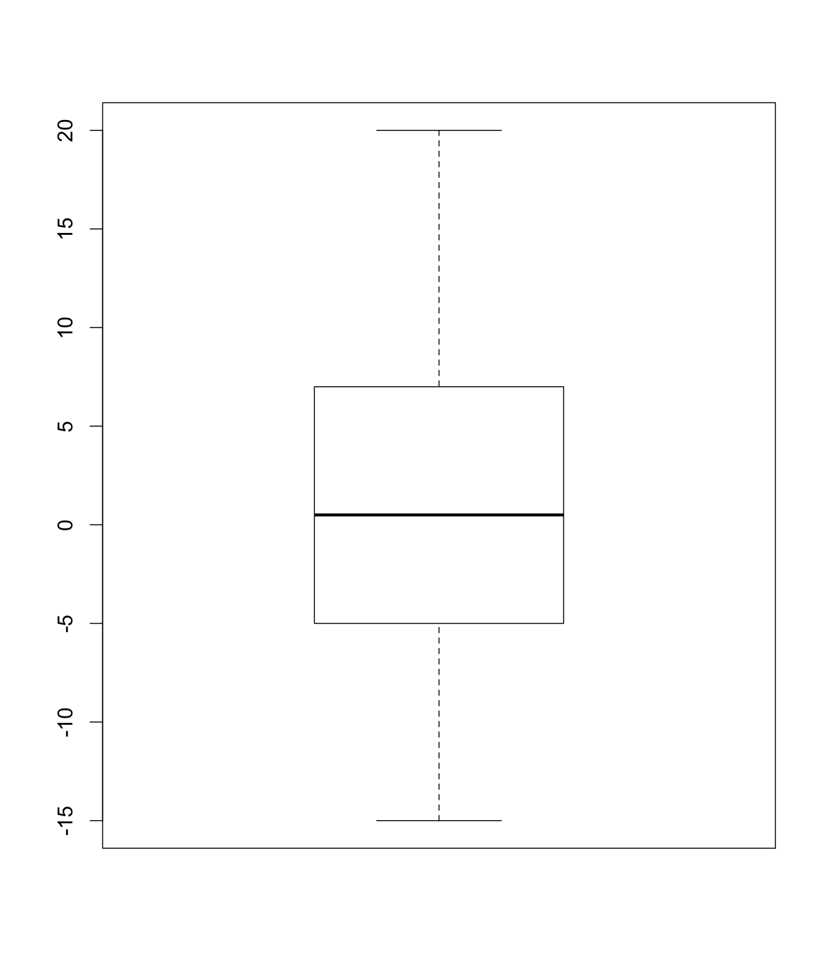

**2.** Since the data was centered around zero there was not much of a difference in the perceived stress levels over the course of the study. You can see this best in the boxplot where the stress levels are fairly centered with very little of a difference.