A. Code: > `stress.(1)` <- read.csv("C:/Users/mmaguilar/Downloads/stress (1).csv", sep="")

> View(`stress.(1)`)

Output: Subject Group PSSbefore PSSafter

1 A1 Sport 25 13

2 A3 Sport 17 15

3 A4 Sport 12 13

4 A5 Sport 21 22

5 A6 Sport 29 25

6 A7 Sport 28 24

7 A8 Sport 21 19

8 B1 Sport 18 19

9 B2 Sport 20 24

10 B3 Sport 29 21

11 B4 Sport 27 22

12 B5 Sport 44 33

13 B6 Sport 23 8

14 B7 Sport 18 12

15 B8 Sport 27 30

16 A2 Control 0 16

17 C1 Control 30 27

18 C2 Control 12 31

19 C3 Control 29 21

20 C4 Control 25 33

21 C6 Control 2 9

22 C7 Control 6 26

23 C8 Control 20 20

24 C9 Control 27 28

25 C10 Control 14 21

26 C11 Control 15 29

B. Code: > head(`stress.(1)`)

Output: Subject Group PSSbefore PSSafter

1 A1 Sport 25 13

2 A3 Sport 17 15

3 A4 Sport 12 13

4 A5 Sport 21 22

5 A6 Sport 29 25

6 A7 Sport 28 24

C. code:> tail(`stress.(1)`)

Output: Subject Group PSSbefore PSSafter

21 C6 Control 2 9

22 C7 Control 6 26

23 C8 Control 20 20

24 C9 Control 27 28

25 C10 Control 14 21

26 C11 Control 15 29

D. code: stress$Differences<-stress$PSSafter-stress$PSSbefore

E. code: mean(stress$Differences)

Output: [1] 0.8461538

Code: sd(stress$Differences)

Output: [1] 9.194313

Code: hist(stress$Differences)

boxplot(stress$Differences)

output: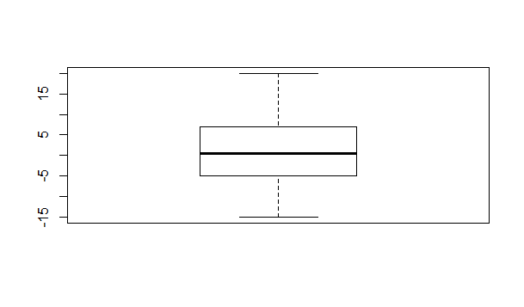

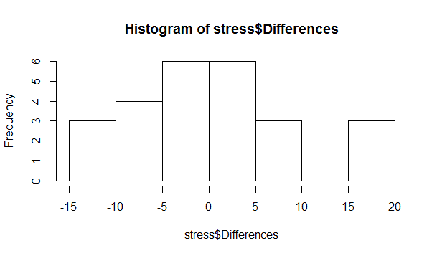

F. Looking at the figures in part e we can see the changes in stress.