**ThingPlug oneM2M SDK API**



**IoT Tech Lab**

**문서 개정 내역**

|  |  |  |  |
| --- | --- | --- | --- |
| 변경일 | 버전 | 변경 내용 | 비고 |
| 2016.08.08 | 0.1 | 최초 작성 |  |
| 2016.10.25 | 1.0 | Wrapper 추가 |  |
|  |  |  |  |

**목 차**

[1 SDK 디렉토리 구조 4](#_Toc465166193)

[1.1 구조 4](#_Toc465166194)

[1.2 상세 설명 4](#_Toc465166195)

[2 SDK 구성도 5](#_Toc465166196)

[2.1 구성도 5](#_Toc465166197)

[3 API(Application Programming Interface) 6](#_Toc465166198)

[3.1 Configuration API 6](#_Toc465166199)

[3.2 Request API 9](#_Toc465166200)

[3.3 Request API wrapper (V1) 10](#_Toc465166201)

[3.4 Request API wrapper (V1.12) 13](#_Toc465166202)

[3.5 HOWTO Request API wrapper 16](#_Toc465166203)

[4 각종 Code 정보 17](#_Toc465166204)

[4.1 m2m:resourceType 17](#_Toc465166205)

[4.2 API Error code 18](#_Toc465166206)

# SDK 디렉토리 구조

## 구조

**|–oneM2M** (ThingPlug oneM2M SDK root folder)

**|–docs** (Developer guide & API documentation)

**|–samples** (Samples including makefiles for build)

**|–lib** (external libraries - paho, TLS, )

**|–include** (Header files of the ThingPlug oneM2M SDK)

**|–src** (Source files of the ThingPlug oneM2M SDK)

**|–oneM2M\_V1** (Source files of the ThingPlug oneM2M v1 API)

**|–oneM2M\_V1\_12** (Source files of the ThingPlug oneM2M v1.12 API)

**|–net** (Source files of the MQTTS)

## 상세 설명

|  |  |
| --- | --- |
| Directory | Description |
| **oneM2M** | ThingPlug oneM2M SDK 루트 폴더 |
| **docs** | 개발 가이드와 API document 폴더 |
| **samples** | SDK 를 이용한 샘플 Application들 폴더 |
| **lib** | 외부 라이브러리나 소스들 폴더 |
| **Include** | 동작에 필요한 header 파일들 폴더 |
| **Src** | 전체 소스 폴더 |
| **oneM2M\_V1** | ThingPlug oneM2M v1 관련 소스 폴더 |
| **oneM2M\_V1\_12** | ThingPlug oneM2M v1.12 관련 소스 폴더 |
| **net** | MQTT/TLS 관련 소스들 폴더 |

# SDK 구성도

## 구성도

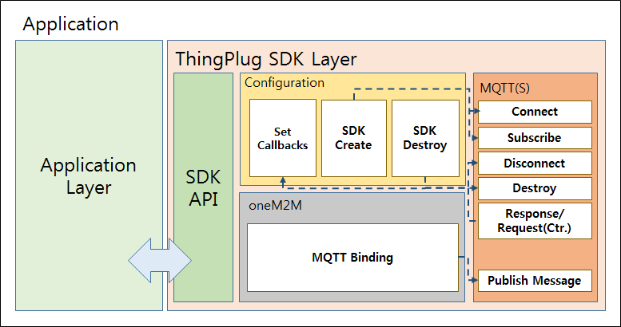

# API(Application Programming Interface)

## Configuration API

|  |  |
| --- | --- |
| 서버에 접속 결과 콜백 함수(사용자 등록) | |
| **void tpMQTTConnectCallback(int result);** | |
| **param** | **description** |
| result | connection result |

|  |  |
| --- | --- |
| 서버에 subscribe 결과 콜백 함수(사용자 등록) | |
| **void tpMQTTSubscribeCallback(int result);** | |
| **param** | **description** |
| result | subscribe result |

|  |  |
| --- | --- |
| 서버에 tpMQTTDisconnect() 함수 호출 결과 콜백 함수(사용자 등록) | |
| **void tpMQTTDisconnectCallback(int result);** | |
| **param** | **description** |
| result | disconnect result |

|  |  |
| --- | --- |
| 서버와 연결이 끊어졌을때 콜백 함수(사용자 등록) | |
| **void tpMQTTConnectionLostCallback(char\* cause);** | |
| **Param** | **description** |
| Cause | The reason for the disconnection. |

|  |  |
| --- | --- |
| 서버에 메시지가 전달되었을때 콜백 함수(사용자 등록) | |
| **void tpMQTTMessageDeliveredCallback(int token);** | |
| **param** | **description** |
| token | A value representing an MQTT Message. |

|  |  |
| --- | --- |
| 메시지를 받았을때 콜백 함수(사용자 등록) | |
| **void tpMQTTMessageArrivedCallback(char\* topic, char\* payload, ine payloadLen);** | |
| **Param** | **description** |
| topic | The topic associated with the received message. |
| payload | A pointer to the payload of the MQTT message. |
| payloadLen | The length of the MQTT message payload in bytes. |

|  |  |
| --- | --- |
| 콜백함수들을 등록해주는 함수로 tpSDKCreate() 함수보다 먼저 호출되어야 한다.  (ARDUINO 등에서 형태가 달라질 수 있음) | |
| **int tpMQTTSetCallbacks(tpMQTTConnectCallback\* cc, tpMQTTSubscribeCallback\* sc, tp MQTTDisconnectCallback\* dc,**  **tpMQTTConnectionLostCallback\* clc, tpMQTTMessageDeliveredCallback\* mdc, tpMQTTMessageArrivedCallback\* mac);** | |
| tpMQTTMessageArrivedCallback 을 제외하고는 NULL 허용 | |
| **return type** | **description** |
| int | set callbacks result |

|  |  |
| --- | --- |
| 서버 연결을 위한 정보, 보안, 토픽 등을 등록하는 함수로 호출되면 서버와의 연결 및 subscribe 까지 자동으로 진행된다. | |
| **int tpSDKCreate(char\* host, int port, int keepalive, char\* userName, char\* password, int enableServerCertAuth,**  **char\* subscribeTopic[], int subscribeTopicSize, char\* publishTopic);** | |
| **Param** | **description** |
| host | host address |
| port | port |
| keepalive | keep alive interval |
| userName | ThingPlug ID |
| password | uKey of ThingPlug ID |
| enableServerCertAuth | True/False option to enable verification of the server certificate |
| subscribeTopic | subscribing topics |
| subscribeTopicSize | subscribing topic size |
| publishTopic | publish topic |
| **return type** | **description** |
| int | request result |

|  |  |
| --- | --- |
| 서버와의 연결상태를 확인한다. | |
| **int tpMQTTIsConnected();** | |
| **return type** | **description** |
| int | when result is true, connected |

|  |
| --- |
| 서버와의 연결을 끊는다. |
| **void tpMQTTDisconnect();** |

|  |
| --- |
| SDK 를 초기화 한다. |
| **void tpSDKDestroy();** |

## Request API

|  |  |
| --- | --- |
| ThingPlug oneM2M v1 프로토콜을 요청한다. | |
| **int tp\_oneM2M\_V1\_Request(int resourceType, int operation, char\* to, char\* ri, void\* pc);** | |
| **param** | **description** |
| resourceType | resource type(AE, remoteCSE...) /wiki/s/ko_KR/5998/b35c841f380357005e7608cc93741793c4035766.92/_/images/icons/emoticons/help_16.png 4 참조 |
| operation | CREATE, UPDATE, DELETE, RETRIEVE /wiki/s/ko_KR/5998/b35c841f380357005e7608cc93741793c4035766.92/_/images/icons/emoticons/help_16.png 4 참조 |
| to | request URI(/ThingPlug) |
| ri | request identifier |
| pc | primitive content(리소스별 정보 구조체) |
| **return type** | **description** |
| int | request result |

|  |  |
| --- | --- |
| ThingPlug oneM2M v1.12 프로토콜을 요청한다. | |
| **int tp\_oneM2M\_V1\_12\_Request(int resourceType, int operation, char\* fr, char\* to, char\* ri, void\* pc);** | |
| **param** | **description** |
| resourceType | resource type(AE, remoteCSE…) /wiki/s/ko_KR/5998/b35c841f380357005e7608cc93741793c4035766.92/_/images/icons/emoticons/help_16.png 4 참조 |
| operation | CREATE, UPDATE, DELETE, RETRIEVE /wiki/s/ko_KR/5998/b35c841f380357005e7608cc93741793c4035766.92/_/images/icons/emoticons/help_16.png 4 참조 |
| fr | remoteCSE-ID or AE-ID |
| to | request URI(/ThingPlug) |
| ri | request identifier |
| pc | primitive content(리소스별 정보 구조체) |
| **return type** | **description** |
| int | request result |

## Request API wrapper (V1)

|  |  |
| --- | --- |
| 디바이스 등록을 요청한다. (node, remoteCSE) | |
| **int tpRegisterDevice(int resourceType, char\* fr, char\* to, char\* ri, char\* mga, char\* nm, char\* cst, char\* passcode, char\* poa, char\* nl);** | |
| **param** | **description** |
| resourceType | resource type(AE, remoteCSE…) /wiki/s/ko_KR/5998/b35c841f380357005e7608cc93741793c4035766.92/_/images/icons/emoticons/help_16.png 4 참조 |
| fr | from |
| to | request URI |
| ri | request identifier |
| mga | node mga |
| nm | remoteCSE resource name |
| cst | remoteCSE type |
| passcode | remoteCSE passcode |
| poa | remoteCSE point of access |
| nl | remoteCSE node link |
| **return type** | **description** |
| int | request result |

|  |  |
| --- | --- |
| container 등록을 요청한다. | |
| **int tpRegisterContainer(char\* fr, char\* to, char\* ri, char\* nm, char\* dKey, char\* lbl);** | |
| **param** | **description** |
| fr | from |
| to | request URI |
| Ri | request identifier |
| nm | container resource name |
| dKey | device key |
| lbl | labels |
| **return type** | **description** |
| int | request result |

|  |  |
| --- | --- |
| mgmtCmd 등록을 요청한다. | |
| **int tpRegisterMgmtCmd(char\* fr, char\* to, char\* ri, char\* nm, char\* dKey, char\* cmt, char\* exe, char\* ext, char\* lbl);** | |
| **param** | **description** |
| fr | from |
| to | request URI |
| ri | request identifier |
| nm | mgmtCmd resource name |
| dKey | device key |
| cmt | cmd type |
| exe | exec enable |
| ext | exec target |
| lbl | labels |
| **return type** | **description** |
| int | request result |

|  |  |
| --- | --- |
| 센서값을 add 한다. | |
| **int tpAddData(char\* data, unsigned char length);** | |
| **param** | **description** |
| data | adding data |
| length | data length |

|  |  |
| --- | --- |
| 주기보고를 요청한다. (contentInstance) | |
| **int tpReport(char\* fr, char\* to, char\* ri, char\* dKey, char\* cnf, char\* con, unsigned char useAddedData);** | |
| **param** | **description** |
| fr | from |
| to | request URI |
| ri | request identifier |
| dKey | device key |
| cnf | content info |
| con | content |
| useAddedData | use added data flag |
| **return type** | **description** |
| int | request result |

|  |  |
| --- | --- |
| 제어결과를 전달한다. (execInstance) | |
| **int tpResult(char\* fr, char\* to, char\* ri, char\* dKey, char\* exr, char\* exs);** | |
| **param** | **description** |
| fr | from |
| to | request URI |
| ri | request identifier |
| dKey | device key |
| exr | exec result |
| exs | exec status |
| **return type** | **description** |
| int | request result |

## Request API wrapper (V1.12)

|  |  |
| --- | --- |
| 디바이스 등록을 요청한다. (node, AE) | |
| **int tp\_v1\_12\_RegisterDevice(int resourceType, char\* fr, char\* to, char\* rqi, char\* rn, char\* ni, char\* mga, char\* poa, char\* api);** | |
| **param** | **description** |
| resourceType | resource type(AE, remoteCSE…) /wiki/s/ko_KR/5998/b35c841f380357005e7608cc93741793c4035766.92/_/images/icons/emoticons/help_16.png 4 참조 |
| fr | from |
| to | request URI |
| rqi | request identifier |
| rn | resource name |
| ni | node id |
| mga | node mga |
| poa | AE point of access |
| api | AE App ID |
| **return type** | **description** |
| int | request result |

|  |  |
| --- | --- |
| container 등록을 요청한다. | |
| **int tp\_v1\_12\_RegisterContainer(char\* fr, char\* to, char\* rqi, char\* rn);** | |
| **param** | **description** |
| fr | from |
| to | request URI |
| rqi | request identifier |
| rn | container resource name |
| **return type** | **description** |
| int | request result |

|  |  |
| --- | --- |
| mgmtCmd 등록을 요청한다. | |
| **int tp\_v1\_12\_RegisterMgmtCmd(char\* fr, char\* to, char\* rqi, char\* rn, char\* cmt, char\* ext);** | |
| **param** | **description** |
| fr | from |
| to | request URI |
| rqi | request identifier |
| rn | mgmtCmd resource name |
| cmt | cmd type |
| ext | exec target |
| **return type** | **description** |
| int | request result |

|  |  |
| --- | --- |
| 센서값을 add 한다. | |
| **int tp\_v1\_12\_AddData(char\* data, unsigned char length);** | |
| **param** | **description** |
| data | adding data |
| length | data length |

|  |  |
| --- | --- |
| 주기보고를 요청한다. (contentInstance) | |
| **int tp\_v1\_12\_Report(char\* fr, char\* to, char\* rqi, char\* cnf, char\* con, unsigned char useAddedData);** | |
| **param** | **description** |
| fr | from |
| to | request URI |
| rqi | request identifier |
| cnf | content info |
| con | content |
| useAddedData | use added data flag |
| **return type** | **description** |
| Int | request result |

|  |  |
| --- | --- |
| 제어결과를 전달한다. (execInstance) | |
| **int tp\_v1\_12\_Result(char\* fr, char\* to, char\* rqi, char\* exr, char\* exs);** | |
| **param** | **description** |
| fr | from |
| to | request URI |
| rqi | request identifier |
| exr | exec result |
| exs | exec status |
| **return type** | **description** |
| int | request result |

## HOWTO Request API wrapper

**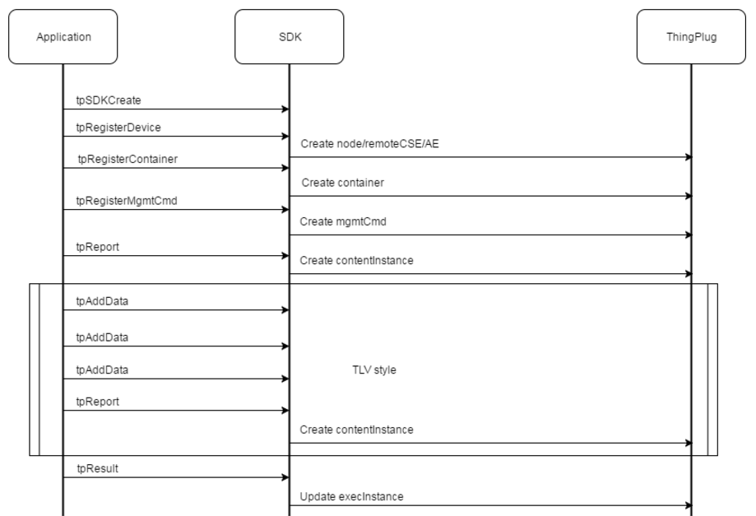**

# 각종 Code 정보

## m2m:resourceType

|  |  |
| --- | --- |
| **Value** | **Interpretation** |
| 1 | accessControlPolicy |
| 2 | AE |
| 3 | container |
| 4 | contentInstance |
| 5 | CSEBase |
| 6 | delivery |
| 7 | eventConfig |
| 8 | execInstance |
| 9 | group |
| 10 | locationPolicy |
| 11 | m2mServiceSubscriptionProfile |
| 12 | mgmtCmd |
| 13 | mgmtObj |
| 14 | node |
| 15 | pollingChannel |
| 16 | remoteCSE |
| 17 | request |
| 18 | schedule |
| 19 | serviceSubscribedAppRule |
| 20 | serviceSubscribedNode |
| 21 | statsCollect |
| 22 | statsConfig |
| 23 | subscription |
| 10001 | accessControlPolicyAnnc |
| 10002 | AEAnnc |
| 10003 | containerAnnc |
| 10004 | contentInstanceAnnc |
| 10009 | groupAnnc |
| 10010 | locationPolicyAnnc |
| 10013 | mgmtObjAnnc |
| 10014 | nodeAnnc |
| 10016 | remoteCSEAnnc |
| 10018 | scheduleAnnc |

*(출처 : TS-0004-Service\_Layer\_Core\_Protocol-V1\_6\_0.pdf)*

**Table 1: Interpretation of resourceType**

## API Error code

|  |  |
| --- | --- |
| **Value** | **Description** |
| 0 | No error. Indicates successful completion |
| -1 | A generic error code indicating the failure |
| -2 | MQTTAsync\_PERSISTENCE\_ERROR |
| -3 | The client is disconnected. |
| -4 | The maximum number of messages allowed to be simultaneously in-flight has been reached. |
| -5 | An invalid UTF-8 string has been detected. |
| -6 | A NULL parameter has been supplied when this is invalid. |
| -7 | The topic has been truncated (the topic string includes embedded NULL characters). String functions will not access the full topic.Use the topic length value to access the full topic. |
| -8 | A structure parameter does not have the correct eyecatcher and version number. |
| -9 | A qos parameter is not 0, 1 or 2 |
| -10 | All 65535 MQTT msgids are being used |
| -11 | the request is being discarded when not complete |
| -12 | no more messages can be buffered |
| -13 | Resource type or Operation is not supported |
| -14 | Some parameter is invalid |

**Table 2: ThingPlug SDK API Error code**