CHOOSE THE LETTER OF THE CORRECT ANSWER
1. Which of the following is an example of scientific process? (1.1.1.1)
A. Germinating B. Evaporating
C. Soaking D. Organizing
2. Which of the following is not needed for photosynthesis to occur? (2.2.1.1)
A. Water B. Carbohydrates
C. Chlorophyll D. Light
3. All plants have a green substance in their leaves. This green substance is known as …(2.2.1.2)
A. Glucose B. Sunlight
C. Chlorophyll D. Carbondoixide
3. During the lesson Mr Ponanje and his pupils looked at what was happening in the two glass jars in the experiment. What scientific process was he using? (1.1.1.1)
A. Comparing B. Analysing
C. Relating D. Recording

Students in standard five placed a leaf in bottle containing potassium hydroxide.

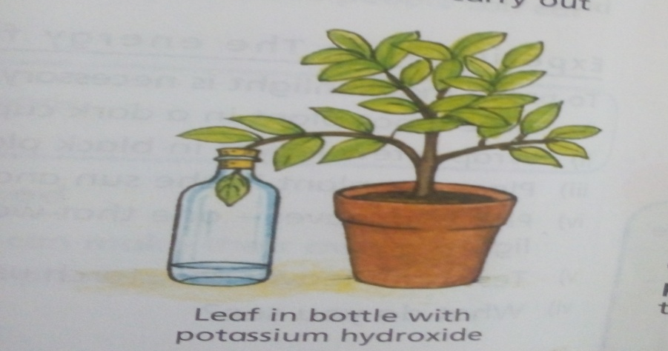

4.Which condition required by photosynthesis is being investigated? (2.2.1.1)
A. Water B. Sunlight
C. Carbon dioxide D. Chlorophyll
5. Which statement is not true about air? (2.4.1.3)
A. It is made of different gases B. It is needed for things to burn
C. It has smell D. It is colourless
6. The followings are characteristics of vertebrates except ……………………… (2.3.1.1)
A. They have a skull and brain B. They have exoskeleton
C. They have backbone D. They have endoskeleton
7. Which of the following animals is an amphibian? (2.3.1.3)
A. Tadpole B. Snake
C. Dove D. Fish
8. The change of gas directly to solid is known as …………………… (3.1.1.1)
A. Melting B. Condensation
C. Freezing D. Sublimation
9. Which of the following is a way of collecting rain water? (2.5.1.3)
A. Cups B. Taps
C. Dams D. Vehicles
10. What is air? (2.4.1.1)
A. Substance that cannot occupy space. C. Any substance that is moving
B. Substance that can be seen D. Mixture of different gases
11. The following are major components of air except …………………. (2.4.1.2)
A. wind B. Oxygen
C. Nitrogen D. Carbon dioxide
12. Which of the following is not an example of environmental problems? (1.1.2.1)
A. Soil erosion B. Littering
C. Overgrazing D. Afforestation
13. How can we reduce the spread of HIV/AIDS in Botswana? (1.1.2.2}
A. Encourage people to have many partners C. Teach people about the dangers of HIV/AIDS
B. Encourage people not to use condoms D. Punish people who talk about HIV/AIDS
14. Which of the following animals is a group of invertebrates? (2.3.1.4)
A. Dog, butterfly, mosquito B. Bees, termites, ants
C. Cat, snake, ostrich D. Grasshopper, monkey, frog
15. During the process of photosynthesis which of the following is not released? (2.2.1.2)
A. Energy B. Chlorophyll
C. Carbohydrates D. Oxygen

16. Which of the following statement shows that living things depend on non-living things? (2.1.1.1)
A. People need plants only to live B. Plants can live without air
C. Water is necessary for both plants and animals D. Soil is not necessary for plants to grow
17. Which of the following animals give birth to their babies and feed them with milk? (2.3.1.3)
A. Pigs B. Ostriches
C. Doves D. Ducks
18. Which one of the following will not prevent an iron object from rusting? (2.4.2.2)
A. Store in oil B. Pack in silica gel
C. Paint with zinc D. Store in wet place
19. What source of water might people who live in an area where there is little rainfall use? (2.5.1.1)
A. Underground source B. Surface source
C. Atmospheric source D. Water cycle source

Use the water cycle below to answer question 20 – 22 (2.5.1.2)

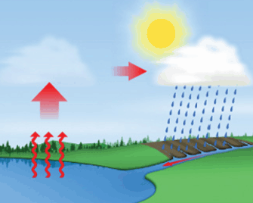
F
H
G

20. Which process is taking place at F?
A. Transpiration B. Evaporation
C. Precipitation D. Condensation
21. What takes place at G in the diagram?
A. Evaporation B. Transpiration
C. Precipitation D. Condensation
22. At which point is transpiration taking place ?
A. F B. H
C. G D. I
23. Which of the following is a way of conserving water in Botswana? (2.5.1.4)
A. Brushing teeth under running tap B. Growing plants that need more water
C. Not fixing leaking taps D. Taking a shower rather than a bath
24. The following are inner planets in the solar system except ……….. (2.7.1.2)
A. Venus B. Mars
C. Jupiter D. Mercury
25. Which of the weather chart below represent windy condition? (2.6.1.4)

A. B. C. D.

26. The planet earth is the capable of supporting life because of ………. (2.7.1.4)
A. High temperature B. Suitable temperature
C. No atmosphere D. Extremely cold

27. Most animals died due to lung cancer disease at Bobonong village. What will happen to the vegetation around the village? (2.1.1.2)
A. Decrease B. Become dry
C. Increase D. Destroyed

28. Modiri conducted the experiment as follows (2.4.1.1)

B
A
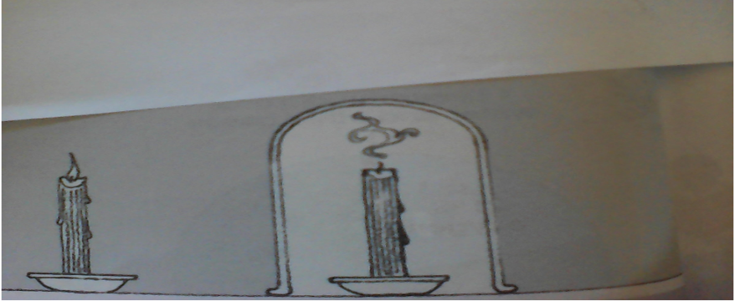

Candle A burn normally and Candle B went off. Why candle B went off?
- Too much air B .Need more water C. Oxygen is used up D. It kept burning
29. Which of the following is the effect of the limited water on the lives of people? (2.5.1.5)
A. Jobs are created B. More water for farming C. Water become scares D. Not hard to grow
Use the diagram below for question 30 – 31

30. What is the name of the instrument shown above? (2.6.1.2)
A. Rain gauge B. Barometer C. Thermometer D. Wind vane
31. Which unit is used to measure rainfall?
A. Millimeter B. Kilograms C. Millibars D. Degrees
32. ______________ can make their own food (2.1.1.2)
A. Mammals B. Green plants C. wood D. Animals

33. Which class of vertebrates should be at M?
Birds Reptiles M Amphibians Mammals
A. Warms B. Ostrich C. Fish D. Invertebrates
34. Which are the three outer planets in the solar system? (2.7.1.2)
A. Saturn, Uranus, Neptune B. Mars, venus, Earth
C. Uranus, Venus, Pluto D. Mercury, Saturn, Pluto
35. Where do plants get their energy?
A. Air B. Water C. Sun D .Animals
36. Which of the following gases is not a component of air?
A. Oxygen B. Nitrogen C . Carbon dioxide D. Hydrogen
Use the pie chart below to answer question 37-38

37. Which component of air is labeled T?
A. Oxygen B. Nitrogen C. Carbon D. Carbon dioxide
38. The percentage for component R is …………………...
A. 78% B. 1% C.21% D.14%

39. The following are examples of instruments that are used to measure weather conditions except …
A. Spedometer B. Barometer
C. Anemometer D. Hygrometer
40. Which element of weather is correctly matched with its instrument?
A | Humidity | Barometer
B | Air pressure | Hygrometer
C | Sunshine | Thermometer
D | Wind speed | Anemometer

41. The following are classes of vertebrates that reproduce by laying eggs except …………..
A. Reptiles B. Mammals C. Amphibians D. Fish
42. Which of the following state of matter is a solid?
A. juice B. milk C. doom D. salt
Use the weather chart for February to answer question 43 -45
Monday | Tuesday | Wednesday | Thursday | Friday | Saturday | Sunday
1 | 2 | 3 | 4 | 5 | 6 | 7
8 | 9 | 10 | 11 | 12 | 13 | 14
15 | 16 | 17 | 18 | 19 | 20 | 21
22 | 23 | 24 | 25 | 26 | 27 | 28

43. On which days was it very cloudy?
A. Saturday and Sunday B. Monday and Wednesday
C. Tuesday and Saturday D. Monday and Saturday
44. On which days was the weather hail?
A. Monday, Tuesday B. Tuesday, Wednesday
C. Wednesday, Thursday D. Thursday, Friday
45. How was the weather on the 22 of this calendar of the year?
A. Cloudy B. Strong winds C. Sunny D. Hail
46. Which of the planet in the solar system is mercury?
Sun A B C Mars D
47. Which star is nearer to the earth?
A. Morning star B. Sun C. Mars D. Comet
48. Which characteristic of fish enables it to live in water?
A. It has hair B. It has gills
C. It has fur D. It has feathers
49. What causes rusting?
A. Iron only B. Water and air C. Grease D. Oil
50. Mr Bombela left his spade outside the house after weeding and after three days his tool was covered with reddish brown colour. Which process resulted to the reddish brown colour?
A. Weeding B. Rainfall C. Coating D. Rusting



CENTRAL REGION REGIONAL EXAMINATION

END OF TERM ONE (1) 2019

SCIENCE FOR STANDARD FIVE (5)

MARKING KEY
1. D 22. B 43.D
2. B 23. D 44.B
3. A 24.C 45.B
4. C 25. D 46.A
5. C 26. B 47.B
6. B 27. C 48.B
7. A 28. C 49.B
8. D 29. C 50.D
9. C 30. A
10. D 31. A
11. A 32. B
12. D 33. C
13. C 34. A
14. B 35. C
15. B 36. D
16. C 37. D
17. A 38. A
18. D 39. A
19. A 40.D
20. C 41. B
21. A 42. D

