Subscriber
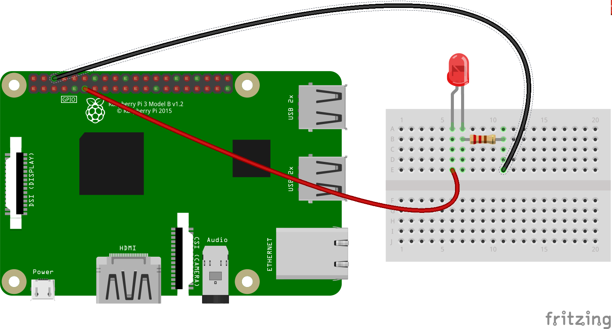

import paho.mqtt.client as mqtt
from gpiozero import LED
red = LED(17)
def on_connect(client, userdata, flags, rc):
print("Connected with result code "+str(rc))
client.subscribe("temperature")
def on_message(client, userdata, msg):
message = str(msg.payload)
message = message[2:(len(message)-1)]
message = float(message)
print(message)
if message < 10.0 and message >= 0.0:
print(message)
red.blink(1,1)
elif message >= 10.0 and message < 20:
print(message)
red.blink(0.5,0.5)
elif message >=20 and message <30:
print(message)
red.blink(0.25,0.25)
client = mqtt.Client()
client.on_connect = on_connect
client.on_message = on_message
client.connect("192.168.1.147", 1883, 60)
client.loop_forever()

