Wheel of Fortune – Powered by Raspberry Pi and Pibrella

Introduction
Pibrella is an add on board from the lovely people at Pimoroni and Cyntech. The board enables anyone to easily learn physical computing using Scratch GPIO or Python. Physical computing is an exciting and innovative area of technology and provides children with massive incentive to learn computing.

Learning objective
In this project we will build a motorised wheel which will rotate for a random amount of time and when it stops it will select a question / person from the wheel.

Resources
Game wheel pieces and code can be downloaded from
https://github.com/lesp/Picademy_WheelOfFortune/archive/master.zip

Lesson Summary

- An introduction to Pibrella
- Build our hardware and wheel
- Program our project using Python

An introduction to Pibrella
Pibrella is a £10 add on board for the Raspberry Pi that enables anyone to learn physical computing and electronics. Fixing over the GPIO pins Pibrella simplifies the pins into groups that offer different forms of functionality.

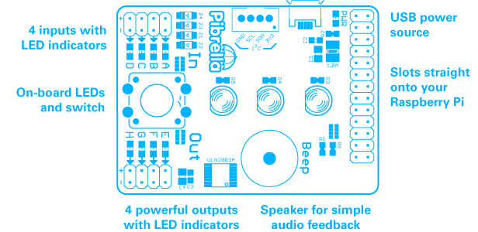

Build our hardware and wheel
- Turn off your Raspberry Pi and firmly attach your Pibrella.
- Connect the motor to output “e”
- Print off and cut out the wheel and selector.
- Affix wheel to motor using blutack and also secure your motor to the desk using more blutack.
- Set up your Raspberry Pi and power it up.

Program our project using Python
Open the IDLE3 application as root, you can do this via LXterminal by typing
sudo idle3
When IDLE3 has finished loading click on File >> New to open a blank editor window.
Let's get coding!
Import Modules
Our first line will be to import the pibrella module into our code. This enables us to use the Pibrella with Python.
import pibrella

Next we will import two more modules one which will control the speed of our game and another to enable our project to select a random number.

from time import sleep
from random import randint
You can see that these modules have been imported differently. Rather than import the whole library we only import the libraries that we need.

Create a function
Functions are awesome! Using functions we can create a sequence of code that can be used whenever we need it. Our function controls the spin of our wheel which is triggered by pressing the red button on our Pibrella.
We start by defining the name of the function, in this case spinwheel,
def spinwheel(pin):
You will see that in brackets the word pin, this is an argument that Pibrella needs in order to use the button with our project.
We next create a variable called duration and the data that we will store inside of our variable will be the random integer chosen using the following code.

duration = randint(1,10)

We now turn on the power to output e of our Pibrella, this starts the motor turning. The motor will continue to turn while the project sleeps, and this duration is the randomly chosen number that we earlier created.
You will notice that there is a print(duration) function in the code, this will output the random number to the Python shell for debugging purposes.
The last step in the function turns off the power to output e of our Pibrella.
Here is the code for the function for your reference.

def spinwheel(pin):
duration = randint(1,10)
print(duration)
pibrella.output.e.on()
sleep(duration)
pibrella.output.e.off()

Now that we have completed the function, we create a line that will handle the button press event. When the button is pressed, this event is True and the code created in the function will be executed.

pibrella.button.pressed(spinwheel)

With our code complete, save your work and when ready click on Run >> Run Module to start the project. Go ahead and press the big red button on the Pibrella. We should see the wheel move for a random number of seconds. The exact duration will be output to the Python shell.
Your code should look like this

import pibrella
import signal

from time import sleep
from random import randint

def spinwheel(pin):
duration = randint(1,10)
print(duration)
pibrella.output.e.on()
sleep(duration)
pibrella.output.e.off()

pibrella.button.pressed(spinwheel)

Congratulations, you've made your own version of the Wheel of Fortune.

Extension Activity
The Pibrella add on board also comes with three LEDs that we can easily use in our code.

To turn on a single LED, for example the red LED we type
pibrella.light.red.on()

And to turn off

pibrella.light.red.off()

To turn on all of the LEDs
pibrella.light.on()

And to turn off

pibrella.light.off()

You can also blink the LEDs for example the red LED.

pibrella.light.red.blink(ON_TIME, OFF_TIME)

Adapt the function that we created earlier so that the LED are used.

Plenary
Pibrella comes with a rich and powerful library of functionality and you can find out more from http://pibrella.com/

- How could you adapt this project for use in your school?
- Could this project be built with Scratch GPIO?

Outcome

All students

- Understand what the Pibrella is and what it can do.
- Begin to understand physical computing and electronics.
- Used Python to create a randomly rotating wheel.

