**CS 4341.002 Team Project**

**Team Name: We Are the Protoss**

**Spring 2016**

Contents-

1. File Listing
2. How to import into ModelSim
3. File Descriptions

1. File Listing-

* ALUDecoder.v
* ALUDecoderTest.v
* Data_Memory.v
* Instruction_memory.v
* MainALU.v
* MainDecoder.v
* MainDecoderTester.v
* Multiplexer.v
* README.md
* Register_File.v
* ShiftLeftTwo.v
* SignExtender.v
* SignExtenderTest.v
* SimpleAdder.v
* SingleCycleProcessor.v
* /tests
  + test_data.mem
  + test_instrs.mem
  + test_reg.mem
  + test2_data.mem
  + test2_instrs.mem
  + test2_reg.mem

2. How to import into ModelSim-

1. Verify all files in the File Listing section are present in the zipped folder
2. Open ModelSim and choose File -> New -> Project
3. Choose any name and directory
4. Choose “Add Existing File” from the prompt
5. Navigate to our folder with all of our code and select all of the *.v files
6. Change the file pathing for the memory elements
   1. In Instruction_Memory.v change the $readmemh path to your absolute path to access the …/tests/test_instrs.mem file.
   2. In Data_Memory.v change the $readmemh path to your absolute path to access the …/tests/test_data.mem file.
   3. In Instruction_Memory.v change the $readmemh path to your absolute path to access the …/tests/test_reg.mem file.
   4. An example of an absolute path is “C:/Users/John/Documents/CS3341-MIPS-processor/tests/test2_reg.mem”
7. Compile all (every file should complete successfully)
8. You now have all the code necessary to run and test our program

3. File Descriptions-

ALUDecoder.v

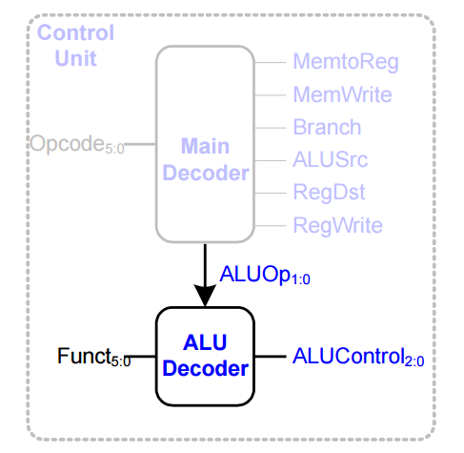

Takes in the ALUOp code and Funct code to choose an ALUControl. The ALUOp has a meaning of either add, subtract, or function. Funct Chooses a special function such as SLT. The output is ALUControl, which is sent to the Main ALU to control how the ALU handles its inputs.

Data_Memory.v

This is where our programs holds its main memory for all data. writeData is the data that is stored in memory at address addr if memWrite is true. readData is output from the address addr if memRead is true.

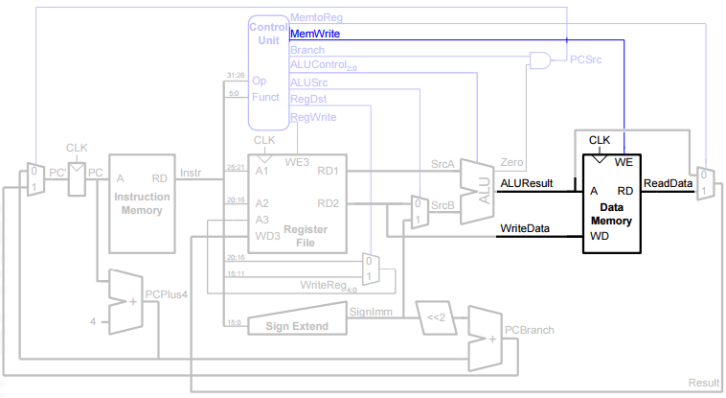

Instruction_memory.v

This holds the set of instructions that we want to execute. addr holds the address we are at. instruct is the output that holds the encoded instruction in memory.

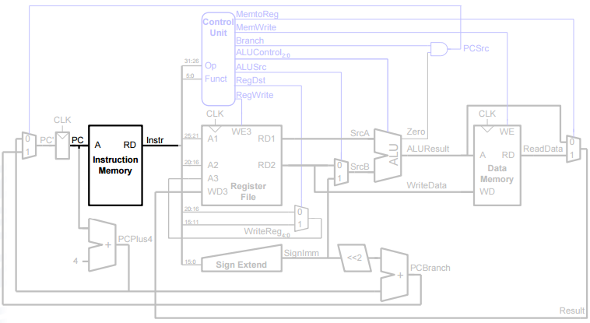

MainALU.v

This is where we handle the calculations needed to use the MIPS processor. SrcA and SrcB are the operands. ALUControl chooses what we do with the operands. ALUResult and Zero are the outputs that depends on the result of the operation executed.

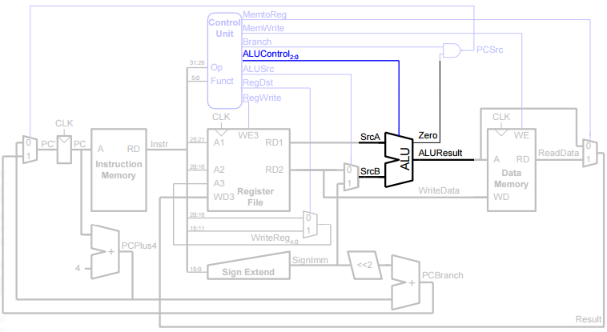

MainDecoder.v

This is our control unit that changes control signals depending on the opcode. These modify the execution of the datapath.

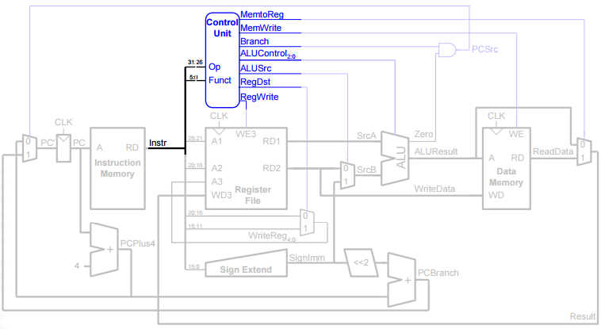

Multiplexer.v

This is a simple multiplexer module that selects between two inputs depending on the selection signal. The selected signal is then output to the next module.

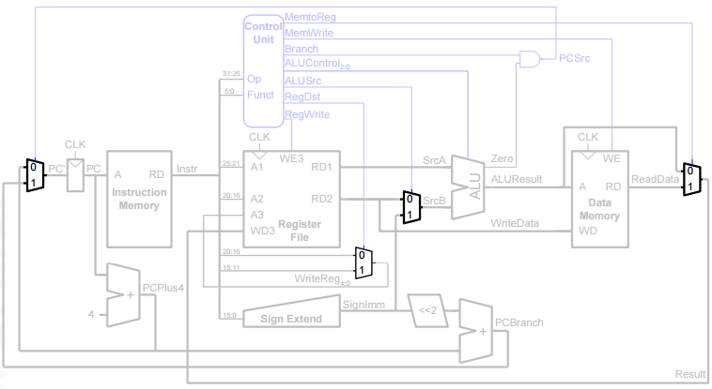

Register_File.v

This holds our MIPS registers for usage in instruction operands. The outputs are chosen depending on the reg inputs. There are 32 registers, just like you would expect in MIPS. regwrite decides if we should write back to the register file from the writeback stage.

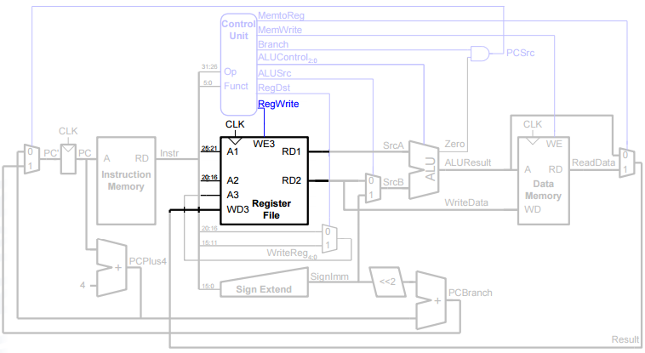

SignExtender.v

This is a simple sign extender from 16 bits to 32 bits so that we can extend the values preserving their sign.

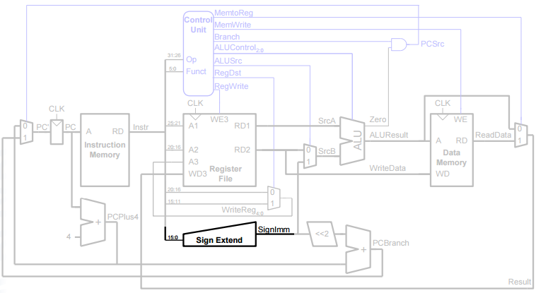

SimpleAdder.v

This is just an adder that outputs the addition of the 2 inputs. This is used to increment the PC value with and without branching.

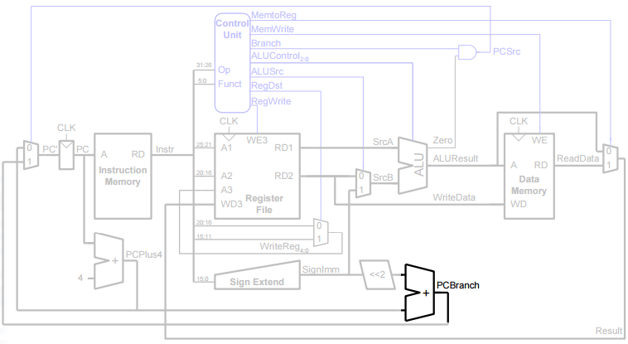

ShiftLeftTwo.v

This is just a simple shifter that appends two 0’s to the right side of the input.

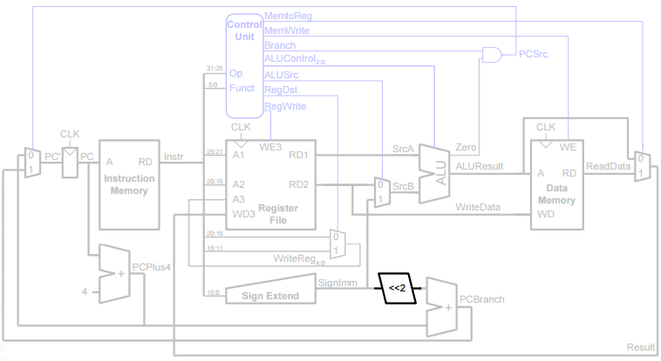

SingleCycleProcessor.v

This module is the collection of all other modules that drives the entire circuit. You will see a reference to all other modules here. The program counter is also changed here depending on a branch, jump, or just a +4 advancement. Many wires are defined here to serve as an intermediate location between the various modules.

Our current implementation simulates a single cycle processor. We have a select number of instructions that can be executed, where we exclude complex instructions and pseudo instructions that would require more advanced decoding. You can see the instructions that can be decoded in the Main Decoder module.

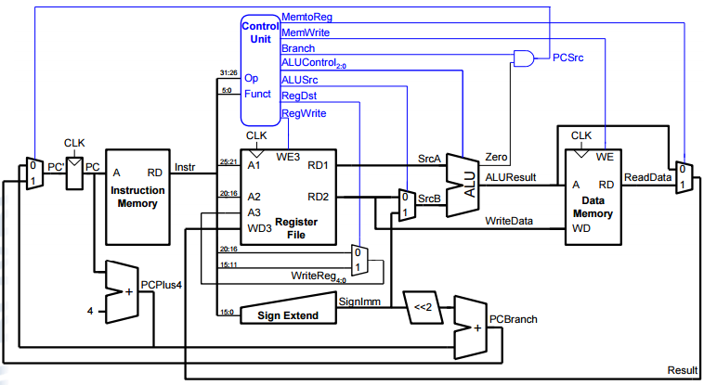

/tests Files

These files serve as our MIPS assembly program. They are values encoded into hex that are read into our memory elements, which are the data memory, the instruction memory, and the register file. These can be modified with data that will be read into Verilog, but we have already prepared two samples for use. They are the exact same MIPS instructions you would expect if you translate the hexadecimal into MIPS assembly operations.

For example, the first sample performs the sw, lw, add, and addi commands to show basic instruction execution. The second sample performs branching and jump commands to show flow control modification.

Be sure to set your pathing for reading these file in correctly. You can see how in the second section. The memory elements should be loaded with their values after the reset cycle when simulating. It should be noted that the pathing must be absolute, meaning on a Windows machine, starting from a letter drive to the /tests file.