DISTRIBUIDORA EL PALMAR
Business Intelligence & Decision Support
Project Blueprint • SQL + Power BI
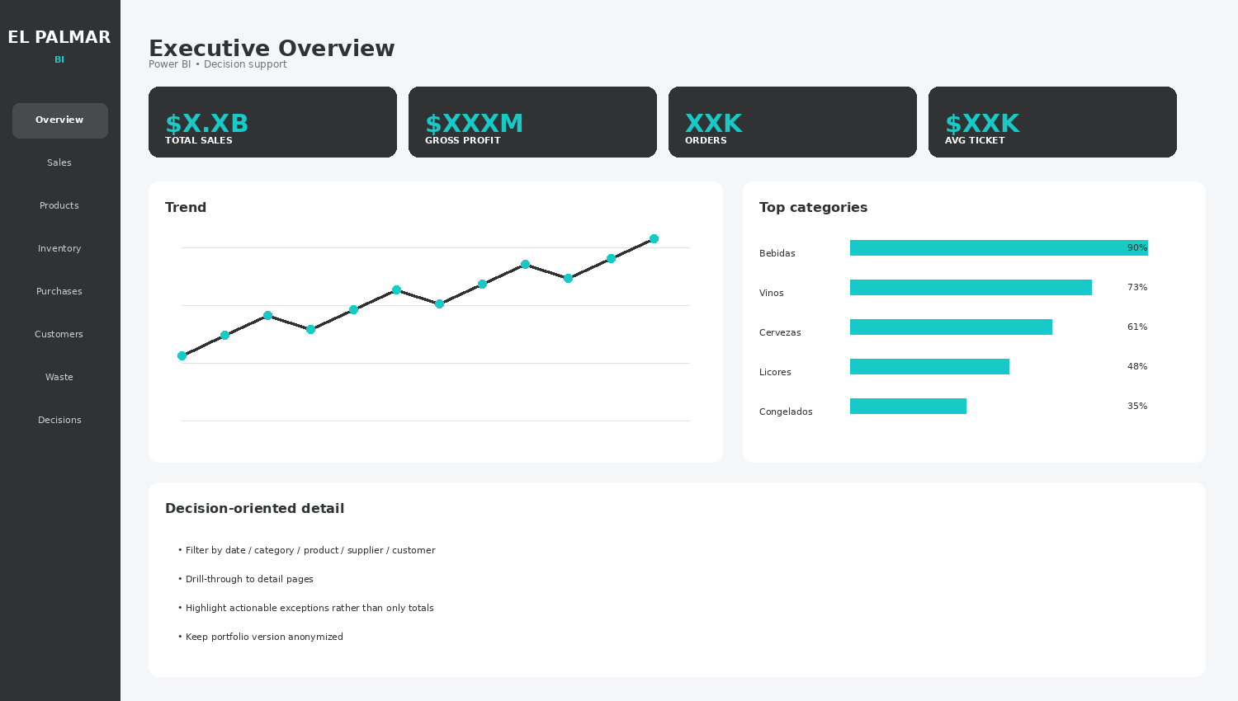
Portfolio-ready design specification and query planning document

Table of Contents
1. Project purpose and business questions
2. Navigation and information architecture
3. Executive Overview
4. Sales Performance
5. Products & Profitability
6. Inventory & Stock Health
7. Purchase Decision Center
8. Customer Intelligence
9. Waste & Returns
10. Decision Center
11. SQL layer and data architecture
12. Refresh strategy
13. SQL query checklist
Main objective
Build a refreshable, navigable Power BI system that helps El Palmar increase sales and profit, reduce stockouts and waste, and make better purchasing decisions.

1. Project Purpose & Business Questions
The project will connect MrCloud operational data to a decision-oriented Power BI model. It is designed as both a practical management tool and a portfolio project demonstrating SQL, data modeling, DAX and BI design.
- What is happening to sales, profit and customer activity?
- Which products generate revenue and gross profit?
- Which products are slow-moving, critical or out of stock?
- How much capital is tied up in inventory?
- What should be purchased, how much and from which supplier?
- Which customers are valuable or at risk?
- Where are the largest losses from waste and returns?
Portfolio angle
The project goes beyond descriptive reporting by adding an action layer: purchase proposals, stock alerts, margin reviews and loss priorities.

3. Executive Overview

Purpose
One-screen health check.

Information required
Sales, gross profit, orders, average ticket, customers, inventory value and waste.

Visual design
Trend + category mix + top products + alerts.

Decision use
Use it as the entry point; navigate to detail pages for investigation.

4. Sales Performance

Purpose
Understand demand and identify revenue opportunities.

Information required
Sales, units, orders, customers, average ticket.

Visual design
Trend + category/family + top products + period comparisons.

Decision use
Compare revenue and units to distinguish price effects from demand.
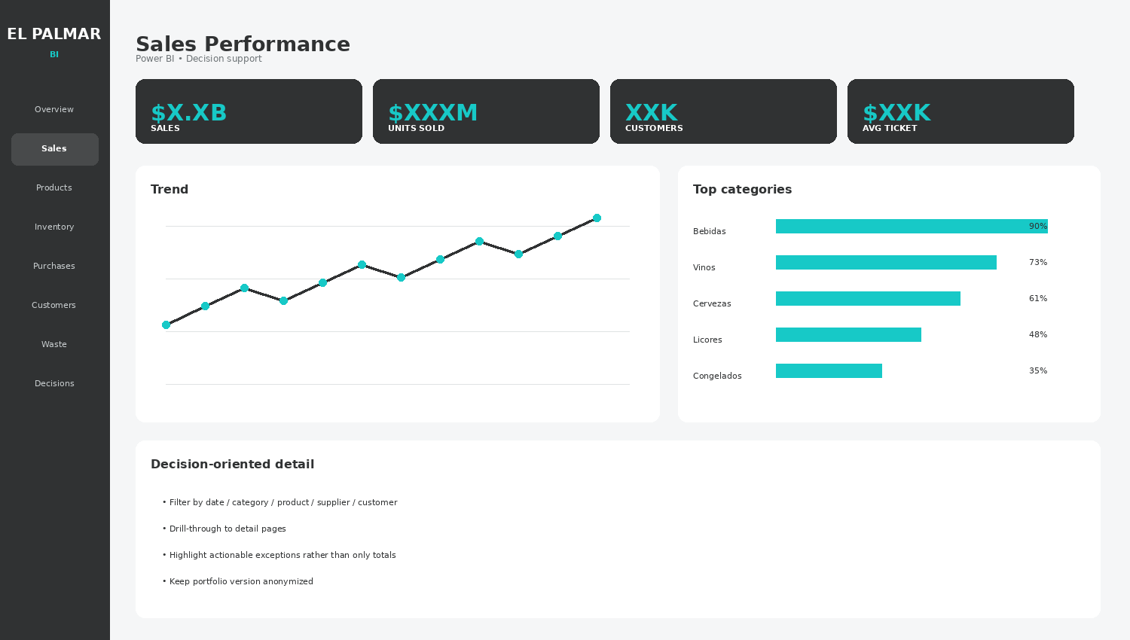

5. Products & Profitability

Purpose
Find products that create or destroy margin.

Information required
Sales, cost, gross profit, margin, low-margin count.

Visual design
Profitability matrix + product ranking + review table.

Decision use
Protect high-margin products; review low-margin products and cost changes.
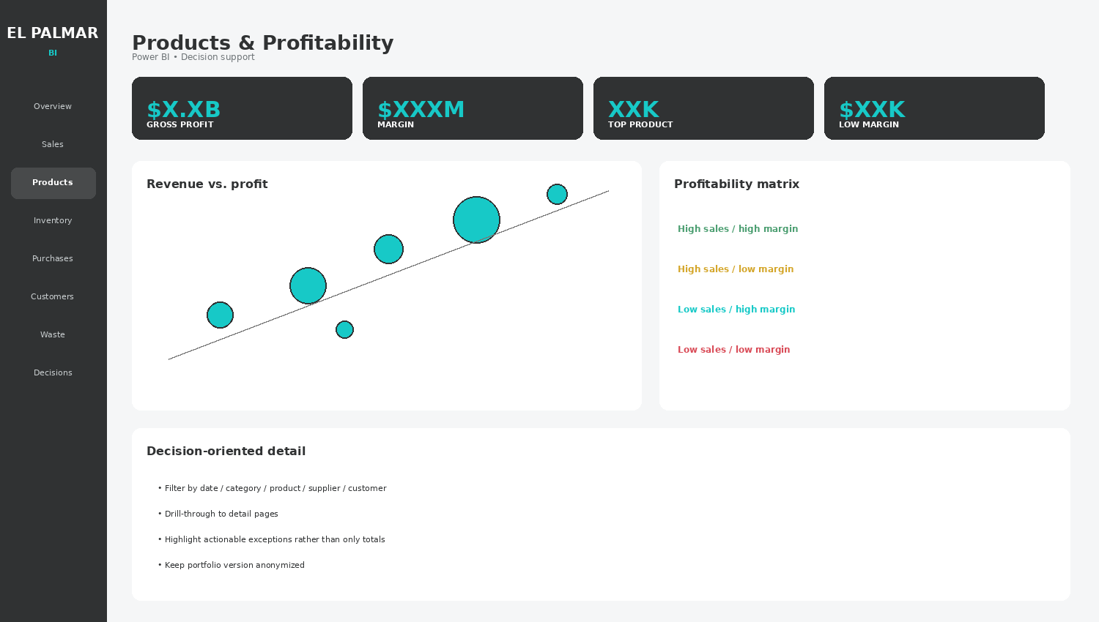

6. Inventory & Stock Health

Purpose
Control availability and capital tied up in stock.

Information required
Inventory value, stockouts, critical items, coverage, turnover.

Visual design
Stock health + coverage days + inventory by category/bodega.

Decision use
Prioritize replenishment and reduce excess stock.
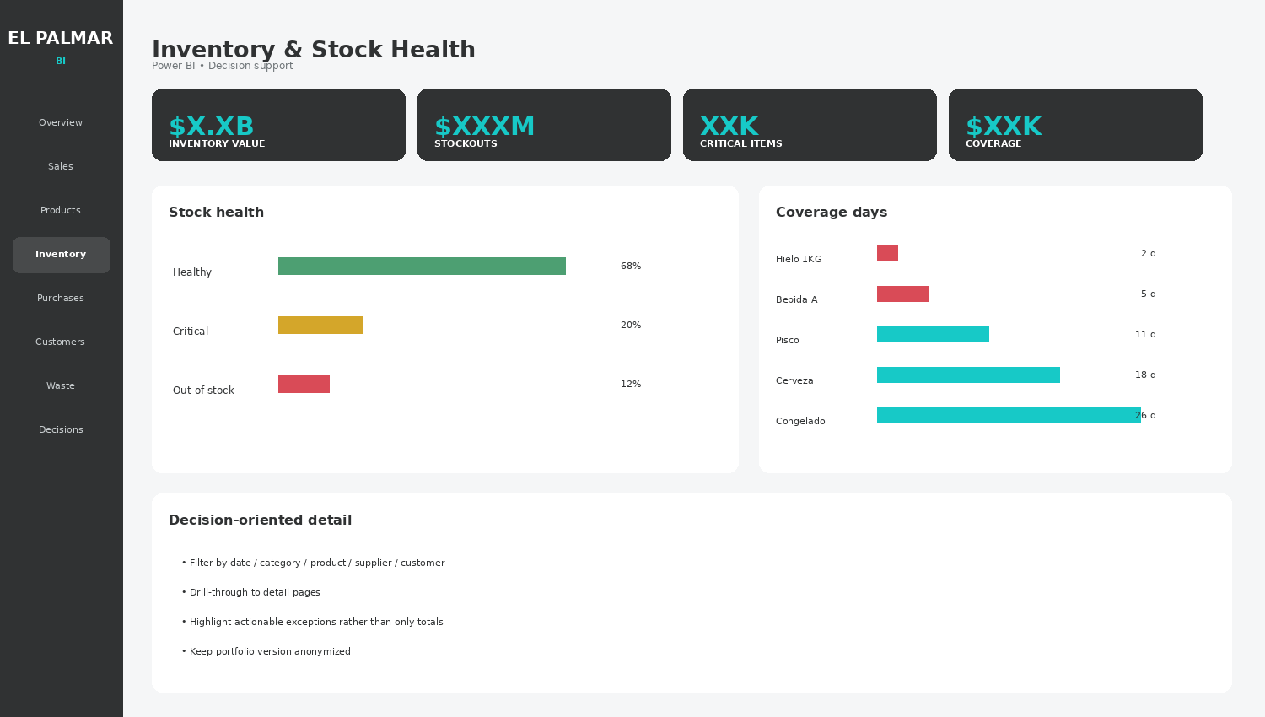

7. Purchase Decision Center

Purpose
Turn demand and stock into a repeatable buying proposal.

Information required
Proposal count, estimated spend, suppliers, cost alerts.

Visual design
Supplier spend + cost changes + proposal table.

Decision use
Use demand, lead time, safety stock and purchasing-unit conversions.
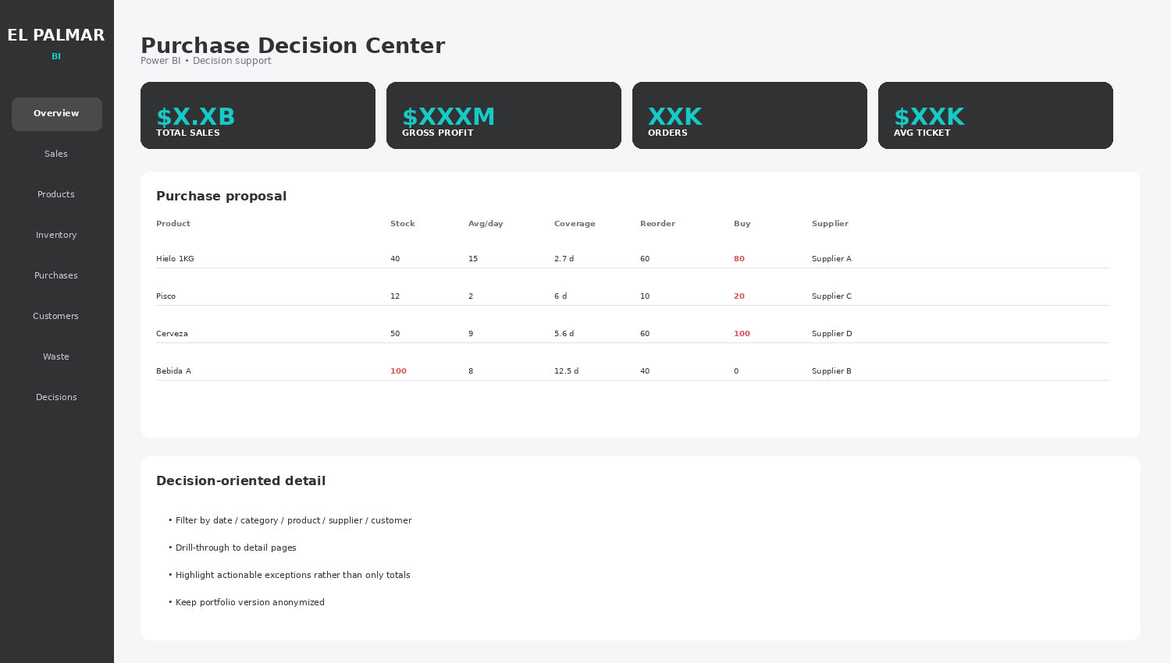

8. Customer Intelligence

Purpose
Understand customer behavior and growth opportunities.

Information required
Active, new and at-risk customers, average ticket.

Visual design
Activity trend + segments + geography if reliable.

Decision use
Identify reactivation and high-value customer opportunities.
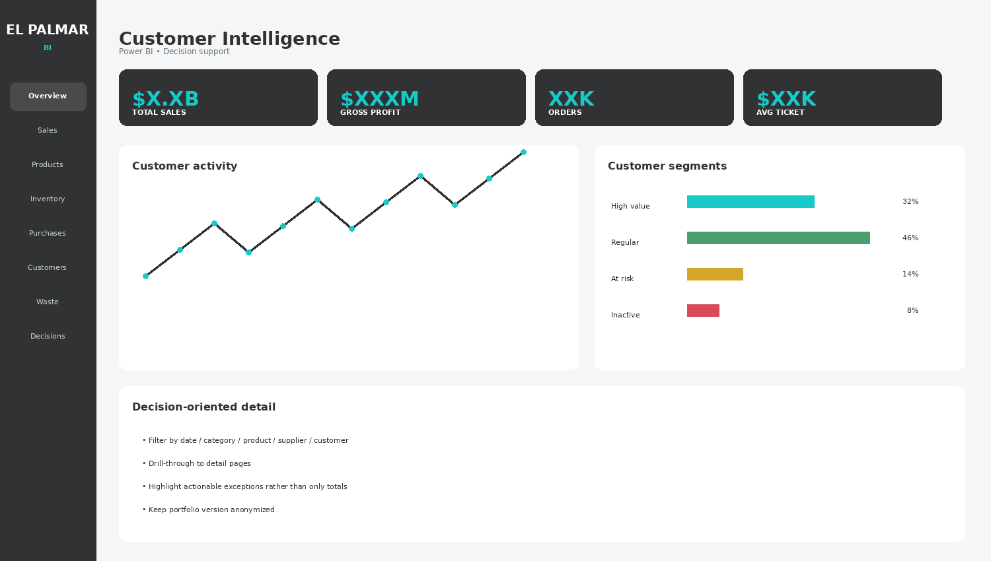

9. Waste & Returns

Purpose
Quantify losses and identify operational causes.

Information required
Waste value, waste %, returns, priority loss items.

Visual design
Trend + category losses + priority table.

Decision use
Connect losses to sales, expiry, storage, handling and purchasing.
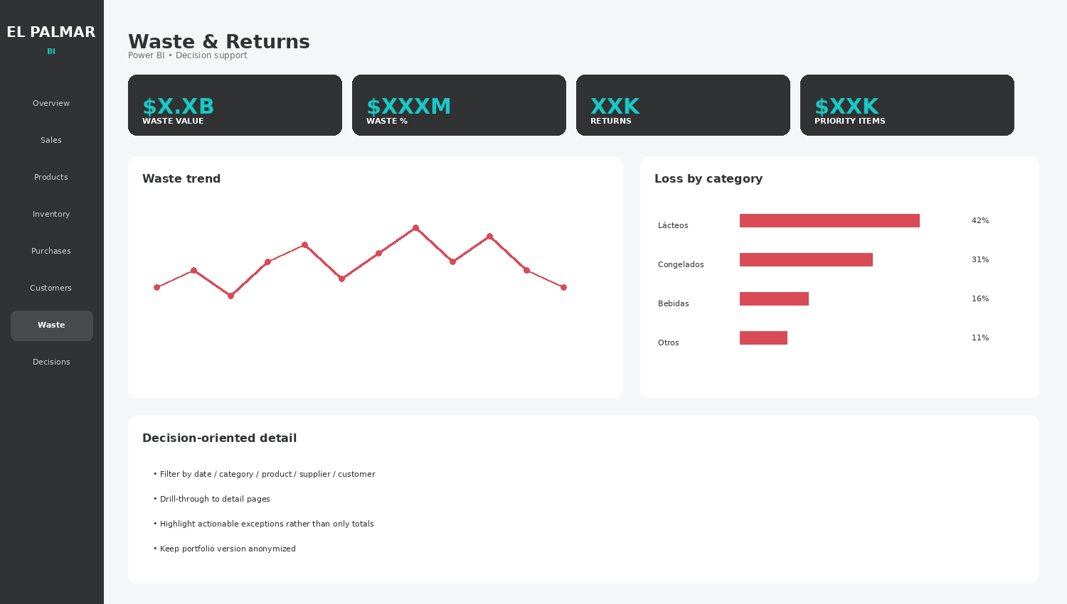

10. Decision Center

Purpose
Summarize the actions that deserve attention now.

Information required
Opportunities, actions, risk, revenue upside.

Visual design
Alert cards + recommended actions + impact indicators.

Decision use
Make the dashboard actionable without pretending it automatically makes decisions.
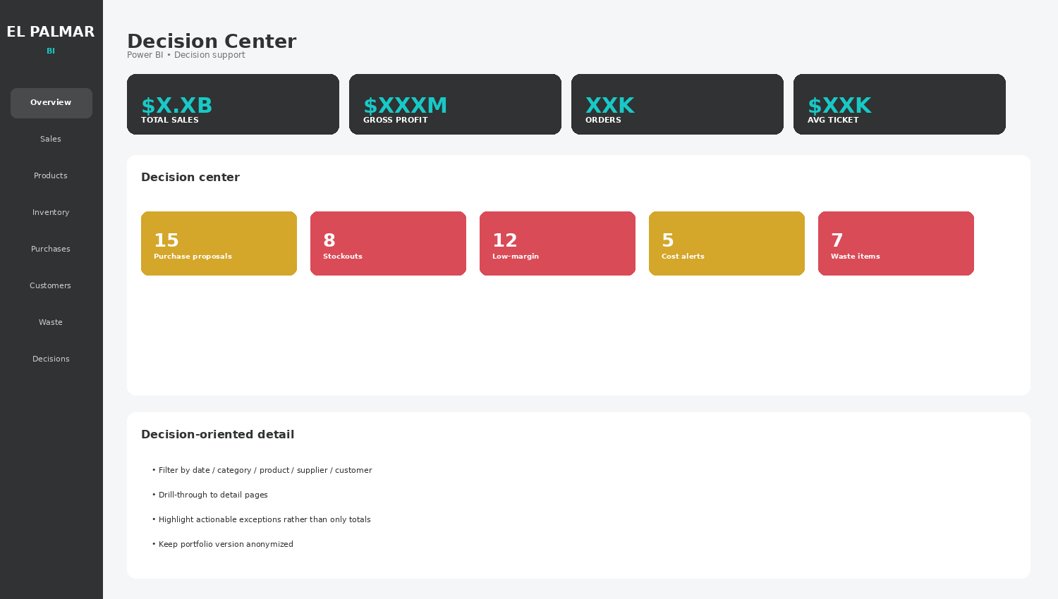

11. SQL Layer & Data Architecture
The recommended architecture is: MrCloud/MySQL → SQL analytical views → Power BI semantic model → DAX → dashboard.

Core SQL views
View | Purpose
vw_ventas | Transaction-line sales fact with date, document, product, quantity, price, customer and seller.
vw_productos | Product master with category, family, brand, measure and relevant price attributes.
vw_inventario | Current stock by product and warehouse plus inventory value.
vw_compras | Purchases, supplier and cost history.
vw_clientes | Customer and geographic attributes where appropriate.
vw_mermas | Waste/loss events and reasons.
vw_propuesta_compra | Decision layer combining demand, stock, coverage, reorder point and suggested purchase.

Purchase recommendation logic
- Average daily demand = units sold / selling days in the chosen history window.
- Coverage days = available stock / expected daily demand.
- Reorder point = expected demand during supplier lead time + safety stock.
- Suggested purchase = target stock − available stock, rounded to the real purchase unit.
- Estimated spend = suggested quantity × expected purchase cost.
- Flag exceptions for review instead of automatically creating orders.

12. Refresh Strategy
The target workflow is refreshable. Once the model and SQL views are built, new records in the same MrCloud tables should flow into Power BI through Refresh without rebuilding the dashboard.
- Normal new sales/purchases/customers: Refresh only.
- Column/table changes in MrCloud: update SQL or Power Query/model.
- New analytical requirement: add the necessary view/fields and measures.

13. SQL Query Checklist
This checklist is the bridge from business requirements to the actual MySQL work. Each item must be mapped to a real table and column before the final views are written.
Area | Data needed | Used for
Sales | date, document, product, quantity, sale price, totals, customer, seller | Sales and ticket metrics
Products | product ID, name, category, family, brand, measure, active status | Product dimension
Costs | purchase cost, cost history, effective dates | Profit and margin
Inventory | product, warehouse, current quantity, value | Stock and coverage
Inventory history | date, movement type, quantity in/out | Demand and rotation
Purchases | date, supplier, product, quantity, cost | Buying analysis
Suppliers | supplier ID, product relation, lead time if available | Purchase proposal
Customers | customer ID, comuna/region if appropriate | Customer and map
Waste | date, product, quantity/value, reason | Loss analysis
Returns | date, product, quantity/value, reason | Returns
Units | base unit, display/box relationship, conversion factor | Purchase-unit proposal

First SQL step
Document the real columns of vedocumentogeneral and vedocumentodetalle, then build and validate the first sales view before moving to inventory and purchase logic.
Suggested starting commands:
DESCRIBE vedocumentogeneral;
DESCRIBE vedocumentodetalle;
El Palmar BI • Project Blueprint

