Development Environment
Setting Guide

Confidential
Date: 11 August 2015

V1.1

Revision History
Date | Version | By | Description of Change
08/11/15 | 1.0 | Dai Luu | Initial created.
03/09/15 | 1.1 | Anh Do | Add 6.2.6 Install SVN plug-in (for Eclipse)

Table of Contents
1 Java SDK 4
1.1 Install JDK 7 Update 80 or above 4
1.2 Set up java system environment 4
2 MySQL server 6
2.1 Install MySQL 5.6.26 6
2.2 Prepare database and granting access permission 6
2.3 Import initial data to MySQL database 7
3 Tomcat web server 8
3.1 Install Tomcat 8.0.24 8
3.2 Start Tomcat 8
4 Maven Build Tool 9
4.1 Install Maven 3.3.3 9
4.2 Set up MVN_HOME variable 9
4.3 Configure maven repository 10
5 SVN Client 11
5.1 Install TortoiseSVN 11
5.2 Check out source code from SVN server 11
6 Eclipse IDE 13
6.1 Install Eclipse Luna 13
6.2 Configure Eclipse settings 13
6.2.1 Configure JDK 13
6.2.2 Install maven plugin 15
6.2.3 Configure Maven 16
6.2.4 Import code templates, formatter 19
6.2.5 Configure encoding to UTF-8 21
6.2.6 Install SVN plug-in 22

Java SDK

Install JDK 7 Update 80 or above
- Download latest Java archive from Oracle official site (http://www.oracle.com/technetwork/java/javase/downloads/java-archive-downloads-javase7-521261.html#jdk-7u80-oth-JPR). Current latest version is 1.7 update 80.
- Use following account below to download
  - User name: lquangdai
  - Password: Dota@123
- Run executable file to install JDK

Set up java system environment
- Set up JAVA_HOME system environment after installation is completed
  - Control Panel --> System --> Advanced system setting
  - In System properties dialog, select “Environment variables” button in “Advanced” tab
  - Create new system variable named “JAVA_HOME” in system variable list, with value is installed JDK folder in previous step (usually is “C:\Program Files\Java\jdk1.7.0_80”)
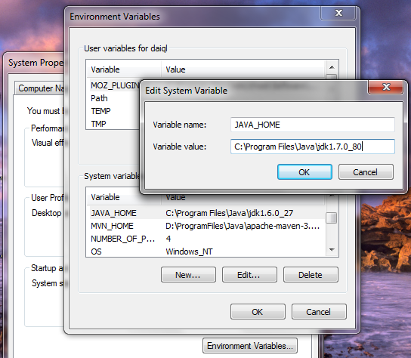
- Edit “PATH” system variable to include JAVA_HOME
PATH=%PATH%;%JAVA_HOME%\bin
- Use following command to check which version of Java (java & javac) is currently being used by system in command prompt window
C:\Users\tester>java -version
java version "1.7.0_80"
Java(TM) SE Runtime Environment (build 1.7.0_80-b15)
Java HotSpot(TM) 64-Bit Server VM (build 24.80-b02, mixed mode)

C:\Users\tester>javac –version
javac version "1.7.0_80"

MySQL server

Install MySQL 5.6.26
- Download latest MySQL Community 5.6 Installer for Windows from MySQL download site (https://dev.mysql.com/downloads/mysql/). After completing download also run executable file
- Follow these instructions in Installer, remember to start MySQL server and makes it automatic start on system boot.
- Next, it is most important to change the root user’s password with command prompt window from installed MySQL folder
C:\Program Files\MySQL\MySQL Server 5.6\bin>mysqladmin -u root password [your_root_password_here]

Prepare database and granting access permission
- Create new database named “maper_db” in MySQL server and appropriate account which will be used in setting system configurations
C:\Program Files\MySQL\MySQL Server 5.6\bin>mysql –h localhost –u root –p
<input your root password>
create database `maper_db` character set utf8 collate utf8_general_ci;
commit;

- Next, we create a new account of the “maper_db” database and grant mandatory permissions to newly created account
grant all on `maper_db`.* to `maper-user`@`localhost` identified by `Abc@123` with grant option;
commit;
flush privileges;
quit;

- Re-check again granted permissions of newly created account

C:\Program Files\MySQL\MySQL Server 5.6\bin>mysql –h localhost –u maper-user -p
--- <Abc@123>
use maper_db;
select table_name from information_schema.tables where table_schema='maper_db';
select table_name from information_schema.tables;
quit;

Import initial data to MySQL database
- Check out 2 initial SQL script files from SVN repository (“deliverables\trunk\design\database\scripts”) to "D:\Temp\data" directory
- Execute following command to create empty database structure
C:\Users\tester>D:
D:>cd Temp\data
D:\Temp\data>mysql –h –u mapper-user –p maper_db < 01_data_collector_create_db.sql
[input mysql password]

- Next, execute following command to initialize necessary data in the database
D:\Temp\data>mysql –h –u mapper-user –p maper_db < 01_data_collector_init_data.sql
[input mysql password]

Tomcat web server

Install Tomcat 8.0.24
- Download latest Tomcat 8.0.24 ZIP archive from Tomcat 8 download site (https://tomcat.apache.org/download-80.cgi).
- After completing download also extract this archive to “D:\ProgramFiles\Java\ apache-tomcat-8.0.24” with given commands
C:\Users\tester>D:
D:>mkdir ProgramFiles\Java
D:>cd D:\ProgramFiles\Java
D:\ProgramFiles\Java>cp <Downloaded folder>\apache-tomcat-8.0.24-windows-x86.zip apache-tomcat-8.0.24-windows-x86.zip
D:\ProgramFiles\Java>unzip apache-tomcat-8.0.24-windows-x86.zip

Start Tomcat
C:\Users\tester>D:
D:>cd D:\ProgramFiles\Java\apache-tomcat-8.0.24\bin
D:\ProgramFiles\Java\apache-tomcat-8.0.24\bin>startup.bat

Maven Build Tool

Install Maven 3.3.3
- Download latest maven build tool 3.3.3 from maven download site (https://maven.apache.org/download.cgi)
- After completing download also extract this archive to “D:\ProgramFiles\Java\apache-maven-3.3.3” with given commands
C:\Users\tester>D:
D:>mkdir ProgramFiles\Java
D:>cd D:\ProgramFiles\Java
D:\ProgramFiles\Java>cp <Downloaded folder>\apache-maven-3.3.3-bin.zip apache-maven-3.3.3-bin.zip
D:\ProgramFiles\Java>unzip apache-maven-3.3.3-bin.zip

Set up MVN_HOME variable
- Set up MVN_HOME system environment
  - Control Panel --> System --> Advanced system setting
  - In System properties dialog, select “Environment variables” button in “Advanced” tab
  - Create new system variable named “MVN_HOME” in system variable list, with value is installed maven folder in step above (“D:\ProgramFiles\Java\apache-maven-3.3.3”)
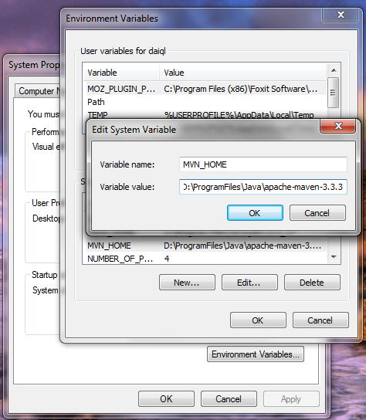
- Edit “PATH” system variable to include MVN_HOME
PATH=%PATH%;%MVN_HOME%\bin

Configure maven repository
- Create new folder named “repo” under installed maven folder (“D:\ProgramFiles\Java\apache-maven-3.3.3\repo”)
- Open file “D:\ProgramFiles\Java\apache-maven-3.3.3\conf\setting.xml” in Notepad or your favorite text editor
- Add following line after line 54 of this file
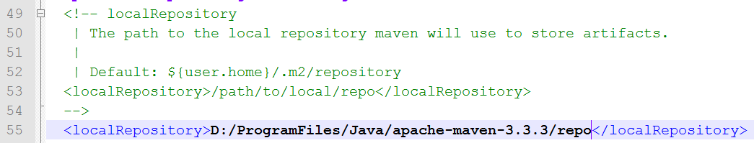
- Save the changes

SVN Client

Install TortoiseSVN
- Download TortoiseSVN 1.9.0 client from official TortoiseSVN download site (http://tortoisesvn.net/downloads.html)
- Follow instructions in installer

Check out source code from SVN server
- Create new empty folder “D:\Projects\maper\SVN”
- Use TortoiseSVN to check out source from public SVN server to created folder above
The link of SVN is http://103.249.100.174/svn/maper
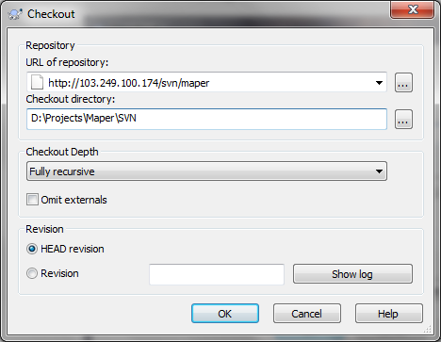
And input your account in authentication dialog
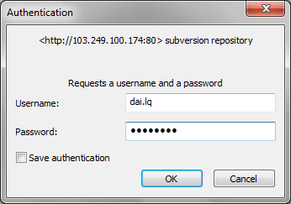

Eclipse IDE

Install Eclipse Luna
- Download Eclipse Luna for Java EE developer from Eclipse download site (https://eclipse.org/downloads/packages/eclipse-ide-java-ee-developers/lunar)
- After completing download also extract this archive to “D:\ProgramFiles\Java\eclipse” folder

Configure Eclipse settings

Configure JDK
  - Window --> Preferences
  - Select “Java” --> “Installed JREs” from left tree
  - Select “Add” button in right panel to add new JDK into eclipse
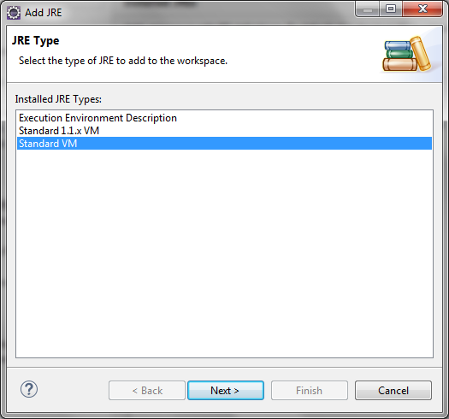
  - Select “Standard VM” and Next button
  - Next screen, select installed JDK 1.7.0_80 folder in “JRE home”, update “JRE name” to “jdk1.7.0_80” appropriately. The JRE libraries will be auto-loaded
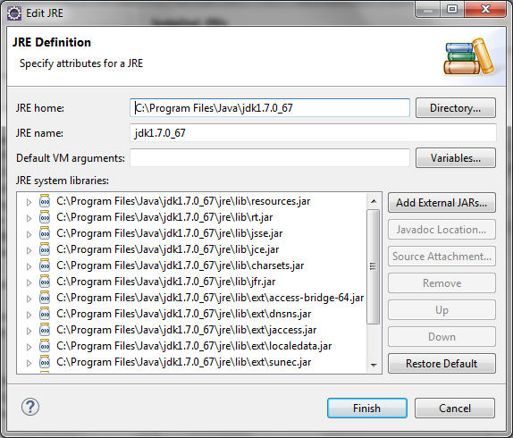
  - Then, “Finish” button to complete
  - Being sure that, created JDK has been selected as by default as screen below
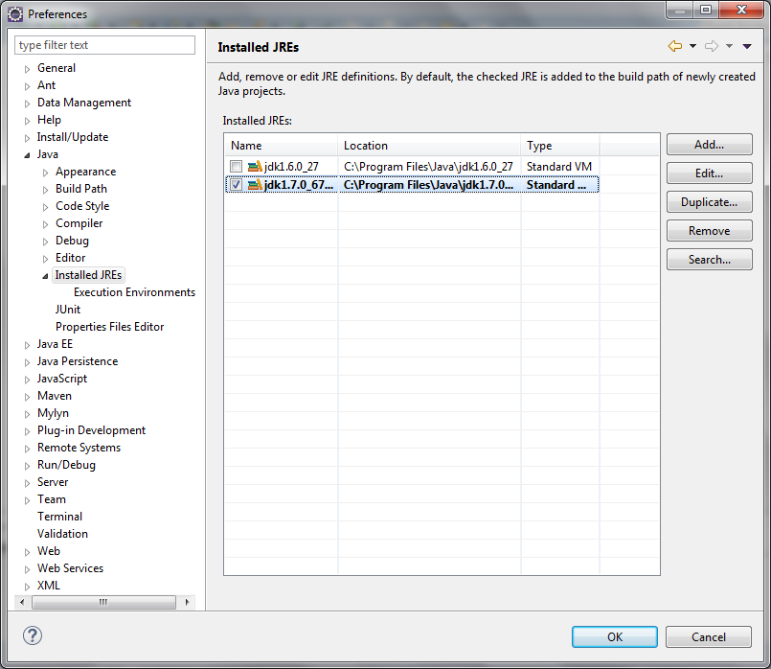

Install maven plugin
  - Help --> Eclipse marketplace
  - Input “Maven Integration for Eclipse” in Find file, and “Go” button
  - Select “Install” button of “Maven Integration for Eclipse (Luna)” item as screen below
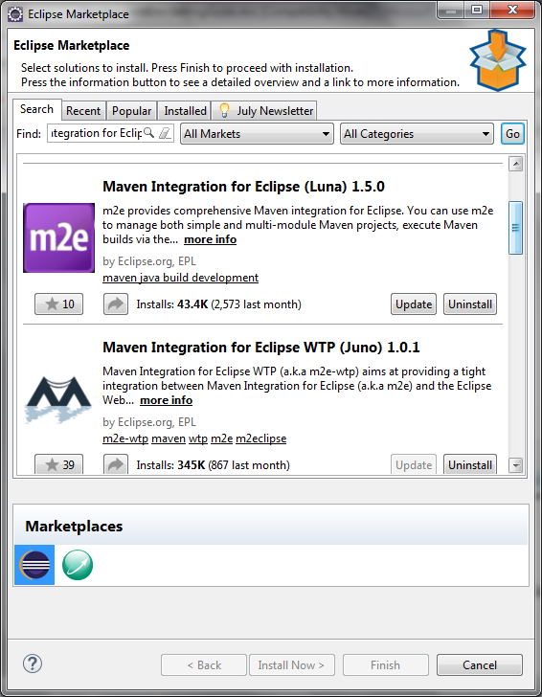

Configure Maven
  - Window --> Preferences
  - Select “Maven” --> “Installations” from left tree
  - Select “Add” button in right panel to add new Maven into eclipse
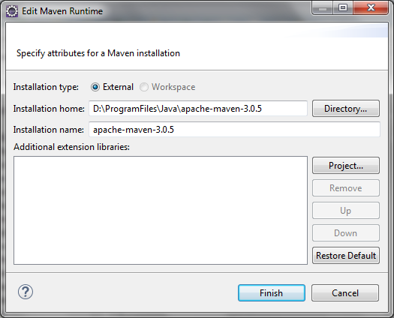
  - Select appropriate folder of installed maven 3.3.3 (D:\ProgramFiles\Java\apache-maven-3.3.3), and update installation name with correct value
  - Select Finish button to complete
  - Being sure that, new installed maven has been chosen in dialog (by default, eclipse has embedded maven, but we do not use this one)
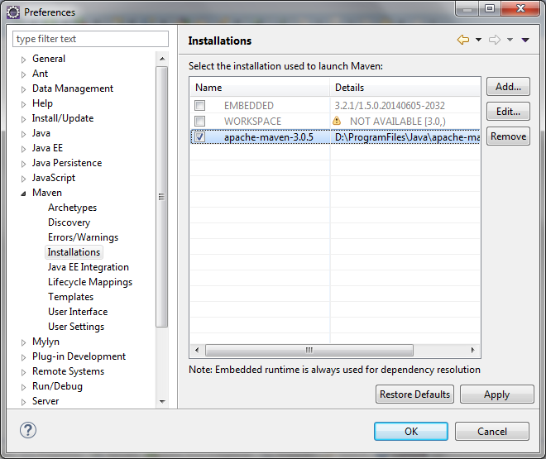
  - Select “Maven” --> “User Settings” from left tree
  - Being sure that, current settings have been configured with correct maven version (maven 3.3.3) in the dialog
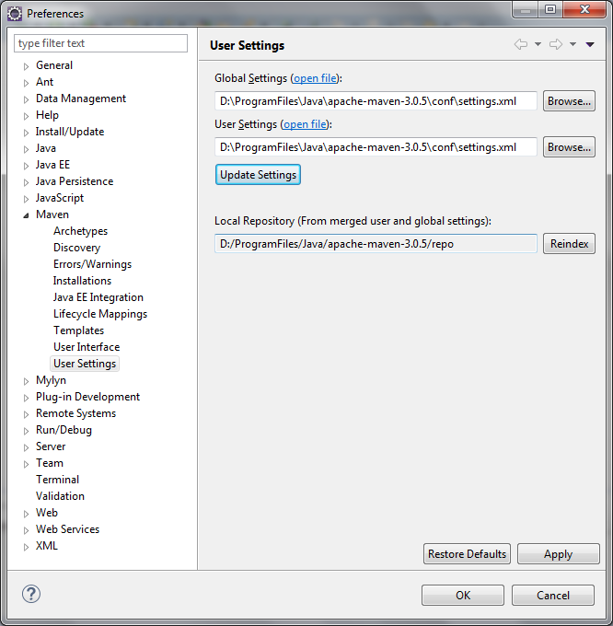

Import code templates, formatter
- Select “Window” --> “Preferences”
- Select “Java” --> “Compiler” from left tree
- Being sure, version 1.7 has been chosen in compliance level of compiler
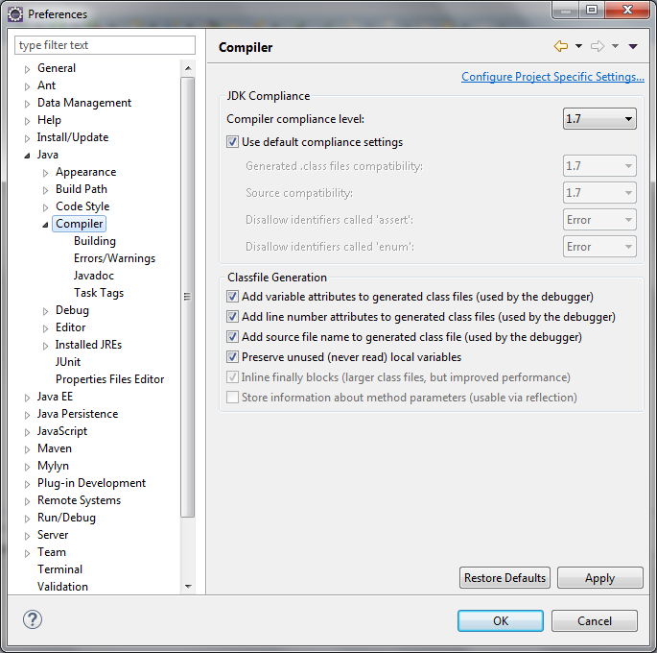
- Select “Java” --> “Code Style” --> “Code Templates” from left tree
- Select “Import” button, then select from predefined templates that has been checked out from SVN at folder (“environment\development\eclipse-settings”)
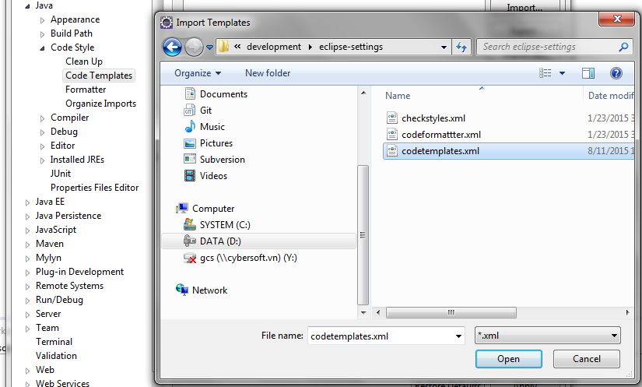
- Being sure that “Automatically add comments for new methods and types” checkbox should be checked. Then select “Apply” button
- Do the same steps for import “code formatter” (Java --> Code Style --> Formatter) and make sure that “JavaCodeFormatter” should be chosen in active profile drop-down box.

Configure encoding to UTF-8
- “Windows” --> “References”
- Select “General” --> “Workspace” from the left tree, make sure that text file encoding should be “UTF-8” as image below
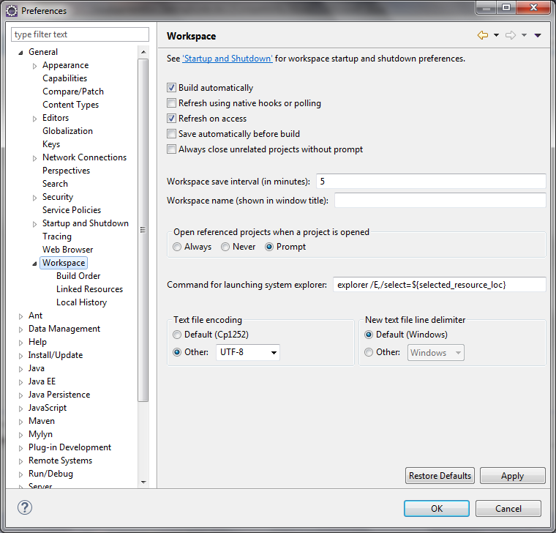

Install SVN plug-in
  - Help --> Eclipse marketplace
  - Input “Subversive” in Find file, and “Go” button
  - Select “Install” button of “Subversive – SVN Team Provider 3.0.0” item as screen below
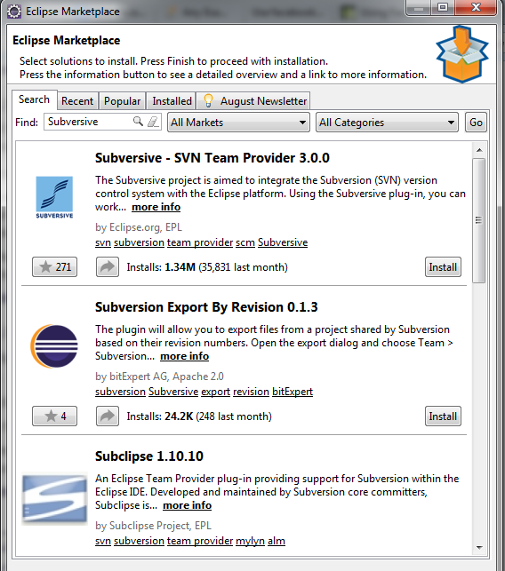
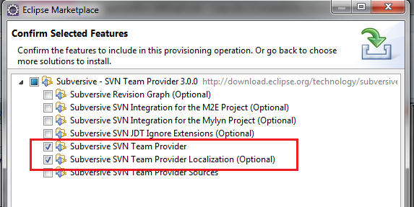

- Chose Windows/Preferences/SVN Connector
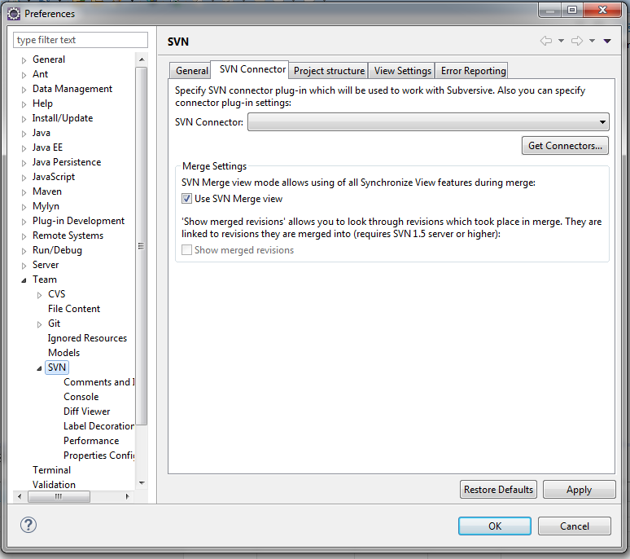

- Click “Get Connectors” button

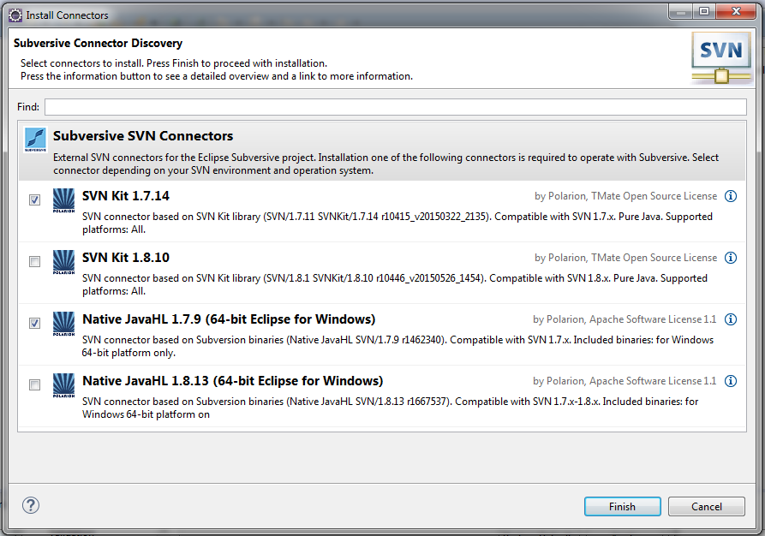
- Chose components to install as above image
- When see warning dialog, Click OK

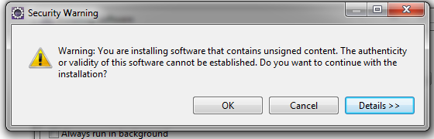

- Chose Window/Show View/Others/SVN Repositories to show SVN Repositories View
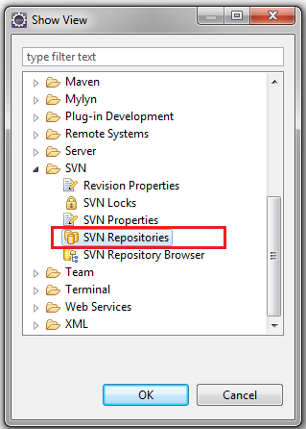

- Right click on SVN Reposistories view and chose Repository Location
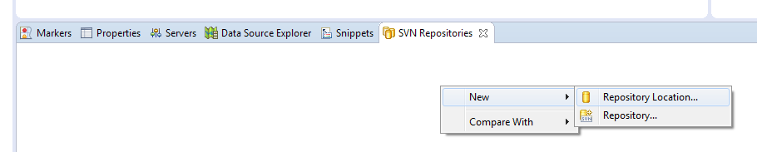

- Enter http://103.249.100.174/svn/maper/deliverables/trunk/implementation on URL and then enter other fields of SVN account

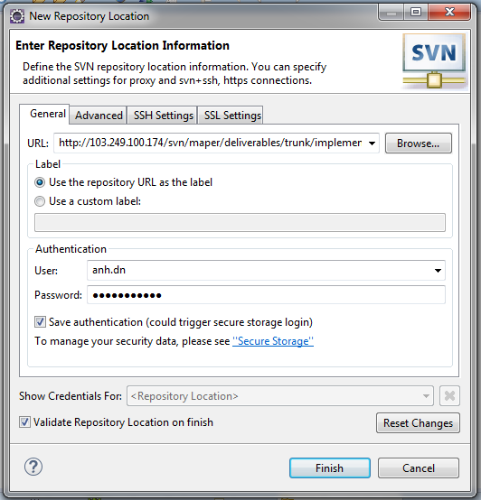

- Check out source code from SVN server
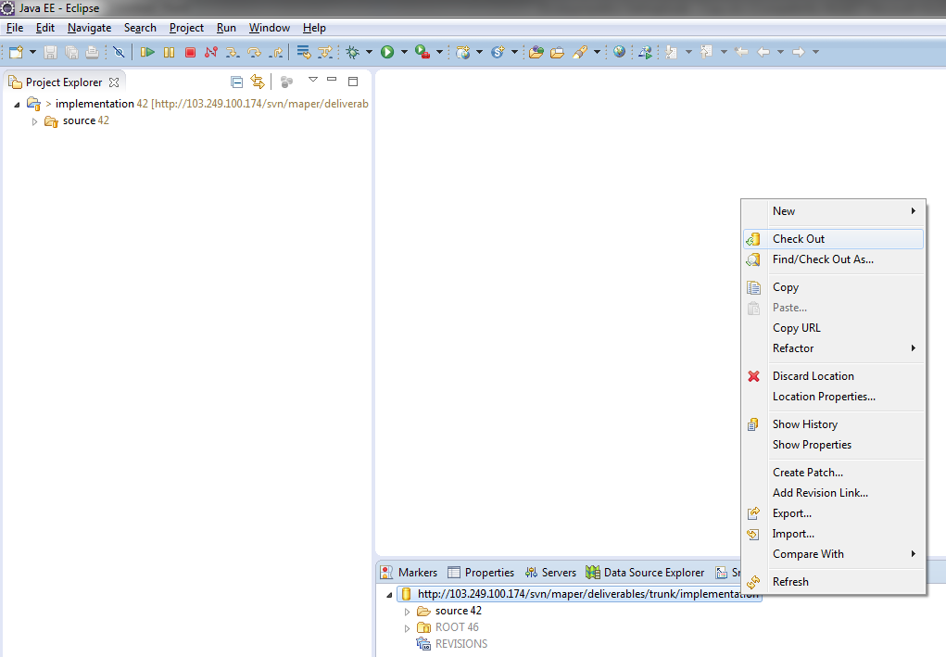
- Import projects into Eclipse as Existing Maven Projects

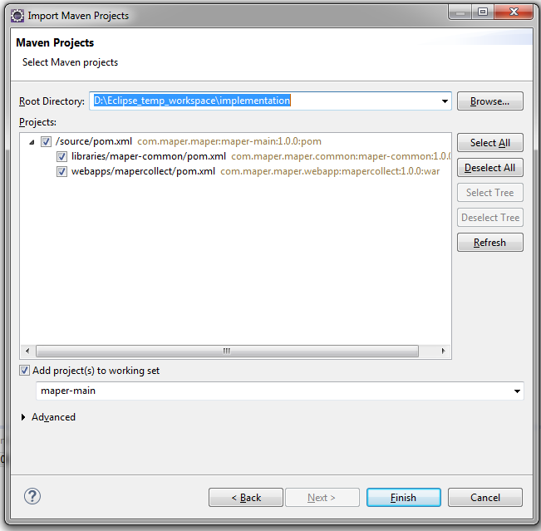

- Use SVN plug-in to see what change in source files
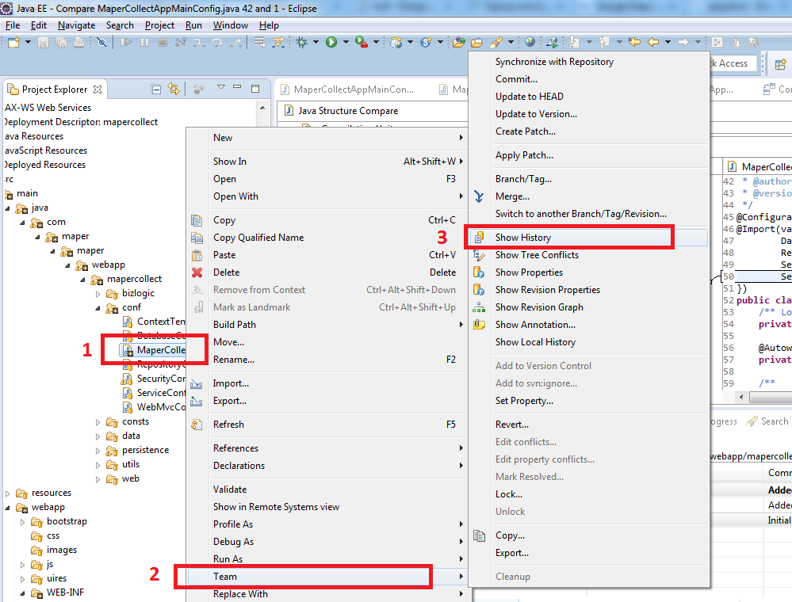
- Chose the file to compare
- Right click to open pop-up menu, then chose Team
- Chose Show History to see history view
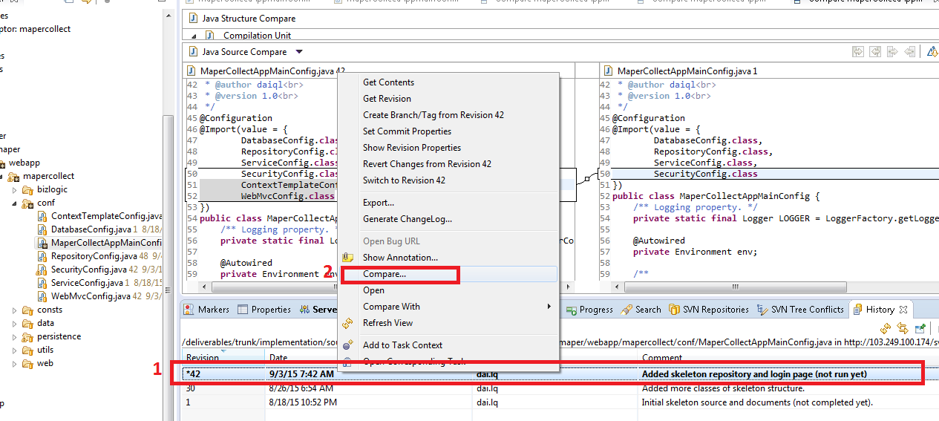
- In history view, chose revision to compare with local source
- Right click to open pop-up menu, then chose Compare to open a 2-panels window to see difference

