Main part -LINKCHANGES 0:

You can use DistanceVector.exe in package to run this program in Windows OS

Distance table output:

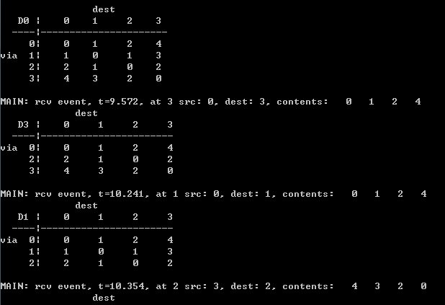

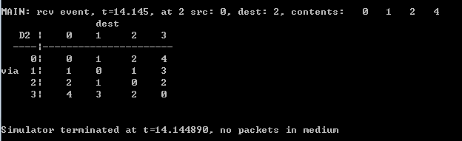

Bonus part -LINKCHANGES 1:

You can use DistanceVector(LinkChange).exe in package to run this program in Windows OS

After link cost changes from 1 to 20 and when the oscillation is finally stabilized:

Distance table output:

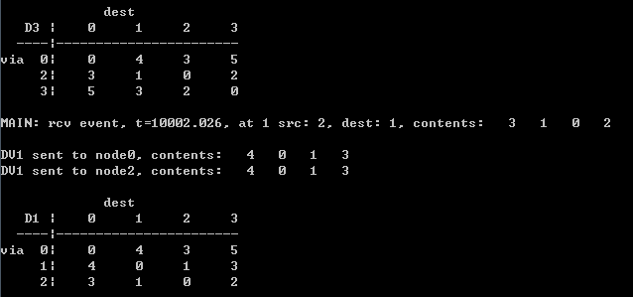

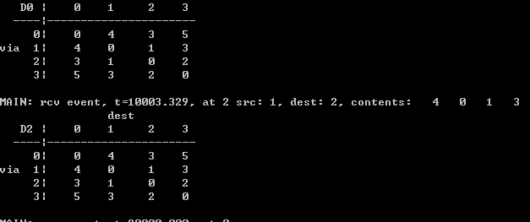

After link cost returns to 1 and when the oscillation is finally stabilized:

Distance table output:

