Estimating non-phytoplankton contributions to measurements of volatile suspended sediments

Volatile suspended sediment (VSS) quantifies the organic portion of suspended sediments, and in lakes, a large proportion of VSS can be attributed to phytoplankton biomass. However, some VSS also can be attributed to other sources (e.g., allochthonous organic matter). Here, we describe an approach for estimating the phytoplankton and non-phytoplankton components of VSS.

Data

We analyze data collected from Missouri (MO) lakes from 1989 – 2016. Lakes with greater than 20 samples of VSS and Chl measurements were selected from the data set, yielding a total of 7518 samples collected from 142 different lakes.

Statistical analysis

We model the contributions of phytoplankton and non-phytoplankton components to VSS. We assume that the phytoplankton component can be modeled as a power function of Chl and residual variation is composed of non-phytoplankton VSS and measurement error:

$$\overline{{VSS}_{i}}=b{Chl}_{i}^{k}+{VSS}_{np,i}$$

Where ${\overline{VSS}}_{i}$ is the mean value of VSS for sample *i*, *Chli* is the Chl concentration, *VSSnp,i* is non-phytoplankton VSS, and *b* and *k* are model coefficients estimated from the data. Estimated values of VSSnp for different samples are modeled as being log-normally distributed about a lake-specific mean value:

$$\log\left({VSS}_{np,i}\right)=Normal\left[\log\left(u_{j\left[i\right]}\right), s_{u}\right]$$

Where *uj[i]*is the mean concentration of non-phytoplankton VSS at site *j* corresponding to sample *i*, and *su* is the standard deviation. The distribution of values for *uj[i]*are assumed to also assumed to be log-normally distributed. Measured values of VSS are assumed to be log-normally distributed about the mean value:

$$\log\left({VSS}_{i}\right)=Normal\left[\log\left(\overline{{VSS}_{i}}\right), s_{VSS}\right]$$

Where the standard deviation *sVSS* can be thought of as an estimate of measurement error.

All model equations were fit simultaneously using the rstan, a probabilistic programming language for statistical inference (insert cite). Weakly informative prior distributions were specified for all parameters to limit the degree to which extreme values were considered during the simulation of the model solution.

Results

The value of the model coefficient b was estimated as 0.22 with a 90% credible interval ranging from 0.20 and 0.24, while the coefficent k was estimated as 0.83 with a 90% credible interval from 0.81 to 0.85. The estimated relationship between VSS and Chl defines the lower bound of the distribution of points. In samples in which VSSnp is low, the model equation can be simplified such that it defines a straight line in a log-log plot of Chl vs VSS (Figure 1).

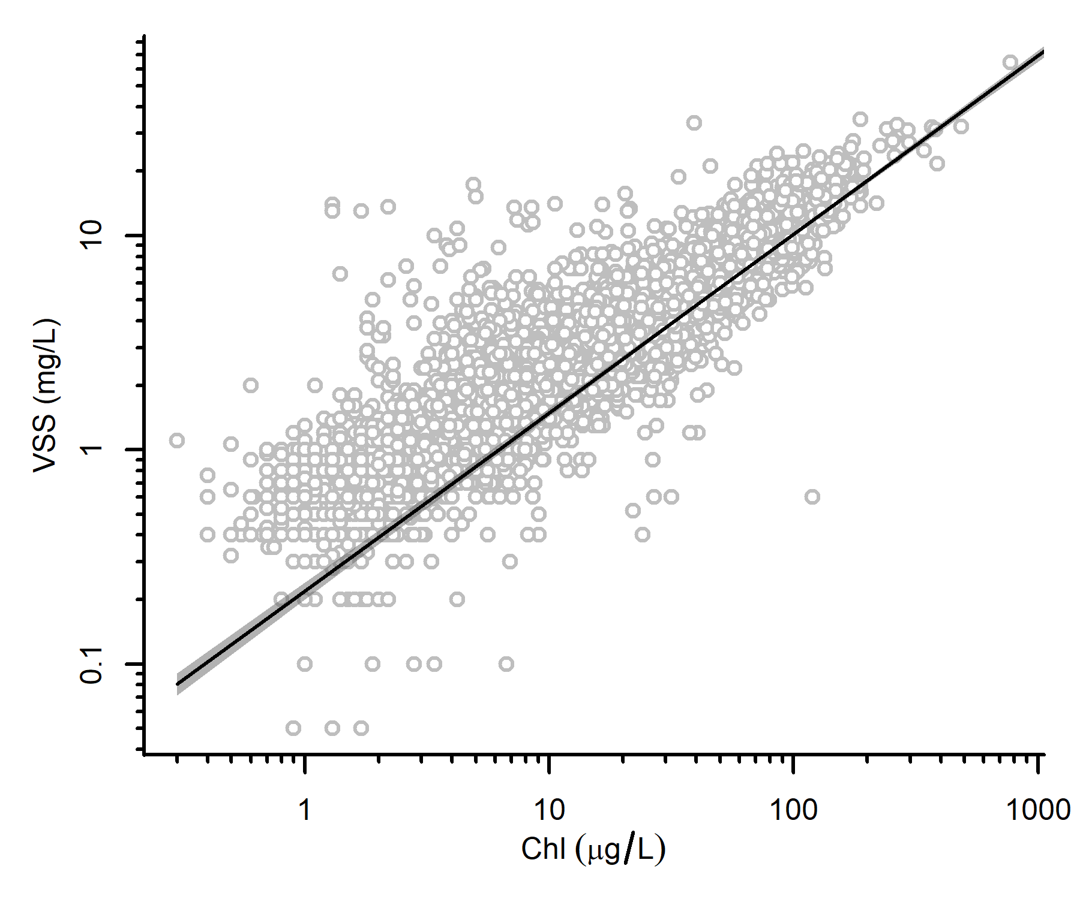

Figure . Chl vs. VSS. Open circles: sampled values; solid line: estimated relationship between Chl and VSS; gray shading: 90% credible interval about mean relationship.

The model results can be translated into an expression for the ratio of Chl to phytoplankton biomass, which varies with changes in Chl. Based on this equation, we estimate that at Chl = 1 µg/L, Chl is 0.45% of the total biomass, whereas at Chl = 100 µg/L, Chl is 0.99% total biomass.