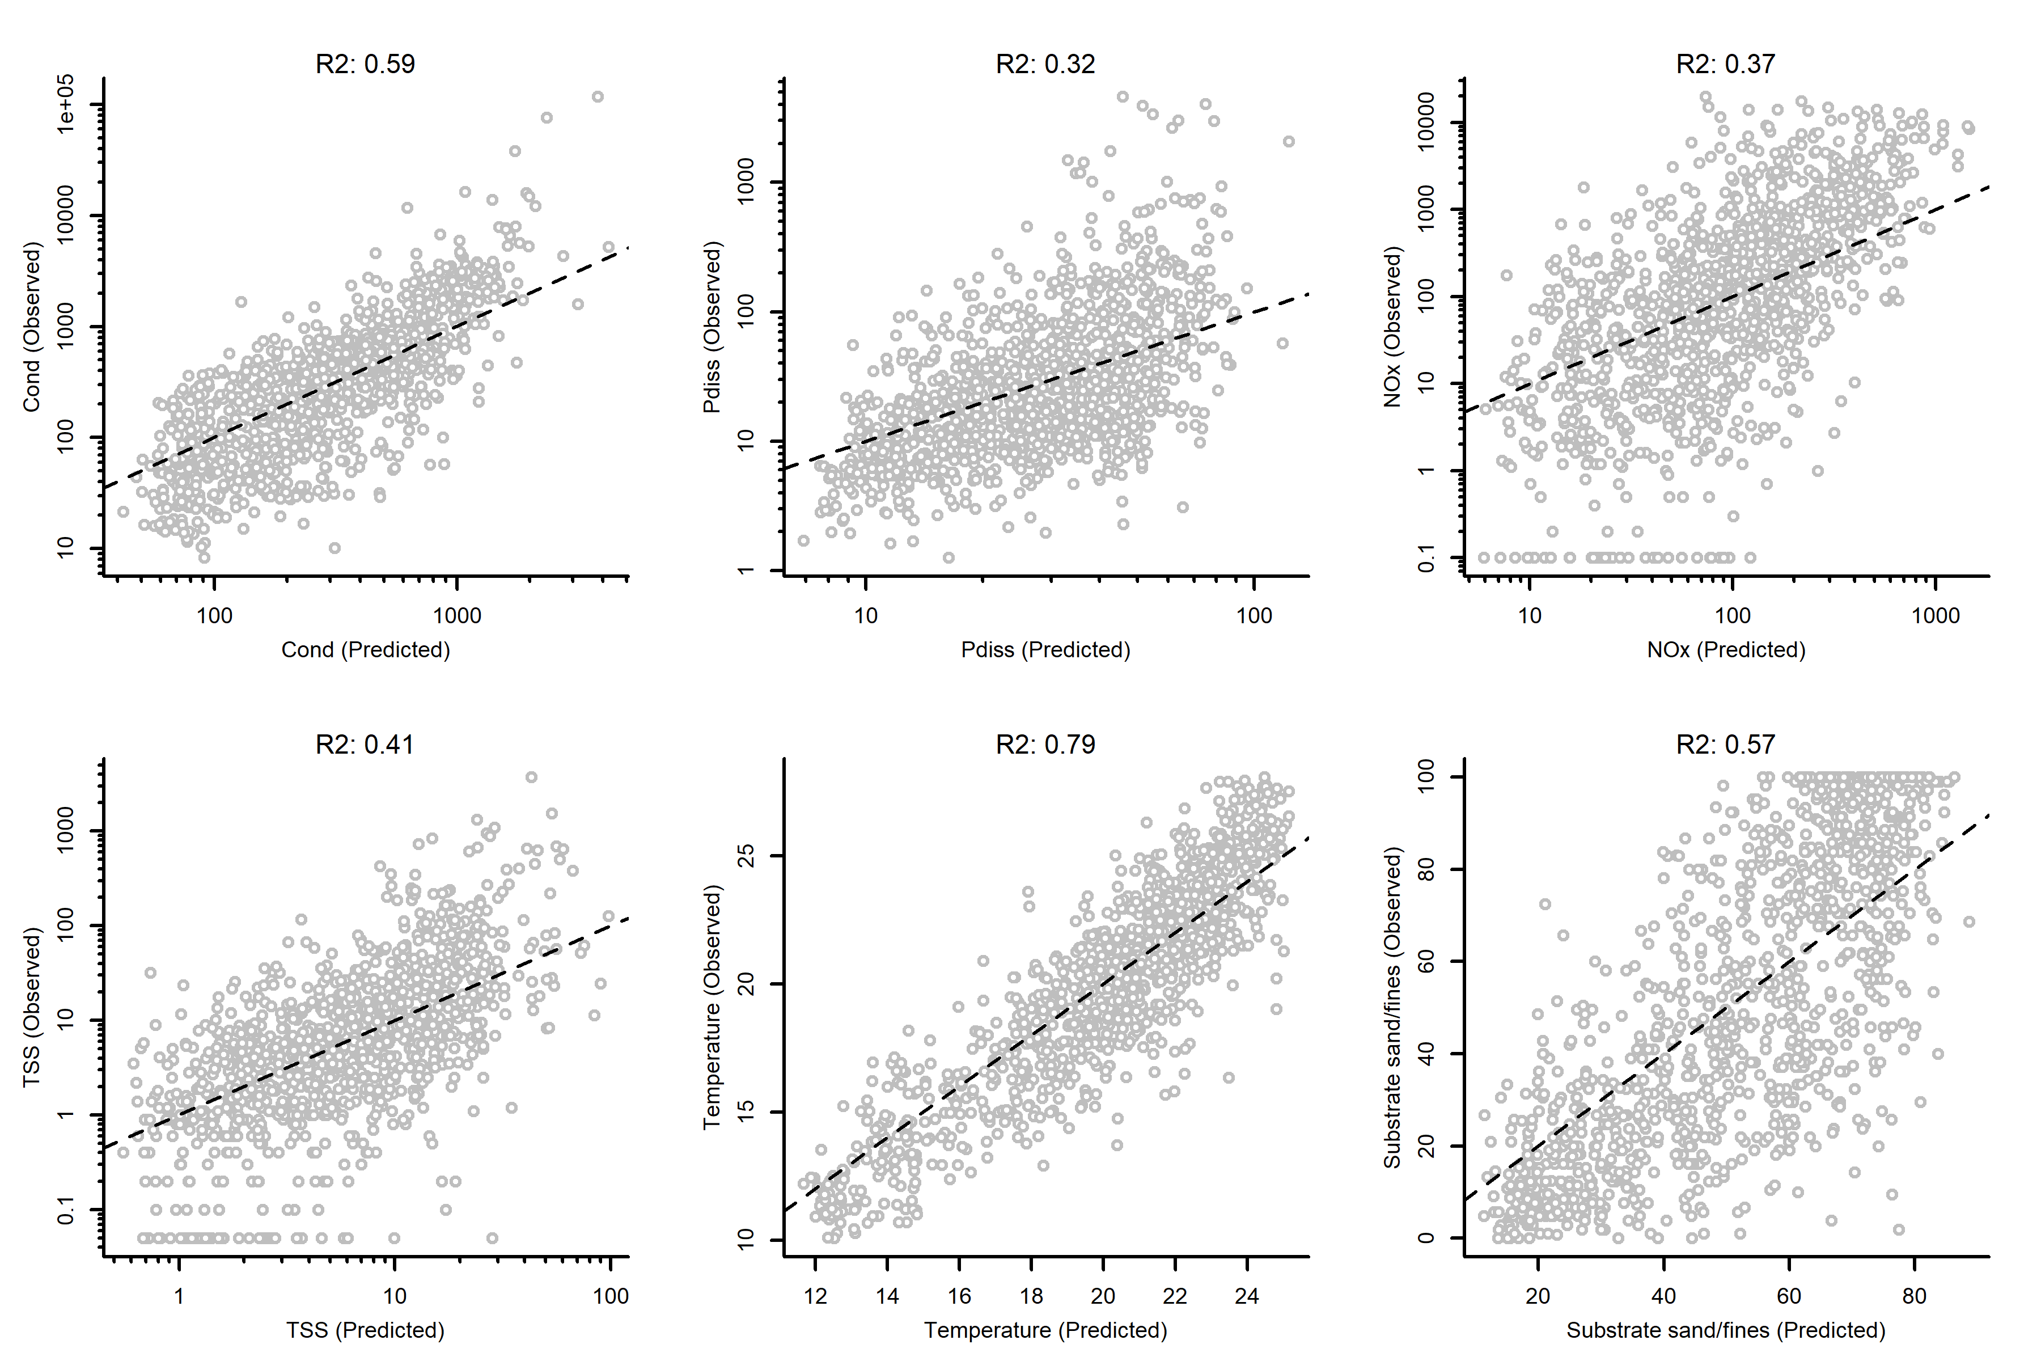

Figure . Performance of macroinvertebrate inferences using NRSA data.

Macroinvertebrate assemblage composition can be used to accurately infer site conductivity and temperature, based on national data. They also provide information on TSS and substrate composition, but less accurate predictions of nutrient concentrations.

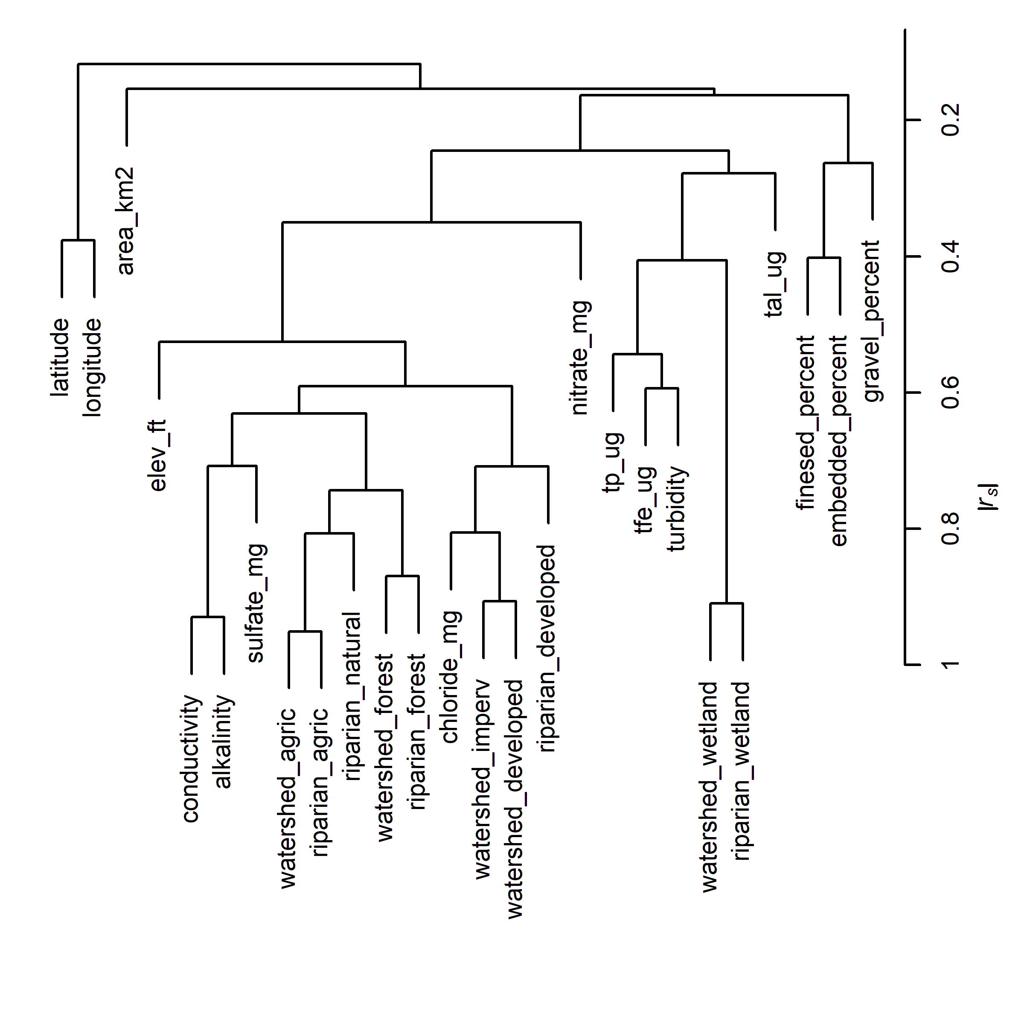

Figure . Predictor variable clusters.

Vermont environmental and land use metrics group exhibit a strong grouping between chloride and developed lands and between agriculture and forested lands. Direct measurements of water chemistry (e.g., TP, conductivity, nitrate) and local habitat (e.g., gravel_percent) were not strongly associated with land use.

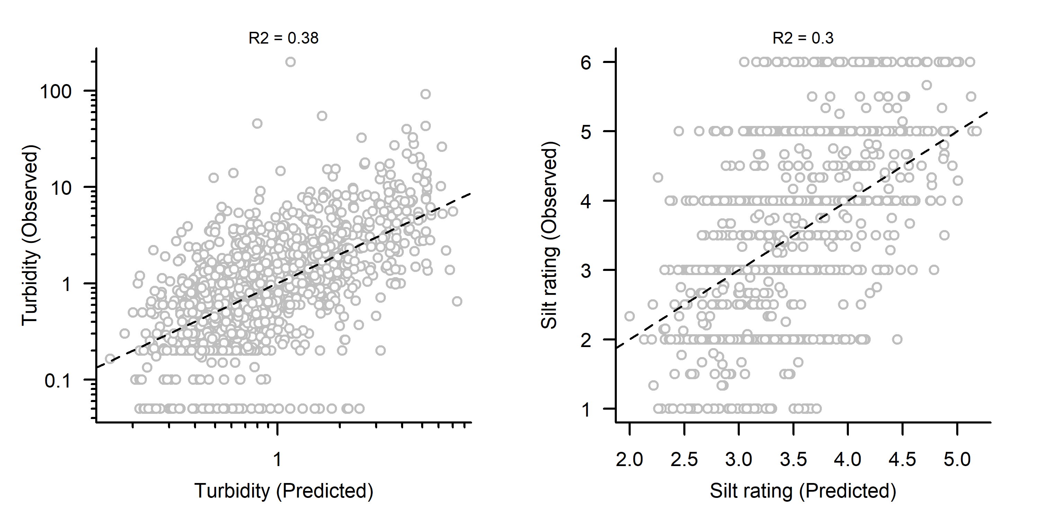

Figure . Macroinvertebrate inferences using VT data.

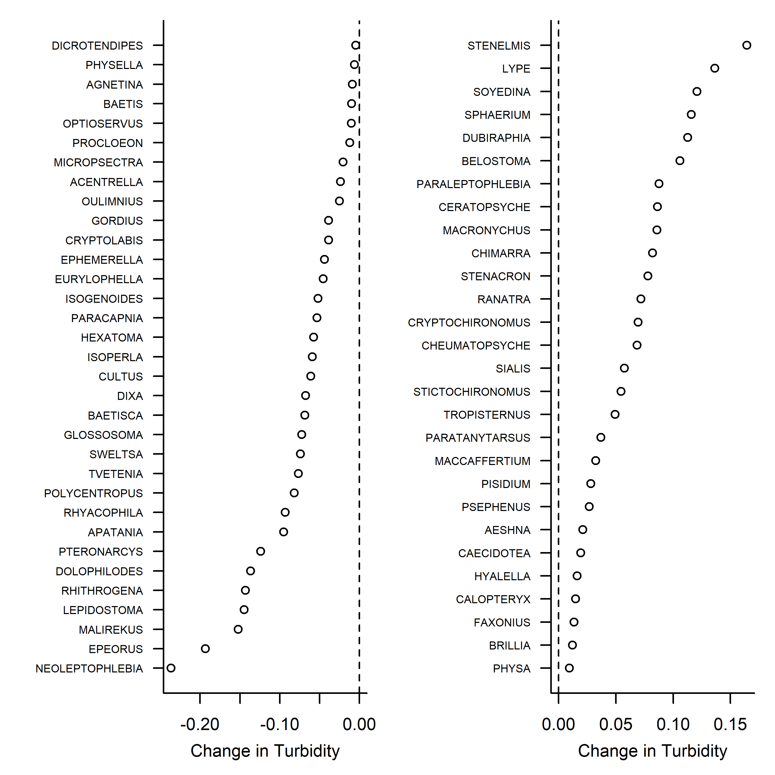

Figure . Taxa that are sensitive (left) and tolerant (right) to turbidity.

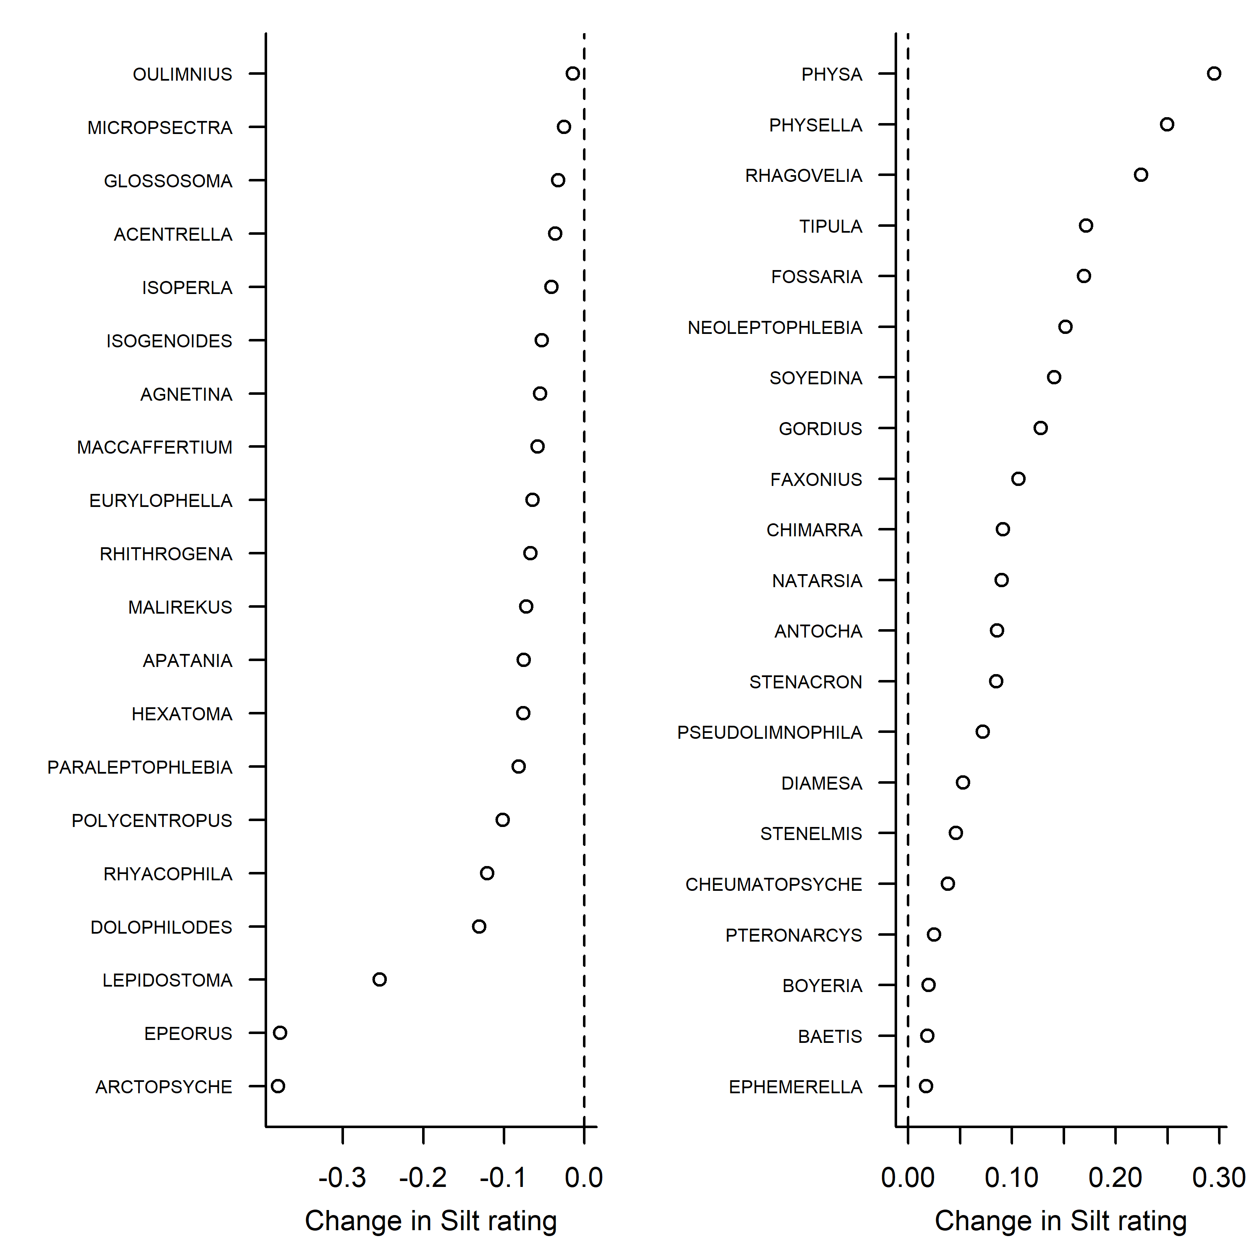

Figure . Taxa sensitive (left) and tolerant (right) to increases in silt rating.

December 20, 2023

* Added species identification for particular taxa.
* Restricted data to kicknets
* Added alkalinity and chloride as variables.
* Included taxa that occurred in at least 20 samples.

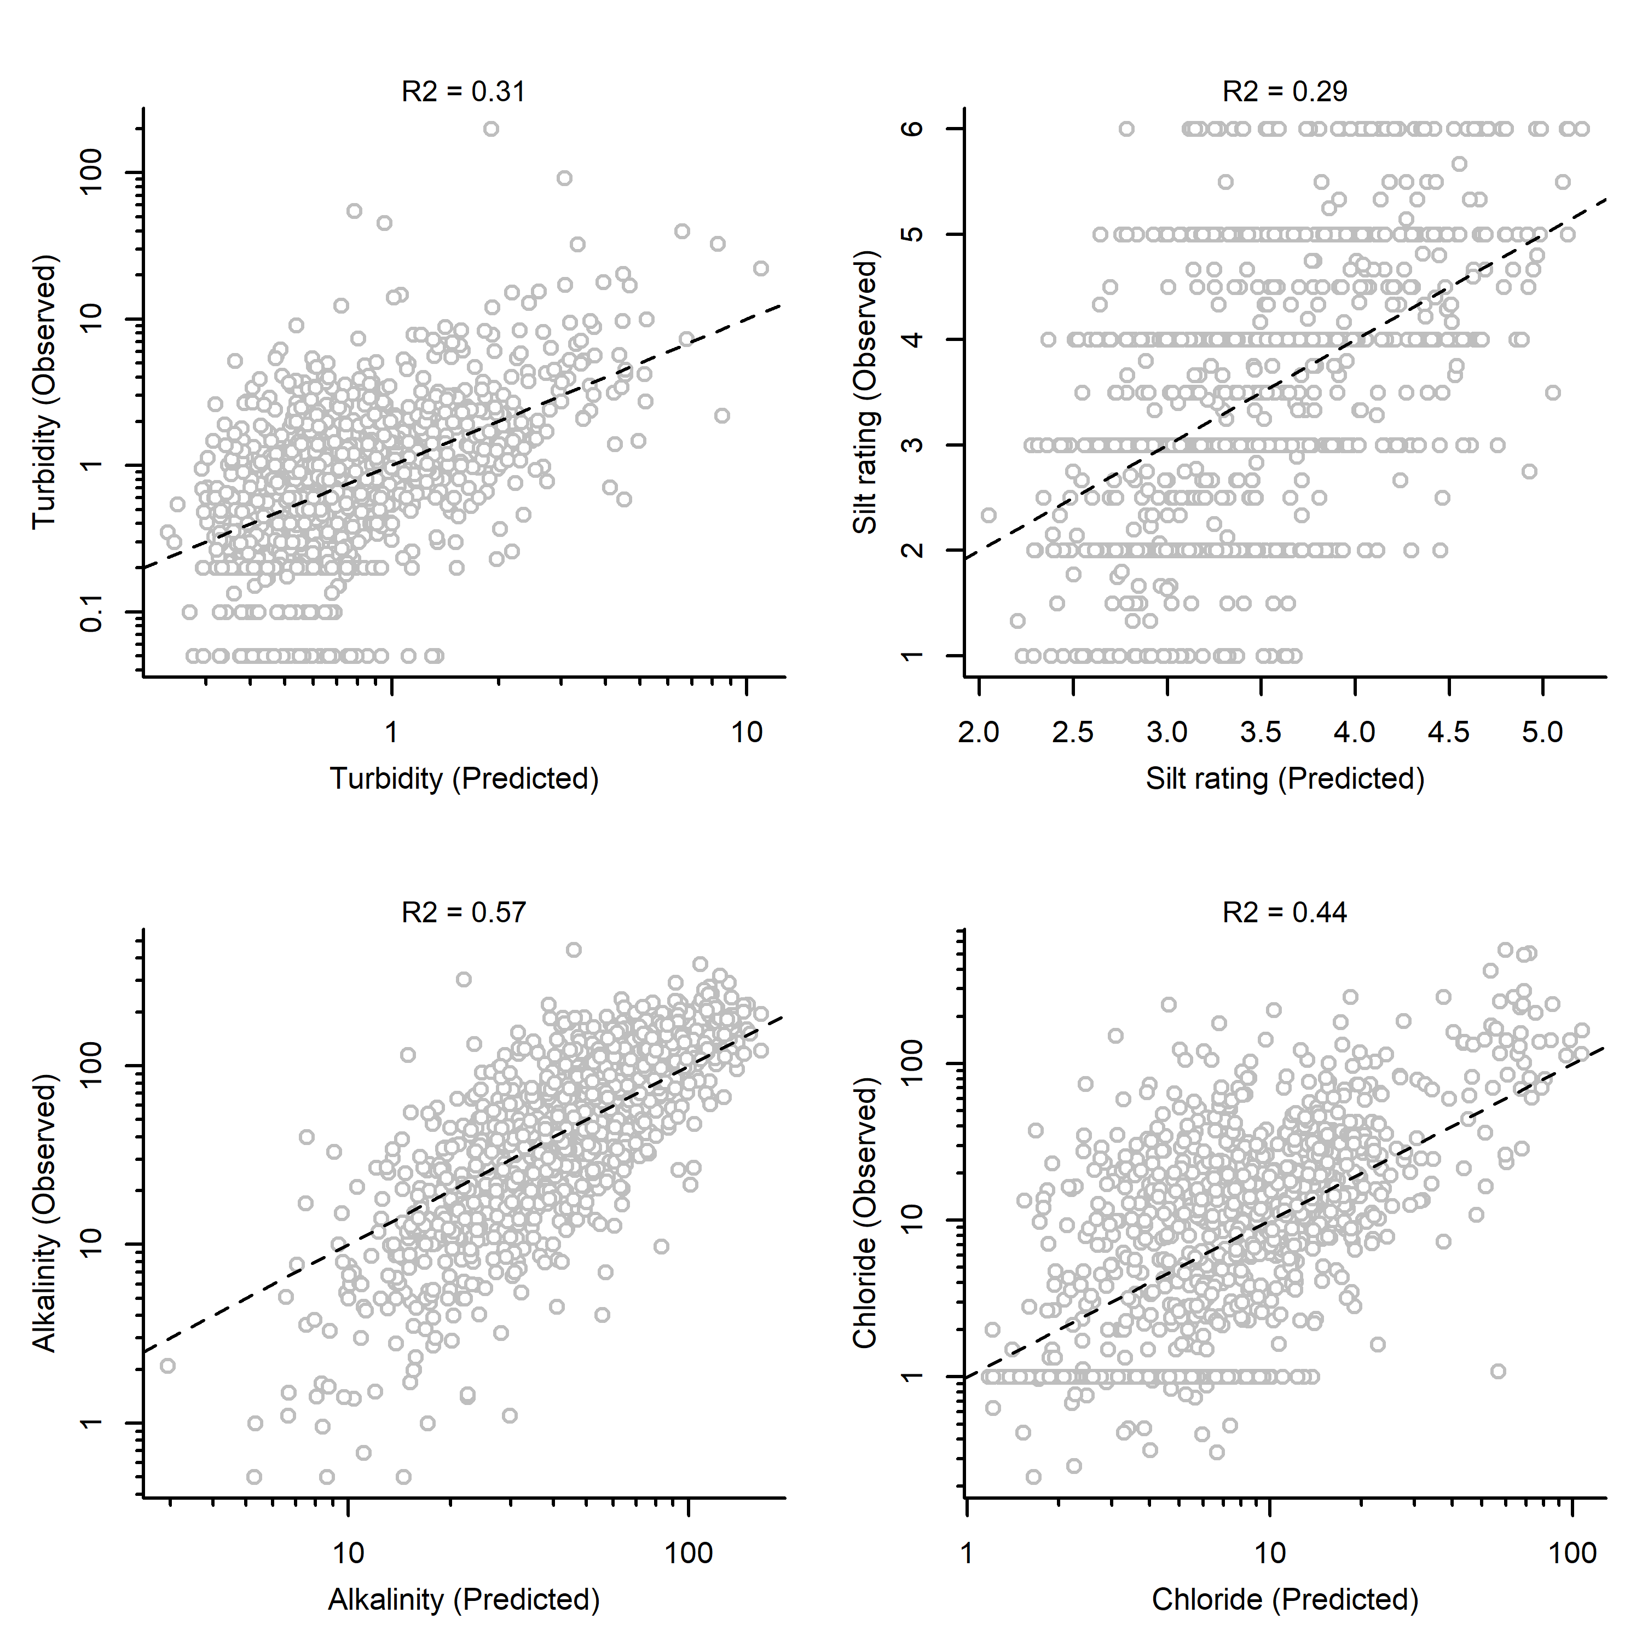

Figure . Inferred environmental conditions vs. observations using only kicknet data.

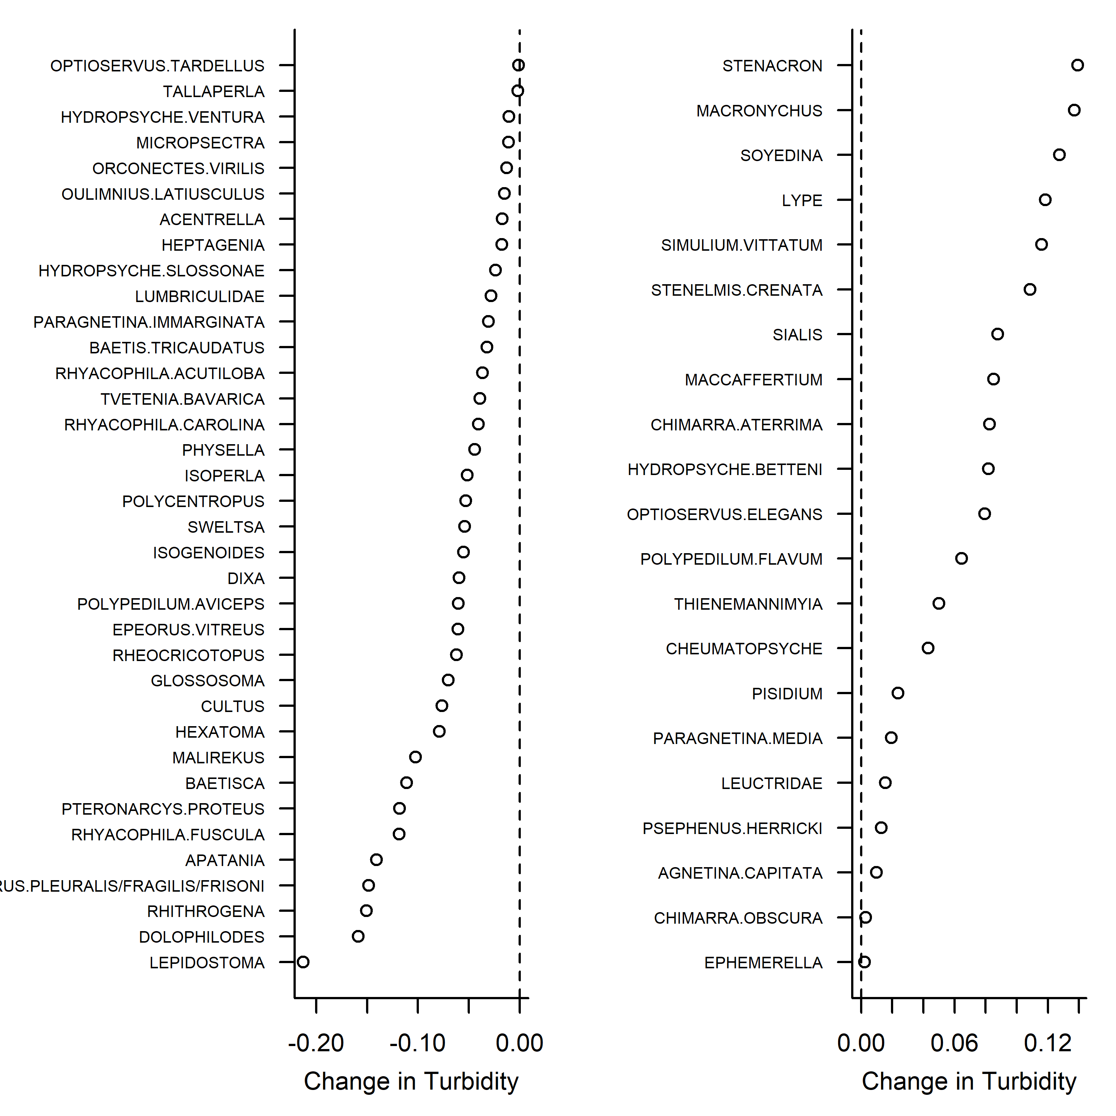

Figure . Turbidity sensitive and tolerant taxa.

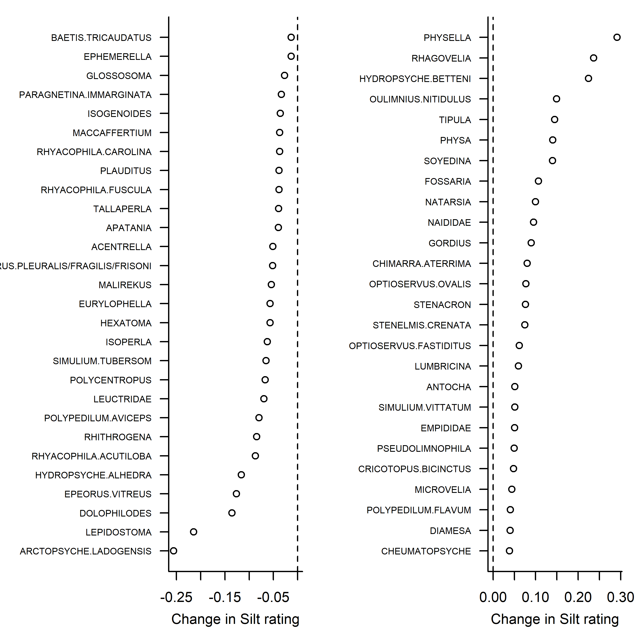

Figure . Silt sensitive and tolerant taxa

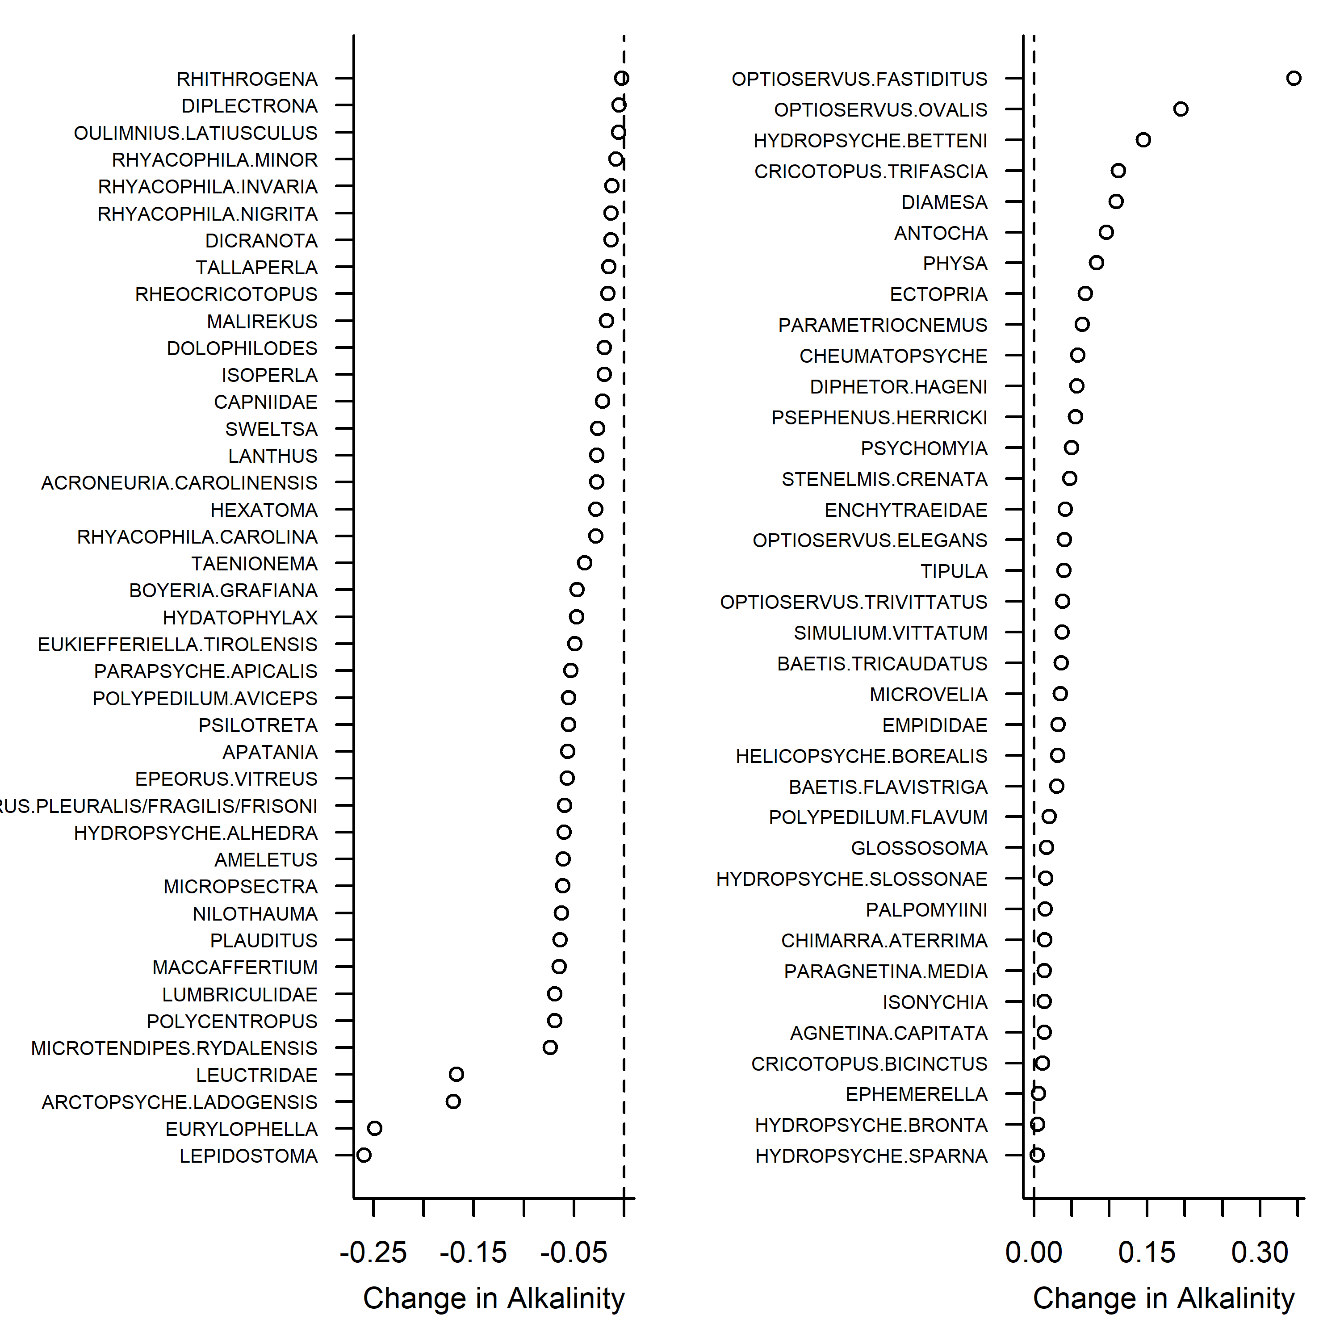

Figure . Alkalinity sensitive and tolerant taxa.

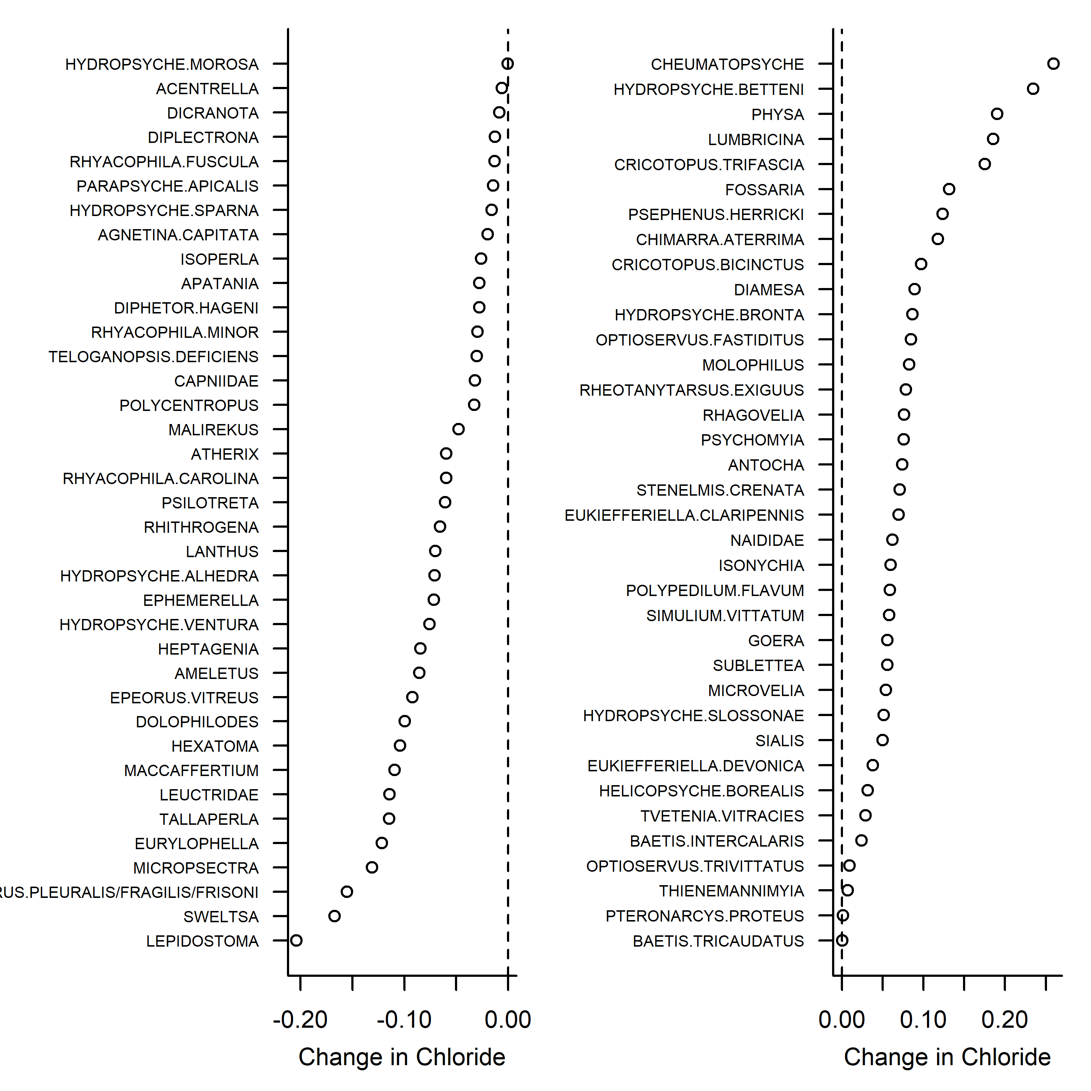

Figure . Chloride sensitive and tolerant taxa.