# Bend Angle Viewer

## I. Modify hardware:

### 1. Hardware requirement:

* 1x ADAFRUIT BLUEFRUIT LE MICRO module (https://www.adafruit.com/products/2661)
* 1xMini. JST SH 1.0mm 4-Pin Female Connector
* 1x mini Breadboard (https://www.adafruit.com/products/2661)
* Connection wires

### 2. Connection:

* Open the DMI true degrees receiver device.
* On the board, locate the JST connector slot (red square in figure 1). Plug the Mini. JST SH 1.0mm 4-Pin Female Connector into that slot.
* Plug the Adafruit bluefruit LE Micro on the mini Breadboard. Attach the mini breadboard on the receiver main board (as shown in figure 1)
* Refer to figure 1 for soldering addition wire connections:
  + At location A: Solder wire to the black wire.
  + At location B: Solder wire to the most right wire.
* Refer to figure 1 for pin number and connection, connect pins as follow:
  + Connect pin 1 to pin GND of the Adafruit bluefruit LE Micro.
  + Connect pin 4 to pin 10 of the Adafruit bluefruit LE Micro.
  + Connect pin 5 to pin 9 of the Adafruit bluefruit LE Micro.
  + Connect pin 6 to pin BAT of the Adafruit bluefruit LE Micro.

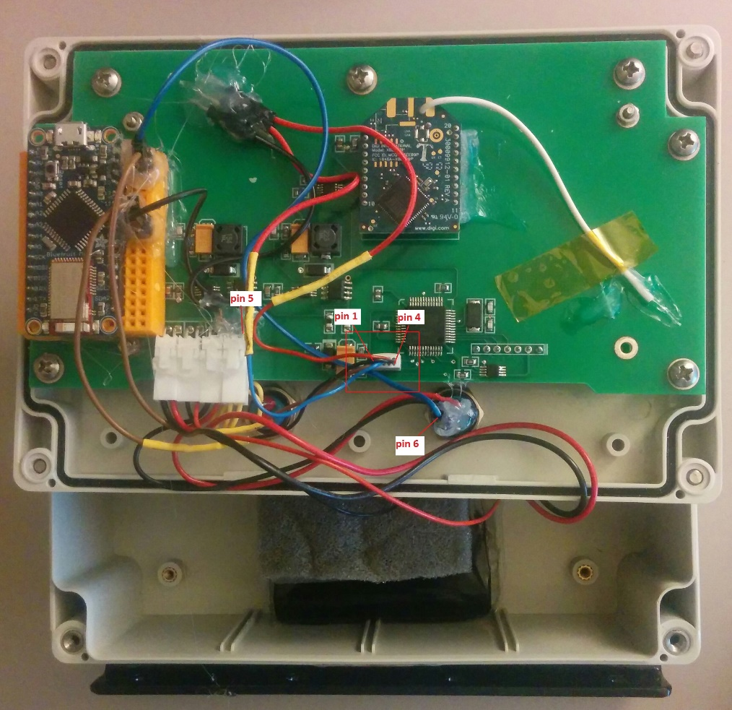

Figure 1

### 3. Firmware update:

#### a. Prepare environment:

* Install Arduino IDE on your PC, go to the link below for instruction how to do it. <https://www.arduino.cc/en/Main/Software>
* After you have downloaded and installed Arduino IDE, place the Adafruit_BluefruitLE_nRF51 library folder your arduinosketchfolder/libraries/ folder. You may need to create the libraries subfolder if it’s your first library.
* After you have downloaded and installed Arduino IDE and add require library, you will need to start the IDE and navigate to the Preferences menu

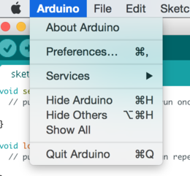

* A dialog will pop up just like the one shown below.

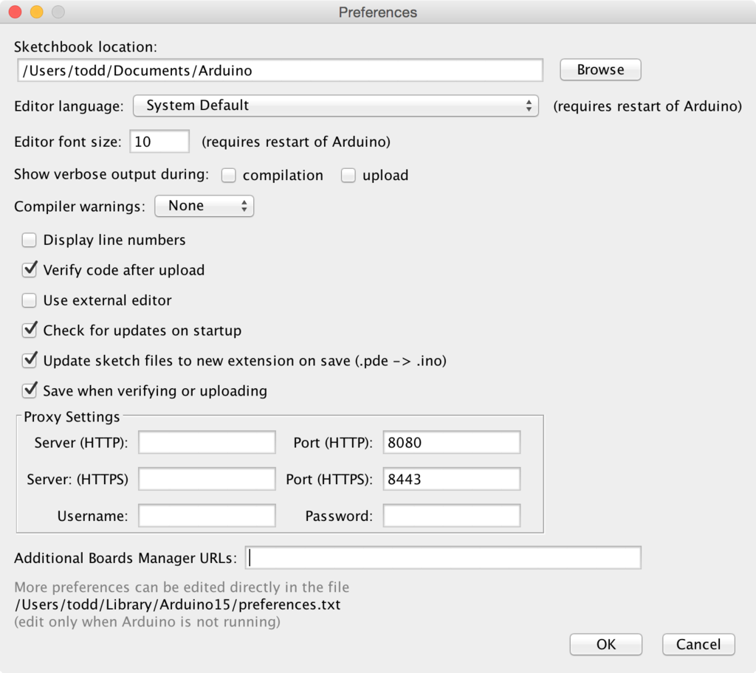

* Copy and paste the link below into the Additional Boards Manager URLs option in the Arduino IDE preferences.

<https://adafruit.github.io/arduino-board-index/package_adafruit_index.json>

* Now that you have added the appropriate URLs to the Arduino IDE preferences, you can open the Boards Manager by navigating to the Tools->Board menu.

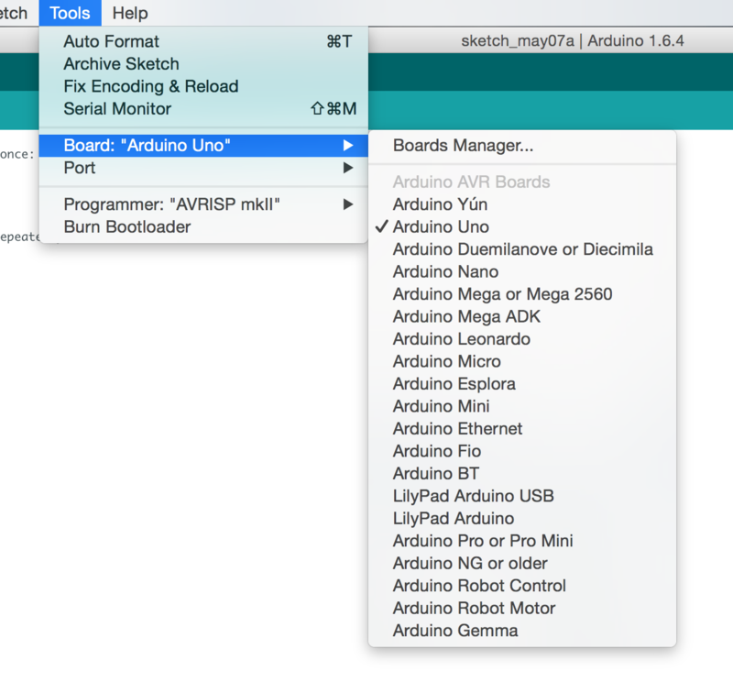

* Once the Board Manager opens, click on the category drop down menu on the top left hand side of the window and select Contributed. You will then be able to select and install the boards supplied by the URLs added to the preferences. In the example below, we are installing support for Adafruit AVR Boards, but the same applies to all boards installed with the Board Manager.

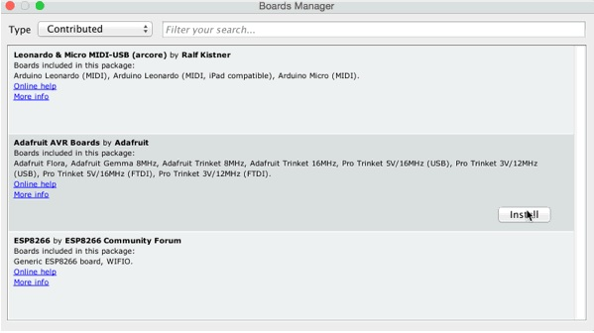

* Next, quit and reopen the Arduino IDE to ensure that all of the boards are properly installed. You should now be able to select and upload to the new boards listed in the Tools->Board menu.

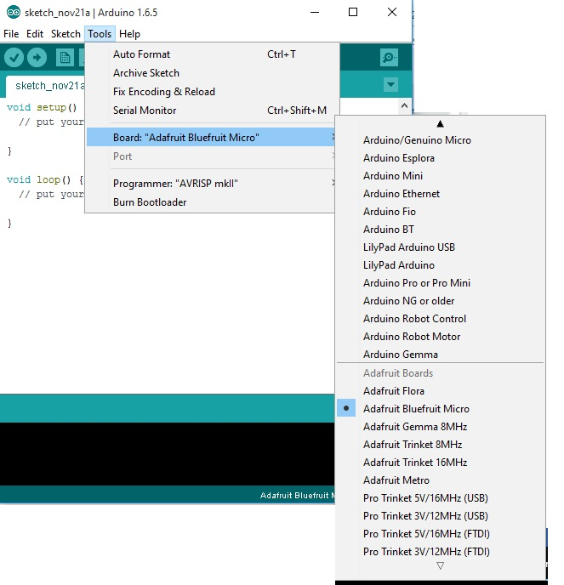

#### b. Update firmware for ADAFRUIT BLUEFRUIT LE MICRO board:

* Use USB cable to connect the ADAFRUIT BLUEFRUIT LE MICRO to your PC.
* Launch the IDE and select Bluefruit Micro from the Boards menu. Also select correct port of board in the Port menu.

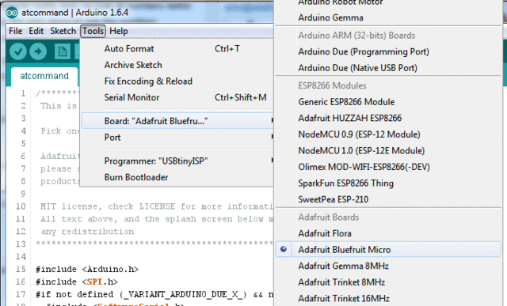

* In Arduino IDE, open file bendAngleViewer.ino (location in bendAngleViewer_arduinoSourceCode folder).
* Upload firmware to Bluefruit Micro board.

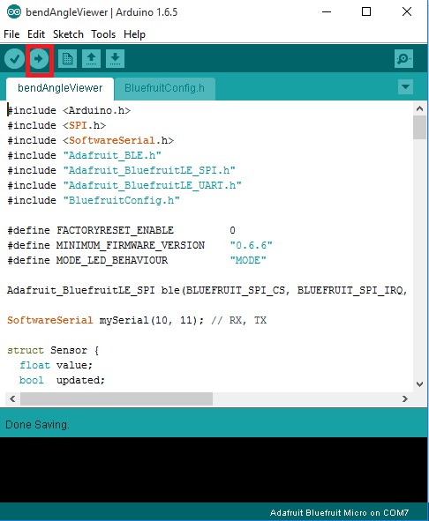

**After finish all above steps, now you are now ready to use the DMI true degrees receiver via bluetooth.**

## II. Desktop Application

Desktop application to interact with Bend Angle devices via Bluetooth.

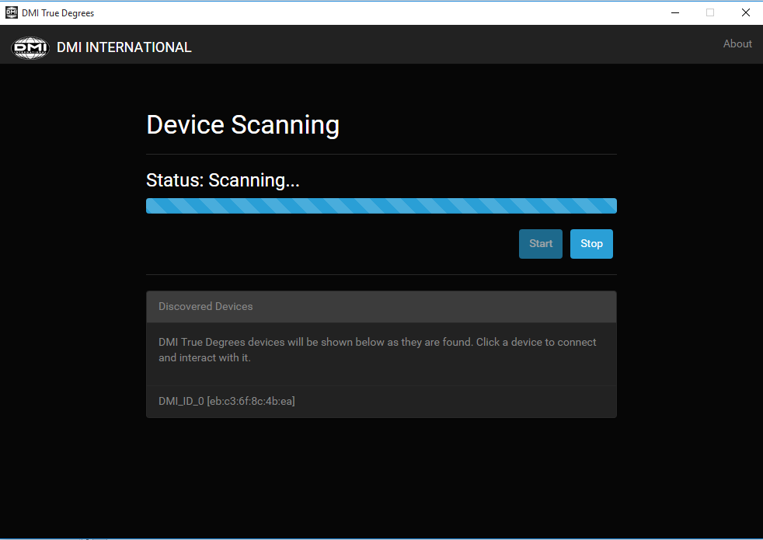

### 1. Using software:

Please follow the following steps to use Bend Angle Viewer application on your Windows PC.

#### a. Install Bluetooth driver:

* Plug the CRS8501 Bluetooth dongle to PC.
* Run the Zadig tool (zadig_2.1.2.exe)
* On the Zadig tool windows, select the Options -> List All Devices menu item

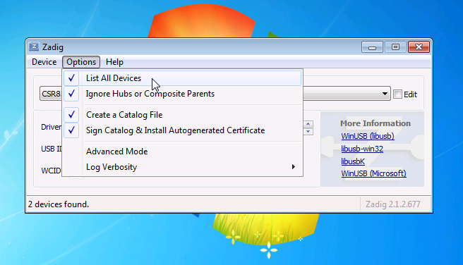

* Find the BLE adapter in the device drop down list, in this case a CSR8510, and then select a WinUSB driver in the combo box on the right side of the green arrow. Click the Replace Driver button

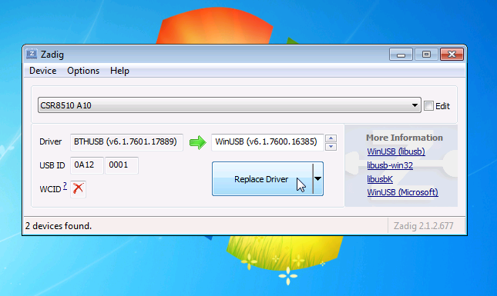

* Zadig tool will replace the driver for the device with a WinUSB driver. When it finishes you should see a successful install dialog

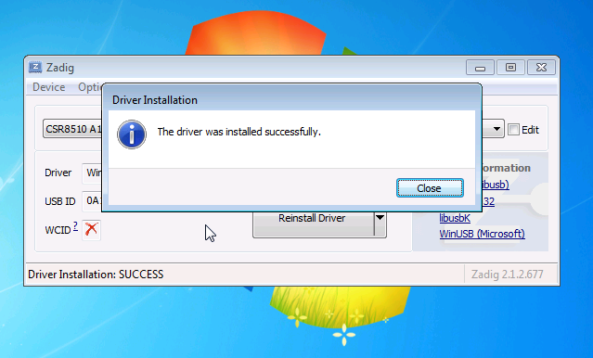

**After finish all above steps, you should now be ready to use the Bend Angle Viewer application on your Windows PC. Run the file BendAngleViewer.exe**

* Select device that you want to get data in the discovered devices box

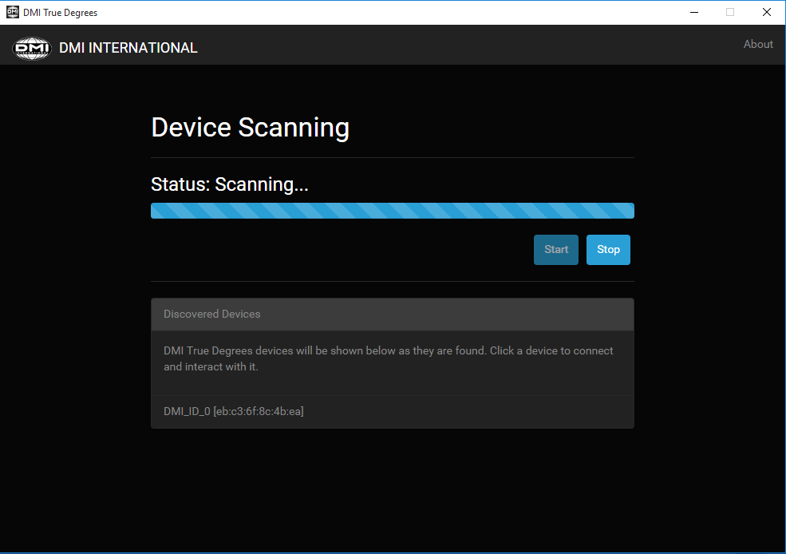

* **After connect to device, enter the information on the next screen**

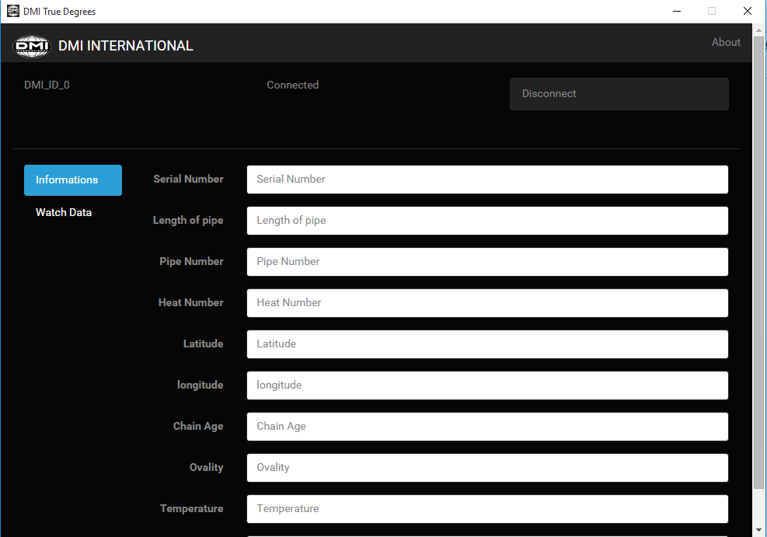

* **Click on the Watch data button to begin watch the data received**
  + **To reset to 0 angle, press Set Zero button, after 5s, the device will set current angle to 0, to cancel process, press that button again.**
  + **To add data to log, press Add Data button**
  + **To remove last added data, press Remove Last Data button**
  + **To remove all data, press Remove All Data button**
  + **To export Data to pdf file, press Export Data button, then choose where to save data file.**
  + **To disconnect device, press Disconnect button.**

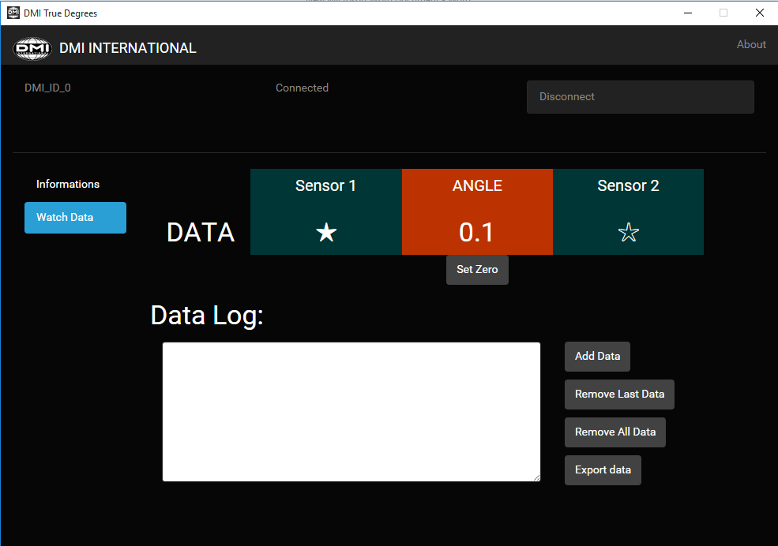

## III. Android Application:

Go to google play store, search and install “**bend angle viewer**” app (or visit this link <https://play.google.com/store/apps/details?id=com.bendangle.bluefruit.le.connect>)

* Tap the Scan button on the bottom toolbar to start/stop devices scanning. Drag down and release to clear the list of found devices and begin scanning.
* Tap device's connect button to connect the corresponding device.

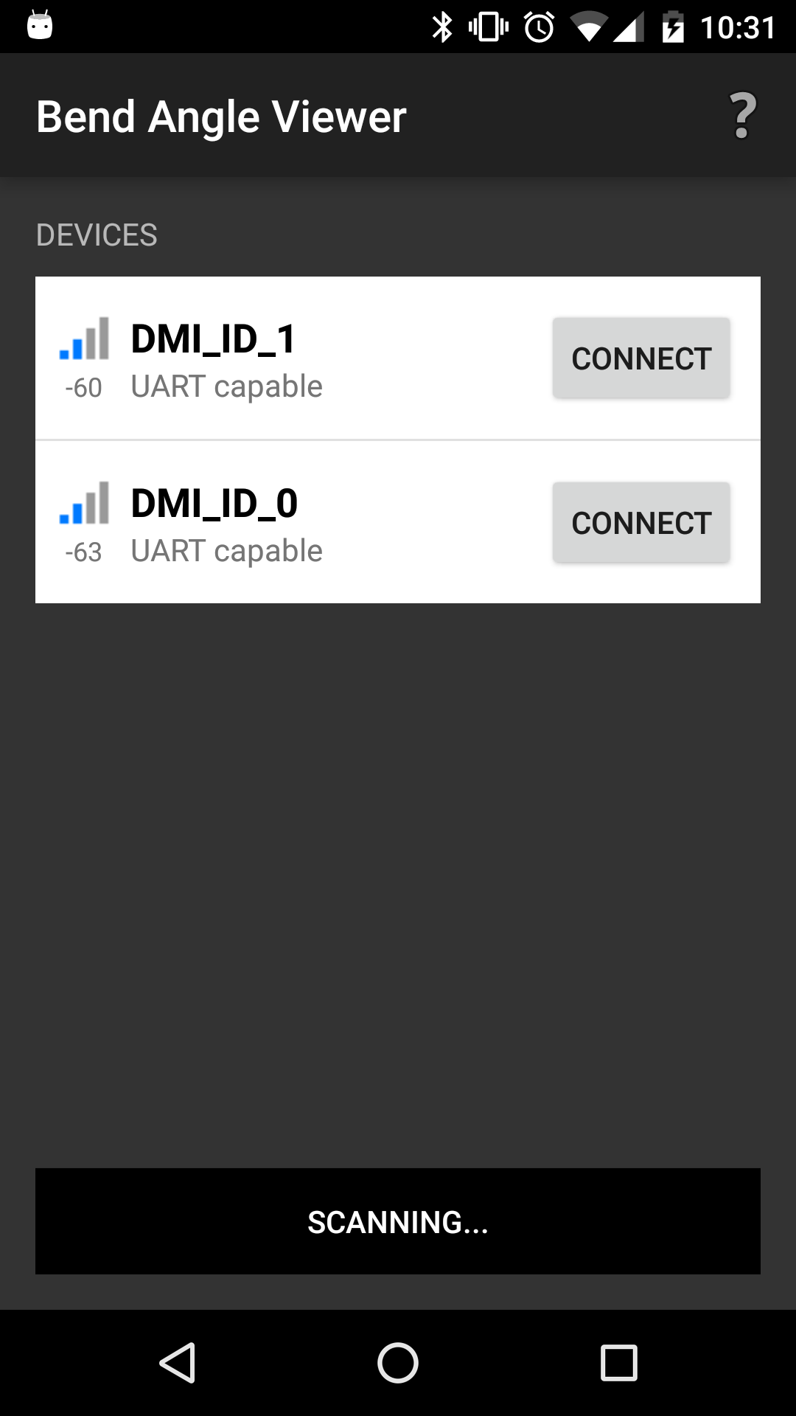

* After connect to device, setup the information by click the top right button.
* Press Reset button to set angle to 0 (after 5s device will set current angle as 0 degress). To cancel press it again
* Press Add Dada button to add data to log.
* Press Delete Last Data button to delete last added data from log.
* Press Delete All button to delete all log data.
* Press Export button to export data and information.

|  |  |
| --- | --- |
|  |  |