Leszek Dubicki
Studen ID: x14125439

Hangman Project

Softwere Development
- Application description
Github link: https://github.com/leszekdubicki/hangman
- The input is provided by the user by guessing/typing the letters and making decisions weather they would like to play again.
- The process is split into several classes of the application. The main game processing – getting letters from player and passing letter into GuessWord class is done in main application class. Drawing random word and keeping all the words in memory is done in WordsCollection class. Checking if provided letter is in the word, counting lives, recording chosen letters and checking whether the player has won or lost the game is done inside GuessWord class.
- The output is split between several classes as well. Game statistics and asking the player if he want to continue is done in the main class. Status message of guessing the current word is provided by GuessWord class (since it has all the information needed), and displaying the gallows with the hanging man is passed to class Executioner created only for this purpose.
- Class diagram

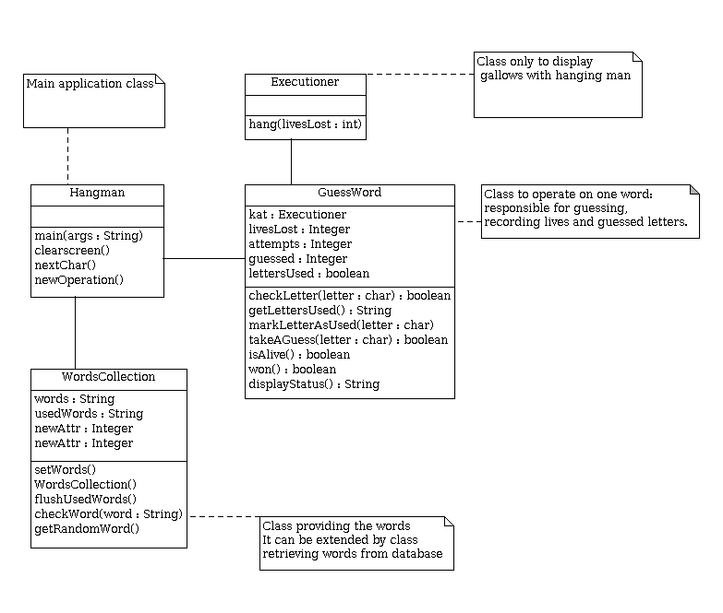

- Screen shots of the game

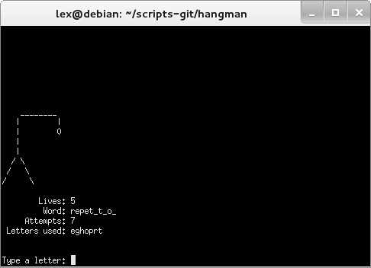

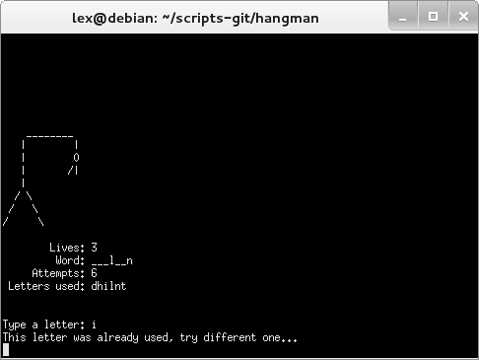

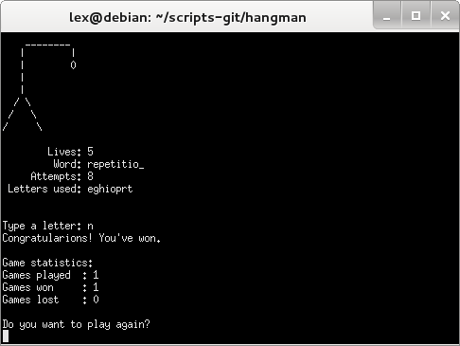

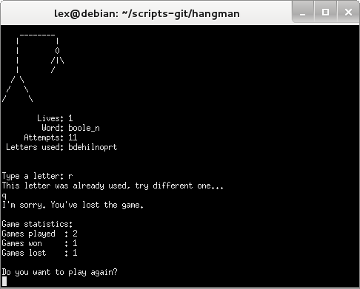

- Project summary

Task | Implementation
All code compiles without errors | Yes
All code runs without runtime errors/exceptions (i.e. the application does not crash while running) | Yes
List of 30 words – array construction | Yes
Random selection of a word | Yes
Validation of user input: e.g. check if letter used before, if yes, ask to re-enter | Yes
Validation of user input: more advanced whether the character is a letter or a number and reject numbers | Yes
Check for multiple characters matches | No (not allowed to enter more than one)
If no match, deduct a life and show the output | Yes
If no match and no lives left, show the output with appropriate message | Yes
If match and letters still left to be guessed, show the output and ask to guess another letter | Yes
If match and word guessed, show the output with appropriate message | Yes
Process to place guessed letters into the appropriate placeholders (to replace the suitable dashes) | Yes
Check previously used letters using loops | Yes
Play again after a Won game | Yes
Play again after a Lost game | Yes
Play again the game and randomly select a word from the existing array of words (do not create it aBez tytułu1gain) | Yes
Display statistics for all the games played | Yes

