<!-- NAME: TANYA GOEL

SECTION: A

ROLL NO.: 52

PROBLEM STATEMENT: WRITE A PROGRAM TO IMPLEMENT LIST,

TABLE AND IMAGES IN HTML.

-->

<!DOCTYPE html>

<html>

<head>

<title>Ques-1</title>

</head>

<body>

<h3>OUTPUT : </h3>

<table border="1">

<tr>

<th>Name</th>

<th>Articles</th>

<th>Count</th>

<th>Profile pic</th>

</tr>

<tr>

<td>Aman Singla</td>

<td>

<ol>

<li>Written </li>

<li>improved</li>

<li>Requested</li>

</ol>

</td>

<td>

<ul>

<li>10</li>

<li>25</li>

<li>5</li>

</ul>

</td>

<td>

<img src = "1.png" height="150px" width = "150px">

</td>

</tr>

<tr>

<td>Shaurya Rohilla</td>

<td>

<ol>

<li>Written </li>

<li>improved</li>

<li>Requested</li>

</ol>

</td>

<td>

<ul>

<li>20</li>

<li>25</li>

<li>10</li>

</ul>

</td>

<td>

<img src = "2.png" height="150px" width = "150px">

</td>

</tr>

<tr>

<td> Aishwarya</td>

<td>

<ol>

<li>Written </li>

<li>improved</li>

<li>Requested</li>

</ol>

</td>

<td>

<ul>

<li>30</li>

<li>50</li>

<li>60</li>

</ul>

</td>

<td>

<img src = "3.png" height="150px" width = "150px">

</td>

</tr>

</table

</body>

</html>

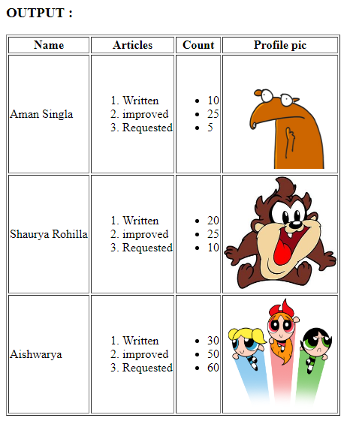

<!-- NAME: TANYA GOEL

SECTION: A

ROLL NO.: 52

PROBLEM STATEMENT: WRITE A PROGRAM TO IMPLEMENT FORM AND FRAME IN HTML.

-->

<!DOCTYPE html>

<html>

<head>

<title>Ques-2 (FRAME)</title>

<frameset border="2" rows="50%,*">

<frame name="p1" src="form.html">PAGE 1</frame>

<frame name="p2" src="table.html">PAGE 2</frame>

</frameset>

</head>

</html>

<!DOCTYPE html>

<html>

<head>

<title>FORM</title>

<style>

label:hover{

font-size: 30px;

}

input[type="text"]

{

color:green;

}

fieldset{

border: 10px solid yellow;

background-color: lightyellow;

padding-left: 10px;

}

label{

padding-left: 250px;

align: right;

}

</style>

</head>

<body>

<form>

<fieldset>

<legend>Your face</legend>

<label for="img">Your Image:</label>

<input type="file" /><br/>

<label for="preview">Image Preview:</label>

</fieldset>

<fieldset>

<legend>Your General Details</legend>

<label for="myname">Name:</label>

<input type="text"/><br/>

<label for="gen">Gender:</label>

<input type="radio" name="gender" value="Male"/>Male

<input type="radio" name="gender" value="Female"/>Female<br/>

<label for="dob">Date of Birth:</label>

<input type="date" placeholder="dd/mm/yyyy"/><br/>

<label for="colr">Favourite color:</label>

<input type="color" name="clr"/><br/>

<label for="cntry">Which Country:</label>

<!-- <input type="text" name="cntry" list="country"> -->

<select id="country">

<option value="UK">Uk</option>

<option value="US">us</option>

<option value="India">in</option>

</datalist>

</fieldset>

</form>

</body>

</html>

**OUTPUT**

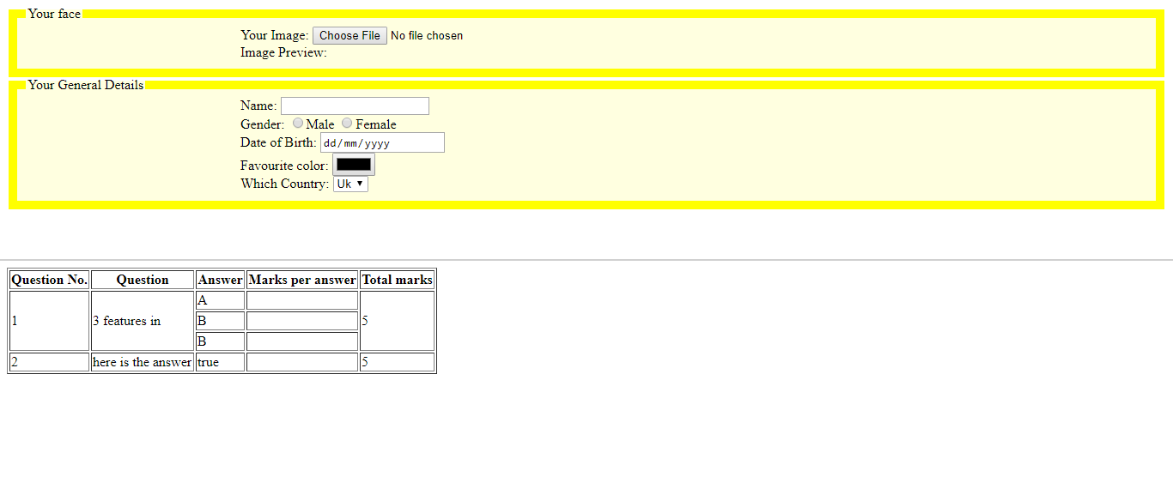

<!-- NAME: TANYA GOEL

SECTION: A

ROLL NO.: 52

PROBLEM STATEMENT: WRITE A PROGRAM IN JAVASCRIPT TO ADD A CALCULATOR ON A WEB PAGE

-->

<!DOCTYPE html>

<html>

<head>

<script type="text/javascript">

function display(val){

document.getElementById("result").value += val;

}

function clr(){

document.getElementById("result").value = "";

}

function res(){

var temp = document.getElementById("result").value

var ans = eval(temp)

document.getElementById("result").value = ans

}

</script>

<style type="text/css">

input[type = "button"]{

width: 30px;

height: 20px;

background: lightgrey;

border: none;

text-align: center;

}

input[type = "text"]{

color: white;

background: black;

direction: rtl;

width : 122px;

height: 20px;

border: none;

}

table{

border-radius: 5px;

border: 1px solid;

border-spacing: 0px;*/

border-collapse: collapse;

background-color: grey;

border-color: grey;

}

td{

padding: 0px;

margin: 0px;

}

</style>

</head>

<body>

<table>

<tr >

<td colspan="4"><input type="text" id="result" readonly placeholder="0" autofocus style="border-radius: 5px 5px 0px 0px;"></td>

</tr>

<tr>

<td><input type="button" value="+" onclick="display('+')" ></td>

<td><input type="button" value="-" onclick="display('-')" ></td>

<td><input type="button" value="x" onclick="display('*')" ></td>

<td><input type="button" value="/" onclick="display('/')" ></td>

</tr>

<tr>

<td><input type="button" value="7" onclick="display('7')" ></td>

<td><input type="button" value="8" onclick="display('8')" ></td>

<td><input type="button" value="9" onclick="display('9')" ></td>

<td rowspan="4" ><input type="button" value="=" onclick="res()" style="background-color: orange ;color: black; height: 80px; border-radius: 0px 0px 5px 0px" ></td>

</tr>

<tr>

<td><input type="button" value="4" onclick="display('4')" ></td>

<td><input type="button" value="5" onclick="display('5')" ></td>

<td><input type="button" value="6" onclick="display('6')" ></td>

</tr>

<tr>

<td><input type="button" value="1" onclick="display('1')" ></td>

<td><input type="button" value="2" onclick="display('2')" ></td>

<td><input type="button" value="3" onclick="display('3')" ></td>

</tr>

<tr>

<td><input type="button" value="0" onclick="display("0")" style="border-radius: 0px 0px 0px 5px "></td>

<td><input type="button" value="." onclick="display(".")" ></td>

<td><input type="button" value="AC" onclick="clr()" ></td>

</tr>

</table>

</body>

</html>

**OUTPUT**

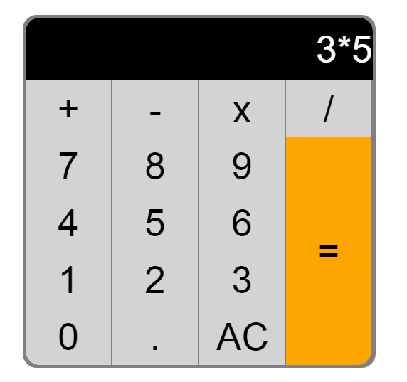

<!-- NAME: TANYA GOEL

SECTION: A

ROLL NO.: 52

PROBLEM STATEMENT: WRITE A CODE IN JAVASCRIPT TO VALIDATE A

FORM (NAME, EMAIL, AND MOBILE)

-->

<!DOCTYPE html>

<html>

<head>

<title>Form Validation</title>

</head>

<script>

function validateform(){

var name= document.myform.name.value;

var email = document.myform.email.value;

var mobNo= document.myform.mobileno.value;

var mailformat = /^\w+([\.-]?\w+)*@\w+([\.-]?\w+)*(\.\w{2,3})+$/;

if (name==null || name==""){

alert("Name can't be blank");

return false;

}

if(mobNo.length<10){

alert("Mobile number must be of 10 digits.");

return false;

}

if(email.match(mailformat) == null){

alert("Please enter in correct email format");

}

}

</script>

<body>

<form name="myform" onsubmit="return validateform()" >

Name: <input type="text" name="name"><br/>

Mobile No: <input type="number" name="mobileno"><br/>

Email id: <input type="text" name="email"><br/>

<input type="submit" value="register">

</form>

</body>

</html>

**OUTPUT**

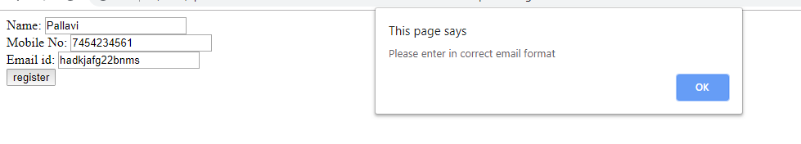

<!-- NAME: TANYA GOEL

SECTION: A

ROLL NO.: 52

PROBLEM STATEMENT : DEMONSTRATE A HTML FILE THAT INCLUDES JAVA SCRIPT.

SCRIPT THAT USES FUNCTIONS FOR THE FOLLOWING PROBLEMS:

A) PARAMETER: A STRING

OUTPUT: THE POSITION IN THE STRING OF THE LEFT-MOST VOWEL

B) PARAMETER: A NUMBER

OUTPUT: THE NUMBER WITH ITS DIGITS IN THE REVERSE ORDER.

-->

<!DOCTYPE html>

<html>

<head>

<title>Ques-5</title>

<script>

function findVowel(){

var string = document.getElementById("parameter1_id").value ;

string = string.toLowerCase();

var i = 0;

for(i = 0; i<string.length; i++){

if (string.charAt(i) == "a"||string.charAt(i) == "e"||

string.charAt(i) == "i"||string.charAt(i) == "o"||

string.charAt(i) == "u")

{

document.getElementById("output1_id").value = i+1 ;

break;

}

}

}

function reverseNumber(){

var number = document.getElementById("parameter2_id").value ;

var len = number.length;

var rev = "";

for(i = len-1 ;i>= 0 ; i--)

{

rev += number[i] ;

}

document.getElementById("output2_id").value = rev ;

}

</script>

</head>

<body >

<p>

Parameter 1: <input type="text" id = "parameter1_id" ><br/>

<input type = "button" value = "Result" onclick = "findVowel()"><br/>

Output :<input type="text" id = "output1_id"><br/>

<br/><br/>

Parameter 2: <input type="text" id = "parameter2_id"><br/>

<input type = "button" value = "Result" onclick = "reverseNumber()"><br/>

Output :<input type="text" id = "output2_id">

</body>

</html>

**OUTPUT**

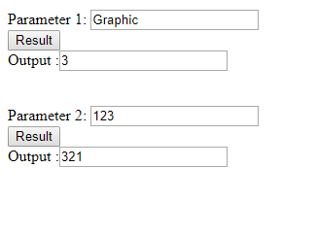

<!-- NAME: TANYA GOEL

SECTION: A

ROLL NO.: 52

PROBLEM STATEMENT : WRITE A CODE IN JAVASCRIPT TO IMPLEMENT THE ARRAY AND MATH OBJECT.

-->

<!DOCTYPE html>

<html>

<head>

<title>Ques-6</title>

<script>

function Arrayfunc(){

document.write("<h1>Array object:</h1>","<br/>");

var name_list = ["ABCD","shauryadeepak","swapnil","Jeet","Aman"] ;

document.write("accessing elements in the array :","<br/>");

document.write("1: ",name_list[0]," ","2: ",name_list[1],"<br/>");

var l = name_list.length ;

document.write("length of array is : ",l,"<br/>");

document.write("convert array into the string: ",name_list.toString(),"<br/>");

document.write("perform joining operation on the array: ","<br/>");

document.write(name_list.join("_@_"),"<br/>");

document.write("insert jiten name in the last :","<br/>")

name_list.push("jiten");

l = name_list.length;

document.write("last element in the modified array :",name_list[l-1]);

}

function Mathfunc(){

document.write("<h1>Math object:</h1>","<br/>");

document.write("value of Pi is: ",Math.PI,"<br/>");

document.write("value of 2^5 is: ",Math.pow(2,5),"<br/>");

document.write("ceil value of 2.5 is: ",Math.ceil(2.5),"<br/>");

document.write("floor value of 2.5 is: ",Math.floor(2.5),"<br/>");

document.write("minimum value among 10,20,5 is: ",Math.min(10,20,5),"<br/>");

document.write("maximum value among 10,20,5 is: ",Math.max(10,20,5),"<br/>");

document.write("square root of 16 is: ",Math.sqrt(16),"<br/>");

}

</script>

</head>

<body >

<script>

Arrayfunc();

Mathfunc() ;

</script>

</body>

</html>

**OUTPUT**

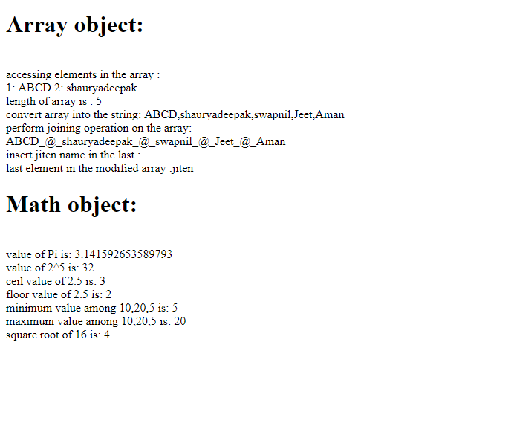

<!-- NAME: TANYA GOEL

SECTION: A

ROLL NO.: 52

PROBLEM STATEMENT : WRITE A PHP PROGRAM TO STORE CURRENT DATE-TIME IN A COOKIE AND

DISPLAY THE ‘LAST VISITED ON’ DATE-TIME ON THE WEB PAGE UPON REOPENING OF THE SAME PAGE.

-->

<?php

$itm = 60*60*24*60+time();

setcookie('last_visit',date("G:i -m/d/y"),$itm);

if(isset($_COOKIE['last_visit'])) {

$visit = $_COOKIE['last_visit'];

echo "Your last visit was - " .$visit;

}

else {

echo "You have some stale cookies!" ;

}

?>

**OUTPUT**



<!-- NAME: TANYA GOEL

SECTION: A

ROLL NO.: 52

PROBLEM STATEMENT : WRITE A PHP PROGRAM TO STORE PAGE VIEWS COUNT IN SESSION,

TO INCREMENT THE COUNT ON EACH REFRESH, AND TO SHOW THE COUNT ON WEB PAGE.

-->

<?php

session_start();

if(isset($_SESSION['page_count']))

$_SESSION['page_count'] += 1;

else

$_SESSION['page_count'] = 1;

echo "You are visitor number - " .$_SESSION['page_count'];

?>

**OUTPUT**



<!-- NAME: TANYA GOEL

SECTION: A

ROLL NO.: 52

PROBLEM STATEMENT : CREATE AN HTML FORM AND THE WRITE A PHP CODE FOR

INSERTING THE EMPLOYEE INFORMATION IN DATABASE. INFORMATION INCLUDES

EMPLOYEE NAME, ADDRESS, PHONE NUMBER, EMAIL ID, SALARY ETC.

ALL THE POSSIBLE VALIDATIONS SHOULD BE THERE.

-->

<html>

<head>

</head>

<body>

<p1>Employee Information</p1>

<form action="conn.php" method="get">

<table>

<tr>

<td>Name</td>

<td><input type="text" name="myname" placeholder="Name"/></td>

</tr>

<tr>

<td>Address</td>

<td><input type="text" name="myaddress" placeholder="Address"/></td>

</tr>

<tr>

<td>email</td>

<td><input type="text" name="myemail" placeholder="Email"/></td>

</tr>

<tr>

<td>Mobile</td>

<td><input type="text" name="mymobile" placeholder="Mobile"/></td>

</tr>

<tr>

<td><input type="Submit" value="Save"/></td>

<td><input type="reset" value="reset"/></td>

</tr>

</table>

</form>

</body>

</html>

<?php

$server = "localhost";

$username = "root";

$password = "";

$dbname = "empdb";

$conn = mysqli_connect($server, $username, $password, $dbname);

if(!$conn){

echo "Not Connected";

echo "<br/>";

}

echo $name = $_REQUEST['myname'];

echo "<br/>";

echo $address = $_REQUEST['myaddress'];

echo "<br/>";

echo $email = $_REQUEST['myemail'];

echo "<br/>";

echo $mobile = $_REQUEST['mymobile'];

echo "<br/>";

$sql = "insert into employee (name, address, email, mobile) values('$name', '$address', '$email', '$mobile')";

if(mysqli_query($conn, $sql)){

echo "One Row Inserted";

}

else{

echo "Failed to insert".mysqli_error($conn);

}

?>

**OUTPUT**



<!-- NAME: TANYA GOEL

SECTION: A

ROLL NO.: 52

PROBLEM STATEMENT : CREATE AN HTML FORM AND WRITE A PHP CODE FOR FETCHING

THE EMPLOYEE INFORMATION FROM THE MYSQL DATABASE WHOSE SALARY IS LESS THAN 10,000PM.

-->

<?php

$server = "localhost";

$username = "root";

$password = "";

$dbname = "empdb";

$conn = mysqli_connect($server, $username, $password, $dbname);

if(!$conn){

echo "Not Connected";

echo "<br/>";

}

$sql = "select * from employee where salary < 10000";

$result = mysqli_query($conn, $sql);

if (mysqli_num_rows($result) > 0) {

while($row = mysqli_fetch_assoc($result)) {

echo " Name: " . $row["name"]. " Salary " . $row["salary"]. " Email " . $row["email"]. " Mobile ". $row["mobile"]. "<br>";

}

}

else {

echo "0 results";

}

?>

**OUTPUT**

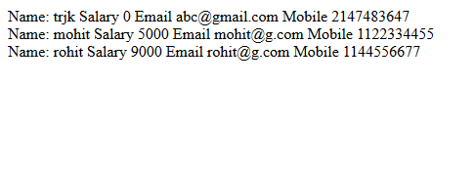

<!-- NAME: TANYA GOEL

SECTION: A

ROLL NO.: 52

PROBLEM STATEMENT : 12 WITH THE HELP OF PHP CODE INSERT SOME TEXT IN TEXT FILE.

AFTER INSERTING THE TEXT READ THE TEXT FROM THE SAME TEXT FILE AND SHOWS IT ON WEB PAGE.

-->

<?php

$myfile = fopen("file.txt", "w");

$txt = "wadu heck hek wadu wadu hek";

fwrite($myfile, $txt);

fclose($myfile);

$myfile = fopen("file.txt", "r");

echo fread($myfile,filesize("file.txt"));

fclose($myfile);

?>

**OUTPUT**

