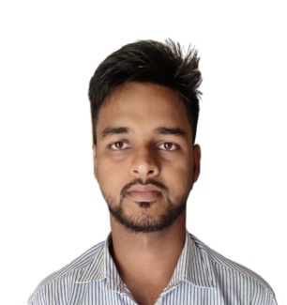**ARABINDA NAYAK**

pngegg.png 7205119203

[arabinda725@gmail.com](mailto:arabinda725@gmail.com)



png-transparent-linkedin-logo-linkedin-logo-computer-icons-business-symbol-linkedin-icon-miscellaneous-blue-angle-thumbnail.png linkedin.com/in/arabinda-nayak

github-logo.png github.com/let-start-github

arabindaportfolio.netlify.app

## CAREER OBJECTIVE

* Seeking a position to utilize my knowledge and skills in a challenging and simulating environment with commitment for excellence and to enhance career revenue and also to serve as a role model for other.

## EDUCATION

* Master in computer Application|NIT|Bhubaneswar| **2022-Continue**
* Bachelor’s in Science|HNS Mahavidyalaya|Kendrapara| **2019-2022**
* 12th Science |Stewart Science College|Cuttack| **2017-2019**
* 10th CHSE|Harianka High School|Kendrapara **2017**

## PROJECT

* **Project Title: Student Details Database**
  + - Using HTML, BOOTSTRAP, JAVASCRIPT, PHP, MYSQL **11/2022 – 11/2022**
* **Project Title: Prediction of deases of a patient data**
  + - Machine Learning using Python **01/2023 - 02/2023**
* **Project Title: Ecommerce website**
  + - Using HTML, CSS, JAVASCRIPT
* **Project Title: Port Folio**
  + - Using HTML ,CSS ,BOOTSTRAP ,JAVASCRIPT

## TECHNICAL SKILL

* **PROGRAMMING LANGUAGE**:-C ,JAVA ,PYTHON ,PHP ,JAVASCRIPT
* **FRONT END:-** HTML , CSS , BOOTSTRAP , REACT , JQUERY
* **BACKEND :**-DJANGO,PHP,ORACLE ,MYSQL ,MONGO DB
* **EXTRA COURSE:**- OS-CIT ,DCA ,PGDCA

**SUBJECT OF INTREST**

* Artificial Intelligence
* Ethical hacker

**SOFT SKILL**

* Good communication skills with a keen enthusiastic nature for acquiring knowledge
* Positive attitude
* Ability to motivate and lead others in a team.
* Time Management.
* Continuous Improvement Mindset.
* Integrity and Honesty.

**PERSONAL DETAILS**

* DOB: 25TH JAN 2002
* Languages Known: English, Hindi, Odia
* Address: Mangalpur, Charirakaba, Cuttack, 754293, Odisha