VCD5D-WORKSHOP-FALL2020 LESSION PLAN

**Week1 - 8/24: INTRO**

* Syllabus
* Group division/group name
* App idea
* Git install + bash set up for Mac users
* Human Center Design intro + steps

ImageHW#1 (20pts): app idea + 5 design sources for inspiration

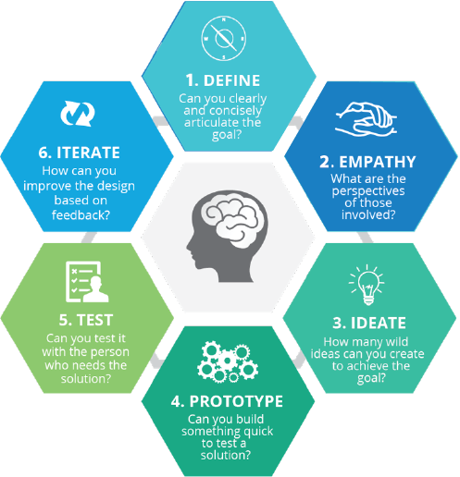Image

**Week2 - 8/31: DEFINE/RESEARCH**

* Market research
* Competitive Analysis
* Business + User Goal
* Business Value Proposition

HW#2 (30pts): Market Research + Competitive Analysis + Business Value Proposition

**Week3 - 9/7: HOLIDAY**

**Week4 - 9/14: EMPATHY**

* User Persona
* Customer Journey map
* Introduction on command line
* VS CODE download + plugin

HW#3 (30pts): 2 user personas + journey map

**Week5 - 9/21: Ideate**

* Critique HW#3
* Brain storming – app features
* Task flow for sign up + sign in example
* Command line practice cont.
* App info architect (each app screen with features list)

HW#4 (30pts):   
1) affinity map app ideas

2) app features plotting charts  
3) 4 tasks flow

**Week6 - 9/28: Wireflow 1**

* Apple & Android Design style guide
* Wireflow example: sign up + log in + profile + app start screen
* [Editing Shapes & The Pen Tool](https://www.xdguru.com/adobe-xd-guide/editing-shapes-pen-tool/)
* [Masking](https://www.xdguru.com/adobe-xd-guide/masking/)
* [The Repeat Grid](https://www.xdguru.com/adobe-xd-guide/repeat-grid/)
* [Sharing](https://www.xdguru.com/adobe-xd-guide/sharing/) & coediting
* Intro to web dev html + project structure
* Github.io set up + deploy first website

HW#5 (30pts):

1. Information architecture diagram (15)
2. Feature 1 (15pt) wireflow
3. Feature 2 (15pt) wireflow

**Week7 - 10/5: Wireflow 2**

* Critique HW#5
* [Boolean Operations](https://www.xdguru.com/adobe-xd-guide/boolean-operations/) – PathFinder in XD
* [Styling Objects (fills, blurs, ..)](https://www.xdguru.com/adobe-xd-guide/styling-objects/)
* [Prototyping](https://www.xdguru.com/adobe-xd-guide/prototyping/)
* Wireflow cont
* HTML intro part 1

HW#6 (45pts): wireflow for the last 3 features/ revise HW#5 from feedback & connect them all together

**Week8 - 10/12: UI KIT/DESIGN SYSTEM**

* Critique HW#6
* Moodboard class activities
* Adobe XD [Assets Panel](https://www.xdguru.com/adobe-xd-guide/assets-panel/)
* [CC Libraries Integration](https://www.xdguru.com/adobe-xd-guide/creative-cloud-libraries/)
* [Importing Assets](https://www.xdguru.com/adobe-xd-guide/importing/)
* Design system/ui kit contents
* HTML intro part 2

HW#7 (45pts): moodboard (10) + Design system for the app (25)

**Week9 - 10/19: component/state in XD – CSS intro part 1**

* Critique hw#8
* [Importing Assets](https://www.xdguru.com/adobe-xd-guide/importing/)
* [Export Assets](https://www.xdguru.com/adobe-xd-guide/exporting/)
* [Component in XD](https://www.xdguru.com/adobe-xd-guide/symbols/)
* [Prototyping](https://www.xdguru.com/adobe-xd-guide/prototyping/)
* Intro to CSS part 1

HW#8 (50pts):

1. hifi prototype for 5 main features ios (20)
2. hifi prototype for 5 main features android (20)
3. log in/register screen + app launch screen (10)

**Week10 - 10/: hifi Prototype – CSS part 2**

* Critique #9
* Component-state in XD.
* Animation with XD
* CSS part #2

HW#9 (50pts):

1. Revise HW#8
2. Add 2 interactive state per screen

**Week11 - 11/02: Testing – Bootstrap Grid**

* Usuabily testing
* User feedback
* Critique HW#9 [project 1]
* Bootstrap Grid + +flex box + alignment

HW#10 (30pts):

1. Conduct test your prototype in real devices and collect user feed back
2. Revise

**Week12 - 11/09: Resume Design – Bootstrap grid/CSS cont. + navigation**

* Resume content/Example/resume page set up from github.io repo
* BootStrap navigation/nav bar
* CSS pseudo classes, shorthand

HW#11 (20pts): Design your resume

**Week13 - 11/16: Resume Code – BS components**

* BS components with js and jquery
* Set up github page with git branch
* Git branches set up – merge/pull command

HW#12 (20pts): revise and code up resume

**Week14 - 11/23: BS components cont. + Final project**

* Final project contents/design
* Git branches practice merge/pull
* BS components cont. : contact form + cards & modal combination + display gif image/videos in html

HW#13 (30pts): design final presentation (web + mobile) & push up all asset to github share project folder

**Week15 - 11/30: Last lecture week**

* Critique HW#13
* Setting up final project submission

1. Mini Portfolio page -> work project list (3 minimum with BS modal to view project in detail), resume, contact page
2. Favicon + BS tool tip + BS spy scroll
3. Click project link to go to final presentation page

Final Project: merge and submit to master branch for “final presentation” repo  
Submit 2 links:   
1) portfolio link -> individual  
2) final project link -> group