

**Research and develop Web App for recommendation of calories and nutritional menu.**

**COMP1682** **Final Year Project**

**BSc H Computing**

**Student Name: Le Tan Dat Banner ID: 001138239**

**Information Technology majors**

**Table of Contents**

**1.Introduction:** 7

**1.1 Project Overview** 7

**1.2 Aim** 12

**1.3 Project Objectives** 12

**1.3.1 Research issues to build a website** 12

**1.3.2 Design Documentation** 12

**1.3.3 Product Deployment** 13

**1.3.4 Development of test documents.** 13

**1.3.5 Assessment Report and Conclusion**. 13

**1.3.6 Packing and document synthesis.** 14

**2. LITERATURE REVIEW:** 15

**2.1** **Definition BMR** 15

**2.2 History of BMR** 15

**2.3** **The Harris-Benedict method** 16

**2.4** **Technology and tool:** 17

**2.4.1** **SQL** 17

**2.4.2** **PHP** 18

**2.4.3** **HTML** 19

**2.4.4** **CSS** 19

**2.4.5** **JavaScript** 20

**2.4.6** **MySQL** 21

**2.4.7** **JSON** 21

**2.4.8** **Webserver:** 22

**2.4.9** **Tool** 24

**3** **Product Reasearch** 26

**3.1** **MyFitnessPal** 26

**3.2** **FatSecret** 27

**3.3** **Compare MyfitnessPal with FatSecret** 28

**4** **Legal, Social, Ethical and Professional** 30

**5** **Analysis requirement** 31

**5.1 Requirements Analysis: 31**

**5.2 Compare MyfitnessPal and Fatsecret study with other app tracking health: 31**

**5.3 Functional Requirements 32**

**6** **Design:** 36

**6.1** **Use Case** 36

**6.2** **Database** 38

**6.3** **Sequence Diagram** 39

**6.4** **Wireframe** 41

**7** **Implementation of the project:** 46

**7.1** **Implement Front-end** 47

7.2 **Implement back-end** 49

**7.2.1** **Code Implement** 49

**7.2.2 Screenshot of database** 62

**7.3** **Function implement** 63

**7.4** **Screenshot** 68

**8** **Testing** 72

**8.1 Test Function of Admin** 72

**8.2 Test Function of user** 75

**9** **Evaluation** 77

**9.1. Self-assessment of the product** 77

**9.2 Project process evaluation** 80

**10** **Conclusion** 82

**10.1** **Evaluation of individual results:** 82

**10.2** **What went well?** 83

**10.3** **What didn't go well?** 83

**10.4** **More product features in the future** 83

**10.5** **Conclusion:** 84

**References** 85

**Appendix A – Project Proposal** 89

**Table figure**

**Figure 1 Top 10 Most Obese OECD Countries** 8

**Figure 2 Percentage of the global population that used a mobile app or fitness tracking device to track their health as of 2016, by age** 9

**Figure 3 Most popular health and fitness apps in the United States as of May 2018, by monthly active users** 10

**Figure 4 Compare MyfitnessPal with FatSecret** (Anon., n.d.) 29

**Figure 5 Table requirement function** 34

**Figure 6 Non-requirement function** 35

**Figure 7 Use case of user** 36

**Figure 8 Use case of admin** 37

**Figure 9 Diagram Table database** 38

**Figure 10 Sequence diagram of admin** 39

**Figure 11 Sequence diagram of user** 40

**Figure 12 Wireframe of homepage** 41

**Figure 13 Wireframe of Recipe page** 42

**Figure 14 Wireframe of login and register** 43

**Figure 15 Wireframe of suggestion menu page** 44

**Figure 16 Wireframe of Admin page** 45

**Figure 17 file data.json** 62

**Figure 18 Table user data from sever phpMyAdmin** 63

**Figure 19 Admin page** 68

**Figure 20 Homepage** 69

**Figure 21 Form register** 70

**Figure 22 Form login** 71

# **1.Introduction:**

**1.1 Project Overview**

In modern life, the development of society leads to increasing demand for delicious food, there are no more famines or lack of food as in the old days. The quantity of food is plentiful and diverse, leading to uncontrolled eating has occurred. In the world with the economic standards in the developing countries, there have been changes in lifestyles, and unhealthy dietary habits have become more common. Life is easily accessible low-value foods lead to obesity, uncontrolled weight gain, or emaciation and malnutrition. It leads to a rapid increase in the majority of cardiovascular diseases, diabetes, cancer, overweight - obesity, gout, dyslipidemia, etc. Sometimes people gain weight for unknown reasons, know and correct understanding of the diet and nutrient content will help them control and eat healthy foods, and they will certainly control their body weight.

Statistics on the rate of obesity

According to the WHO, over 1.9 billion people worldwide are overweight, with 650 million being obese (2016). Between 1975 and 2016, the obesity rate tripled. (ProCon.org, 2020 )

According to a study by Fitch Solutions Macro Research, the rapid rise in obesity in Southeast Asia is putting a strain on regional countries' health-care systems and budgets, such as Malaysia and Indonesia. With just 2.1 percent of the population identified as obese, Vietnam is the least obese nation.The United States is the most obese country in the OECD (36.2 percent ). (ProCon.org, 2020 )

Vietnam, on the other hand, has had the greatest rise in the number of obese individuals. According to a survey by Fitch, Vietnam had the largest growth in the number of obese citizens in the five years leading up to 2014. (Phuong, 2019)

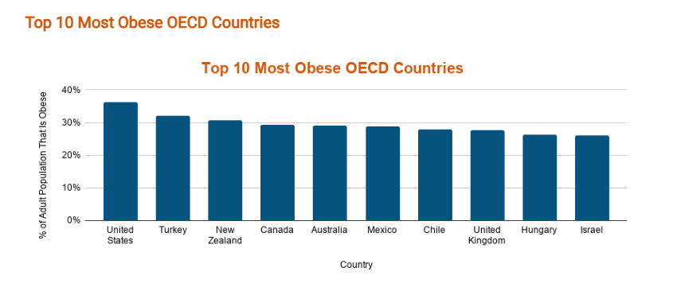

**Figure 1 Top 10 Most Obese OECD Countries**

Statistics on health applications

Age: Out of all age groups worldwide, the age group 30 to 39 has the highest proportion of people using mobile apps to track their health with 41% in 2016. (Elflein, 2019)

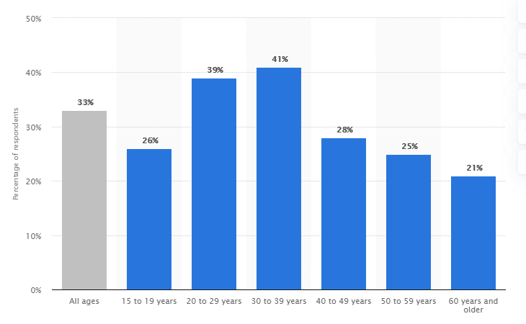

**Figure 2 Percentage of the global population that used a mobile app or fitness tracking device to track their health as of 2016, by age**

Digital Health Application Market:

Downloads of health-tracking apps have skyrocketed in recent years. The number of applications available for free on the Apple App Store has almost doubled since 2015. Calorie Counter by MyFitnessPal was the most popular health and fitness app on Google Play in March 2019. (Elflein, 2019)

The number of health and fitness apps released on Google Play in the first quarter of 2019 was 37,143. (Department, 2021)

With 27.4 million users as of May 2018, Fitbit was the most popular health and fitness app. With 19.1 million subscribers, MyFitnessPal came in second. MyFitnessPal have 200 million subscribers with $128 million in sales by 2020. (Department, 2021)

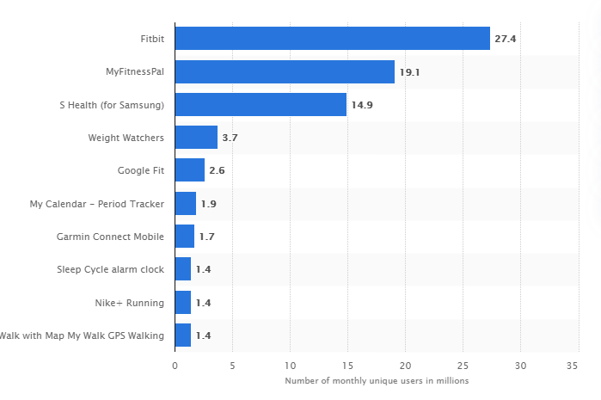

**Figure 3 Most popular health and fitness apps in the United States as of May 2018, by monthly active users**

In 2018, data analytics and mHealth apps are the top sponsored digital health categories worldwide. Funding for the global digital health industry amounted to the US $ 14.6 billion in 2018. (Department, 2021)

From there, it shows that the interest of users of different ages in health monitoring applications is huge. As well as the benefits these apps bring to the developers and the health of users.

Based on literature review of several health applications such as MyfitnessPal, FatSecret. For example, Myfitnespal is a place to share knowledge and update the diet of the day. With Myfitnesspal you can count your calories, exercise during the day. It's for those who live a busy life, want to lose weight or simply maintain a healthy weight. Or the FatSecret app a free calorie counter. It includes food diary, nutrition database, healthy recipes, exercise diary, weight chart and diary. However, my research on Myfitnesspal also has a disadvantage that most of the foods uploaded by the user may be inaccurate, difficult to enter the number of kilograms and net weight of the food. In addition, there are also some errors such as often unable to login, the search function is not stable. (MyFitnessPal, 2020)

Fatsecret nutrition information can be misleading. Too focused on the topic of promoting weight loss makes some parts of users want to gain weight, or maintain it, dissatisfied because the whole system is all about weight loss, no personalization, suggestions. for weight gain. In addition, these applications also support too little and inaccurate about Vietnamese food. (FatSecret, 2021)

Project with the aim of researching and developing a complete web application that tracks the basal metabolic rate in the human body based on the height, weight, age, and sex entered by the user. And tracking users' calorie balance by calculating the number of calories they consume from food for each meal of the day and energy expenditure from exercise, giving nutritional menu suggestions for people Vietnam.

The researches will have a regional scope in Vietnam focusing on the problems of the disadvantages of the above applications such as recommendations for nutritional menus of the application will be disaggregated according to each purpose and type of user different. Ensures the accuracy of the food nutrition database, exercises and gives recommendations for single-purpose nutrition (weight loss, weight gain, weight maintenance) or each other type of person. vegetarians, salty eaters, dieters, and so on.

**1.2 Aim**

The project aim to research and develop a web application that calculates BMR, calculate calories consumed and energy expenditure from exercise, and suggests nutritional menus.

**1.3 Project Objectives**

This section discusses the goals that the project must follow to ensure that it is successful in implementation.

**1.3.1 Research issues to build a website**

This objective will produce three parts of documentation: Document Review, Technical Review, and Technology Application Evaluation.

+ Document review: Access and research through the internet to find related articles, books, and magazines, analyze to find solutions to problems for the project under consideration.

+ Technical evaluation: Access and research through the internet to find articles, books, magazines, analysis of related techniques that can be applied to the project.

+ Technology evaluation: Select appropriate technology for easy implementation and implementation for the project.

**1.3.2 Design Documentation**

This goal will generate design documents that clearly define the product designs, indicators, and techniques applicable to the project:

+ Statement of requirements: Research and decide priority level and non-priority level for the project's requirements.

+ Sequence diagram and Use case diagram: Learn project system and design Use case diagram and Sequence diagram for each product function.

+ Entity-relationship diagram: Research system database operations and draw ERD diagrams.

User interface: Create user interface design, draw wireframe diagrams

**1.3.3 Product Deployment**

This goal will implement the project after the design drawings are available.

+ Building user interface: On the basis of the agreed design, coding to build Front-end for the product

+ Database design and construction: Create prototype database storage tables of the project, then input data.

+ Deploying, building applications, and functions: Based on the table of functions required by the project from which to deploy the functions associated with the database.

**1.3.4 Development of test documents.**

This goal is to generate test scripts and their results for each project function and look

+ Check database:

+ Application and Function Test

+ Check User Interface

**1.3.5 Assessment Report and Conclusion**.

This goal will create two parts of a document that assesses the project's results and the success of the project. Evaluate the project's strengths and weaknesses.

+ Review Report: This report will focus on product reviews from their own reviews and evaluating product user experience compared to claims.

+ Conclusion report: Making an assessment on the strengths and weaknesses of the product, the achieved goals, the issues that need to be developed and maintained in the future.

**1.3.6 Packing and document synthesis.**

At this stage, synthesize all applicable documents for the project. Package and create customer-ready slides:

+ Create slides

+ Print documents

+ Packing products

# **2. LITERATURE REVIEW:**

* 1. **Definition BMR**

The basal metabolic rate (BMR) is a measurement of the body's energy required to maintain life at rest. This measurement depicts the least amount of energy a human may have in a given day.

BMR is used with the physical activity level (PAL) to calculate the amount of energy needed in a day (TDEE).

**TDEE calculation:**

* Total daily energy expenditure is a measure of the energy people burn in a day, which can be used to maintain, gain, and lose weight. It depends on the level of physical activity (which a person has such a habit. The formula counts :TDEE = BMR × PAL

## History of BMR

- Lavoisier is credited with the father of the basal metabolic rate in 1777 (BMR). He and his wife found out that the volume of food eaten and the temperature of the physical activity environment influence the rate of oxygen intake. The minimum resting metabolic rate after absorption, which is presumably the first calculation of BMR, is measured by Lavoisier. (Athony J Hulbert, November 2004)Magnus-Levy coined the term ‘basic metabolic’ in 1899. This term is of great value to the early scientists, it confirms the need to perform tests with standard requirements. Includes: no physical activity; post-absorption state; minimum index of emotional disturbance; alertness; normal nutritional status; the body has no disease or infection; thermal environment. But after comparing and applying with reality it is not possible to meet all of the above conditions. For example, many of the early human studies reported by DuBois, Lusk, and Rubner (1900 –1920) did not seriously meet the requirements of the tropical environment, and were obtained in subjects lacking alertness, anxiety sedimentation leads to slightly higher BMR data than reality. (Henry, November 2005)

In 1895, A. Magnus-Levy discovered that secretions from the thyroid gland stimulate the rate of human metabolism. Until tests were developed in 1960 to measure thyroid hormone levels in the blood, BMR measurement became an important essential measurement used to evaluate the state of an individual's thyroid gland. (Athony J Hulbert, November 2004)

Application of BMR: BMR helps to learn about biological concepts and the causes of obesity

The BMR test marked a new era in clinical medicine. In 1950, the only reliable way to diagnose thyroid dysfunction was to determine the subject's BMR. BMR measurements are routinely performed during clinical exams and are thought to be a diagnostic tool for thyroid disease, diabetes and leukemia.

* 1. **The Harris-Benedict method**

The Harris-Benedict equation is a method used to calculate an individual's basal metabolic rate (BMR).

Harris and Benedict have collaborated on biometric analysis related to BMR. And published a study called "Biometric study of basic human metabolism". BMR measurements were performed on 136 males and 103 females at the Carnegie Nutrition Laboratory in Boston.

The Harris and Benedict analysis clearly shows the research process. Using rigorous statistical concepts, they developed the following equations to predict BMR:

Males: h = 66.4730 + (13.7516 x W) + (50033x S) + (6.7750 x A)

Females h = (665.0955) + (9.5634x W) + (1,8496 x S) + (4,6756 x A)

In which, h = kcal / day, W = weight in kilograms, S = stature in cm, A = age in years.

First, they apply the principle of biometrics to their analysis. Second, they use subjects that guarantee rigorous experimental conditions before making the measurements. Their analysis showed that both height and weight have a certain effect on BMR. The Harris-Benedict equation has become a widely used equation. (Henry, November 2005)

* 1. **Technology and tool:**
     1. **SQL**

SQL is a programming language that is widely used in relational databases and data flow management systems.

The project's intended use is as follows :Using the PhpMyAdmin tool features by using the open-source relational database management system (MySQL) based on Structured Query Language (SQL) for the registration function of the application. Create a users table, insert records into the database, delete records from the database, and get data from the database.

Advantages of SQL:

- Faster query processing: Can quickly and easily navigate a wide range of databases. Insert, Delete, and other operations can be completed efficiently without losing time. (Anon., 10 Apr, 2020)

- You don't know how to code. For data extraction that does not require a large number of lines of code. With only a few basic terms like Choose, INSERT, UPDATE, and so on, all is streamlined. SQL has simple syntax rules that make it a user-friendly, no-nonsense language. (Anon., 10 Apr, 2020)

- Answers to complicated questions can be obtained in seconds thanks to interactive vocabulary, which is simple to learn and understand.

- Interactive language: For beginners and programmers, is extremely simple to read, understand, and use.

Disadvantages of SQL:

- Interface that is difficult to use SQL has a clumsy and unintuitive gui that makes it difficult for developers to work with the database. (Anon., 10 Apr, 2020)

- Price: There are several paid and non-free premium versions that are tough to use for programmers.

* + 1. **PHP**

PHP (Hypertext Preprocessor) is a commonly used general-purpose open source scripting language that can be embedded in HTML and is particularly useful for web creation. (Anon., n.d.)

The project uses mostly PHP language to create functions, create new, add, edit, and delete tables such as food tables, user information tables, fitness tables, history tables. The tables' data will be saved in JSON files for fast storing and retrieval of large volumes of information.

Advantages:

- Open source: PHP is free and open-source, allowing developers to easily install it and get it up and running. (Pedamkar, n.d.)

- Platform independent: PHP-based programs can run on any operating system. It saves a great deal of time and money.

- Simple and easy: One of PHP's advantages is its simplicity, as well as its ease of learning and coding. Create an environment that encourages programmers to engage and learn.

-Databases: PHP makes it simple to bind to a database in a safe manner.

- Fast: PHP is quick to load web pages, which gives programmers an advantage in terms of development time. Other programs spend more time linking to the database and querying results.

- Maintenance: With automatic programming, the PHP system makes maintenance simpler.

- Support: A vast online community is available to assist programmers in learning and developing products.

Disadvantage:

- Security: Since it is open-source, it is simple to discover a flaw that can be used to hack its flaws. (Deepak, n.d.)

- Insufficient for large-scale applications: Big, dynamic programs are difficult to manage due to the programming language's lack of modularity.

- Weak type: Programmers who mix up arrays and hash tables may end up with unpredictable results.

- Ineffective error management: The system has ineffective error handling approaches. It does not endorse a proper developer measure. Error-handling experience is expected.

* + 1. **HTML**

Hypertext Markup Language (HTML) is a programming language that allows a set of relatively simple symbols, grammar, and code to be incorporated into a file to represent words and images on a page, adding context and information to the website. (HAYES, Nov 4, 2020)

Advantages:

- Its widespread success and dissemination contribute to the creation of a large community that can sustain it.

- HTML is supported for all browsers. (ARA, SEPTEMBER 15, 2018)

- It's simple to read, absorb, and apply.

- There is no expense since it is pre-installed on all systems and tools.

Disadvantages:

- The longer the code is, the easier it is to create some complexity for the website (ARA, SEPTEMBER 15, 2018)

- The only pages that can be generated are basic static pages.

- HTML has little protections because it is just a list of web content files.

* + 1. **CSS**

"CSS" is the abbreviation for "Cascading Style Sheet." Styles are applied to the HTML content of Web pages using this tool. Text types, layouts, sizes, fonts, colors, and other facets of a Web page can all be described using CSS. (Anon., n.d.)

**Advantages of CSS:**

- Save time by simply changing the layout of the HTML material of the web page. Styles for elements (id, class, body, etc.) may be repeated once and used several times. Models for dynamic web pages. (Anon., 23 Nov, 2020)

- CSS that is compatible can be found on different websites.

- It is clearly not fussy or frustrating, and it greatly reduces the work required to learn to code.

- CSS updates that are mobile-friendly.

- It aids in deciding where modifications to web elements on the page can be made.

- Models for online HTML content that are easily customized by the user.

- It decreases the scale of file transfers.

**Disadvantages of CSS:**

- Due to the lack of availability, the software must be tested and run on different browsers. (Anon., 23 Nov, 2020)

- There is no promise of safety.

- Beginners would find it difficult to navigate.

- When using CSS, there can be issues across various browsers.

* + 1. **JavaScript**

JavaScript is a scripting language that enables you to perform complicated tasks on websites, making them more interactive and reactive rather than static. (Anon., n.d.)

JavaScript allows you to create interactive content, manipulate media, create animations, and do a lot more.

The project employs the JavaScript programming language to build a user-friendly interactive website. In addition, JavaScript is used to perform BMR, TDEE, calorie of food measurement, exercise calculation, and remaining calorie calculation by querying data from JSON files.

**Advantages:**

- JavaScript is quick since it uses a lot of nimble coding and runs in the client-side window. (Gupta, 27-Nov-2019)

- JavaScript is relatively simple, basic, and common to learn and practice due to its simplicity and popularity.

- JavaScript is compatible with a wide range of languages.

- Provides the ability to create complex user interfaces.

**Disadvantages:**

- Security: Because code is written and stored locally on the user's computer, it can be used for malicious purposes. (Gupta, 27-Nov-2019)

- Browser Support: JavaScript is sometimes understood differently by different browsers. This makes it difficult to code across multiple browsers.

* + 1. **MySQL**

MySQL is an open source relational database management framework that uses SQL to add, delete, and modify data in a database. To write code and extract data from the servers, my website intends to use MySQL in combination with PHP. (Anon., March 6, 2007)

**Advantages:**

- Your actual cost of ownership would be lower. (Anon., n.d.)

- MySQL is easy to use and it is open source.

- MySQL is a platform-independent database server. This is something that cross-platform projects, especially web applications.

- Can design and grow scalable, modular systems with a high level of uptime.

- MySQL Data Security: Data is safeguarded with an encrypted password, which is impossible to crack due to the complexity of the encryption algorithms.

**Disadvantages**

- ROLE, COMMIT, and stored procedures are not supported in lower versions. (Anon., n.d.)

- There is no effective support for very massive datasets.

- Transactions aren't processed seamlessly, and evidence is quickly corrupted.

- In comparison to other databases, there are no strong debugging methods.

- Check restrictions in SQL aren't allowed.

* + 1. **JSON**

JSON (JavaScript Object Notation) is designed to be simple, flexible, and light so that users can quickly read data while sharing and manipulating other languages to send data between web servers and browsers. (Sharma, n.d.)

The majority of JSON files are used in the project to store data for tables on the website, and they can be quickly modified using the JavaScript programming language. Also , calorie calculation techniques, BMR, etc are all written in JavaScript language and querying data from JSON data.

The basic elements are contained in JSON notation. (Sharma, n.d.)

- Object: Curly braces () are used to start and finish the object.

- Member Object: Including comma-separated strings and values ( ,)

- Arrays: Arrays contain various values and begin and end with curly braces.

- Value: A value may be a string, an entity, an array, or a collection of characters.

- String: Strings are surrounded by double quotes and contain a colon (:).

**Advantage of JSON:**

- JSON's Advantage - Agility: Data queries can be done more efficiently and rapidly due to the syntax's ease of use, lightness, and flexibility. (Geekboots, Jan 30, 2020)

- Support for all browsers: Making JSON compliant with all browsers does not necessitate a lot of difficult.

- JSON is an excellent platform for storing and exchanging large amounts of data (image, audio, video, etc.).

**Disadvantages of JSON:**

- When running a query that calls JSON, there is no error handling. (Geekboots, Jan 30, 2020)

- JSON can be easily hacked for its lack of security and its simplicity.

- JSON has only limited tools in use.

* + 1. **Webserver:**

The web server needs to deal with two hardware and software issues, working together. The web server must deal with two hardware and software problems that must be resolved in tandem. (Anon., n.d.)

The web server's program details, the web server's software data and the website's part files are stored on the web server's hardware. (For instance, HTML, photos, CSS, and JavaScript). Site servers provide Internet connectivity and assist in the transmission of physical data to other network-connected computers.

For the software includes a component that monitors how users access files stored on the webserver. Since the app has a feature that tracks how users view files stored on the webserver, it can be used to identify potential security issues. This is, at the very least, an HTTP server. (Anon., n.d.)

HTTP server functionality provides software that can read and interpret URLs (web addresses) and HTTP (which are the simple network protocols that enable browsers to read and access content from websites).The HTTP server connects to the domain names of the domains it hosts and sends the content of the web page to the browser of the end user. (Anon., n.d.)

When a browser tries to open a file on a web server, it uses HTTP to make the request. When the request arrives at the right web site, the HTTP server acknowledges it, begins searching for the requested text, and replies to the browser. If the server is unable to locate the requested text, it will respond with a 404 error code.

**Advantages:**

- Interaction: Hosting providers provide it simple to communicate. (Roomi, n.d.)

- Configuration: The configuration is simple to construct thanks to the webserver's created log files.

- Adaptability: Web hosting is much more versatile and comfortable than traditional hosting.

- Share resources :Do not allow sharing of resources with others without permission from the owner's request.

**Disadvantages:**

- Cost: The costs of using a web host are normally very high. (Roomi, n.d.)

- Safety is paramount: Web servers still have a lot of security issues.

- The ease with which you can use web hosting is determined by the kind of website you are using.

- Without an Internet connection, the web servers are unable to run.

- Overload, hardware failure, and software failure will occur when the webserver receives more traffic than average.

* + 1. **Tool**

1. **Sublime Text 3**

Sublime Text 3 is a smooth, portable, and easy-to-use lightweight cross-platform code editor with a responsive support group. It's a powerful code editor with the ability to customize settings and expand its features with Package Control.

**Benefit**

- Ease of Use is a benefit. For novice users, Sublime Text is an easy-to-use text editor. As a result, beginner programmers will quickly read, train, and use it. (Anon., n.d.)

- Multi-option choices, feature-rich, detailed, easy-to-understand shortcuts

- The package manager update process makes it simple to add new features.

- Cross-platform user interface: Sublime Text has a user interface that is cross-platform. This means it will work on Mac OS X, Windows, and Linux, and the interface will be the same on all three platforms.

1. **PhpMyAdmin**

* phpMyAdmin is a database management and administration platform for MariaDB and MySQL database server frameworks. This tool will bind to several database systems, as well as the servers and node units that are attached to them. (Pedamkar, n.d.)

**Advantages:**

- The database systems are simple to manage. (Pedamkar, n.d.)

- The database management system comes at no extra cost.

- Import/export of widely used file formats is supported in a flexible manner.

- Tables are specifically labeled and built separately for database manipulation and SQL query editing.

- Displaying all active plugins from the linked database is now possible.

**Disadvantages:**

- Since it only supports MySQL and MariaDB, it cannot be used for other databases. (Pedamkar, n.d.)

- It's old, opposed to the technical advancements of today's industry standards .

1. **Web Hosting**

Web hosting is a program that allows people to browse websites over the internet. Web hosting provides a web server with all of the required configuration, such as Apache and MySQL, as well as archives, records, and website content. (NghiaNT, 2020-06-08)

Byet.host is a free web hosting service.With more than ten years of experience and over one million websites hosted, Byet.host is one of the best free hosting services in the world. (NghiaNT, 2020-06-08)

Benefit:

- It is a low-cost, open-source tool for creating a web server. (NghiaNT, 2020-06-08)

- Use unlimited capacity and bandwidth.

- Add-on domains, Parked Domains, and Sub-Domains are all unlimited.

- FTP protocol is supported.

- Files can be uploaded and data can be accessed via the File Manager.

- MySQL accounts are unrestricted.

- 5 email addresses may be enabled for use.

- Monitor available features with VistaPanel's Control Panel.

- SSL compatibility

- Install WordPress and other source code with ease.

1. **Product Reasearch**

Currently, health monitoring applications are no stranger to everyone. Thousands of diverse applications with different benefits and uses are developed each year millions of downloads and uses. That shows that health tracking applications are always interested and widely used by users around the world.

Here's a look at the top popular fitness tracking applications:

* 1. **MyFitnessPal**

MyFitnessPal is a popular nutritional weight loss app with over 165 million users in 2016. In the United States, 83% of nutritionists participating in the survey held at the 2015 Food and Nutrition Conference and Expo recommended use applications related to nutrition and health, in MyFitnessPal and Fitbit mentioned the most. (Evenepoel, et al., 13 / 2 /2020)

In a survey in the UK, Australia, Canada, New Zealand and the United States, it is the preferred application of sports nutrition experts. MyFitnessPal stands out and is impressed by its rich and country-specific database with more than 6 million food items. The application is free for users and extremely user-friendly, easy to use. The outstanding features can be mentioned as barcode scanner of packaged food, integration with equipment, or other specialized health monitoring application. There are mobile app versions and web-based versions available. (Evenepoel, et al., 13 / 2 /2020)

Pros:

- It's completely open. It’s free. (Ottawa, January 28, 2015)

- Should search the barcode on anything you're eating instead of searching for it in the app. This is a very helpful function.

- The style of the website is also really appealing, and you can compare your statistics.

- The program is simple to use. The device is well-designed and works properly.

- The pie chart that indicates how much starch, fat, and protein you eat on a daily basis is incredibly helpful. It shows you how much of both you ate on the specific day, as well as what your regular goal was. It's really easy to compare.

Defect:

- While MyFitnessPal will predict your daily calorie intake based on this, it may not be reliable in relation to reality. And they have no idea how much you've burned, how many times you've done it, or how long you've rested. (Ottawa, January 28, 2015)

- Entering all of the data into the logging system will be very difficult. - Individual ingredients from each dish must be added to each meal component, rather than just understanding how many calories are in the dish.

- It took much too long to calculate calories and keep a journal.

* 1. **FatSecret**

FatSecret is an online website built-in 2006. FatSecret's goal is to build an online weight loss, diet support community by capturing the practical information of members motivated to Making better choices and decisions to achieve the desired goal. (Laura W. Black (Ohio University, 2010 )

FatSecret was developed from the idea that obtaining a wealth of information, accompanied by high value on diet, nutrition, and weight management topics can be synthesized to make a community strong and comprehensive. (Laura W. Black (Ohio University, 2010 )

Pros:

- The user interface is simple and easy to use. (Anon., 2021)

- The community site is about as genuine as it gets.

- Challenges that occur on a daily basis have an extra boost in motivation to train.

- Includes a personal and a food diary (ideal for keeping track of emotions, particularly if you've ever been an emotional eater).

Cons:

- The app has a propensity to pause and cause the screen to slow down. (Anon., 2021)

- It is sometimes unable to sync.

- There is a lack of nutritional awareness on occasion, especially when it comes to whole foods.

- Fitbit isn't a supported device.

* 1. **Compare MyfitnessPal with FatSecret**

|  |  |  |  |  |
| --- | --- | --- | --- | --- |
| Feature | Specific Features | Description | MyfitnessPal | FatSecret |
| Genaral | Free app | You can download the app for free, from platforms | ✓ | ✓ |
| Supports widgets | This gives you more control and helps you to see details at a glance without having to open the window. | ✓ | ✓ |
| Language supported | The software supports a larger number of languages. This allows you to use it in any language you choose, making it more accessible to users all over the world. | 18 | 12 |
| Activity tracking | Exercise dairy | It includes an activity diary, which makes it easy to keep track of your previous workouts. | ✓ | ✓ |
| Counts, how many calories you have burned? | If you're on a strict training diet or trying to lose weight, this will come in handy. It can also help you to become more motivated. | ✓ | ✖ |
| Exercise tagging | You can add specifics of your exercise once you've finished exercising (e.g., jogging, swimming, cycling). As a result, the system may provide more precise data, such as the amount of calories burned. | ✓ | ✖ |
| Activity reports | Provides activity report | Your behavior data is analyzed to generate reports that you can access through the app or website. This encourages you to see how active you've been and provides feedback to help you develop. | ✓ | ✓ |
| Includes access to online portal | Your monitoring data is submitted to the manufacturer's web site from your smartphone or device and can be seen in the form of reports and graphs. | ✓ | ✓ |
| Nutrition tracking | Has weight tracking | You can enter your weight data to make tracking adjustments simpler. | ✓ | ✓ |
| Tracks calorie intake | You can enter the foods you consume into the app to help you properly balance your diet. | ✓ | ✓ |
| Suggests recipes | It will provide you with meal suggestions, making it easier for you to eat healthily. | ✓ | ✖ |
| Has food diary | A food journal makes it easy to keep track of what you've eaten, which is crucial for remaining healthy and losing weight. | ✓ | ✓ |

**Figure 4 Compare MyfitnessPal with FatSecret** (Anon., n.d.)

1. **Legal, Social, Ethical and Professional**

From a legal perspective, one of the laws considered to be the “Data Protection Act 1998” related to the project was proposed because of personal information such as height, weight, date of birth, Relevant gender, name, user account.

Private: With the development of every new technology to maintain patient health information, privacy is of the utmost concern.

Protect: Health service providers need to care about and combat security threats with data security policies to minimize the possibility of user data breaches.

License: This raises licensing issues between jurisdictions for medical professionals.

From the ethical point of view, the database of food nutrition tables and exercises must ensure accuracy and suitability for each subject based on the medical basis of the nutrition regimen for each type of user. Make sure not to buy or sell personal data of users, do not give out foods with wrong ingredients, with false information.

Ethical considerations for human nutrition and food security directives need to clearly state ingredients and calories consumed.

Ethical and web issues

The ethical behavior for Web professionals includes the following:

- Do not send unsolicited mass e-mails or spam.

- Do not buy domain names that you do not intend to use.

- Do not knowingly distribute malicious program code such as a virus or worm.

- Do not forward chain e-mail messages, especially those that imply threats.

- Be honest with your customers and don't charge too high for technical services they might not understand.

- Can not confuse with other potential users with regard to the origin and ownership of each website.

- The website will create a link that will not contain information or content that is false, inaccurate, or illegal, contrary to law, ethics, public order, and must not contain content contrary to third party rights.

- I will also have to use third-party software when developing my application, which means I have to make sure that the third-party code's license is compatible with my code's license.

- Ensure monitoring or taking responsibility for the services provided on the application website.

1. **Analysis requirement**

## **Requirements Analysis:**

Analysis of requirements.

The project's requirements will be studied and referenced from the articles of objective comparison and part of a subjective comparison of individuals. Research and learn from predecessor projects, and determine requirements what will and won't perform that a Developer believes they can add to improve the program.

* 1. **Compare MyfitnessPal and Fatsecret study with other app tracking health:**

From research, the relevant requirements for the project will be identified. The project's criteria will be researched and cited from empirical comparison papers.

Diet monitoring and mobile app use tips have a lot of traction and potential, as shown by the high number of downloads. All ration collection apps use the same nutritional assessment system (log food) and data entry technologies (i.e. text search and a barcode scanner). Neither app has a decision engine that can provide customized dietary recommendations. (Rodrigo Zenun Franco, 2016)

While weight loss can be one of the key drivers for using nutrition-based applications, it is important to remember that nutritional evaluation should not only be related to weight loss to target obesity. Ideal weight is not recommended for users, but is sometimes required as input. (Rodrigo Zenun Franco, 2016)

The user can also set a target date for hitting a certain weight. However, if used without professional guidance, this could lead to the person starting an unhealthy diet or developing an eating disorder. (Rodrigo Zenun Franco, 2016)

Personalized diet guidance is minimal, despite the popularity of integrating food diaries and certain forms of PA track. (Rodrigo Zenun Franco, 2016)

In the applications checked, personalized recommendations focused on health status or particular classes, such as vegetarians and non-vegans, are not applicable. The process of nutritional assessment is the same in all serving selection implementations (i.e. food logging). (Rodrigo Zenun Franco, 2016)

Improved communication between consumers and healthcare providers is needed, with the process of making nutritional guidelines including more feedback from qualified experts. (Rodrigo Zenun Franco, 2016)

Along with the scope of research is in my country Vietnam, I find that the researched applications do not provide correct and complete Vietnamese food. And in Vietnam, such health-tracking apps are also rare or uncommon, nutrition menu guides are just blog posts that don't have a website to recommend nutritional menus for users. For example, if you want to learn about the weight loss menu in 7 days, then only individual posts and blogs will appear.

## Functional Requirements

## The following are the functional requirements of the project:

## User can log in and register to create an account

## User can view recipes

## User can calculate BMR

## User can calculate food calories by each meal of the day based on the available food database

## User can calculate calories burned from available exercise data

## User can create a historical log of the day's calorie calculations

## The user can calculate the number of calories remaining in the body after absorbing food calories and consumed from exercise through BMR.

## The manager can add, edit, and delete the database about food

## The manager can add, edit, and delete the database of exercises

## The manager can grant, edit or delete permissions for an account they want

## The manager can add, edit, and delete the database of recipes

## The manager can add, edit, and delete the meal menu database

## Personalization system for different goals (weight loss, weight gain, weight maintenance), different types of people (vegetarians, salty eaters, thin people, etc.).

## User can view user profile information.

## Replacement filter for the food search function, exercises

## The following are the non- requirement function specs for this project:

## 1.Customers must be able to access the application easily.

## 2.An easy-to-use user interface.

## 3.Streamlined content for quick access to information.

## 4.Prevent unwanted device access and service.

## 5.The program can be used on a variety of computers (such as a mobile, tablet, desktop, etc.)

## 6.When using various computers or browsers, the app displays without errors.

## 7.Errors that occur as a result of user interaction must be avoided and retrieved.

## 8.Application response and access times should be fast.

## 9.Data must be kept confidential.

## 10.If any new data is added to the database, the Project must be updated.

## 11. An individual's personal data must be able to be deleted upon request.

## In order to give priority to the established specifications, it is necessary to present a MoSCoW table. "Must have", "should have", "might have" and "wouldn't be (this time)" are four categories.

|  |  |  |
| --- | --- | --- |
|  | Requirement | MoSCow |
| 1 | User can log in and register to create an account | Must-Have |
| 2 | User can view recipes | Must-Have |
| 3 | User can calculate BMR | Must-Have |
| 4 | User can calculate food calories by each meal of the day based on the available food database | Must-Have |
| 5 | User can calculate calories burned from available exercise data | Must-Have |
| 6 | User can create a historical log of the day's calorie calculations | Must-Have |
| 7 | The user can calculate the number of calories remaining in the body after absorbing food calories and consumed from exercise through BMR. | Must-Have |
| 8 | The manager can add, edit, and delete the database about food | Must-Have |
| 9 | The manager can add, edit, and delete the database of exercises | Must-Have |
| 10 | The manager can grant, edit or delete permissions for an account they want | Must-Have |
| 11 | The manager can add, edit, and delete the database of recipes | Must-Have |
| 12 | The manager can add, edit, and delete the meal menu database | Should-Have |
| 13 | Personalization system for different goals (weight loss, weight gain, weight maintenance), different types of people (vegetarians, salty eaters, thin people, etc.) | Should-Have |
| 14 | User can view user profile information. | Must-Have |
| 15 | Replacement filter for the food search function, exercises | Should-Have |

**Figure 5 Table requirement function**

|  |  |  |
| --- | --- | --- |
| ID | Requirement | MoSCow |
| 1 | Customers must be able to access the application easily. | Should-Have |
| 2 | An easy-to-use user interface. | Must-Have |
| 3 | Streamlined content for quick access to information. | Should-Have |
| 4 | Prevent unwanted device access and service. | Won’t-Have |
| 5 | The program can be used on a variety of computers (such as a mobile, tablet, desktop, etc.) | Could-Have |
| 6 | When using various computers or browsers, the app displays without errors. | Could-Have |
| 7 | Errors that occur as a result of user interaction must be avoided and retrieved. | Should-Have |
| 8 | Application response and access times should be fast. | Must-Have |
| 9 | Data must be kept confidential. | Should-Have |
| 10 | If any new data is added to the database, the Project must be updated. | Must-Have |
| 11 | 11 An individual's personal data must be able to be deleted upon request. | Could-Have |

**Figure 6 Non-requirement function**

1. **Design:**
   1. **Use Case**

The Use Case diagram in figure 6,7 details how users communicate with and control the app; each user and admin will have different permissions to deploy different ways of using the product.

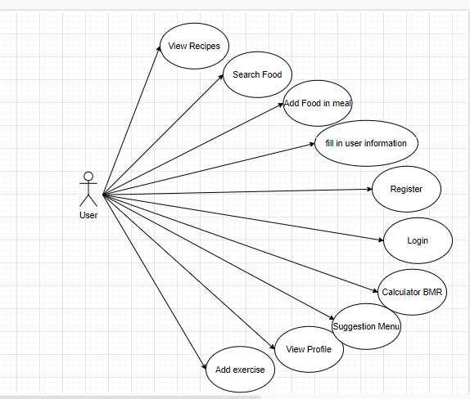

**Figure 7 Use case of user**

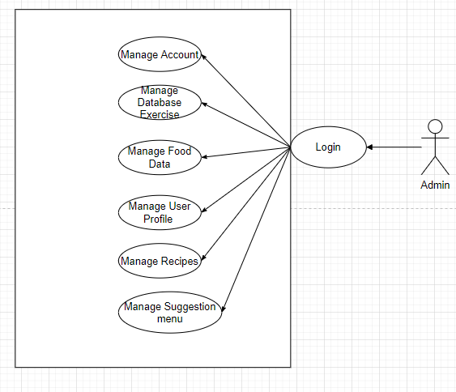

**Figure 8 Use case of admin**

* 1. **Database**

I've built a structure in which the database can handle data, but there's no consistency between the functions by command of a certain table, making this the base tables nothing more than a text file to query data. The database is held in a test mode, text file JSON.

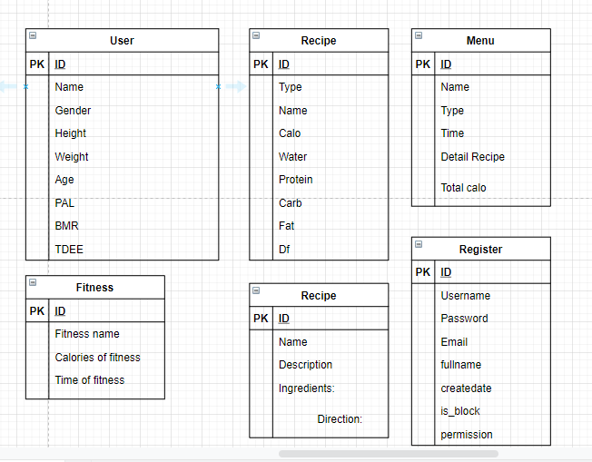

**Figure 9 Diagram Table database**

* 1. **Sequence Diagram**

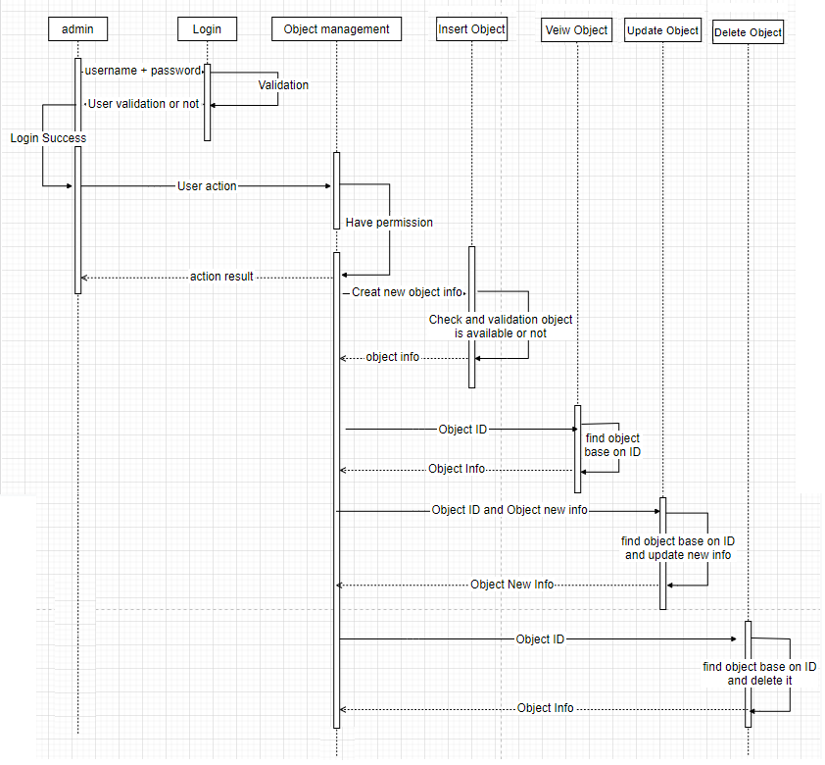

**Figure 10 Sequence diagram of admin**

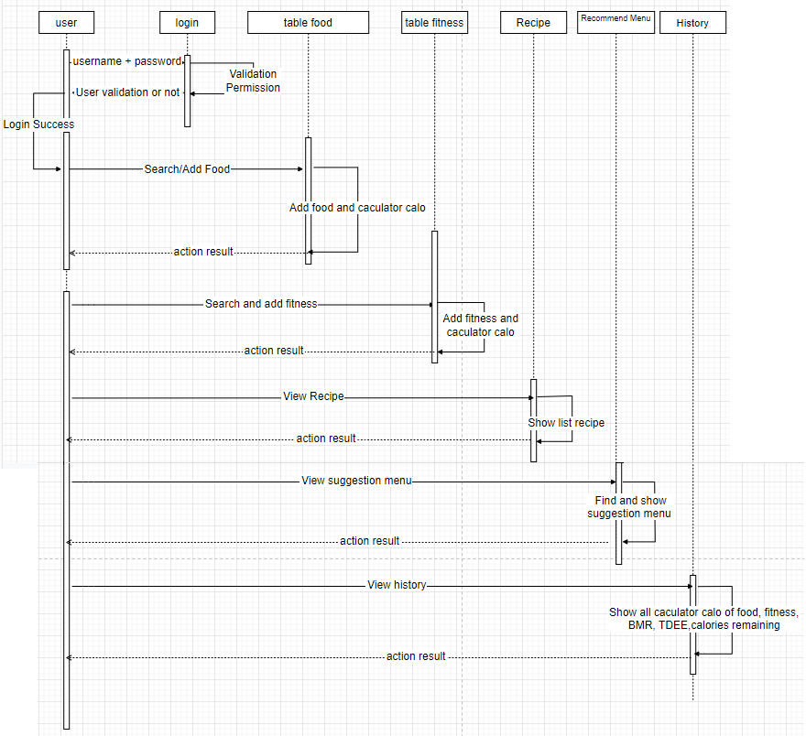

**Figure 11 Sequence diagram of user**

* 1. **Wireframe**

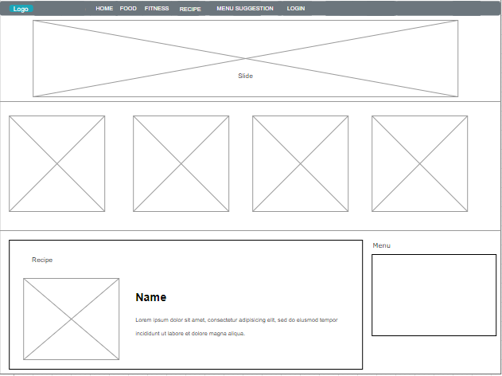

**Figure 12 Wireframe of homepage**

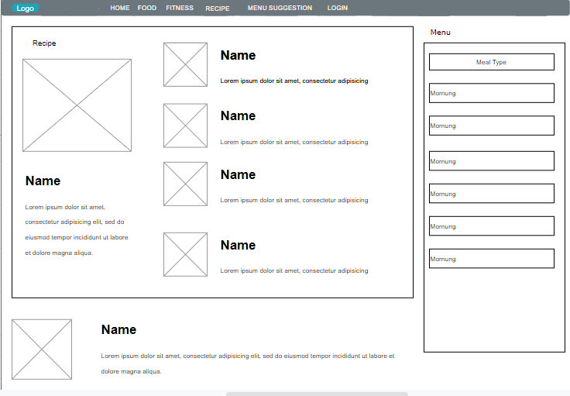

**Figure 13 Wireframe of Recipe page**

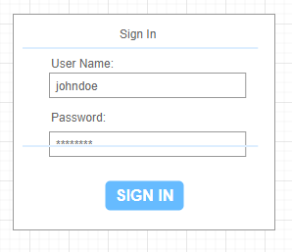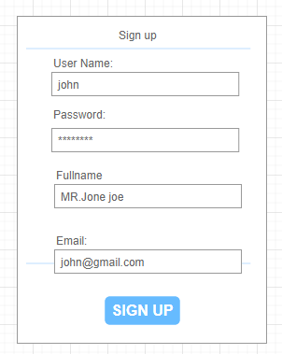

**Figure 14 Wireframe of login and register**

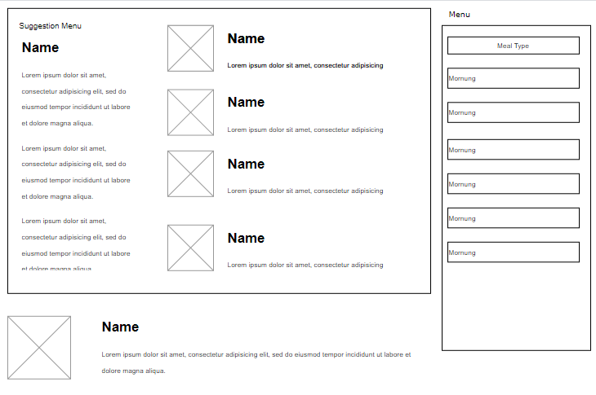

**Figure 15 Wireframe of suggestion menu page**

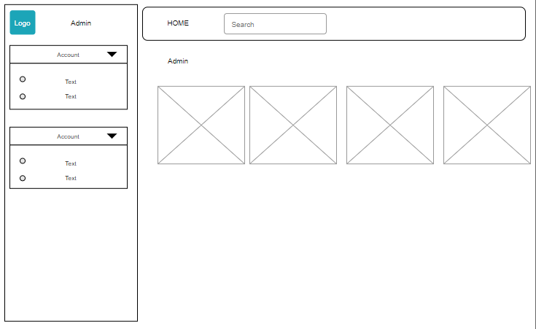

**Figure 16 Wireframe of Admin page**

# **Implementation of the project:**

We will explain the website interface (Front-end) in this section, including functional descriptions and pages. We also show few screenshots of the system's interface, as well as key features.

We will connect the source code to the report through link GitHub. You can retrieve the Source from the following links if you are having trouble copying data and the attachments are not being sent.

Link deloy : <http://datletan2.byethost7.com/>

Link Github: [https://github.com/letandat1234/Web-calculator-calories](https://github.com/letandat1234/Web-calculator-calories?fbclid=IwAR0k9tUZn7wZI8ab2gpe9PzJLs-UBAi26YU6TcxrWXUwoz24CLZdOCExs1c)

|  |  |  |
| --- | --- | --- |
| Role | Username | Password |
| User | User | 123456 |
| Admin | ADMIN | 1234 |

* 1. **Implement Front-end**

**Page of Administrator**

|  |  |  |
| --- | --- | --- |
| No | Page Name | Function |
| 1 | Admin page | The admin page displays navigation tabs |
| 2 | Login | Login page, admin need to log in to be allowed to navigate back to the admin page |
| 3 | View user | View information users can delete user information |
| 4 | Account | Add new accounts, view accounts list, edit, delete, authorize |
| 5 | Table Food | Add new, view, edit, delete food table |
| 6 | Table Fitness | Add new, view, edit, and delete fitness table |
| 7 | Table Recipe | Add new, view, edit, and delete recipe tables |
| 8 | Table Suggestion Menu | Add new, view, edit, and delete the suggestion menu table |

**Page of user**

|  |  |  |
| --- | --- | --- |
| No | Page Name | Function |
| 1 | Login | Login page, users need to log in to be allowed to navigate back to the homepage |
| 2 | View info user | View information user can modify user information |
| 3 | Home | The home page displays navigation tabs |
| 4 | Food | Page display and calculate food calories |
| 5 | Fitness | Page display and calculate exercise calories |
| 6 | Recipe | The page shows the recipes |
| 7 | Suggestion Menu | The page shows suggestion menus |
| 8 | History | The page shows a history of the calculations |
| 9 | Detail Recipe | The page shows recipe details |
| 10 | Detail Suggestion Menu | The page shows details suggestion menus |

## Implement back-end

* + 1. **Code Implement**

|  |  |  |
| --- | --- | --- |
| Function | Code | Explain |
| Code call function from file user.php |  | The user.php file contains functions that can be retrieved.  For example, update function calls the updateUser  By tracing id number generated from data and returning new data to the system.  function updateUser($data, $id)  {  $updateUser = [];  $users = getUsers();  foreach ($users as $i => $user) {  if ($user['id'] == $id) {  $users[$i] = $updateUser = array_merge($user, $data);  }  }  putJson($users);  return $updateUser;  } |
| Validate |  | Call the function validateUser to validate the fields name, type, calories, water, protein, fat, carb, df |
| Create Form |  | The create form is used to enter all information of the food and store data into the data |
| Create |  | New create is based on creating new random ids between about 1000000-2000000  Create new objects  'type'  'name'  'calo'  'water'  'protein'  'fat'  'carb'  'df'  And validate the objects  $errors = [  'type' => '',  'name' => '',  'calo' => '',  'water' => '',  'protein' => '',  'fat' => '',  'carb' => '',  'df' => '',  ];  $isValid = true;  if ($_SERVER['REQUEST_METHOD'] === 'POST') {  $user = array_merge($user, $_POST);  if ($isValid) { |
| Update |  | Update information based on id  Call the getUserById function to get the information by id  Use the food information entry form to make modifications.  <?php include '_form.php' ?>  Then validate  $errors = [    'type' => '',  'name' => '',  'calo' => '',  'water' => '',  'protein' => '',  'fat' => '',  'carb' => '',  'df' => '',  ];  If successful, a list of foods will be returned  header("Location: table.php"); |
| Delete |  | Delete based on id  $userId = $_POST['id'];  deleteUser($userId);  Successful then go back to the food list |
| Table list |  | Successful then go back to the food list  Displayed in the form of a table 1 list of foods taken from data after creating |
| View |  | View is based on id  $userId = $_GET['id'];  $user = getUserById($userId);  if (!$user) {  include "partials/not_found.php";  exit;  }  If correct the id will print the result. Otherwise, the display will be "User does not exist” |

**7.2.2 Screenshot of database**

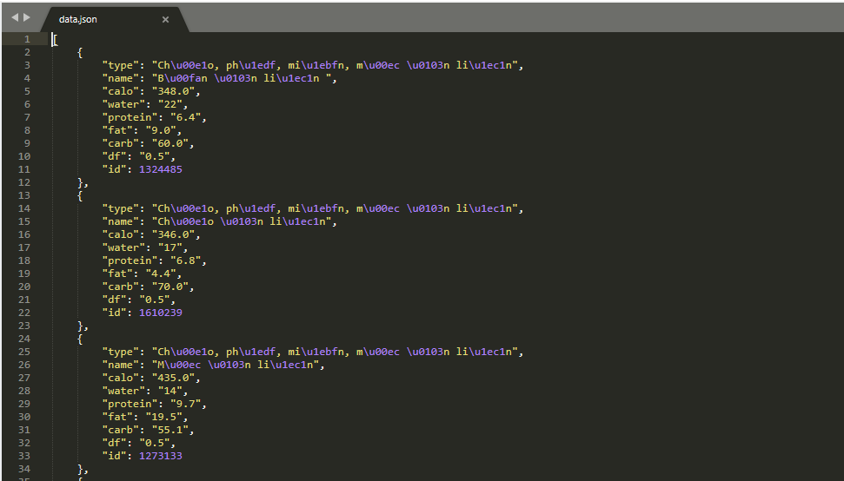

**Figure 17 file data.json**



**Figure 18 Table user data from sever phpMyAdmin**

* 1. **Function implement**

Calculation function

Here, the JavaScript content queries data from data to perform the calculation, the following is the code to calculate the calories of food

**Code implement**

|  |  |  |
| --- | --- | --- |
| Function | Code | Explain |
| Get food |  | Get data from data.json file  Display retrieves the results of the objects put into the display area (the food table) with the class "hidden-xs" |
| Table food |  | The classes hidden-xs show the food data sheet |
| Get type |  | Get data from file type.json |
| Caculator  Calories  Follow food table |  | Declare the variable weight = food-weight  IndexInArray = food-name  Get feedback on add food  Food-name creates the array indexInArray  Perform the calculation of adding dataArray elements from indexInArray in turn multiplied by the weight value (default 100g).  Displays the calculation results to the table marked with the hidden-xs class |
| Filter food |  | Show filter type to the type table with class hidden-xs1 |

* 1. **Screenshot**

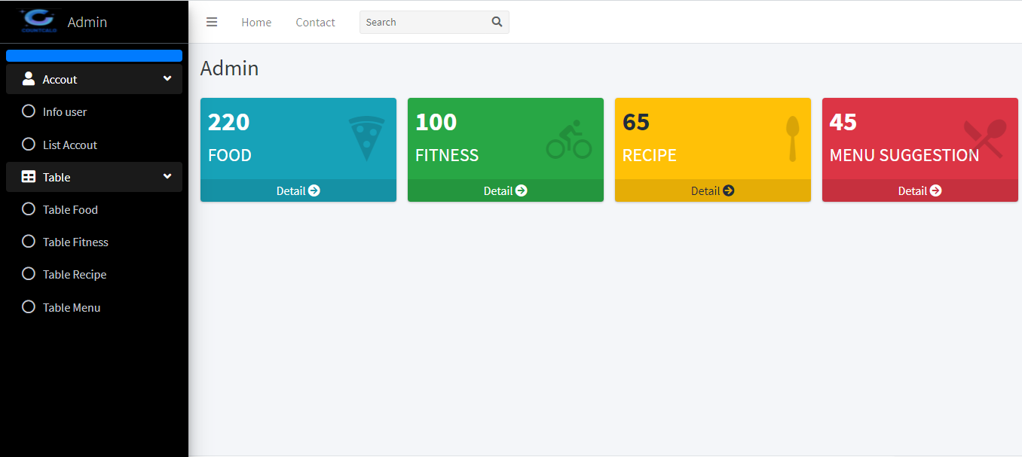

**Figure 19 Admin page**

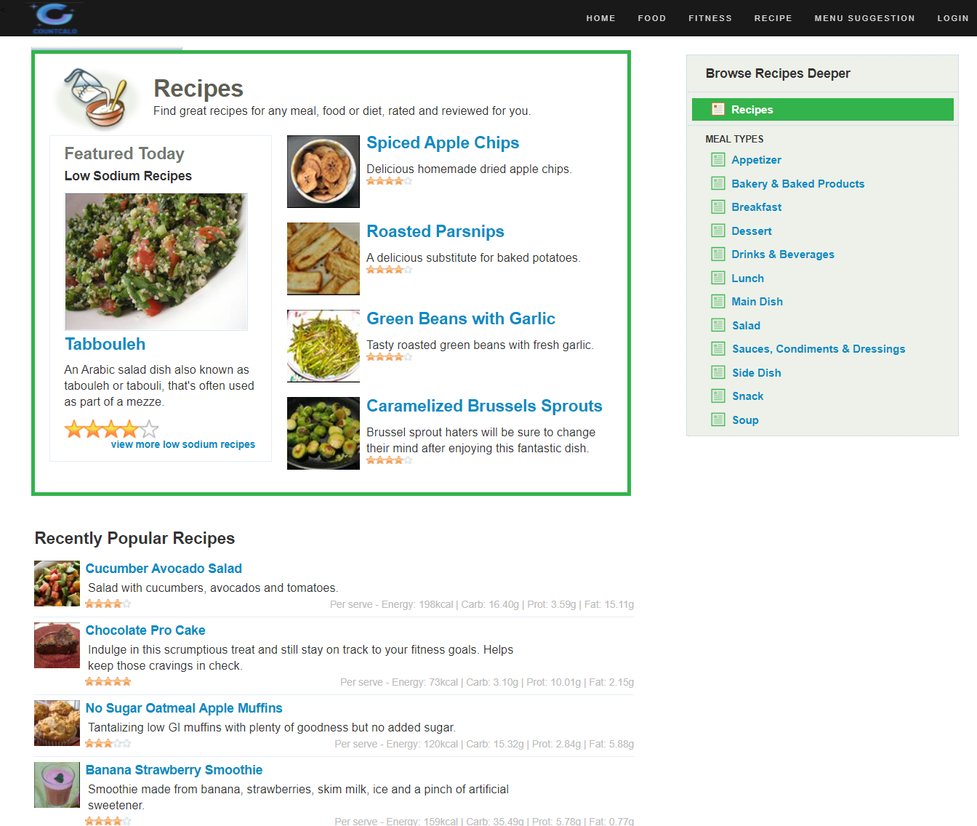

**Figure 20 Homepage**

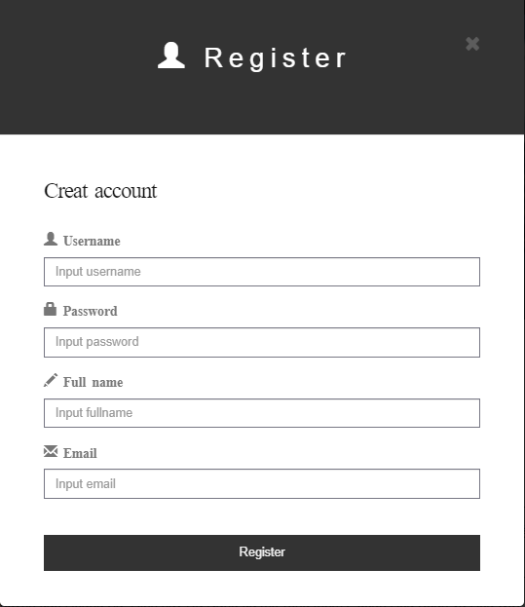

**Figure 21 Form register**

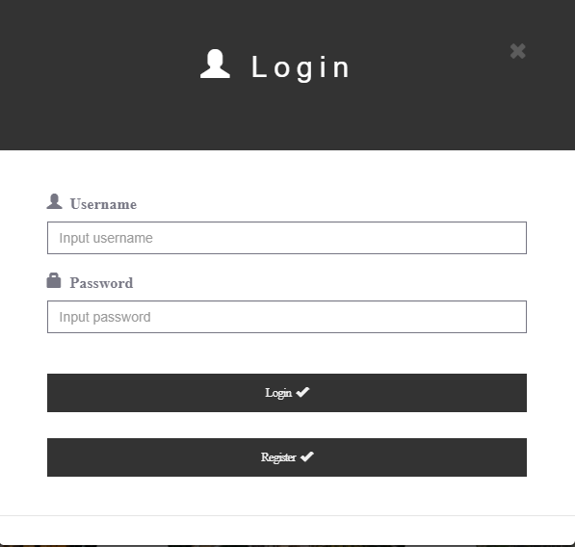

**Figure 22 Form login**

# **Testing**

## 8.2 Test Function of Admin

|  |  |  |  |  |  |
| --- | --- | --- | --- | --- | --- |
| **Test Case Function** | **Description** | **Test data use** | **Expected Results** | **Actual Result** | **Status** |
| **Login** | Does logging in with the admin account redirect to the admin page | **Account**  **Admin123** | **Logging in with admin permissions displays data based on the privileges given by the Admin account, but the Admin account sees all fields.** | **Logging in with admin permissions displays data based on the privileges given by the Admin account, but the Admin account sees all fields.** | **Success** |
| Create account | Create a new account with new information and permissions | **Account**  **Admin** | Enter the information in the username, password, email, full name fields, and choose the right (admin / user). | Enter the information in the username, password, email, full name fields, and choose the right (admin / user). | **Success** |
| Add role | Add role | **Account**  **Admin** | Add new permissions or change permissions (admin / user) | Add new permissions or change permissions (admin / user) | **Success** |
| Edit account | Edit account | **Account**  **Admin** | Change the account information. Enter new information in the fields, Change is successful | Change the account information. Enter new information in the fields, Change is successful | **Success** |
| Delete account | Delete account | **Account**  **Admin** | Successfully delete any account | Successfully delete any account | **Success** |
| Create new food | Create new food | **Account**  **Admin** | Enter new information in the fields. New creation is successful | Enter new information in the fields. New creation is successful | **Success** |
| View food | View food | **Account**  **Admin** | View a list of newly created foods | View a list of newly created foods | **Success** |
| Update food | Update food | **Account**  **Admin** | Edit food information. Successfully changed the information entered in the changed fields. | Edit food information. Successfully changed the information entered in the changed fields. | **Success** |
| Delete food | Delete food | **Account**  **Admin** | Delete 1 any food. Deleted successfully. | Delete 1 any food. Deleted successfully. | **Success** |
| Create new fitness | Create new fitness | **Account**  **Admin** | Enter new information in the fields. Create new fitness successfully | Enter new information in the fields. Create new fitness successfully | **Success** |
| View fitness | View fitness | **Account**  **Admin** | See the fitness list just created | See the fitness list just created | **Success** |
| Update fitness | Update fitness | **Account**  **Admin** | Edit fitness information. Change the information entered in the fields. Successful change. | Edit fitness information. Change the information entered in the fields. Successful change. | **Success** |
| Delete fitness | Delete fitness | **Account**  **Admin** | Delete any 1 fitness. Deleted successfully. | Delete any 1 fitness. Deleted successfully. | **Success** |
| Create new recipe | Create new recipe | **Account**  **Admin** | Enter new information in the fields. Create a new recipe successfully | Enter new information in the fields. Create a new recipe successfully | **Success** |
| View recipe | View recipe | **Account**  **Admin** | See a list of recipes just created | See a list of recipes just created | **Success** |
| Update recipe | Update recipe | **Account**  **Admin** | Edit recipe information. Change the information entered in the fields. Successful change. | Edit recipe information. Change the information entered in the fields. Successful change. | **Success** |
| Delete recipe | Delete recipe | **Account**  **Admin** | Delete any recipe. Deleted successfully. | Delete any recipe. Deleted successfully. | **Success** |
| Create new suggestion menu | Create new suggestion menu | **Account**  **Admin** | Enter new information in the fields. Create a new suggestion menu successfully | Enter new information in the fields. Create a new suggestion menu successfully | **Success** |
| View suggestion menu | View suggestion menu | **Account**  **Admin** | See a list of suggestion menu just created | See a list of suggestion menu just created | **Success** |
| Update suggestion menu | Update suggestion menu | **Account**  **Admin** | Edit the suggestion menu information. Change the information entered in the fields. Successful change. | Edit the suggestion menu information. Change the information entered in the fields. Successful change. | **Success** |
| Delete suggestion menu | Delete suggestion menu | **Account**  **Admin** | Delete any one suggestion menu. Deleted successfully. | Delete any one suggestion menu. Deleted successfully. | **Success** |

* 1. **Test Function of user**

|  |  |  |  |  |  |
| --- | --- | --- | --- | --- | --- |
| **Test Case Function** | **Description** | **Test data use** | **Expected Results** | **Actual Result** | **Status** |
| Login | Does login with the user account redirect to the admin page | Account User | Logging in with admin permissions displays data based on the privileges given by the Admin account, but the Admin account sees all fields. | Logging in with admin permissions displays data based on the privileges given by the Admin account, but the Admin account sees all fields. | **Success** |
| Create info user | Create info user | Account User | Enter new user information in the fields of name, age, gender, height, weight, level of physical activity. Create user info Successfully . | Enter new user information in the fields of name, age, gender, height, weight, level of physical activity. Create user info Successfully . | **Success** |
| View info user | View info user | Account User | View all information of successful users | View all information of successful users | **Success** |
| Calculator BMR | Calculator BMR | Account User | Calculate BMR from the information entered. Successful calculation | Calculate BMR from the information entered. Successful calculation | **Success** |
| Calculator TDEE | Calculator TDEE | Account User | Calculate TDEE = BMR x PAL. Successful calculation | Calculate TDEE = BMR x PAL. Successful calculation | **Success** |
| Calculator food | Calculator food | Account User | Calculate the amount of food calories for each meal. Successful calculation. | Calculate the amount of food calories for each meal. Successful calculation. | **Success** |
| Calculator fitness | Calculator fitness | Account User | Calculate fitness calories. Successful calculation. | Calculate fitness calories. Successful calculation. | **Success** |
| Calculator remaining calories | Calculator remaining calories | Account User | Calculate remaining calories BMR + Total calories of the day (TDEE) - (fitness calories) = remaining calories. Successful calculation | Calculate remaining calories BMR + Total calories of the day (TDEE) - (fitness calories) = remaining calories. Successful calculation | **Success** |
| View history | View history | Account User | See all calculated parameters in history page | See all calculated parameters in history page | **Success** |
| View recipe | View recipe | Account User | See the recipes | See the recipes | **Success** |
| View suggestion menu | View suggestion menu | Account User | See suggestion menus | See suggestion menus | **Success** |

# **Evaluation**

**9.1. Self-assessment of the product**

Products have largely achieved their initial aim of creating a platform that calculates food calories and provides meal recommendations based on goals and type of persons. The functions defined are complete and satisfactory; for example, as an administrator, you can log in and maintain user accounts, manage food data tables, exercises, recipes, and menu suggestions. The user will log in and fill out personal details (height, weight, gender, age, and level of activity). Calculate BMR, TDEE, food calories by meal (breakfast, lunch, dinner), workout calories, calories remaining, analyze history, display topics menu output by aim and user groups, search by scan filter.

- Development process:

Throughout the project, I have tried to apply the Agile philosophy to my project during project. Any process I create is documented in the development plan, but I don't have a good handle on process control because I don't use monitoring tools like Trello to monitor my plans; instead, I rely on self-management. The idea proposal of the project is late for a short period, as well as finding certain problems with project design, such as having little experience of the back-end. I was running behind schedule and had to rush to finish the job. I was still underestimating my ability and thinking so hard about a problem, so I wasted a lot of time getting things done. The questioning often overlooks the Agile approaches, principled criteria.

- Database: I took advantage of bootstrap and applied them to the product, which saves me a lot of work in designing the parts of the product. Tables are only created to store simple function information and to retrieve data.

- User interface and interaction: I used bootstrap to apply to the product, which saved me a lot of time when it came to developing the various parts of the product. However, I haven't been able to come up with the right interface experiences.

- Function:Although the functions have not been perfect, they have also met the necessary requirements set out according to the MoSCoWs table. Of the 15 requests, "Must-Have" was nearing completion and "Should-Have" was similar."

Check requirement

|  |  |  |  |
| --- | --- | --- | --- |
| ID | Requirement | MoSCow | Final Project |
| 1 | User can log in and register to create an account | Must-Have | Complete |
| 2 | User can view recipes | Must-Have | Complete |
| 3 | User can calculate BMR | Must-Have | Complete |
| 4 | User can calculate food calories by each meal of the day based on the available food database | Must-Have | Complete |
| 5 | User can calculate calories burned from available exercise data | Must-Have | Complete |
| 6 | User can create a historical log of the day's calorie calculations | Must-Have | Complete |
| 7 | The user can calculate the number of calories remaining in the body after absorbing food calories and consumed from exercise through BMR. | Must-Have | Complete |
| 8 | The manager can add, edit, and delete the database about food | Must-Have | Complete |
| 9 | The manager can add, edit, and delete the database of exercises | Must-Have | Complete |
| 10 | The manager can grant, edit or delete permissions for an account they want | Must-Have | Complete |
| 11 | The manager can add, edit, and delete the database of recipes | Must-Have | Complete |
| 12 | The manager can add, edit, and delete the meal menu database | Should-Have | Complete |
| 13 | Personalization system for different goals (weight loss, weight gain, weight maintenance), different types of people (vegetarians, salty eaters, thin people, etc.) | Should-Have | Complete |
| 14 | User can view user profile information. | Must-Have | Complete |
| 15 | Replacement filter for the food search function, exercises | Should-Have | Complete |

Management functions have added, deleted, and edited roles of data tables and completed user account information.

The user functions of calculating, viewing recipes, or viewing menu suggestions are also completed. The product meets the basic functions but still needs some more functions to complete product.

While the functions were not flawless, they did meet the required criteria outlined in the MoSCoWs table. Management functions have added, deleted, and edited roles of data tables and completed user account information. Calculating calories, displaying recipes, and viewing menu recommendations are also available to users. The product performs the essential functions, but it also needs certain additional features to be complete.

Other missing or flawed features include: the history tab can be configured to filter by year, similar to a calendar, rather than messy sorting, and the feedback mechanism isn't yet fully functional. More interaction is needed in the user interface, and the features need to be improved. The filter search function should be integrated into the recommendation framework in the near future in order to construct a perfect recommendation form.

**9.2 Project process evaluation**

Overall, I can say that the whole project process has been quite successful.

The first step in this project is to investigate a scientific challenge, in this case the BMR computing method, and to conduct research on related products in order to generate development ideas for the project's current version. I conducted extensive study on this subject by consulting a number of scholarly outlets, including books, journals, essays, and other publications.

Thanks to extensive analysis, I was able to analyze and draw the conclusion that the apps I studied had a problem with none of the apps have a decision tool that could provide recommendations about customized diets personalized according to user purposes.

Along with the reach of study in my home country of Vietnam, I have discovered that the researched apps do not include accurate and full Vietnamese cuisine. Health menu guides are only blog posts that don't have a webpage to prescribe nutritious menus for consumers in Vietnam, where such health-tracking applications are also unusual or uncommon. If you try to read about a 7-day weight-loss meal, for example, you'll only see individual links and websites.

In the following process, I studied and created a list of the functions needed for the project, as well as additional functions discovered during my study, such as filter searching and personalizing the nutrition menu.

The database drawing table for the table is generated to store basic details of the functions which can retrieve data, followed by the creation of use case drawings that describe the functions for the user and admin. The mechanism of how the system operation functions is shown in a sequence diagram. Wireframes are diagrams used to construct web interfaces. Then there's the section where you write code to match the template, build a database, create database query functions, write code for the user interface of website app, and bind the front-end and back-end.

The project's planning and documentation preparation phases are completed concurrently and after the project's product is completed.

The project's final stage is to validate the research results by test and product demonstrations. The results are as expected because of the set objectives for the project study.

# **Conclusion**

* 1. **Evaluation of individual results:**

This project provided me with an excellent opportunity to extend my experience and develop new skills while still honing existing ones. This idea, in my opinion, is a challenge in comparison to everything I during study at university.

However, it was an opportunity for me to put my talents to the test and demonstrate what I had learned over the years. My success was not the best at first because I was having trouble coming up with ideas for the final project, but once I found one that I thought was good, I was able to participate in part of the match. This is my success, my strength is just Front-end, I have not familiar with and experienced in Back-end, I have tried my best to learn, search on the internet, and other friends to help.

I was able to extend my understanding of new languages (SQL, JavaScript) and techniques (BMR, how to use JSON) as a result of this project and the documentation analysis. I want to continue to manage and update this project in the future, as well as revisit and incorporate new features.

Another advantage I discovered about this project was that during my work on this project, I was able to improve my non-technical skills such as creativity, volume management work, make decisions and manage yourself. I believe that all of the above skills have been greatly improved, especially the ability to create and manage oneself, these two skills are very important when doing this project because to create an idea. The project was interesting and suitable for the purpose, I had to be creating a lot think and analyze.

Another benefit I learned about this project was that it allowed me to develop my non-technical skills, such as imagination and workload management, make decisions and manage yourself while working on it. I believe that all of the above skills have improved significantly, especially the ability to build and manage yourself; these two skills are critical when working on this project since they are required to generate an idea. The idea was exciting and appropriate for the function, and I had to do a lot of creating consider and evaluate.

In general, I consider my personal record to be very positive because I finished an exciting and useful project on schedule and to the best of my abilities. This initiative, though, always has space for improvement; nothing is flawless, and there is still something that can be done better.

* 1. **What went well?**

Most reports are written quickly in order to meet project deadlines. Research is going well and is proving to be very useful in determining product specifications. Document analysis clarifies why this project is necessary and aids in comprehending the product's intent. Prototyping and drawing boards are useful because they allow for the detection of issues that may have been avoided in the finished product. The final product complies with the majority of the specifications, is fully functional, is completely usable, and satisfies the criteria of well-defined research problems.

* 1. **What didn't go well?**

If there is more time for restructuring and consolidation, the project will improve. One of the problems that affects the progress of my project is allocating time to study languages, new technologies, and conceptualize a project. Furthermore, finding records and evidence is challenging. I want more developed features, more perfected interfaces, but you don't have enough time.

* 1. **More product features in the future**

In the future, we plan to focus on developing a more complete, diverse, personalized nutritional menu proposal, and the proposal is made to automatically retrieve data from the system and run the resulting AI. The flexible proposal instead of manual like a current project. The required functions are the interface and more optimized. History function needs to set up sort by date like calendar, not messy sort. The filter search function should be integrated into the system to make a perfect recommend system.

I plan to concentrate on creating a more comprehensive, diverse, and customized nutritional menu proposal in the future, with the proposal designed to automatically retrieve data from the device and run the AI that results, instead of a manual as a current project- the modular proposal. The user interface more interactive and more optimized features are needed. The history feature can be set up to filter by year, like a calendar, rather than a sloppy sort. To create a perfect suggest method, the filter search feature should be incorporated into the recommend system.

I'll also make current patches available. Responsiveness on multiple devices need improvement. We'll also study and apply more jQuery and Bootstrap libraries to boost the user interface's smoothness and friendliness, as well as the overall customer experience.

* 1. **Conclusion:**

In summary , this project has been very good, as planned by the developer, but it still needs further Vietnamese food science, research guidance, and nutrition from experts. This job, on the other hand, has strengthened all of my skills, including customer request management, time management, and task division. In addition, the analysis goals has be met.

# **References**

Anon., 10 Apr, 2020. *Advantages and Disadvantages of SQL.* [Online]   
Available at: https://www.geeksforgeeks.org/advantages-and-disadvantages-of-sql/  
[Accessed 10 Apr 2020].

Anon., 2007. *Instituto Cervantes.* [Online]   
Available at: https://www.cervantes.es/aviso_legal_vn.htm

Anon., 2013 . Lesson 11:Ethical and Legal Issues in Web Development. In: s.l.:Certification Partners.

Anon., 2021. *5 trang web và ứng dụng đếm calo tốt nhất.* [Online]   
Available at: https://vi.drderamus.com/5-best-calorie-counters-19018

Anon., 23 Nov, 2020. *Advantages and Disadvantages of CSS.* [Online]   
Available at: https://www.geeksforgeeks.org/advantages-and-disadvantages-of-css/  
[Accessed 23 Nov 2020].

Anon., March 6, 2007. *MySQL.* [Online]   
Available at: https://techterms.com/definition/mysql  
[Accessed 6 March 2007].

Anon., n.d. *Calorie Counter by FatSecret vs Calorie Counter - MyFitnessPal.* [Online]   
Available at: https://versus.com/en/calorie-counter-by-fatsecret-vs-calorie-counter-myfitnesspal

Anon., n.d. *Home : Internet Terms : CSS Definition.* [Online]   
Available at: https://techterms.com/definition/css

Anon., n.d. *MyFitnessPal.* [Online]   
Available at: https://apps.apple.com/vn/app/myfitnesspal/id341232718?l=vi#see-all/reviews

Anon., n.d. *MySQL Advantages and Disadvantages.* [Online]   
Available at: https://www.techstrikers.com/MySQL/advantages-and-disadvantages-of-mysql.php

Anon., n.d. *Sublime Text Review.* [Online]   
Available at: https://comparecamp.com/sublime-text-review-pricing-pros-cons-features/

Anon., n.d. *What is a web server?.* [Online]   
Available at: https://developer.mozilla.org/en-US/docs/Learn/Common_questions/What_is_a_web_server

Anon., n.d. *What is JavaScript?.* [Online]   
Available at: https://developer.mozilla.org/en-US/docs/Learn/JavaScript/First_steps/What_is_JavaScript

Anon., n.d. *What is PHP?.* [Online]   
Available at: https://www.php.net/manual/en/intro-whatis.php

ARA, N., SEPTEMBER 15, 2018. *ADVANTAGES AND DISADVANTAGES OF HTML | WHAT ARE THE ADVANTAGES OF HTML? | WHAT ARE THE DISADVANTAGES OF HTML?-ONLINE HELP.* [Online]   
Available at: https://beingcomputeracy.blogspot.com/2018/09/advantages-and-disadvantages-of-html.html#:~:text=HTML%20can%20create%20only%20static,then%20it%20produces%20some%20complexity.  
[Accessed 15 SEPTEMBER 2018].

Athony J Hulbert, P. E., November 2004. Basal Metabolic Rate: History, Composition, Regulation, and. *Article in Physiological and Biochemical Zoology,* p. 9.

Deepak, n.d. *Advantages and Disadvantages of PHP.* [Online]   
Available at: https://www.phpbabu.com/advantages-and-disadvantages-of-php/

Department, S. R., 2021. *Most popular health and fitness apps in U.S. 2018, by users.* [Online]   
Available at: https://www.statista.com/statistics/650748/health-fitness-app-usage-usa/  
[Accessed 4 Feb 2021].

Elflein, J., 2019. *Share of people worldwide who used technology to track their fitness 2016, by age.* [Online]   
Available at: https://www.statista.com/statistics/742448/global-fitness-tracking-and-technology-by-age/  
[Accessed 9 Aug 2019].

Evenepoel, C. et al., 13 / 2 /2020. Accuracy of Nutrient Calculations Using the Consumer-Focused Online App MyFitnessPal: Validation Study. *Journal of Medical Internet Research.*

FatSecret, 2021. *Calorie Counter by FatSecret.* [Online]   
Available at: https://appgrooves.com/app/calorie-counter-by-fatsecret-by-secret-industries-pty-ltd/negative  
[Accessed 2021].

Geekboots, Jan 30, 2020. *JSON with advantage and disadvantage.* [Online]   
Available at: https://www.geekboots.com/story/json-with-advantage-and-disadvantage  
[Accessed 30 Jan 2020].

Gupta, A., 27-Nov-2019. *Advantages and Disadvantages of JavaScript.* [Online]   
Available at: https://www.tutorialspoint.com/advantages-and-disadvantages-of-javascript  
[Accessed 27 Nov 2019].

HAYES, A., Nov 4, 2020. *HyperText Markup Language – HTML.* [Online]   
Available at: https://www.investopedia.com/terms/h/html.asp  
[Accessed 4 Nov 2020].

Henry, J., November 2005. Basal metabolic rate studies in humans: measurement. *Artical in Public Health Nutrition,* p. 21.

JessicaFanzo, 17 January 2018. Ethics and Global Food Security. In: A. B. R. F. Charles Godfray, ed. *Ethics and Global Food Security.* s.l.:s.n.

Laura W. Black (Ohio University, U. J. J. B. (. U. U. a. L. D. R. (. U. U., 2010 . *Cases on Online Discussion and Interaction: Experiences and Outcomes.* s.l.:s.n.

MyFitnessPal, 2020. *MyFitnessPal.* [Online]   
Available at: https://apps.apple.com/vn/app/myfitnesspal/id341232718?l=vi#see-all/reviews  
[Accessed 2020].

NghiaNT, 2020-06-08. *Deploy Web Lên Hosting (Tạo Web Tin Tức Bằng PHP Phần Cuối).* [Online]   
Available at: https://codelearn.io/sharing/deploy-web-len-hosting-tao-web-tin-tuc-bang-php-phan-cuoi  
[Accessed 08 06 2020].

Ottawa, L. C. •. U., January 28, 2015. *MyFitnessPal: Pros and Cons.* [Online]   
Available at: https://www.hercampus.com/school/u-ottawa/myfitnesspal-pros-and-cons  
[Accessed 28 January 2015].

Pedamkar, P., n.d. *Advantages of PHP.* [Online]   
Available at: https://www.educba.com/advantages-of-php/

Pedamkar, P., n.d. *What is phpMyAdmin?.* [Online]   
Available at: https://www.educba.com/what-is-phpmyadmin/

ProCon.org, 2020 . *Global Obesity Levels.* [Online]   
Available at: https://obesity.procon.org/global-obesity-levels/  
[Accessed 3 27 2020 ].

Phuong, K., 2019. *VN has highest obesity rate in SEA.* [Online]   
Available at: http://news.chinhphu.vn/Home/VN-has-highest-obesity-rate-in-SEA/20197/37110.vgp  
[Accessed 22 07 2019].

Rodrigo Zenun Franco, R. F. A. L. H., 2016. Popular Nutrition-Related Mobile Apps: A Feature Assessment. *Article  in  JMIR mhealth and uhealth · August 2016,* p. 13.

Roomi, M., n.d. *5 Advantages and Disadvantages of Web Server | Drawbacks & Benefits of Web Server.* [Online]   
Available at: https://www.hitechwhizz.com/2021/03/5-advantages-and-disadvantages-drawbacks-benefits-of-web-server.html

Sharma, R., n.d. *JSON – its advantages and disadvantages.* [Online]   
Available at: https://ezeelive.com/json-advantages-disadvantages/

# Appendix A – Project Proposal

**Project Proposal**

**COMP1682** **Final Year Project**

**Web application calculates calories and manages portion sizes, and giving nutritional advice**

**Name: Le Tan Dat Banner ID: 001138239**

**Information Technology majors**

1. **Overview**

In modern life, the development of society leads to increasing demand for delicious food, there are no more famines or lack of food as in the old days. The quantity of food is plentiful and diverse, leading to uncontrolled eating has occurred. In the world with the economic standards in the developing countries, there have been changes in lifestyles, and unhealthy dietary habits have become more common. Life is easily accessible low-value foods lead to obesity, uncontrolled weight gain, or emaciation and malnutrition. It leads to a rapid increase in the majority of cardiovascular diseases, diabetes, cancer, overweight - obesity, gout, dyslipidemia, etc. Sometimes people gain weight for unknown reasons, know and correct understanding of the diet and nutrient content will help them control and eat healthy foods, and they will certainly control their body weight.

Statistics on the rate of obesity

According to the WHO, over 1.9 billion people worldwide are overweight, with 650 million being obese (2016). Between 1975 and 2016, the obesity rate tripled. (ProCon.org, 2020 )

According to a study by Fitch Solutions Macro Research, the rapid rise in obesity in Southeast Asia is putting a strain on regional countries' health-care systems and budgets, such as Malaysia and Indonesia. With just 2.1 percent of the population identified as obese, Vietnam is the least obese nation.The United States is the most obese country in the OECD (36.2 percent ). (ProCon.org, 2020 )

Vietnam, on the other hand, has had the greatest rise in the number of obese individuals. According to a survey by Fitch, Vietnam had the largest growth in the number of obese citizens in the five years leading up to 2014. (Phuong, 2019)

Statistics on health applications

Age: Out of all age groups worldwide, the age group 30 to 39 has the highest proportion of people using mobile apps to track their health with 41% in 2016. (Elflein, 2019)

Digital Health Application Market:

Downloads of health-tracking apps have skyrocketed in recent years. The number of applications available for free on the Apple App Store has almost doubled since 2015. Calorie Counter by MyFitnessPal was the most popular health and fitness app on Google Play in March 2019. (Elflein, 2019)

The number of health and fitness apps released on Google Play in the first quarter of 2019 was 37,143. (Department, 2021)

With 27.4 million users as of May 2018, Fitbit was the most popular health and fitness app. With 19.1 million subscribers, MyFitnessPal came in second. MyFitnessPal have 200 million subscribers with $128 million in sales by 2020. (Department, 2021)

In 2018, data analytics and mHealth apps are the top sponsored digital health categories worldwide. Funding for the global digital health industry amounted to the US $ 14.6 billion in 2018. (Department, 2021)

From there, it shows that the interest of users of different ages in health monitoring applications is huge. As well as the benefits these apps bring to the developers and the health of users.

Based on literature review of several health applications such as MyfitnessPal, FatSecret. For example, Myfitnespal is a place to share knowledge and update the diet of the day. With Myfitnesspal you can count your calories, exercise during the day. It's for those who live a busy life, want to lose weight or simply maintain a healthy weight. Or the FatSecret app a free calorie counter. It includes food diary, nutrition database, healthy recipes, exercise diary, weight chart and diary. However, my research on Myfitnesspal also has a disadvantage that most of the foods uploaded by the user may be inaccurate, difficult to enter the number of kilograms and net weight of the food. In addition, there are also some errors such as often unable to login, the search function is not stable. (MyFitnessPal, 2020)

Fatsecret nutrition information can be misleading. Too focused on the topic of promoting weight loss makes some parts of users want to gain weight, or maintain it, dissatisfied because the whole system is all about weight loss, no personalization, suggestions. for weight gain. In addition, these applications also support too little and inaccurate about Vietnamese food. (FatSecret, 2021)

Project with the aim of researching and developing a complete web application that tracks the basal metabolic rate in the human body based on the height, weight, age, and sex entered by the user. And tracking users' calorie balance by calculating the number of calories they consume from food for each meal of the day and energy expenditure from exercise, giving nutritional menu suggestions for people Vietnam.

The researches will have a regional scope in Vietnam focusing on the problems of the disadvantages of the above applications such as recommendations for nutritional menus of the application will be disaggregated according to each purpose and type of user different. Ensures the accuracy of the food nutrition database, exercises and gives recommendations for single-purpose nutrition (weight loss, weight gain, weight maintenance) or each other type of person. vegetarians, salty eaters, dieters, and so on.

1. **Aim**

The project aim to research and develop a web application that calculates BMR, calculate calories consumed and energy expenditure from exercise, and suggests nutritional menus.

1. **Objective**

**3.1 A Research Report - 14,5 days**

**3.1.1 Summary of research objectives consists of three main parts:Document Review, Technical Reviews , and Reviews of Existing Products.**

**3.1.2 Literature Review - 4 days**

3.1.2.1 Find articles, magazines, books related to the project - 1 day

3.1.2.2 Read and analyze selected documents - 2 days

3.1.2.3 Write a conclusion for Document Review - 1 day

**3.1.3 Technical Review – 6,5 days**

3.1.3.1 Technology research, application of calorie calculation and monitoring of nutrients intake: - 1 day

3.1.3.2 Analysis and selection of suitable technology for database and user interface - 1.5 days

3.1.3.3 Analysis and selection of suitable technology for Front-End -1,5 day

3.1.3.4 Analyze and select suitable technology for Back-End - 2 days

3.1.3.5 Writing a conclusion for Technical Review - 0.5 days

**3.1.4 Review of Existing Products - 4 days**

3.1.4.1 Browse the project application's surveys on the internet - 1.5 days

3.1.4.2 Testing and evaluating the application - 1.5 days

3.1.4.3 Write a conclusion for Existing Product Review - 1 day

**3.2 A Design Documentation - 14 days**

**3.2.1 Summary of Design Document Objective**

**3.2.2 Statement of the initial design requirements - 3 days**

3.2.2.1 Re-read the research report - 0.5 days

3.2.2.2 Decide the priority according to the difficulty to the ease of the requirements - 0.5 days

3.2.2.3 Identify and clearly list requirements based on results - 2 days

**3.2.3 Research features - 4 days**

3.2.3.1 Calculation of Basal Metabolic Rate (BMR) - 1 day

3.2.3.2 Calculate daily food calories, exercise, water intake per day - 1 day

3.2.3.3 Diversity of diets according to the type of user - 1 day

3.2.3.4 Record relevant tools and technology used - 1 day

**3.2.4 UML and flow chart diagram - 1 day**

3.2.4.1 Design use-case diagram for application - 0.5 days

3.2.4.2 Design final flow chart for the product - 0.5 days

**3.2.5 Entity relationship diagram - 1 day**

3.2.5.1 Initial ERD design - 0.5 days

3.2.5.2 Designing the final version of the ERD - 0.5 days

**3.2.6 User Interface - 5 days**

3.2.6.1 Reread existing product report - 1 day

3.2.6.2 Design the user interface - 2 days

3.2.6.3 Draw a sitemap - 0.5 days

3.2.6.4 Draw wireframe - 1.5 days

**3.3 Product Implementation – 35 days**

**3.3.1 Summary of goals for database, UI, and application deployment**

**3.3.2 User Interface – 5 days**

3.3.2.1 Based on the design, choose a tool or language for front-end deployment – 0,5 day

3.3.2.2 Develop user interface by design – 3,5 days

3.3.2.3 Error review and fix bug – 1 day

**3.3.3 Database - 10 days**

3.3.3.1 Create necessary tables and relationships for the first prototype – 1 day

3.3.3.2 Consider the ERD – 0,5 days

3.3.3.3 Select tools, languages ​​for the database – 0,5 day

3.3.3.4 Coding for databases - 8 days

**3.3.4 Implementing code for functions- 8 days**

3.3.4.1 Code implementation for listed functions - 3 days

3.3.4.2 Modification and enhancement of listed functions - 2 days

3.3.4.3 Code implementation, additional functions (search, classify, decentralize, login, sign up) - 3 days

**3.3.5 Application - 12 days**

3.3.5.1 Reading about application development - 1 days

3.3.5.2 Deploy the first prototype - 3 days

3.3.5.3 Design Review - 2 day

3.3.5.4 Modifications and improvements to the prototype - 6 days

**3.4 Testing Documentation – 15 days**

**3.4.1 User-Interface Test - 3 days**

3.4.1.1 Create scenarios to test user-interface - 1 day

3.4.1.3 Evaluation of results - 1 day

3.4.1.4 Find errors, fix bugs - 1 days

**3.4.2 Checking the database - 5 days**

3.4.2.1 Create scenarios to test database - 1 day

3.4.2.3 Evaluation of results - 1 day

3.4.2.4 Find errors, fix bugs - 3 days

**3.4.3 Application - 7 days**

3.4.3.1 Create application test script - 1 day

3.3.3.2 Deploying test application - 1 day

3.4.3.3 Design review, result evaluation - 1 day

3.4.3.4 Find bugs, fix bugs and improve the application - 4 days

**3.5 Evaluation and Conclusions Report – 8 days**

**3.5.1 The objective is to create two parts of evaluation report, conclusion report**

**3.5.2 Evaluation report - 5 days**

3.5.2.1 Evaluate product against the statement of requirements - 1 day

3.5.2.2 Evaluate the quality of interactions and experiences compared to existing applications reviewed in report - 2 days

3.5.2.3 Evaluation of the overall performance of the project - 2 days

**3.5.3 Conclusion Report - 3 days**

3.5.3.1 Conclusion of strengths and weaknesses - 1 day

3.5.3.2 Conclusion of project process based on achieved goals - 1 day

3.5.3.3 Conclusion on the overall performance - 1 day

**3.6 Demonstration the project / product – 3 days**

**3.6.1 Create powerpoints and practice presentations - 1 day**

**3.6.2 Print document - 1 day**

**3.6.3 Product Show, Product Presentation, Project Protection - 1 day**

1. **Legal, Social, Ethical and Professional**

From a legal perspective, one of the laws considered to be the “Data Protection Act 1998” related to the project was proposed because of personal information such as height, weight, date of birth, Relevant gender, name, user account.

From the ethical point of view, the database of food nutrition tables and exercises must ensure accuracy and suitability for each subject based on the medical basis of the nutrition regimen for each type of user. Make sure not to buy or sell personal data of users, do not give out foods with wrong ingredients, with false information.

Ethical considerations for human nutrition and food security directives need to clearly state ingredients and calories consumed.

Ethical and web issues

The ethical behavior for Web professionals includes the following:

- Do not send unsolicited mass e-mails or spam.

- Do not buy domain names that you do not intend to use (a fact also known as domain squatting or cyber-squatting).

- Do not knowingly distribute malicious program code such as a virus or worm.

- Do not forward chain e-mail messages, especially those that imply threats.

Be honest with your customers and don't charge too high for technical services they might not understand.

- Can not confuse with other potential users with regard to the origin and ownership of each website.

- The website will create a link that will not contain information or content that is false, inaccurate or illegal, contrary to law, ethics, public order, and must not contain content contrary to the third party rights.

- I will also have to use third-party software when developing my application, which means I have to make sure that the third-party code's license is compatible with my code's license.

- Ensure monitoring or taking responsibility for the services provided on the application website.

1. **Planning**

**Project overview**

**Project start date:** 11/01/2021

**Project end date:** 18/04/2021

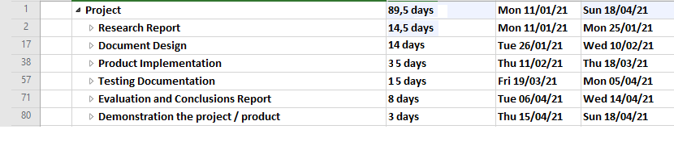

**Research Report**

**Start date:** 11/01/2021

**End date:** 25/01/2021

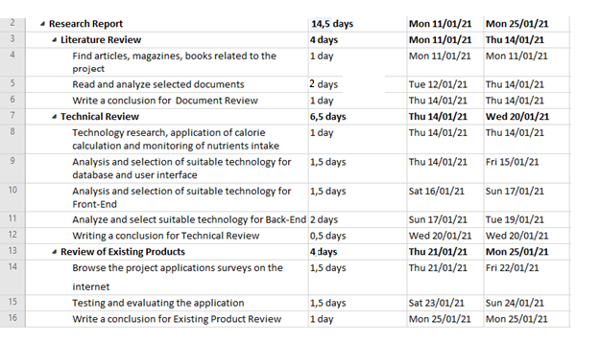

**Design Documentation**

**Start date:** 26/01/2021

**End date:** 10/02/2021

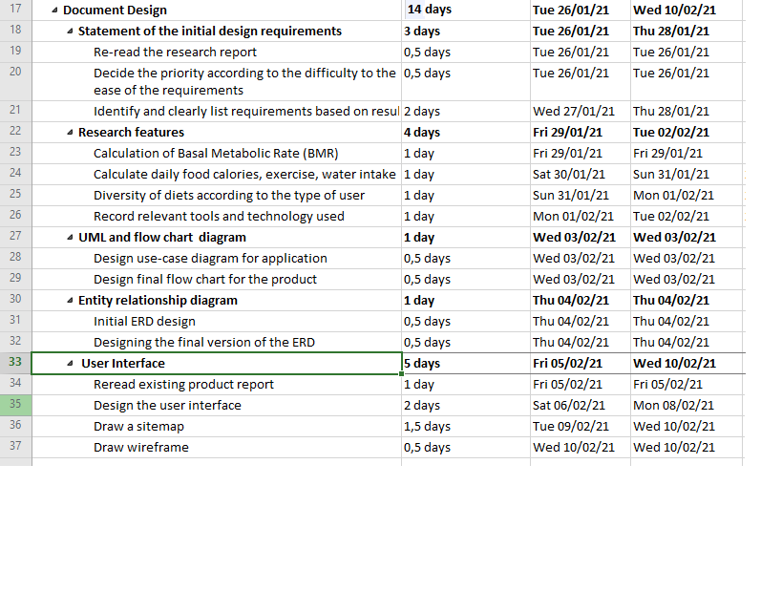

**Product Implementation**

**Start date:** 11/02/2021

**End date:** 18/03/2021

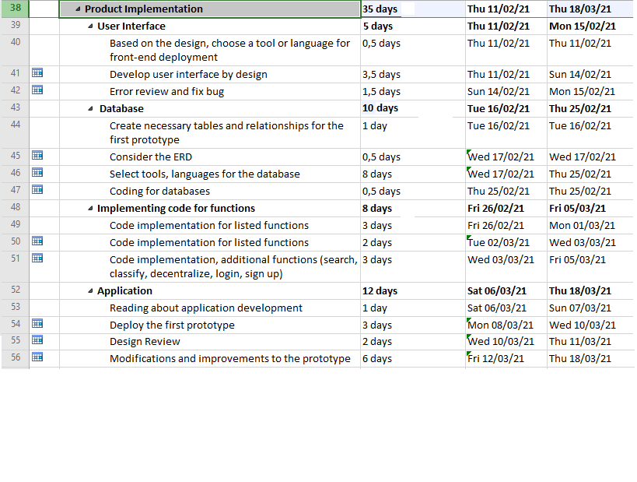

**Testing Documentation**

**Start date:** 19/03/2021

**End date:** 5/04/2021

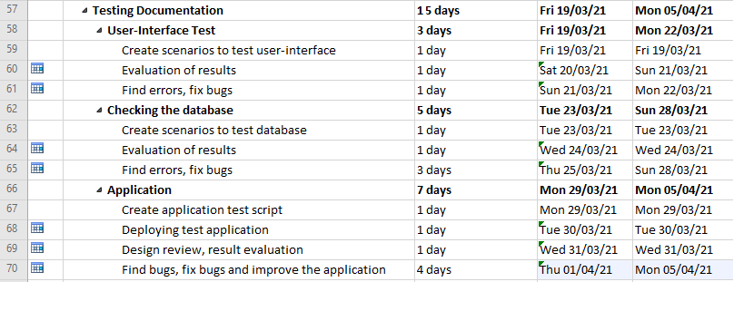

**Evaluation and Conclusion Report and Demonstration the project / product**

**Start date:** 6/04/2021

**End date:** 18/04/2021

