**BÁO CÁO THỰC HÀNH**

**BÀI TẬP THỰC HÀNH 3: NESTED NAVIGATION, SQLite DATAB**

**Sinh viên thực hiện:** Lê Tấn Hòa – 21522081

**Lớp**: IE307.P11.CNCL

**Bài 1: Social Media Feed**

* **Video kết quả:** [**Link**](https://drive.google.com/file/d/1pbLdwqDeWMaajqH-BYd9nEBbQXiy2gUp/view?usp=sharing)
* **Cấu trúc folder:**

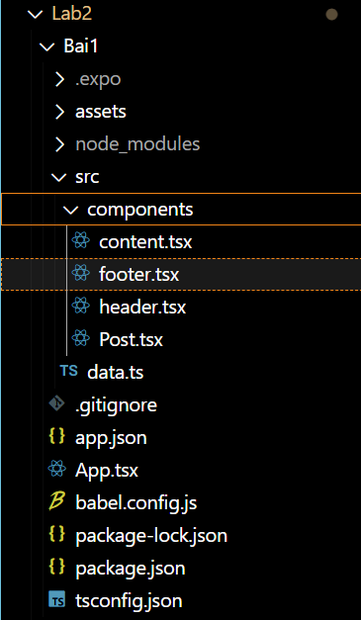

* **Nội dung code:**

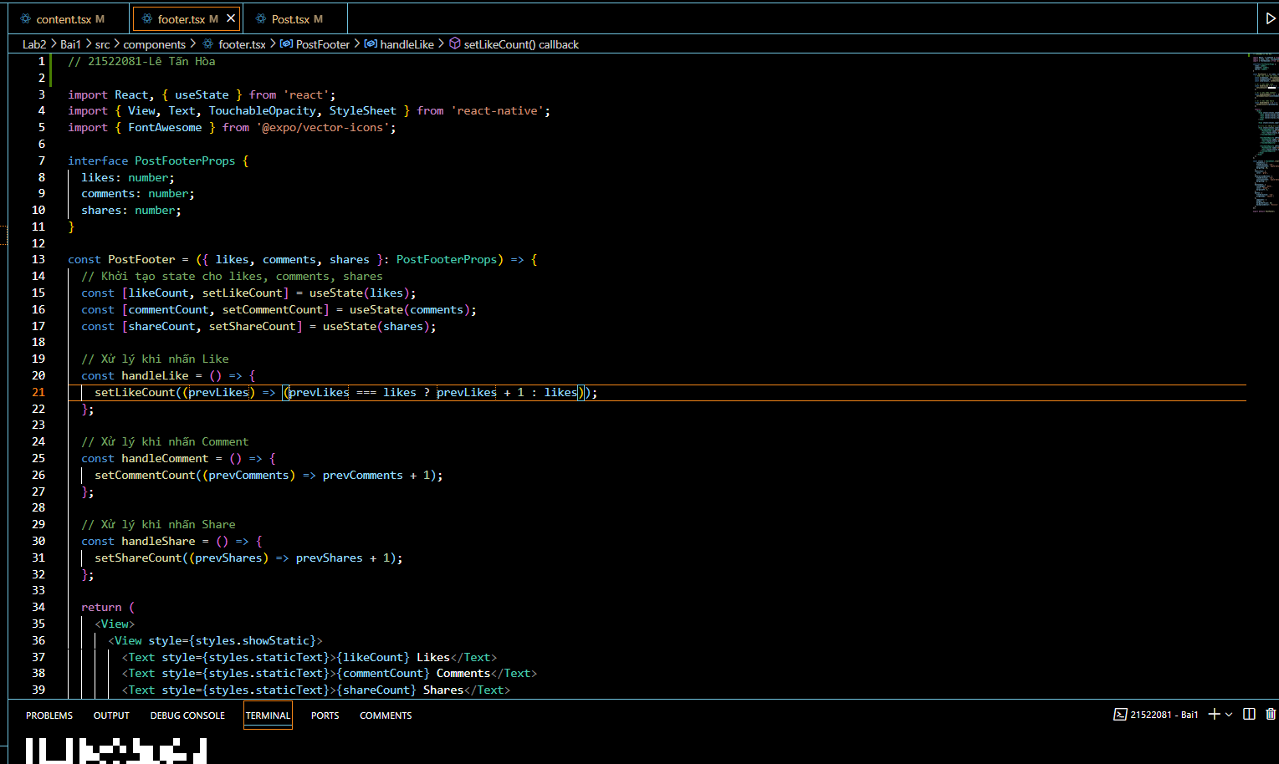 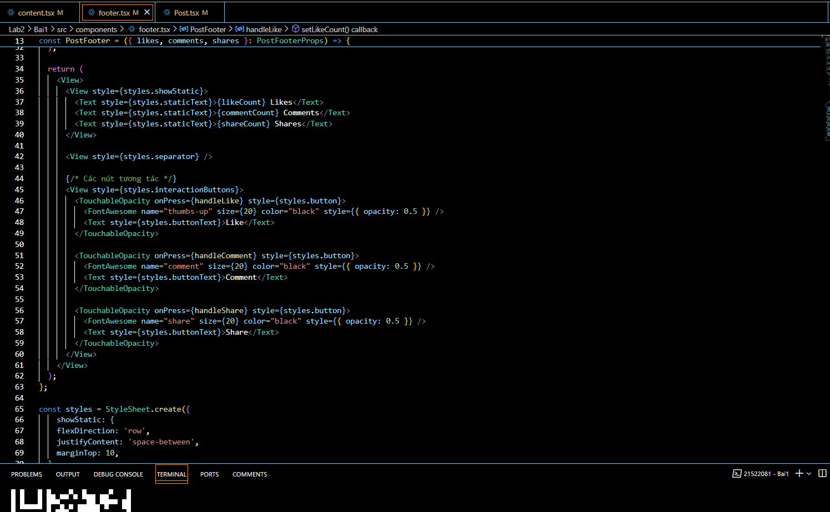

**Bài 2: Settings and Feedback**

* **Video kết quả:** [**Link**](https://drive.google.com/file/d/1CdFMtRq6PWmlZyvTjj040UBOawoEtRA2/view?usp=sharing)
* **Cấu trúc folder:**

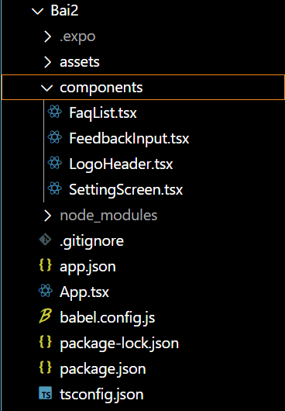

* **Nội dung code:**

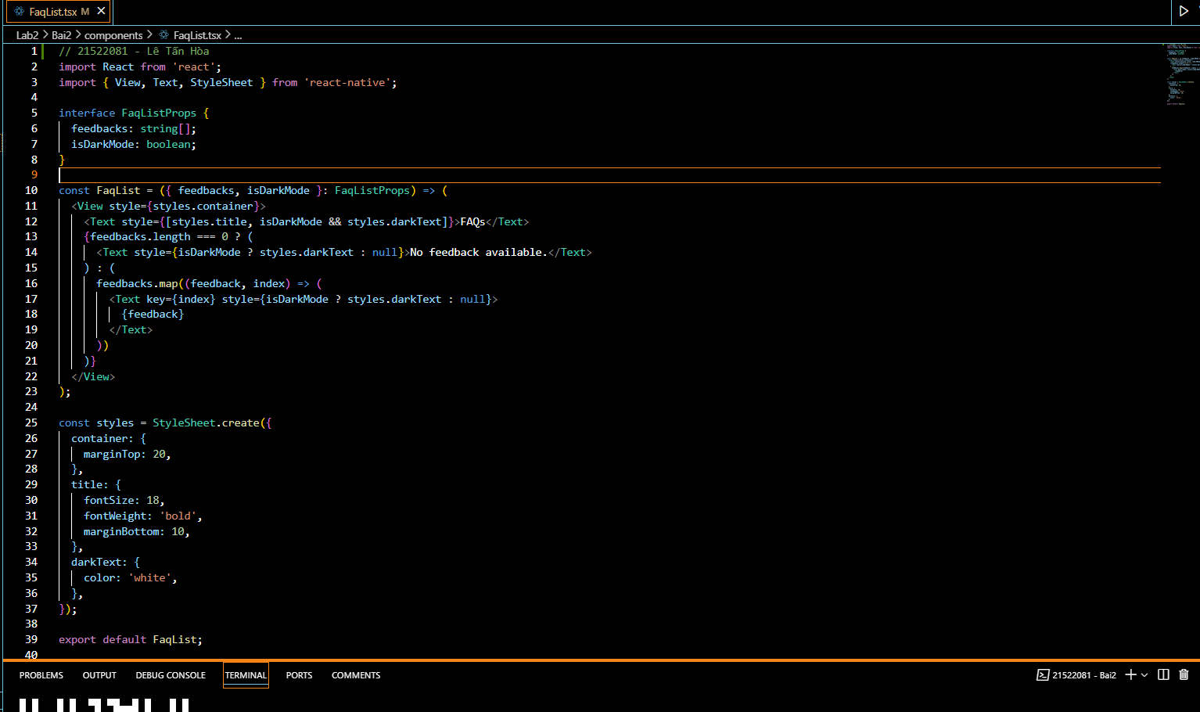

**Bài 3: React Navigation**

* **Video kết quả:** [**Link**](https://drive.google.com/file/d/1rW4uO4aFduJyRDUnYTRpt5boVR-tU5O1/view?usp=sharing)
* **Cấu trúc folder:**

* **Nội dung code:**

