Final Report : Smart Fire System

1 . What is Smart Fire

* 1. . Introduction
  2. . Purpose
  3. . Product Scope

2. Design

* 1. Scrum Board
  2. UML Class Diagram
  3. Database Diagram
  4. GUI (Graphical User Interface)

3. Overall Description

3.1 User Class and characteristics

3.2 Product Functions

4. System Features

4.1 Detect Fire

4.2 Update From User

4.3 Function Requriments

1. Smart Fire

1.1 Introduce

Smart Fire is an app that can detect Fire threat and notify the user where they should go when there is a FIRE happened . this application apply for hotel , apartment, home and school . It’s an app that could help those who can’t get out of the fire . reduce the dead of thousands human .

1.2 Purpose

The purpose of this application is to detect fire and help the one that in danger of FIRE to get them out of danger , predict the fire start and prevented any source that could lead to FIRE .

1.3 Reduct Scope

The “Smart Fire” application only effective when they are camera install in the area like in the hotel , restaurant , apartment , home and school . the app have some set back , it couldn’t 100% help every person in the Fire accident to get out safe and sound .

2. Design

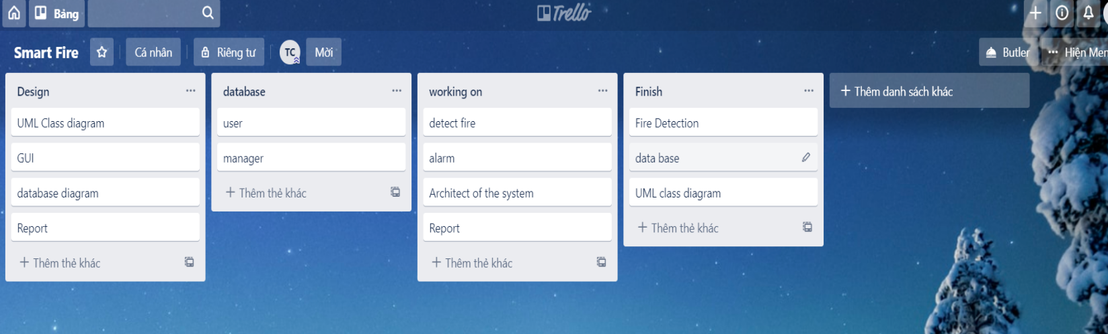 2.1 Scrum board

Schedule of the activity have for the project

2.2 UML Class Diagram

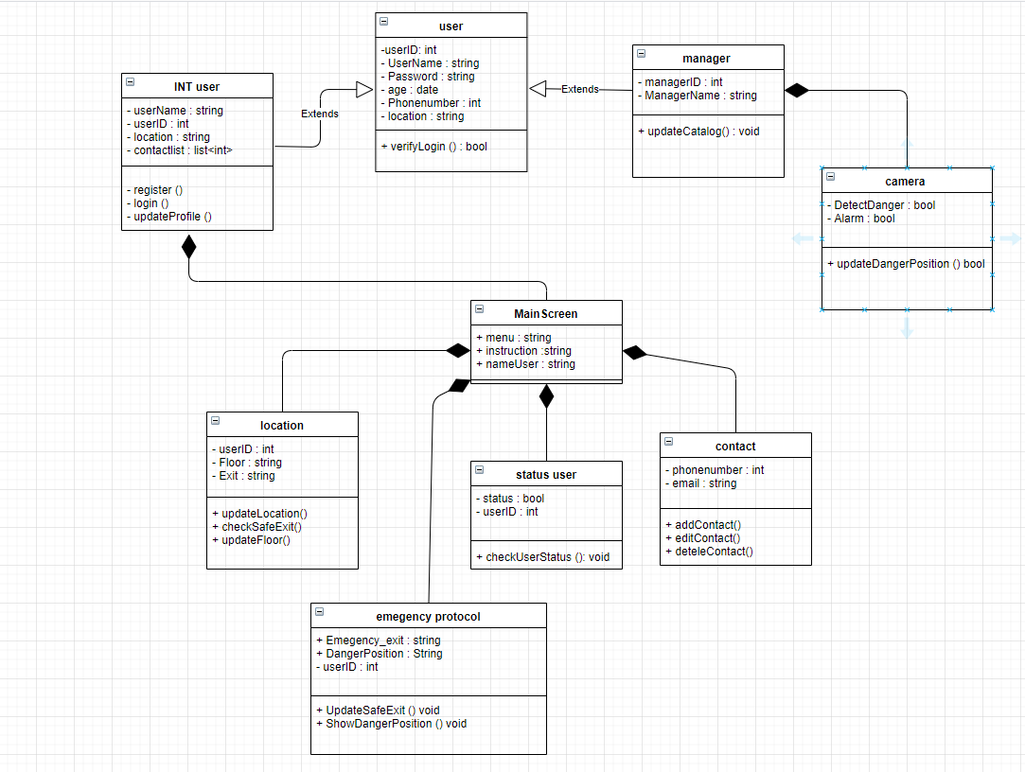

* 1. 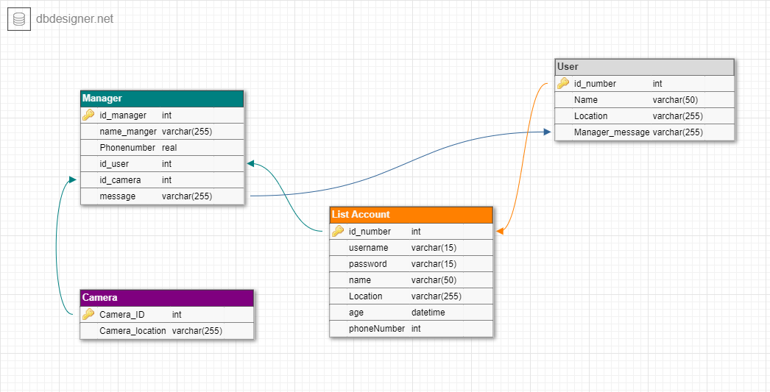database Diagram
  2. 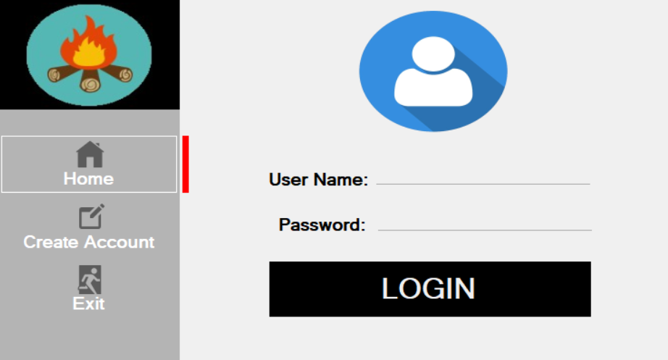GUI (Graphical User Interface)
     1. 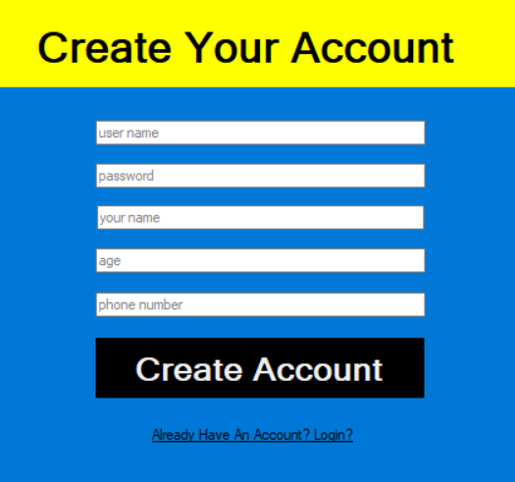User login interface
     2. Create New Acount Interface

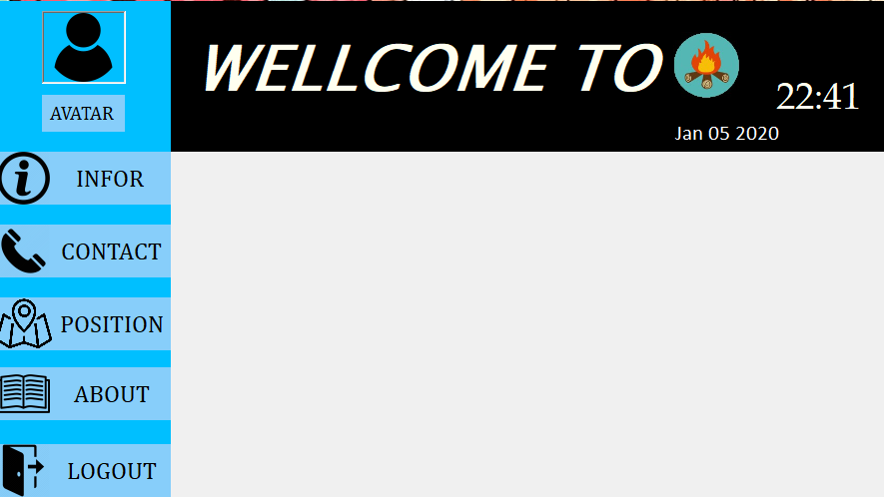

2.4.3 User Interface

3 . Overall Description

3.1 User Class and characteristics

Class user :

+ normal user .

+ Management

3.2 Product function

- Management deparatment

+ receive the position of the FIRE on camera

+ Send notification to the user about the potential threat of a FIRE near their position .

+ Follow the current casualties and update the situation for the user .

* User

+ Receive position of the Fire through the management .

+ Update your own safety status as required when a fire occurs.

+ See safe exits in a fire area to escape.

+ See current status of loved ones when there is a fire warning.

+ Provide photos, update fire situation for management.

4. System Features

4.1 detect Fire

For manager :

When a fire appears within the surveillance camera range, the system will receive the image photo and analysis. If the predicted result is fire, the system will send the recorded imagereceive, location, time of the fire to the manager.

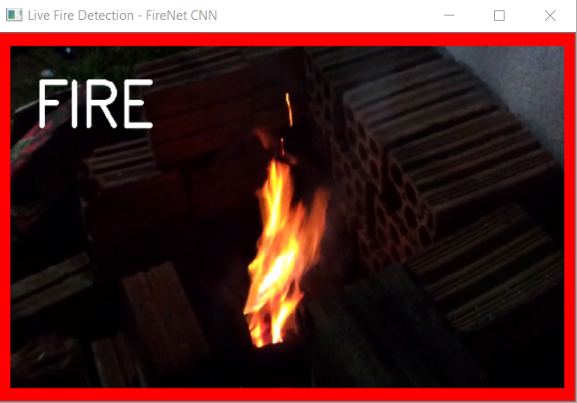

For user :

After the manager has confirmed that a fire has occurred and needs to warn

The system will send notice to all customers within the existing building

fire, and require everyone to update the safety status, the current location of each personal.

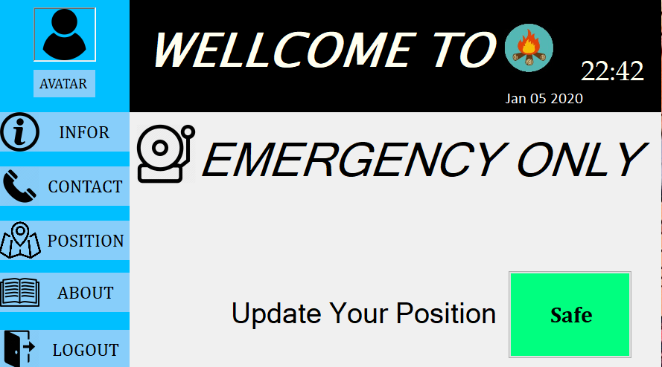4.2 Update From User

When there is a FIRE user need to update their current status , in order for people around to help them .

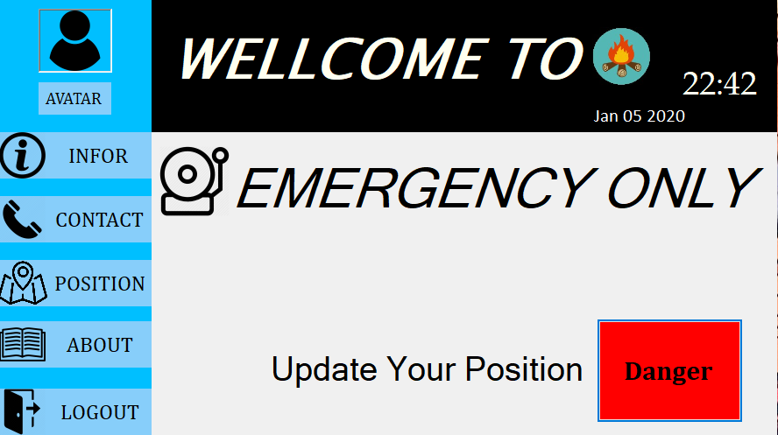

4.3 Requriements

Funtction Requriements :

* Need to stay connected with the fire In order for the app to stay online and keep you safe , when there is a Fire accident happened .
* Remember to stay login ALL THE TIME .
* And all way keep tracking who are important to you

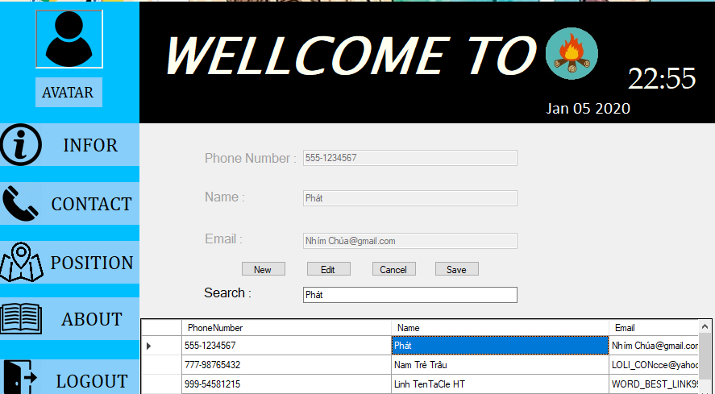To know whether there are in danger or not

* Keep contact with friend and family we don’t know what gona happened next but just in case anything bad happened .