Họ tên: Lê Tấn Phát

Mssv: 21004661

* Bài 7

* Bài 8

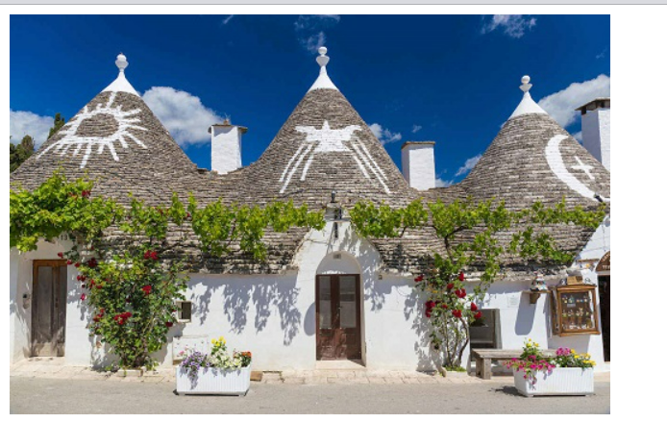

* Bài 9

* Bài 10

* Bài 11

* Bài 12

* Bài 13

* Bài 14

* Bài 15

* Bài 16

* Bài 17

* Bài 18

* Bài 19

* Bài 20

