Preparing art & resources for developing environment
This documentation describes a list of purposes and recommendations for preparing resources in Adobe Photoshop for tools, such as Adobe Animate and Spine.
Adobe Photoshop art preparation
For creating a new document use combination Ctrl + N.
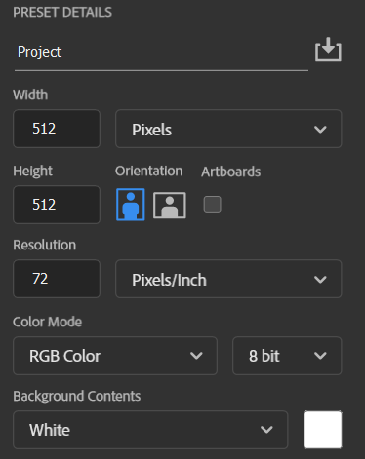
Name the project, set resolution Width x Height depending on your project needs.
Do not create a big document if your resources do not require it. (for example, for small UI buttons)
For most Bitmap projects use Resolution 72
For Vector image projects use Resolution 300
Use Color mode → RGB Color
To import resources in a new document you can paste them directly in Viewport or drag them from your folder.
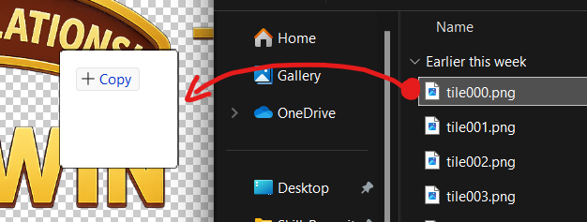

Layers logic and structure
PSD File Requirements:
✅ All layers must be clearly and consistently named, using logic like body_head, fx_glow, ui_button_idle and so on
✅ Use folders (layer groups) to separate logical sections: Body, FX, UI, etc.
✅ Avoid empty layers or layers with default names like Layer 1 or Copy of Layer
✅ Separate elements into different folders. (for example, RightLeg, LeftThigh → Body folder)
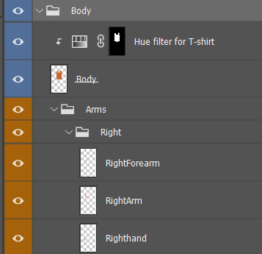
You can see example of naming and structure on bottom pictures.
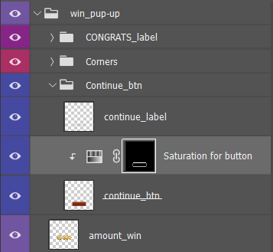

To animate your resources in future , separate your layers and “slice” them logically. It will be easier to work with art. (for example, to animate ALL symbols from this label separately)
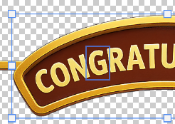
To create more realistic animation of different states of your character (idle, running and so on), slice body parts into different layers. If these parts will bend, you can adjust the layer by drawing extra space in the place that will bend.

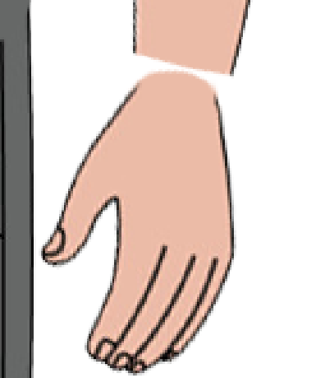
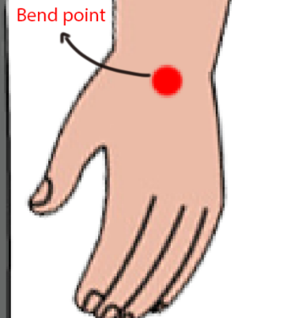
E← Extra space

Example:
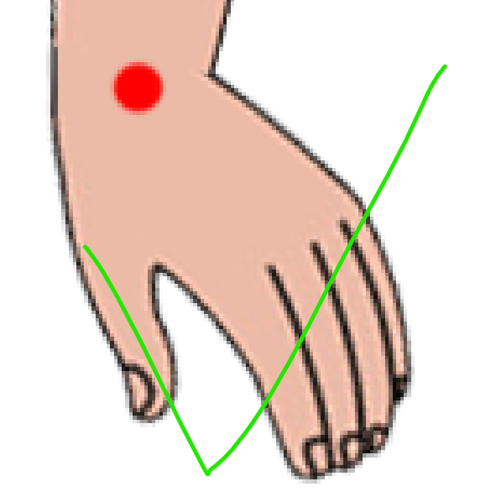
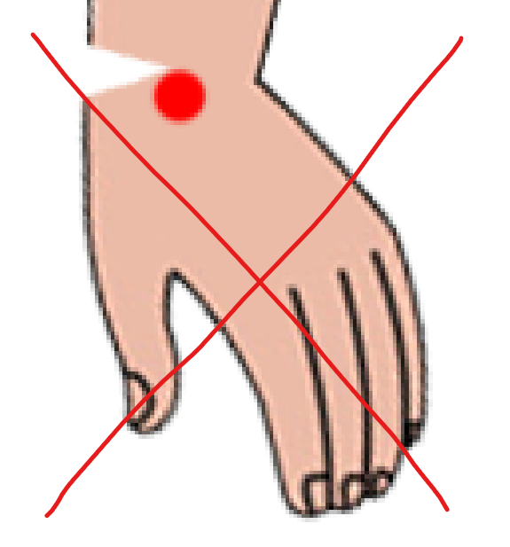
- 2.

Exporting resources from Photoshop to Spine
To export your layers, you can use PhotoshopToSpine Script. It is useful to fast export into .json all your assets from layer. Official EsotericSoftware GitHub
Go File → Scripts → PhotoshopToSpine.
Choose setting that is suitable for your project, make sure Scale is 100% (your project native scale).
Set Output Path, where will be your .json and images files
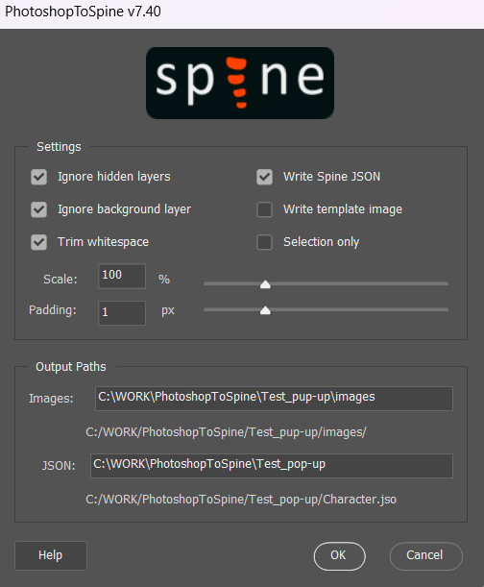

To export in another method (for example to use in future in Adobe Animate) use
File → Export → Layer to Files. (to save canvas size for all layers).
Or
File → Export → Export As … and choose file settings that you need (PNG, JPG formats and so on).
Export Formats:
Target Tool | Format | Notes
Spine | PNG | Transparent background, 72–150 dpi, 100% scale
Animate | PSD / PNG | PSD (for Import), or PNGs with layers

Adobe Animate resource preparation
✅ Import as PSD with layered groups, or separate PNG files.
File → Import → Import to Library
✅ Photoshop layer groups = Timeline layers in Animate.
✅ Avoid complex layer effects or filters that Animate may not support (e.g. heavy shadows or layer styles).
Naming Conventions
Use clear and understandable for other developers prefixes to categorize layers:
- label – for labels
- ui_ – for interface elements
- btn – for buttons
- env_ – for background/environment layers
Example of Library naming and structure
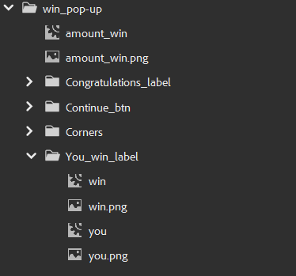
Do not avoid the same logical structure in Timeline viewport:
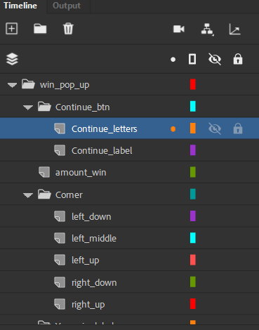
Animation structure
✅ Each animation segment should be in its own Timeline
✅ All animation states in Timeline must end with Keyframe
✅ Idle and similar animations need to be looped (no stretch, edgy and sharp transitions)
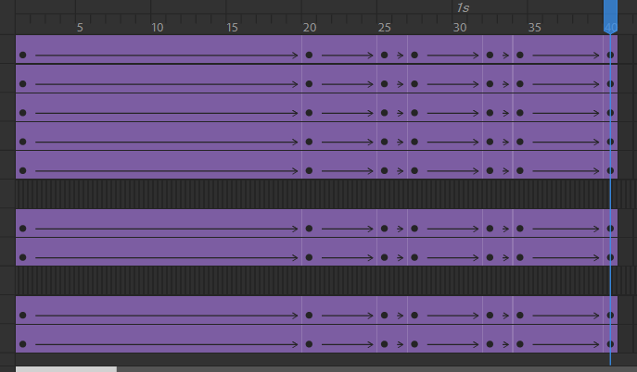
Spine resources preparation
Importing from Photoshop (via Script)
Go to Spine → Import Data… → JSON or binary file → File path → Import.
Select folder where you’re exported .JSON file from Photoshop script saved.
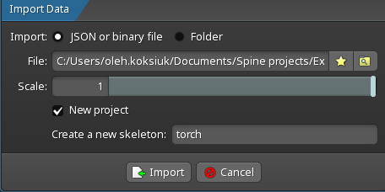
Importing PNG Files Manually
In Spine go to Tree → Images and then on bottom area choose Browse and select folder with your assets that need to be imported.
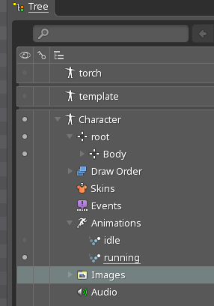
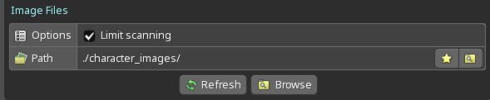
Image Asset Preparation
After importing assets, you need to Parent them to Bones.
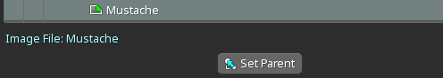
You can just drag image to Bone, or select image then Set Parent and choose Bone.
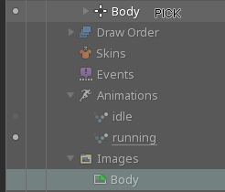
✅ Use PNG format for all assets that need to be animated (or JPG format for static images e.g. backgrounds).
✅ Resolution should match target device scale (1x, 2x). Do not over-scale it.
✅ File names must be unique, logically understandable, no spaces.
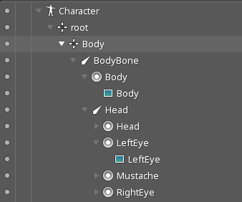
Matching Image Names to Slots
- Slot name must match the PNG filename (without extension)
- Example:
  - Slot: Head
  - Head: Head.png ✅
  - 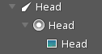
Animate Mode & Keyframes
✅Switch to Animate mode only after skeleton and assets are set.
✅Keep animations in their own timelines: idle, walk, run, jump, attack.
✅Avoid animations states and Keyframes on root bone.
Keyframe Rules
✅Use keyframes for bones, slots.
✅Avoid unnecessary keys. Only key what changes something.
✅Idle and similar animations need to be looped (no stretch, edgy and sharp transitions). And starts and ends with Keyframe:
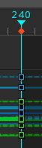
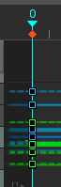

Rigging Bones
✅Use a hierarchical structure (as folders in Tree) Body → LeftArm → LeftForearm → LeftHand
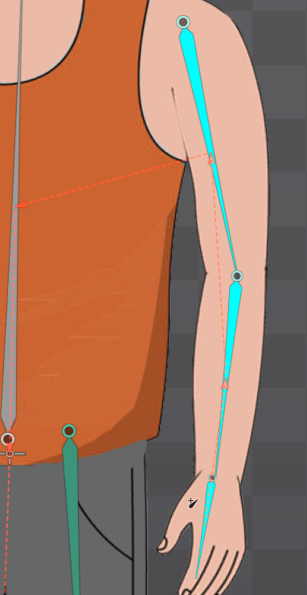
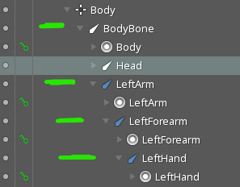

✅Rotate bones from pivot points (e.g. shoulder, elbow)
✅Always preview all animations inside Spine before export by Preview mode Alt + R and check:
- Bone rotations
- Attachments switching correctly
- Timing of keyframes
- Looping for idle/walk cycles

Export Settings
✅Keep image resolution optimized — not larger than needed.
✅Always export using Spine runtime version required by the engine.
Use Spine → Export
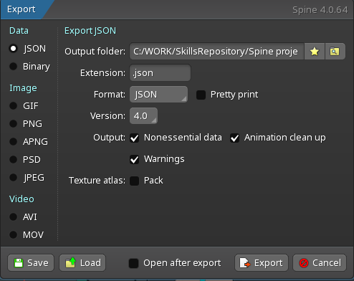
Data:
Check JSON if you need to integrate assets in future development environments
And set options Output folder where will be located .json file of project and runtime Version of Spine
Image or Video:
To export project resources (animations, skeleton) in video or image format.

