*PLANEPHD TEST*

**Welcome to the Challenge.**

This won’t be easy — and that’s the point. Rather than guessing your abilities, we’re giving you the chance to prove them.

The effort won’t be worth $100, but we’re giving you the answers upfront — so we don’t profit from it either.

You shouldn’t do this for the $100 — you should do it for the opportunity behind it. If you succeed here, you could be on a path few ever get a shot at.

The Deliverables:

1. CODE: Provide your code and process that you used to get the results. We might run the code on advertisements that you have not seen, and your entry will also be judged on those results.
2. RESULTS: Paste your results that your code has produced into the TestAnswers.xlsx spreadsheet and check your score on the SCORE tab.
3. DIARY: Provide a diary of your attempt. Take notes at each stage of the project. This diary will be evidence to us of how you would be communicating to the team as you work on the project. Don’t use an LLM for the diary; we will know.

Your entry will be judged on completeness, accuracy, how well you understood the task, and what you learned.

The Test:

We have 11 years of saved Aircraft For Sale information, over 200,000 aircraft listings. We are trying to improve the accuracy of our aircraft valuation index, for which we need good estimates of aircraft engine values. An engine is worth its expected future output. A fresh engine will work for thousands of hours, and thus be worth a lot. A worn out engine may only be worth scrap, because it needs substantial refurbishment to make it whole again.

We critically need to know:

How many hours do the engines have left before overhaul.

We will estimate that from different clues in the advertisements. The easiest is if the advert says so directly. But instead, the ad may say how many hours it’s been since overhaul, or the date of the last overhaul, or that there are 1000 hours left of use on the engines. They may measure time in absolutes (Time Since New), or they may reference a time before or after another event. There can be many metrics, that we need to use to come up with a single answer.

Your task is to come up with a methodology to determine the number of hours left in an engine. You will be given 42 aircraft advertisements, all of them similar model jets.

The advertisements will have an advertisement id (id) and a body of unstructured text, but this text comes from advertisements such as:

<https://www.controller.com/listing/for-sale/244056577/1990-gulfstream-giv-jet-aircraft>

<https://www.aso.com/listings/spec/ViewAd.aspx?id=199359&listingType=true&IsInternal=True&pagingNo=1&searchId=61653654&dealerid=>

We would recommend using a LLM API (some are free) to extract the necessary information. The reason for this is that there are too many possible variations of data people can put into an advertisement, for regex or something similar to be effective. Afterwards, you will need some logic to determine the reasonableness of your extracted data. Finally, you will use the pieces of data collected to come up with a highest probability answer for the final answer: how many hours of engine time are left before overhaul.

Some info:

The initial under taking is to model a single jet engine model, those on a Gulfstream IV jet. A GIV engine has a TBO of 8000 hours, and a 20 year service life. After the 8000 hours or 20 years, whichever comes first, you must overhaul the engine. Additionally, they need a mid-life inspection (HSI or Hot Section Inspection) at the earlier of 4000 hours or 10 years. The overhaul is due within the earlier of 10 years or 4000 hours of the midlife.

An aircraft may be advertised in many different ways, sometimes even using long wording instead of tables.

G-IVSP Reg # N920KM Serial # 1289 Price: Inquire TTAF: 6513 Hrs.

Engines Loc. Make Model Serial# TSN CSN TSML

L Rolls Royce TAY 611-8 16691 6486 3959 3472

R 16692 6513 3979 3472

L&R Engines Midlife c/w March 2006

How do you read this? 6486 hours “Time Since New”, 3959 Cycle Since New, 3472 Time Since Mid-Life (HSI). This aircraft was manufactured in 1996, and hit the 10yr deadline for a HSI in 2006… which is why the midlife shows “c/w” or complied with March 2006. From there, this plane has another 10years before overhaul, and apparently 4000 hours (half of 8000 hrs) – 3472 = 528 hours remaining. This engine only has 528 hours remaining before its 8000 hour overhaul. This engine probably costs $3.5 million to overhaul (each), so this engine will need significant maintenance soon, and the aircraft valuation will be lower because of this.

What if they were running the engines “On Condition”? On Condition means that they could operate the engines past the TBO (time before overhaul) hard stop time of 8000 hours, and trend monitor the engines for vibrations, etc. It also involves inspections. They might be able to get the engines to 12000 hours or more. This is done regularly in airliners, but has only become common in the past 10-20 years in General Aviation. However, for our purposes, we’re going to measure engines as being run out at TBO, or 8000 hours.

The engines could also be enrolled in an insurance program, an Engine Maintenance program, where the owner pays the plan an hourly rate, around $500, for each hour that they fly. $500 x 8000 hours = $4 million. If these engines were on an Engine Program such as Rolls Royce Corporate Care, JSSI, or some others, then the plan provider would pay for both scheduled and unexpected repairs. Thus, the engine’s value would be like it had 0 hours, since the overhaul will be paid for. Beware of ads that say “Eligible for Rolls Royce Corporate Care”. Eligible means they have not paid the premiums, so there is no value for that.

Here's another example:

G-IV Reg # N198GS Serial # 1098 Price: Inquire Available for sale lease or trade TTAF: 9971 Hrs

Make Model Serial# TSN CSN

L RR TAY 611-8 16315 9921 4308

R 16314 9921 4308

APU Garrett GTCP36-100 S/N: P475 Hours

Here we see that they don’t specify any overhaul. We have to assume that these engines are On Condition since they are past TBO, and they are past the 8000 hrs. Notice the APU. Don’t confuse the APU with the engines. Especially don’t confuse the maintenance programs for an APU (usually MSP) with the ones for the engines. An APU is used for electrical power to the plane, especially on the ground when the engines are off.

G-IVSP Reg # PP-WJB Serial # IV-1348 Price: Inquire TTAF: 6318 Hrs.

Engines Loc. Make Model TSN CSN

L Rolls Royce TAY611-8 6183 3510

R 6183 3510

APU Garrett GTCP 36-100G TSN: 4478 Hours Maintenance Condition

Damage History: No RVSM MNPS RNP-5 & RNP-10 G-CMP MSG-3 Maintained #1 Engine 20 Yr Due November 2018 or 7868.8 Hrs. #2 Engine 20 Yr Due October 2017 or 7868.8 Hrs.

This plane shows that the 20yr is due in Nov 2018 or 7868.8 hrs. The engines currently have 6183 hrs, so there are 8000-6183 hrs left, or 1685.8 hrs. However, the ad is from Dec 2015. There are three years left on the engines. We must make an assumption as to the maximum number of hours that a plane will fly in a year, and a reasonable number might be 450 hours. That would mean the time is limited to 1350 hours, not 1685. This isn’t that far off, but what if there were only a year left.

The 1st goal for us is to determine the value of the engines, by determining how many hours of usable time are left on the engines, or whether they are on a maintenance program, also whether they are On Condition. The following is a good template we would like to fill out.

The Red columns are data to be extracted. The Blue columns are data to be calculated from the extracted data.

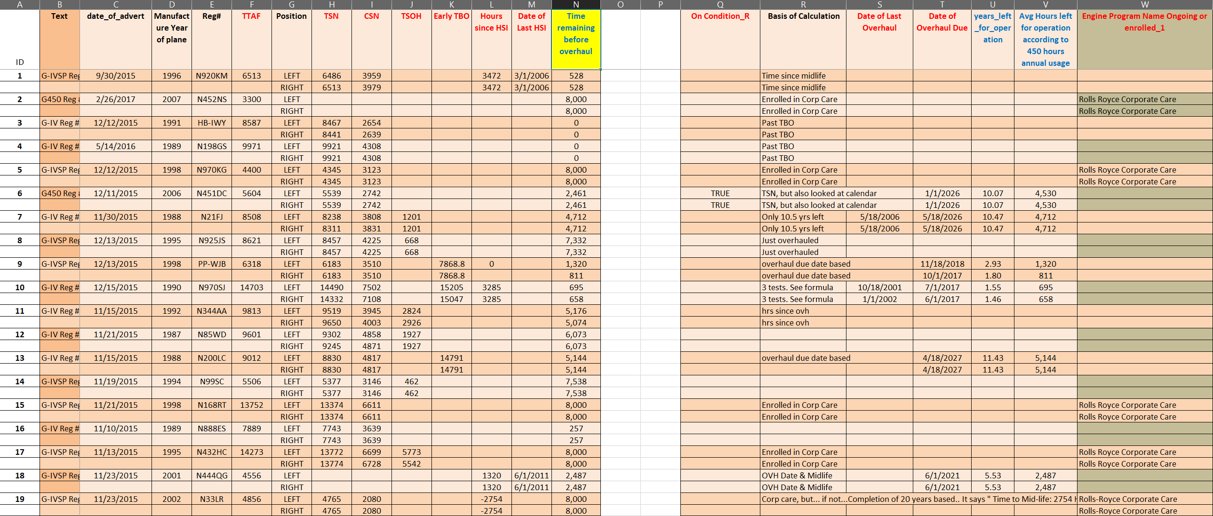

Your job is to write code that can extract the data from the ads that you have been given to fill in/replicate this table. The tables is in the file called TestAnswer.xlsx

Wishing you Good luck,

The Team at Planephd.