Term Project Proposal: Preference-Based Place Recommendation and Route Planning
Oct 22, 2026 · @hyobin

1. Overview
We build a system that recommends Top-N places a user is likely to enjoy, re-ranks them so they are actually reachable, and plans a one-day visiting route through the final N places.
- Domain: place and restaurant recommendation on Yelp business reviews.
- Problem: rating prediction alone pushes far-away places to the top, and place data is far sparser than movie data (median 1 review per user, 99.998% sparsity).
- Approach: machine learning (CF, CBF, Hybrid) produces candidates; deterministic algorithms handle distance re-ranking and route optimization.
Research questions:
- RQ1: How much ranking accuracy is lost, and how much travel distance is saved, when distance is added to the ranking?
- RQ2: Does content-based filtering reduce error for users with few ratings (cold start)?
- RQ3: How close does a fast heuristic route (nearest neighbor + 2-opt) come to the exact optimum, and at what speed?
The end-to-end score for user u and place i is a rating prediction discounted by distance:
$$\text{score}(u,i)={\hat{r}}_{ui}⋅w\left(d(ℓ_{u},ℓ_{i})\right)$$
where the predicted rating comes from one of four recommenders, d is the haversine distance between the user anchor and the place, and w is a decreasing weight in [0, 1].

2. Dataset
We use the Yelp Open Dataset (January 2022 release, yelp.com/dataset): 6,990,280 reviews by 1,987,929 users on 150,346 businesses. The archive is 4.34 GB compressed and 8.65 GB once extracted into five JSON files.
File | Size | Records | Fields we use | Role
business.json | 119 MB | 150,346 | business_id, latitude, longitude, categories, is_open, hours, attributes | Item features, location
review.json | 5.34 GB | 6,990,280 | user_id, business_id, stars, date | Rating matrix (target)
checkin.json | 287 MB | 131,930 businesses | date list | Popularity prior (optional)
tip.json | 181 MB | 908,915 | not used | -
user.json | 3.36 GB | 1,987,897 | not used (mostly friend lists) | -
Measured properties of the full data that shape the design:
Property | Value | Consequence
Rating matrix density | 0.0023% | CF needs aggressive filtering
Reviews per user, median | 1 (57.1% of users have one review) | Cold start is the default case
Reviews per business, median | 15 | Items are better covered than users
Mean rating | 3.75 | Global-mean baseline is strong
Duplicate (user, business) pairs | 244,520 (3.5%) | Need a dedup rule
Closed businesses | 20.4% | Train on them, never recommend them
Distinct categories | 1,311 (mean 4.45 per business) | Needs pruning and weighting
Missing coordinates | 0 | Distance is always defined
The rating matrix density is
$$ρ=\frac{|R|}{|U| |I|}=\frac{6,990,280}{1,987,929×150,346}≈2.34×{10}^{−5}$$
where R is the set of observed ratings, U the users, and I the businesses.

3. Exploratory data analysis
The EDA must justify four decisions: which city, which k-core threshold, how far a user is willing to travel, and which categories to keep. The figures below are planned for the report; those marked measured are already computed on the full data and drawn in this section.
ID | Figure | Plot type | What it shows | Decision it supports
E1 | Rating distribution | Bar chart | J-shaped star histogram (measured) | Relevance threshold, baseline
E2 | Reviews per year | Line chart | Volume 2005 to 2022, COVID dip (measured) | Time window, temporal split
E3 | Activity long tail | Log-log CCDF, users and businesses | Heavy tail of reviews per user and per item | k-core threshold
E4 | Popularity concentration | Lorenz curve + Gini | Share of reviews held by top businesses | Popularity-bias correction
E5 | City comparison | Bar chart | Ratings left after 5-core per city (measured) | City choice
E6 | Spatial density | Hexbin map of the chosen city | Where businesses and reviews cluster | User anchor, radius
E7 | Pairwise distance | Histogram of haversine distance | Typical distance between two places | Decay scale in Section 6
E8 | User activity radius | Histogram + CDF | How far a user’s reviewed places spread | Decay scale, max radius
E9 | Category frequency | Bar chart, top 25 (measured) | Long tail of 1,311 categories | Category pruning
E10 | Category co-occurrence | Heatmap, top 20 x 20 | Redundant or nested categories | Feature design for CBF
E11 | User and item mean rating | Two histograms | Rating bias per user and per item | Need for bias terms
E12 | Popularity vs quality | Scatter, log review count vs mean stars | Whether popular places rate higher | Popularity prior
E13 | k-core shrinkage | Line chart, k = 1 to 20 | Users, items, ratings kept per k | Filter threshold
E14 | Matrix sparsity | Spy plot of a 500 x 500 sample | Visual sparsity before and after filtering | Motivation for MF and CBF
Statistics behind E3, E4 and E8:
F(x)=P(nu≥x)=1|U|u∈U​1[ nu≥x ]
$$G=\frac{\sum_{i=1}^{n}{(}2i−n−1) x_{(i)}}{n\sum_{i=1}^{n}{x_{(i)}}}$$
radius(u)=1nui∈Iu​dcu,ℓi, cu=1nui∈Iu​ℓi
Here n_u is the number of ratings by user u, x_(i) are business review counts sorted ascending, I_u is the set of places u rated, and c_u is the user’s geographic centroid.

Measured figures
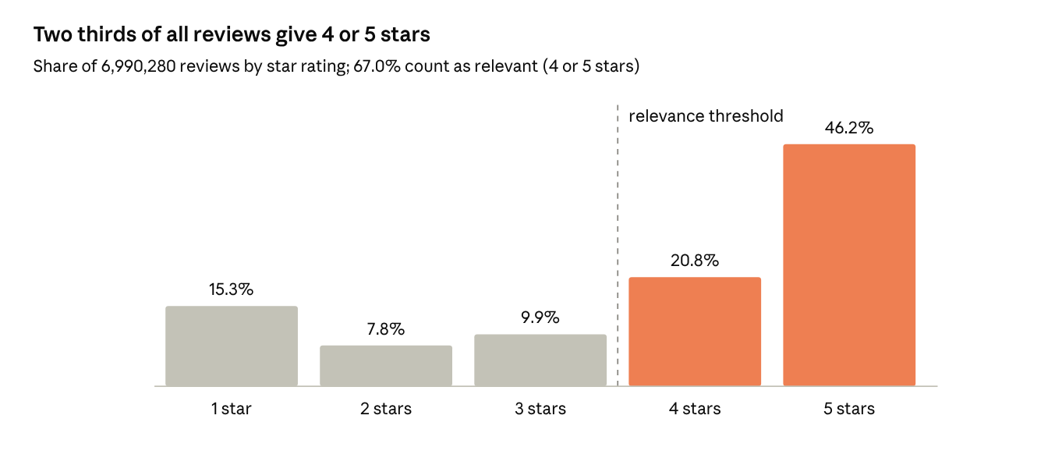
E1 · yelp_academic_dataset_review.json, all 6,990,280 reviews
The skew means a model that always predicts 4 to 5 stars already looks good on RMSE, so ranking metrics carry the comparison.
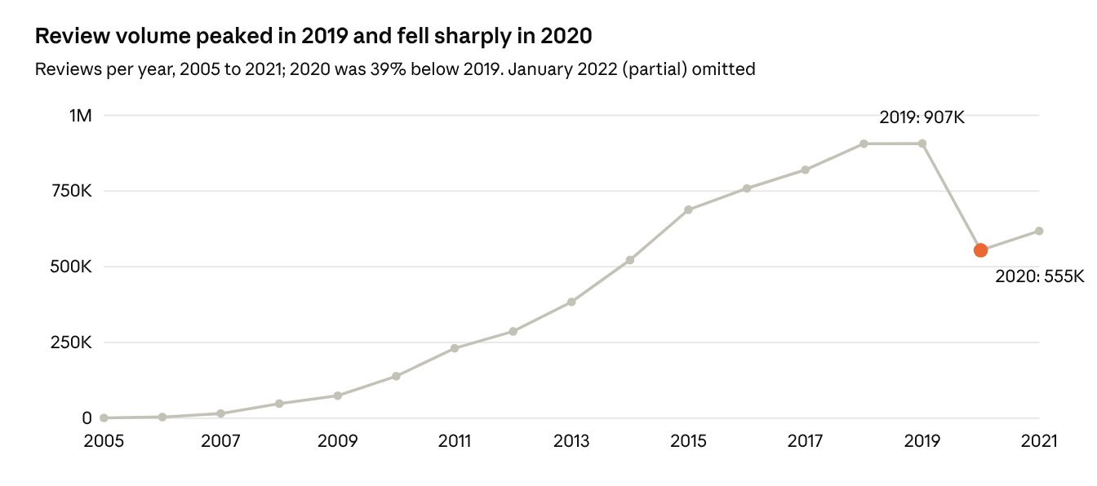
E2 · yelp_academic_dataset_review.json, review date field
The 2020 drop changes rating behavior over time, which is why a temporal split is kept as a robustness check.
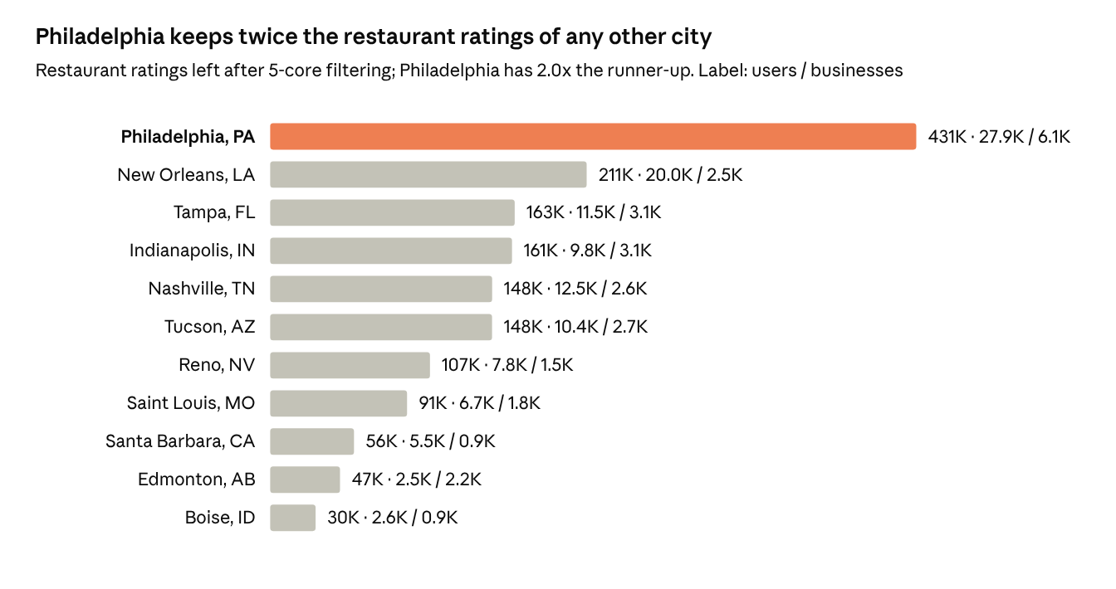
E5 · review + business JSON, Restaurants or Food category, iterative 5-core per city field
Philadelphia gives the most stable ranking metrics; its 6,110 items keep an item-item similarity matrix near 150 MB in float32.
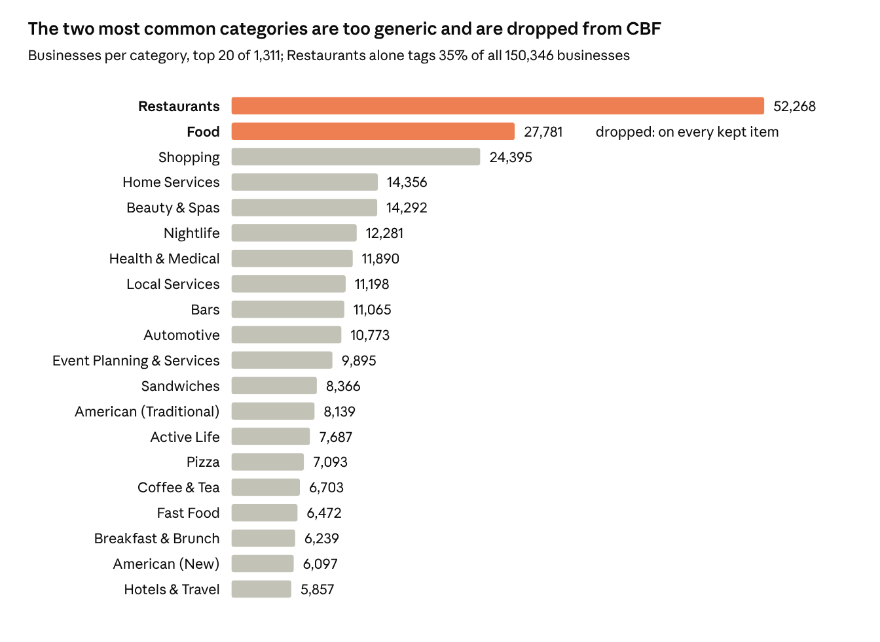
E9 · yelp_academic_dataset_business.json, all 150,346 businesses
Below the top 20 the tail is long: most of the 1,311 categories tag only a few businesses, hence the cutoff of 10 in Section 4.5.

Figures after preprocessing
The figures below use the Philadelphia working set produced by src/preprocess.py (15 km around City Hall, Restaurants or Food, deduplicated).
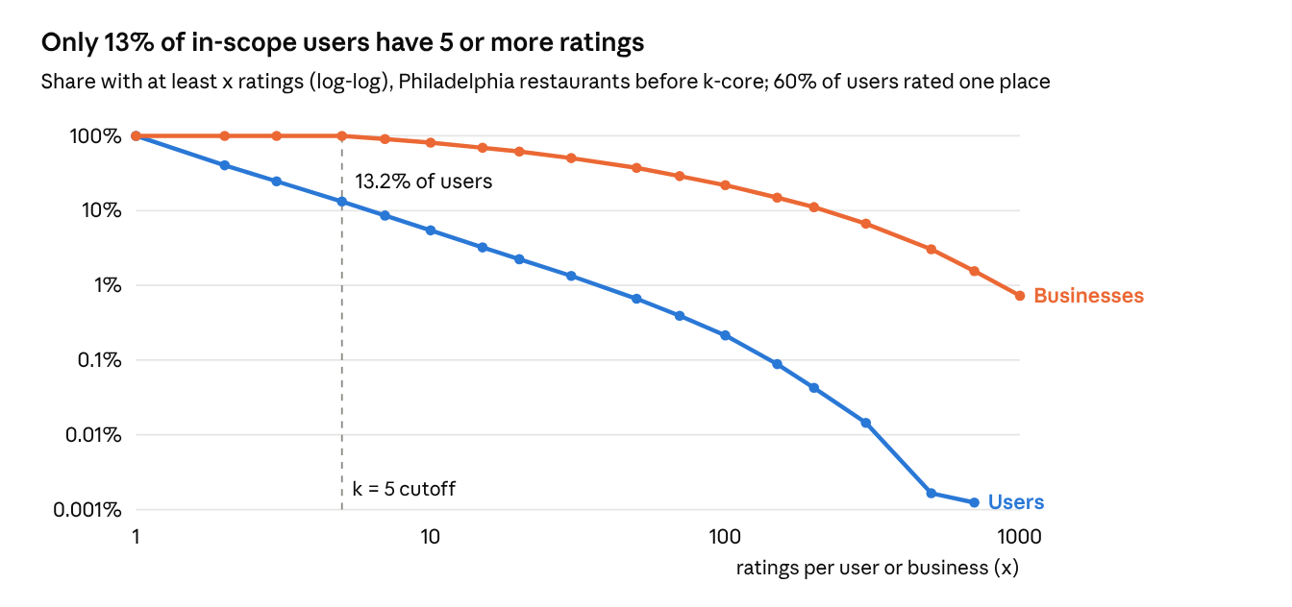
E3 · results/figdata/e3_ccdf.csv · 809,070 deduplicated ratings within 15 km
The user curve falls steeply while every business already has 5 or more ratings, so the k-core filter mainly removes users, not places.
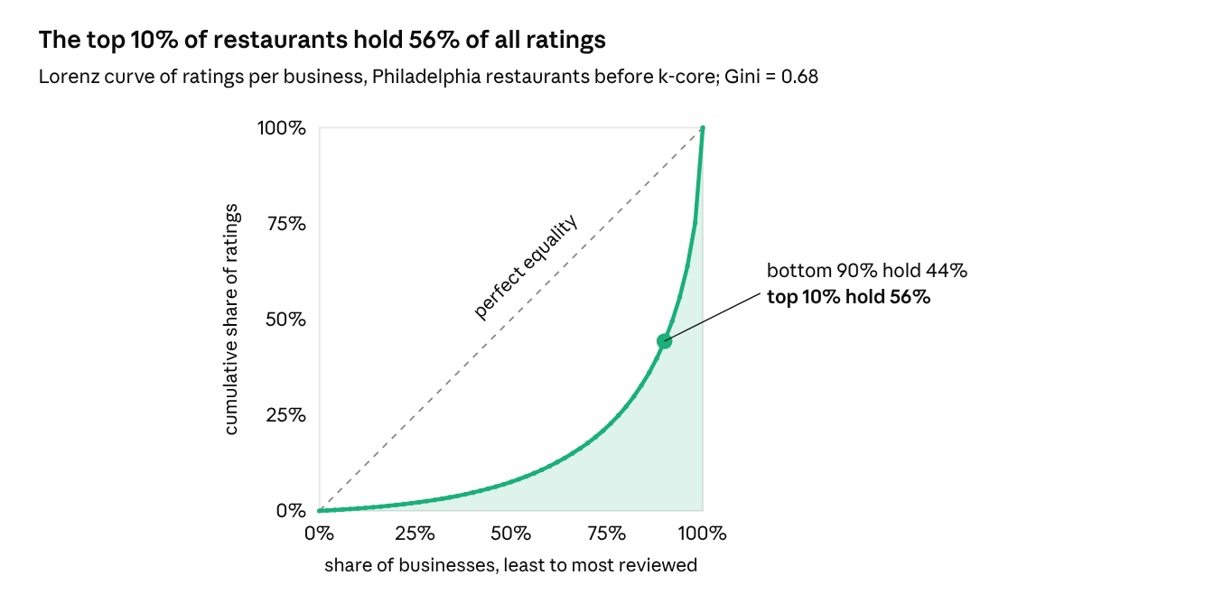
E4 · results/figdata/e4_lorenz.csv · 8,956 restaurants within 15 km
This concentration is the popularity bias that Section 6.5 corrects for.
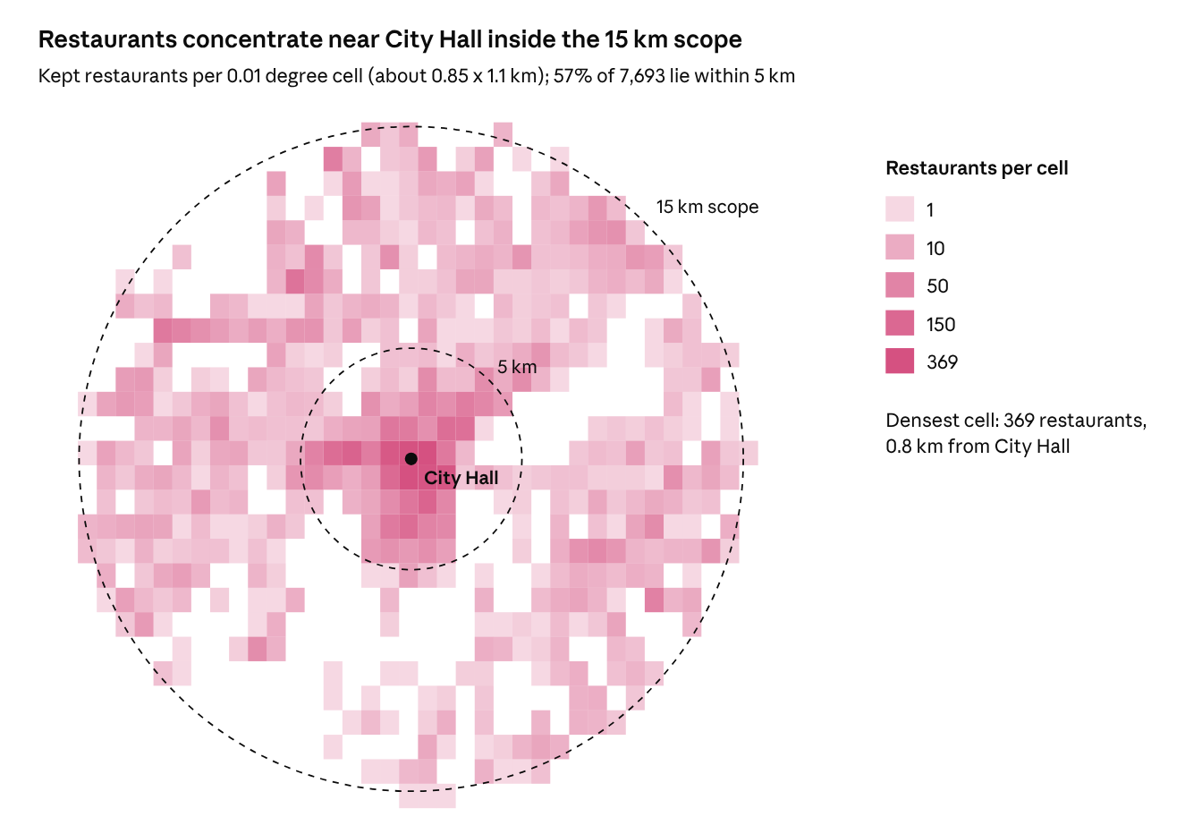
E6 · results/figdata/e6_grid.csv · 7,693 restaurants after 5-core
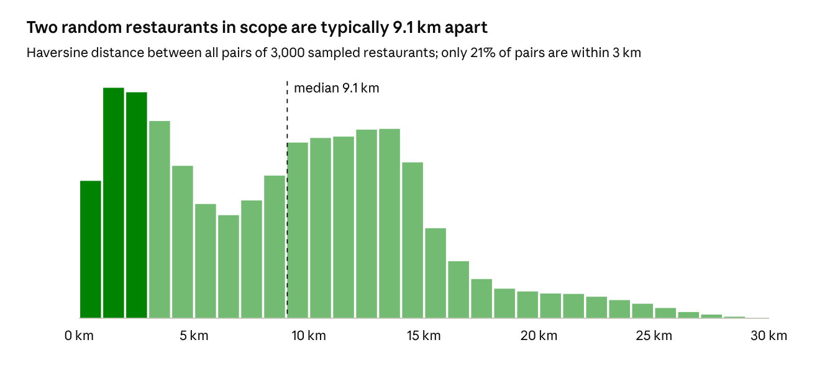
E7 · results/figdata/e7_pair_dist.csv · 4.5 million pairs
The gap between E7 and E8 is the case for distance re-ranking: places are spread about 9 km apart, but users behave locally.
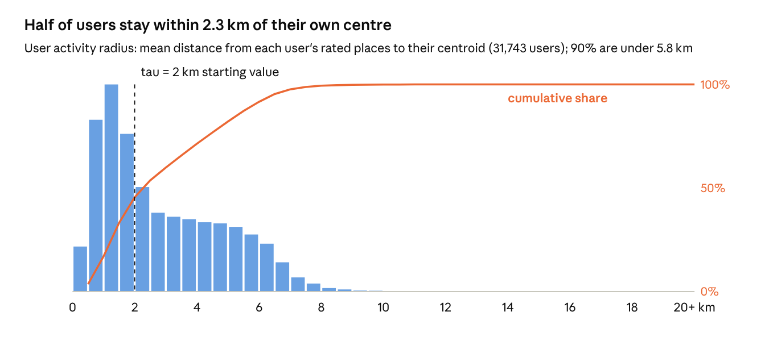
E8 · results/figdata/e8_user_radius.csv · all ratings of 31,743 users
The median distance from a user’s anchor (median of their places) to the places they rate is 1.4 km, and 90% are within 8.5 km. This sets the starting decay scale tau = 2 km.
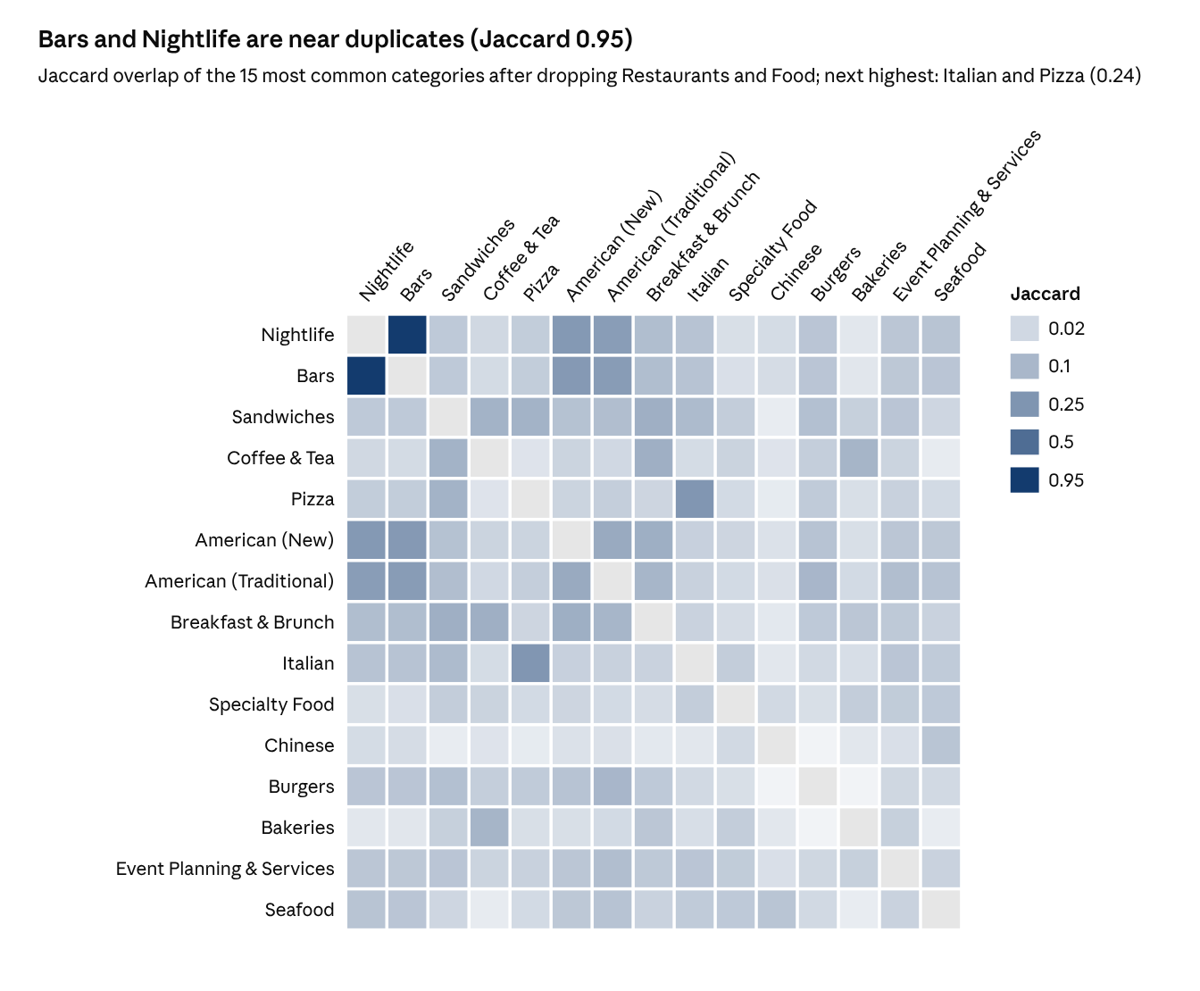
E10 · results/figdata/e10_cooc.csv · 7,693 restaurants after 5-core
Without IDF weighting, Bars and Nightlife would count the same signal twice in the CBF profile.
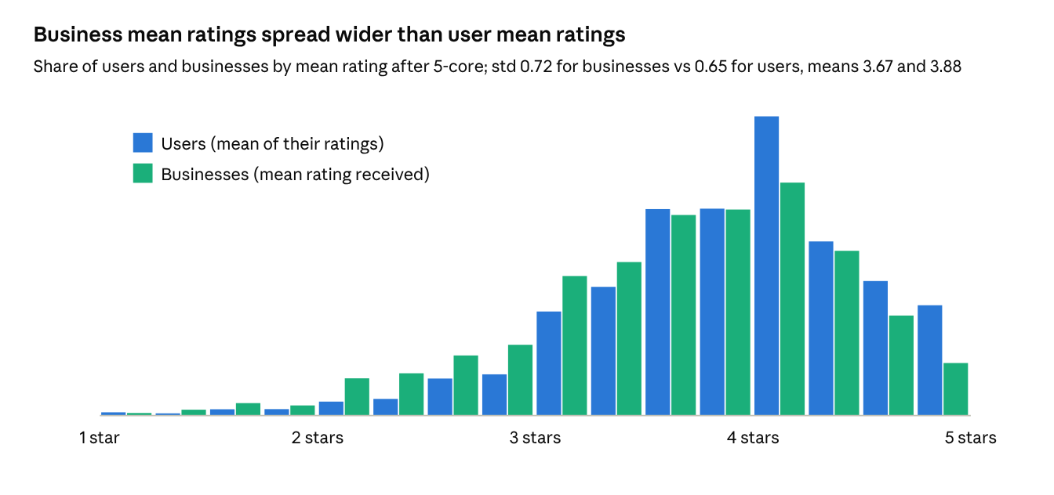
E11 · results/figdata/e11_means.csv · 31,743 users, 7,693 businesses
Both spreads are large, so the bias terms b_u and b_i in Sections 5.1 and 5.3 are needed before any interaction term.
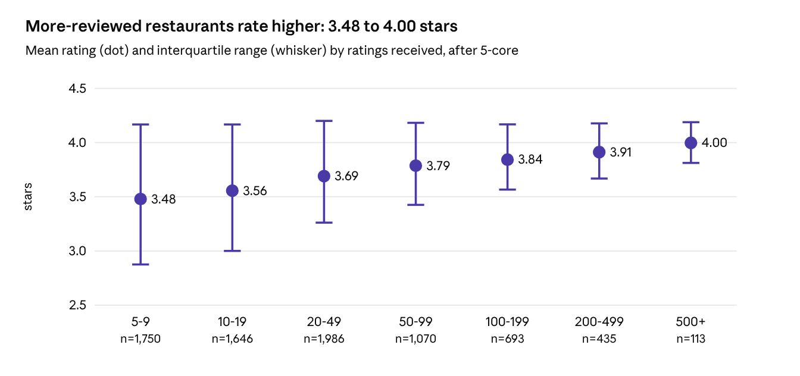
E12 · results/eda_stats.json pop_quality · 7,693 businesses
Popular places also rate higher, so a popularity prior is not just bias; Section 6.5 tests how far it can be pushed down before NDCG drops.

4. Preprocessing
The working set is Philadelphia restaurants within 15 km of City Hall after 5-core filtering: 490,539 ratings, 31,743 users and 7,693 businesses (density 0.20%). It is built by src/preprocess.py; Section 4.8 shows the results.
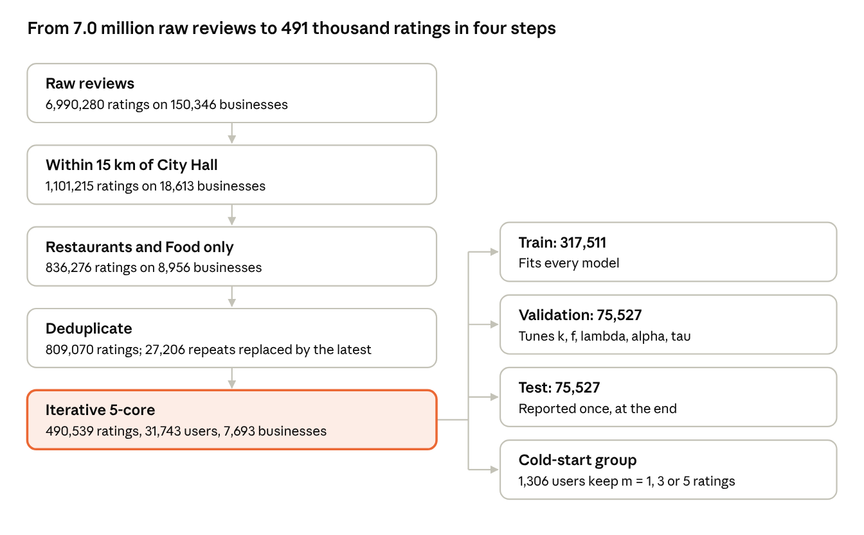
P1 preprocessing pipeline · counts measured on the full data, Oct 22, 2026
R = 15 km around City Hall (39.9526, -75.1636); all counts are measured.

4.1 Scope
Keep businesses within radius R of the city center instead of matching the city string, because suburbs are stored as separate cities (Tampa and Clearwater, for example). Keep only businesses whose categories include Restaurants or Food.
$$I_{\text{city}}=\{ i:d(ℓ_{i},ℓ_{\text{center}})≤R \}∩\{ i:\text{Restaurants}∈C_{i} ∨ \text{Food}∈C_{i} \}$$

4.2 Deduplication
When a user reviewed the same business more than once, keep the most recent rating, which reflects the user’s latest opinion.
$$r_{ui}=r_{ui}^{(t^{*})}, t^{*}=max\{ t:(u,i,t)∈R \}$$

4.3 Iterative k-core filtering
Remove users and businesses with fewer than k ratings and repeat until both conditions hold, since each removal can push others below k. The default is k = 5; E13 justifies the final choice.
$$R_{k}=\text{largest }R^{′}⊆R \text{ s.t. } |I_{u}^{′}|≥k ∀u, |U_{i}^{′}|≥k ∀i$$
City field only (before radius scope) | Ratings | Users | Businesses | Density
Philadelphia, k = 5 | 431,243 | 27,901 | 6,110 | 0.25%
New Orleans, k = 5 | 211,243 | 20,047 | 2,460 | 0.43%
Tampa, k = 5 | 163,211 | 11,530 | 3,093 | 0.46%
Indianapolis, k = 5 | 161,418 | 9,825 | 3,057 | 0.54%

4.4 Rating normalization
User-mean centering removes personal rating scale (some users give 5 to everything). Predictions are mapped back and clipped to the 1 to 5 range.
rui=rui−ru, ru=1|Iu|j∈Iu​ruj
$${\hat{r}}_{ui}=clip\left({\overset{‾}{r}}_{u}+{\hat{\tilde{r}}}_{ui}, 1, 5\right)$$

4.5 Category matrix
Drop Restaurants and Food (present on every kept item) and categories on fewer than 10 businesses. Build a binary matrix X, then weight it by inverse document frequency so rare, specific categories (Ethiopian) count more than generic ones (Sandwiches).
$$X_{ic}=1[ c∈C_{i} ], \text{idf}(c)=log\frac{|I|}{1+|\{i:X_{ic}=1\}|}$$
$$x_{i}=\frac{(X_{ic} \text{idf}(c))_{c}}{∥(X_{ic} \text{idf}(c))_{c}∥_{2}}$$
Optional extra features: price range (RestaurantsPriceRange2, one-hot) and opening hours (14 day-part flags).

4.6 Split
Split each user’s ratings 70 / 15 / 15 into train, validation and test, so every user appears in training. Tune only on validation; report test once. A temporal variant (latest 15% of each user’s ratings as test) is a robustness check.
$$R_{u}=R_{u}^{\text{train}}∪R_{u}^{\text{val}}∪R_{u}^{\text{test}}, |R_{u}^{\text{train}}|=⌊0.7 n_{u}⌋$$

4.7 Cold-start group
k-core filtering removes exactly the users RQ2 is about. So sample 10% of users with at least 10 ratings, keep only m of their training ratings (m = 1, 3, 5), and evaluate on the rest. This simulates new users while keeping the ground truth.
$$U_{\text{cold}}⊂\{ u:n_{u}≥10 \}, |R_{u}^{\text{train}}|=m∈\{1,3,5\} ∀u∈U_{\text{cold}}$$
Planned preprocessing figures: P1 the pipeline diagram above; P2 rating histogram before and after filtering; P3 per-user mean rating before and after centering; P4 split sizes per set (stacked bar); P5 number of categories per business after pruning.

4.8 Preprocessing results
src/preprocess.py runs all steps in 82 seconds and writes data/processed/ plus results/eda_stats.json.
Stage | Ratings | Users | Businesses
Raw reviews | 6,990,280 | 1,987,929 | 150,346
Within 15 km of City Hall | 1,101,215 | - | 18,613
Restaurants and Food | 836,276 | - | 8,956
Deduplicated (latest kept) | 809,070 | 242,139 | 8,956
5-core (working set) | 490,539 | 31,743 | 7,693
The working set has density 0.20% and 188 categories after pruning (from 451 in scope).
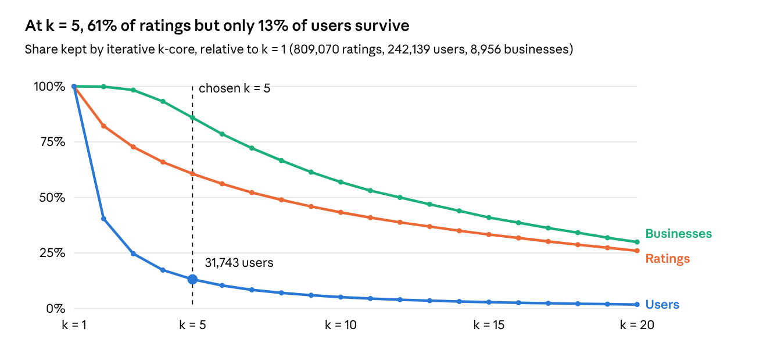
E13 · results/figdata/e13_shrink.csv · iterative k-core for k = 1 to 20
k = 5 keeps most ratings and businesses; raising k to 10 would halve the users again (12,406), so k = 5 stays.
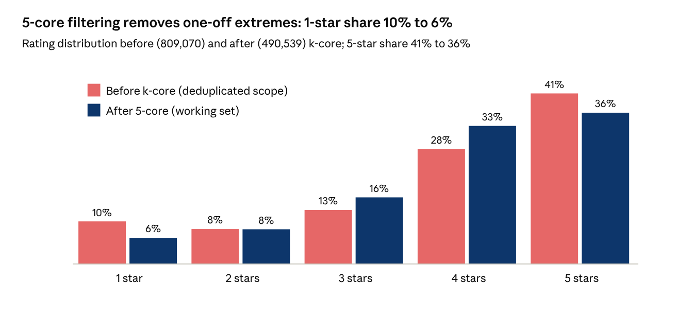
P2 · results/eda_stats.json rating_pre_post
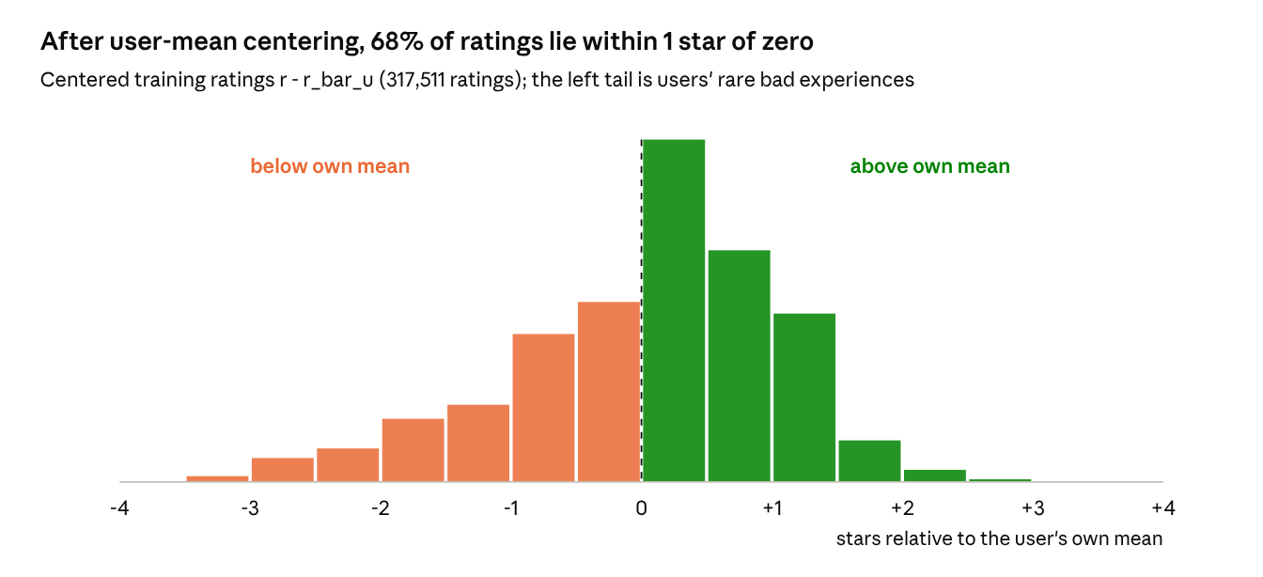
P3 · results/figdata/p3_centered.csv · training split
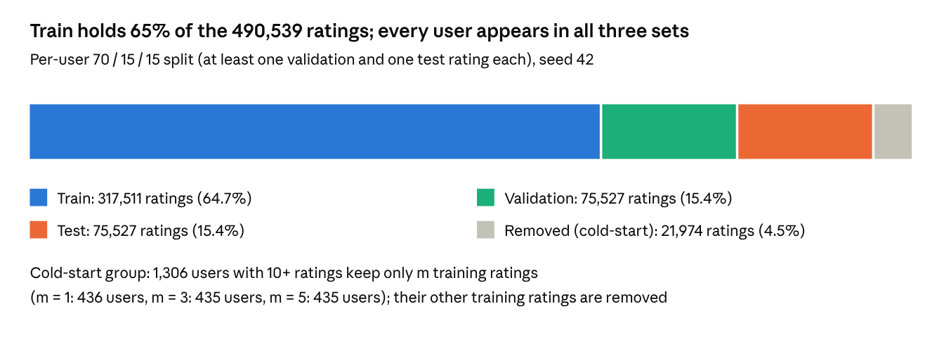
P4 · results/eda_stats.json split, cold
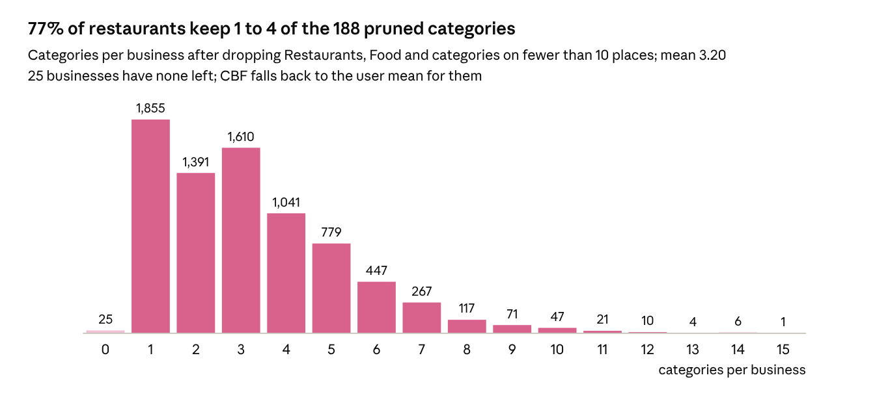
P5 · results/figdata/p5_cats_per_item.csv · 7,693 businesses

5. Models and algorithms
Four recommenders produce a predicted rating for every unseen open business; two baselines anchor the comparison. All models train on the same split and are tuned on validation RMSE.
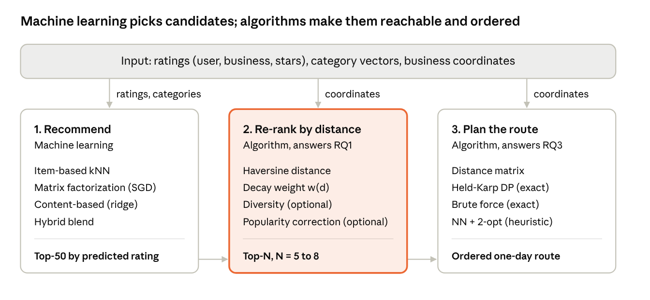
system architecture · 3 stages
Stage 1 is learned from data; stages 2 and 3 are deterministic and need only coordinates.
Family | Model | Learns from | Hyperparameters | Main strength
Baseline | Global mean | Ratings | none | Lower bound
Baseline | Bias model | Ratings | lambda_u, lambda_i | Captures harsh users and great places
Memory-based CF | Item-based kNN | Ratings | similarity, k, shrinkage beta | Interpretable neighbors
Model-based CF | Biased MF with SGD | Ratings | f, eta, lambda, epochs | Best accuracy on dense users
Content-based | Per-user ridge on category vectors | Ratings + categories | lambda_c, category cutoff | Works from 1 to 3 ratings
Hybrid | Adaptive weighted sum | CF + CBF outputs | alpha or kappa | Accuracy across activity levels

5.1 Baselines
The global mean predicts the same value for everyone. The bias model adds a user offset and an item offset, fitted with L2 regularization.
$${\hat{r}}_{ui}=μ$$
$$b_{ui}=μ+b_{u}+b_{i}$$
minb*(u,i)∈R​(rui−μ−bu−bi)2+λuu​bu2+λii​bi2
Alternating closed-form updates:
bi=u∈Ui​(rui−μ−bu)λi+|Ui|, bu=i∈Iu​(rui−μ−bi)λu+|Iu|

5.2 Memory-based CF: item-based kNN
Similarity between businesses i and j is computed over users who rated both, U_ij. Three variants are compared.
Cosine:
simcos(i,j)=u∈Uij​rui ruju∈Uij​rui2 u∈Uij​ruj2
Adjusted cosine (user-mean centered):
simadj(i,j)=u∈Uij​(rui−ru)(ruj−ru)u∈Uij​(rui−ru)2 u∈Uij​(ruj−ru)2
Pearson (item-mean centered):
simpcc(i,j)=u∈Uij​(rui−ri)(ruj−rj)u∈Uij​(rui−ri)2 u∈Uij​(ruj−rj)2
Similarities computed from a handful of co-raters are noisy, so they are shrunk toward zero:
$$s_{ij}=\frac{|U_{ij}|}{|U_{ij}|+β} \text{sim}(i,j)$$
Prediction uses the k most similar items that u has rated, N_k(i; u), on top of the bias baseline:
rui=bui+j∈Nk(i;u)​sij (ruj−buj)j∈Nk(i;u)​|sij|
If u has rated no neighbor of i, the prediction falls back to b_ui. Tuning grid: k in {10, 20, 40, 80}, beta in {0, 25, 100}.

5.3 Model-based CF: matrix factorization
Each user and business gets an f-dimensional latent vector; the rating is their dot product plus biases.
$${\hat{r}}_{ui}=μ+b_{u}+b_{i}+p_{u}^{⊤}q_{i}, p_{u},q_{i}∈R^{f}$$
Loss: mean squared error on observed ratings plus L2 regularization.
L=(u,i)∈Rtrain​(rui−rui)2+λbu2+bi2+∥pu∥2+∥qi∥2
Stochastic gradient descent, one observed rating at a time, with error e_ui and learning rate eta:
$$e_{ui}=r_{ui}−{\hat{r}}_{ui}$$
$$\begin{aligned}b_{u}&←b_{u}+η (e_{ui}−λb_{u}) \\ b_{i}&←b_{i}+η (e_{ui}−λb_{i}) \\ p_{u}&←p_{u}+η (e_{ui} q_{i}−λp_{u}) \\ q_{i}&←q_{i}+η (e_{ui} p_{u}−λq_{i})\end{aligned}$$
Initialization and stopping: latent vectors drawn from N(0, 0.1^2), ratings shuffled every epoch, training stops when validation RMSE has not improved for 3 epochs. Tuning grid: f in {10, 20, 50, 100}, eta in {0.002, 0.005, 0.01}, lambda in {0.01, 0.02, 0.05, 0.1}.

5.4 Content-based filtering
Each user gets a linear taste vector over the IDF-weighted category features from Section 4.5, fitted by ridge regression on what the bias baseline b_ui leaves unexplained. A first run centered on the user mean instead and failed for new users: with one rating the user mean is that rating, and RMSE reached 1.50.
θu=argminθj∈Iu​(ruj−buj−θ⊤xj)2+λc∥θ∥2
Closed form, with X_u the feature rows of the places u rated:
$$θ_{u}=(X_{u}^{⊤}X_{u}+λ_{c}I)^{−1}X_{u}^{⊤}\left(r_{u}−b_{u}\right)$$
$${\hat{r}}_{ui}^{\text{CBF}}=b_{ui}+θ_{u}^{⊤}x_{i}$$
For ranking and explanation, a simpler profile vector is also kept:
pucat=j∈Iu​ruj xjj∈Iu​|ruj|, sim(u,i)=pucat⊤xi∥pucat∥ ∥xi∥

5.5 Hybrid
The proposal’s fixed-weight blend, with alpha chosen by grid search on validation RMSE:
$${\hat{r}}_{ui}=α {\hat{r}}_{ui}^{\text{CF}}+(1−α) {\hat{r}}_{ui}^{\text{CBF}}, α^{*}=arg\min_{α∈\{0,0.1,…,1\}}{\text{RMSE}}_{\text{val}}(α)$$
The adaptive variant trusts CF more as a user rates more places; kappa is the number of ratings at which CF and CBF get equal weight:
$$α(n_{u})=\frac{n_{u}}{n_{u}+κ}, {\hat{r}}_{ui}=α(n_{u}) {\hat{r}}_{ui}^{\text{CF}}+\left(1−α(n_{u})\right) {\hat{r}}_{ui}^{\text{CBF}}$$

5.6 Candidate generation
Candidates are open businesses the user has not rated; the top M = 50 by predicted rating go to re-ranking.
$$C_{u}={top-M}_{ i∈I\backslash I_{u}, \text{is_open}(i)=1} {\hat{r}}_{ui}$$
Planned model figures:
ID | Figure | Plot type
M1 | Validation RMSE vs neighbors k, one line per similarity | Line chart
M2 | Distribution of item-item similarity values | Histogram
M3 | MF train and validation RMSE per epoch | Learning curves
M4 | Validation RMSE over f x lambda | Heatmap
M5 | Validation RMSE vs alpha | Line chart with the minimum marked
M6 | alpha(n_u) for the chosen kappa | Curve over n_u
M7 | Item latent factors projected to 2-D, colored by top category | t-SNE or UMAP scatter
M8 | Largest positive and negative weights of theta_u for sample users | Diverging bar chart
M9 | Learned item bias vs item mean rating | Scatter

6. Distance-aware re-ranking
The M = 50 candidates are re-scored by multiplying predicted rating with a distance weight, then cut to the final Top-N. The decay scale is the single knob that trades accuracy for travel distance, which is exactly what RQ1 measures.

6.1 Distance
Straight-line distance on the sphere (haversine), with Earth radius R_E = 6,371 km and coordinates in radians. Road distance is out of scope and noted as a limitation.
$$d(ℓ_{a},ℓ_{b})=2R_{E}arcsin\sqrt{\sin^{2}​\left(\frac{φ_{b}−φ_{a}}{2}\right)+cosφ_{a}cosφ_{b}\sin^{2}​\left(\frac{λ_{b}−λ_{a}}{2}\right)}$$

6.2 User anchor
Yelp has no user location, so the anchor is the median of the coordinates of the user’s training places (robust to one far trip). In the demo the anchor can also be a typed start point, such as a hotel.
$$ℓ_{u}=\left({median}_{j∈I_{u}^{\text{train}}}φ_{j}, {median}_{j∈I_{u}^{\text{train}}}λ_{j}\right)$$

6.3 Distance weight
Four decay shapes are compared, each with a scale parameter tuned on validation (initial value from the E8 activity radius).
$$w_{exp}(d)=e^{−d/τ}$$
$$w_{\text{gauss}}(d)=e^{−d^{2}/(2σ^{2})}$$
$$w_{\text{pow}}(d)=\frac{1}{(1+d/d_{0})^{γ}}$$
$$w_{\text{cut}}(d)=1[ d≤D_{max} ]$$
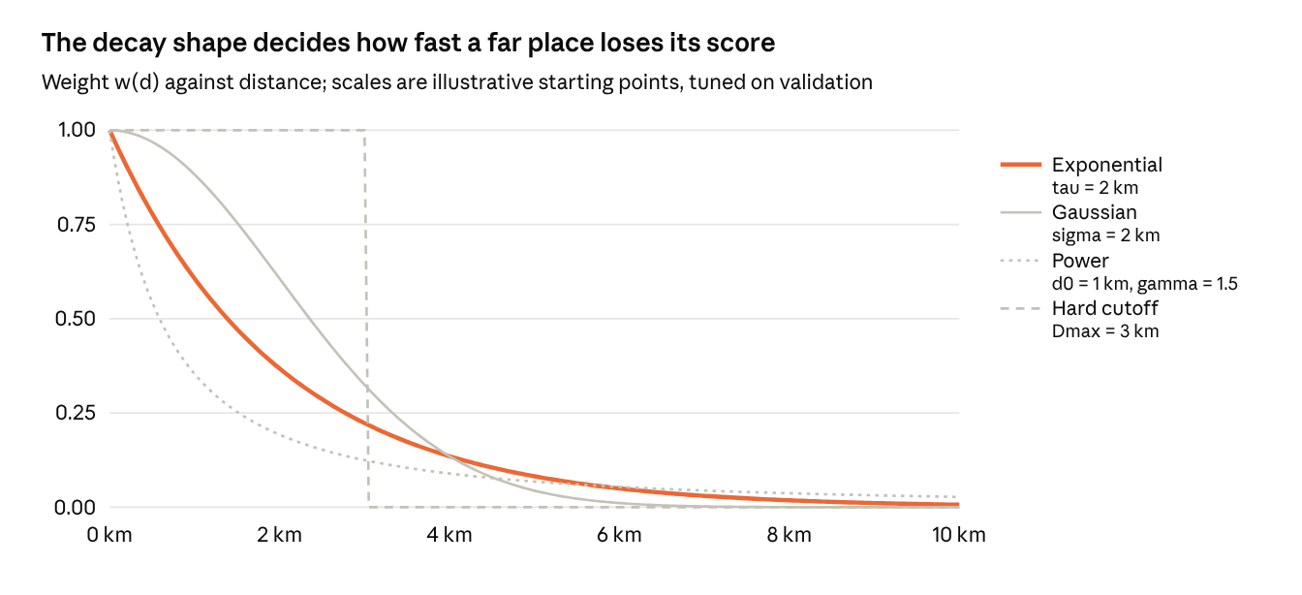
R1 preview · computed from the four formulas above at illustrative scales
The exponential curve is the proposed default: it never drops a place outright but halves its score every tau x ln 2, about 1.4 km at tau = 2 km.
Multiplicative score from the proposal, using the rating rescaled to [0, 1] so a weight of 0.5 always halves the score:
$$\text{score}(u,i)=\frac{{\hat{r}}_{ui}−1}{4}⋅w\left(d(ℓ_{u},ℓ_{i})\right)$$
Additive alternative for comparison, where lambda sets the price of one kilometre:
$${\text{score}}_{\text{add}}(u,i)=\frac{{\hat{r}}_{ui}−1}{4}−λ_{d}⋅\frac{d(ℓ_{u},ℓ_{i})}{D_{max}}$$

6.4 Category diversity (optional)
Maximal Marginal Relevance picks items one at a time, penalizing similarity to items already chosen (set S), with category cosine as similarity:
$$i^{*}=arg\max_{i∈C_{u}\backslash S}\left[λ_{m} \text{score}(u,i)−(1−λ_{m})\max_{j∈S}cos(x_{i},x_{j})\right]$$

6.5 Popularity-bias correction (optional)
Divide by a power of item popularity so long-tail places can surface; gamma = 0 means no correction.
$${\text{score}}_{\text{pop}}(u,i)=\frac{\text{score}(u,i)}{|U_{i}|^{γ}}, 0≤γ≤0.5$$
Planned re-ranking figures:
ID | Figure | Plot type
R1 | The four decay curves at their tuned scale | Line chart, weight vs km
R2 | Accuracy vs distance trade-off: NDCG@10 against mean distance of the list, one point per decay scale | Pareto frontier, the main RQ1 figure
R3 | Mean list distance before vs after re-ranking per user | Paired box plot
R4 | One user’s Top-10 before and after on a map | Two-panel map with anchor
R5 | Precision@10 and distance as tau grows | Dual-axis line chart
R6 | Intra-list diversity vs lambda_m | Line chart
R7 | Share of long-tail items in Top-10 vs gamma | Line chart

7. Route optimization
The final N places (N = 5 to 8) are ordered to minimize total walking or driving distance from the user’s start point. With N at most 8, the exact optimum is cheap: Held-Karp needs at most 8^2 x 2^8 = 16,384 steps.

7.1 Problem
An open-path traveling salesman problem: start at node 0 (the anchor), visit each of the N places once, and stop at the last place. The distance matrix D uses haversine distance.
$$D_{ab}=d(ℓ_{a},ℓ_{b}), a,b∈\{0,1,…,N\}$$
$$π^{*}=arg\min_{π∈S_{N}}\left[D_{0 π(1)}+\sum_{t=1}^{N−1}{D_{π(t) π(t+1)}}\right]$$
A closed tour (return to the start) adds the term D from pi(N) back to 0.

7.2 Exact: brute force
Enumerate all orders. For N = 8 that is 8! = 40,320 permutations, still well under a second.
$$T_{\text{brute}}(N)=O(N⋅N!)$$

7.3 Exact: Held-Karp dynamic programming
Let C(S, j) be the shortest path that starts at 0, visits exactly the set S, and ends at j in S.
$$C(\{j\},j)=D_{0j}$$
$$C(S,j)=\min_{k∈S\backslash \{j\}}\left[C(S\backslash \{j\},k)+D_{kj}\right]$$
$$L^{*}=\min_{j∈\{1,…,N\}}C(\{1,…,N\},j), T_{\text{HK}}(N)=O(N^{2}2^{N})$$
The route is recovered by storing the argmin k for every (S, j) and walking back from the best end node.
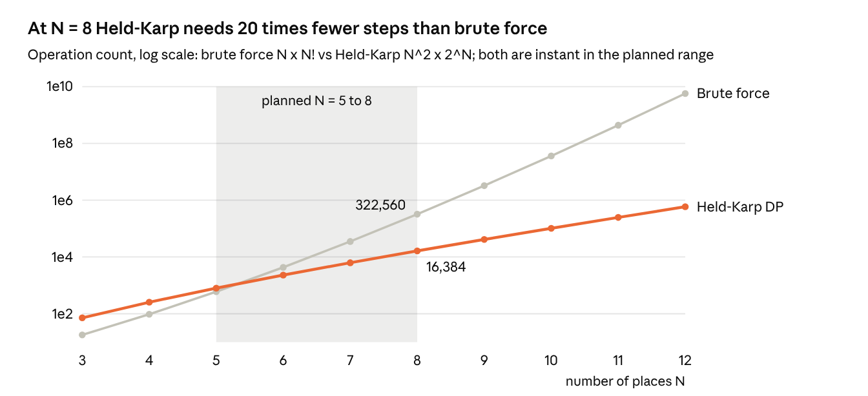
T2 preview · operation counts computed from the complexity formulas; measured runtimes replace these later
Above N = 12 brute force passes 5 billion steps, which is where Held-Karp and the heuristic start to matter.

7.4 Heuristic: nearest neighbor + 2-opt
Nearest neighbor always walks to the closest unvisited place, in O(N^2):
$$π(t+1)=arg\min_{v∉\{π(1),…,π(t)\}}D_{π(t) v}$$
2-opt then reverses the segment between positions a+1 and b whenever that shortens the path, and repeats until no move helps:
$$Δ(a,b)=D_{π_{a}π_{b}}+D_{π_{a+1}π_{b+1}}−D_{π_{a}π_{a+1}}−D_{π_{b}π_{b+1}}<0 ⇒ \text{reverse }π_{a+1..b}$$
Heuristic quality is reported as the optimality gap:
$$\text{gap}=\frac{L_{\text{heur}}−L^{*}}{L^{*}}×100\%$$

7.5 Extension: opening hours (stretch goal)
With arrival time A_v, service time s_v and opening window [o_v, c_v] from the hours field, a route is feasible only if every place is open on arrival:
$$A_{π(t+1)}=max\left(A_{π(t)}+s_{π(t)}+D_{π(t)π(t+1)}/v, o_{π(t+1)}\right)≤c_{π(t+1)}$$
Planned routing figures:
ID | Figure | Plot type
T1 | Optimal route vs recommendation order vs nearest neighbor on one map | Three-panel map with numbered stops
T2 | Runtime vs N for brute force, Held-Karp, NN + 2-opt | Line chart, log y-axis
T3 | Optimality gap of NN and NN + 2-opt over 1,000 random users | Box plot
T4 | Route length: unordered list vs optimized | Paired histogram of saved km
T5 | Gap vs N | Line chart with 95% bands

8. Evaluation
Every model is scored on the same test set with rating-error, ranking, beyond-accuracy, distance and routing metrics. A test rating of 4 or 5 stars counts as relevant; with 67% of ratings at 4 or above, this threshold keeps the task non-trivial only if candidate lists exclude already-rated places.
Stage | Metric | Compared | Answers
Rating prediction | RMSE, MAE | Global mean, bias, Item-kNN, MF, CBF, Hybrid | Which model predicts best
Top-N ranking | Precision@K, Recall@K, NDCG@K, HitRate@K (K = 5, 10) | Same models | Which model ranks best
Beyond accuracy | Catalog coverage, intra-list diversity, novelty | Before and after re-ranking | Side effects of re-ranking
Distance re-ranking | Mean distance of Top-K, NDCG loss per km saved | Decay shapes and scales | RQ1
Cold start | RMSE at m = 1, 3, 5 training ratings | CF only, CBF, Hybrid | RQ2
Routing | Route length, optimality gap, runtime | Brute force, Held-Karp, NN, NN + 2-opt | RQ3

8.1 Rating error
RMSE=1|T|(u,i)∈T​(rui−rui)2, MAE=1|T|(u,i)∈T​|rui−rui|

8.2 Ranking
With L_u^K the top-K list and Rel_u the relevant test items of user u:
Precision@K=1|U|u​|LuK∩Relu|K, Recall@K=1|U|u​|LuK∩Relu||Relu|
$$\text{DCG@}K=\sum_{k=1}^{K}{\frac{2^{ {\text{rel}}_{k}}−1}{\log_{2}(k+1)}}, \text{NDCG@}K=\frac{\text{DCG@}K}{\text{IDCG@}K}$$
HitRate@K=1|U|u​1 |LuK∩Relu|≥1

8.3 Beyond accuracy
$$\text{Coverage}=\frac{|\underset{u}{⋃}L_{u}^{K}|}{|I|}$$
ILD(L)=2K(K−1)i<j∈L​1−cos(xi,xj)
Novelty(L)=1Ki∈L​−log2|Ui||U|

8.4 Distance
duK=1Ki∈LuK​d(ℓu,ℓi), Cost per km=NDCGbefore−NDCGafterdbefore−dafter

8.5 Significance
Model differences are tested per user with a paired t-test on per-user scores, plus a 95% bootstrap interval (B = 1,000 resamples of users):
$$t=\frac{\overset{‾}{δ}}{s_{δ}/\sqrt{n}}, δ_{u}=m_{A}(u)−m_{B}(u)$$
Planned result figures:
ID | Figure | Plot type
V1 | RMSE and MAE per model with 95% CI | Grouped bar chart
V2 | Precision@K and Recall@K for K = 1 to 20 | Line chart per model
V3 | NDCG@10 per model | Dot plot with CI
V4 | RMSE by user activity bucket (5-9, 10-19, 20-49, 50+) | Grouped bar chart per model
V5 | Cold-start RMSE at m = 1, 3, 5 | Line chart: CF, CBF, Hybrid
V6 | Coverage vs NDCG per model | Scatter
V7 | Residual distribution per model | Violin plot
V8 | Predicted vs actual rating | Confusion-style heatmap, 5 x 5
V9 | Summary of all metrics, all models | Results table

9. Preliminary results
A first end-to-end run of src/prototype.py (8 minutes on a laptop) already answers part of each research question. These numbers are preliminary: hyperparameters were tuned on the small grids in Section 5, and Top-N metrics use 3,000 sampled test users.
Question | Preliminary answer | Evidence
Which model predicts ratings best? | Bias, MF, CBF and Hybrid tie at test RMSE 1.051 to 1.052; Item-kNN is worse (1.142) | Figures V1, M1, M3, M4
RQ1: cost of adding distance? | Negative cost: with tau = 2 km, NDCG@10 rises 3.5x (0.0017 to 0.0059) while mean list distance falls from 6.3 to 2.1 km | Figures R2, R3
RQ2: does CBF help cold users? | Not yet: at m = 1, 3, 5 CBF and Hybrid match the bias model within 0.002 RMSE | Figure V5
RQ3: heuristic vs exact route? | NN + 2-opt is exactly optimal for 82% of users (mean gap 0.9%); the unordered list is a median 27% longer than optimal | Figures T3, T4, T2
The largest open problem is ranking: popularity alone beats every rating model on Precision@10 (0.0095 vs 0.0005 to 0.0007), so the final system needs a ranking-aware candidate stage.

9.1 Rating prediction
On this data most of the predictable signal is in the user and item biases. Latent factors and category weights add almost nothing to RMSE, which is itself a finding to report.
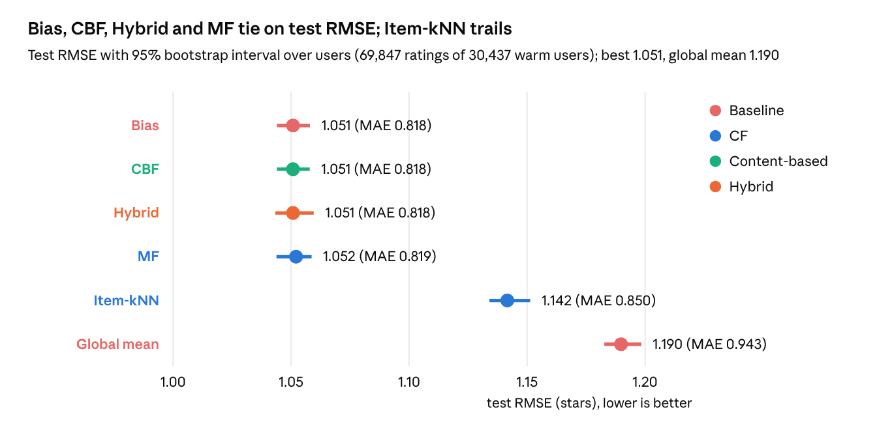
V1 · results/prototype.json test · warm test users
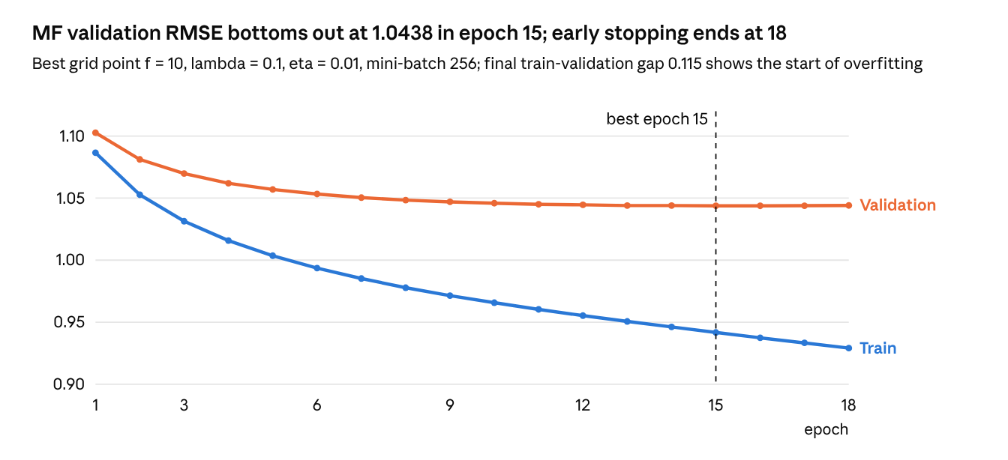
M3 · results/prototype.json mf_curve
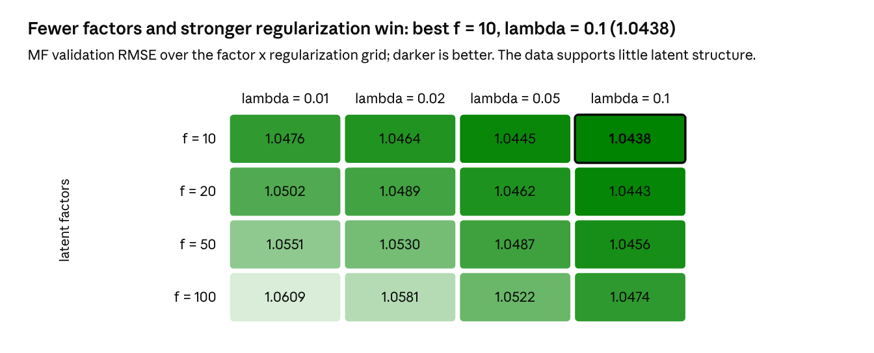
M4 · results/prototype.json mf_grid · validation set
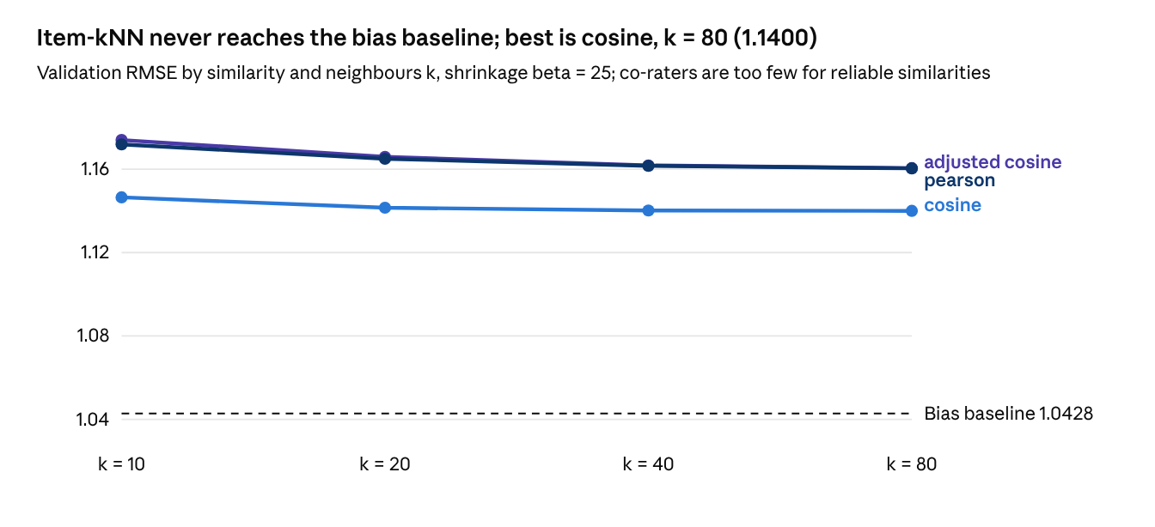
M1 · results/prototype.json knn_grid · validation set
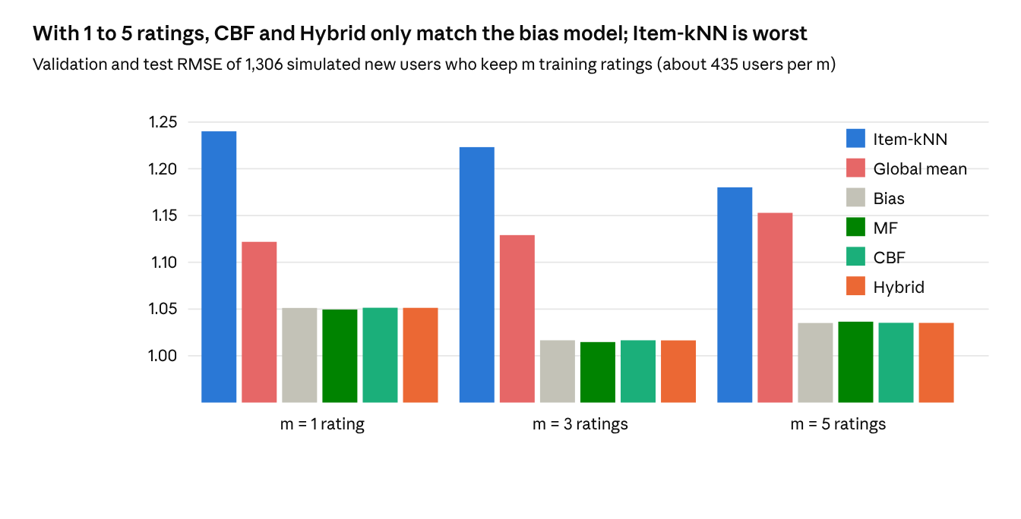
V5 · results/prototype.json cold
RQ2 is still open: in this first run, CBF’s ridge weight settled at lambda = 30, so the category term is almost switched off. Next steps are richer item features (price range, attributes, review text) and tuning CBF on the cold-start group itself.
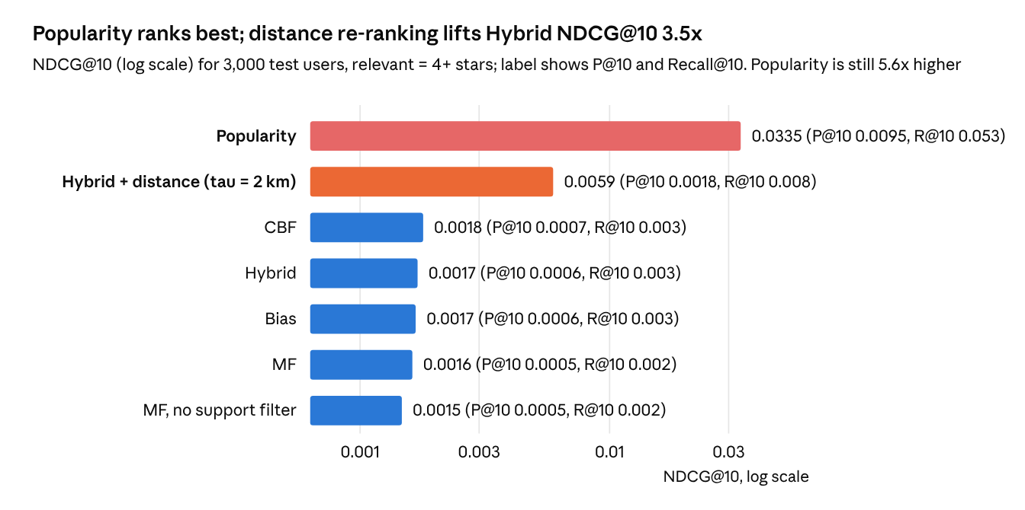
V3 · results/prototype.json ranking, pareto (exp, tau = 2) · 3,000 sampled test users
Rating-trained models favor places that few users rated, even after the minimum-support filter (20 training ratings, 3,288 places). The final system will add a popularity-aware candidate stage before distance re-ranking.

9.2 Distance re-ranking
The RQ1 hypothesis was a trade-off: closer lists, lower accuracy. The first run shows the opposite. Users mostly review places near where they already go, so distance is itself a strong relevance signal.
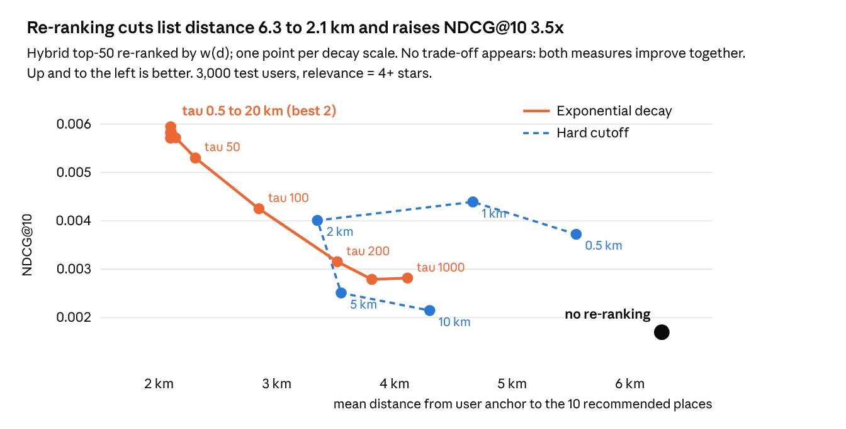
R2 · results/prototype.json pareto · Hybrid candidates, 3,000 test users
Predicted ratings at the top of the list are very close (for the user in 9.4, the top 10 span only 4.57 to 4.70 stars), so any decay scale under 20 km lets distance decide the order. Only very large scales (100 km and up) give back the rating order. The hard cutoff is worse than smooth decay at every radius.
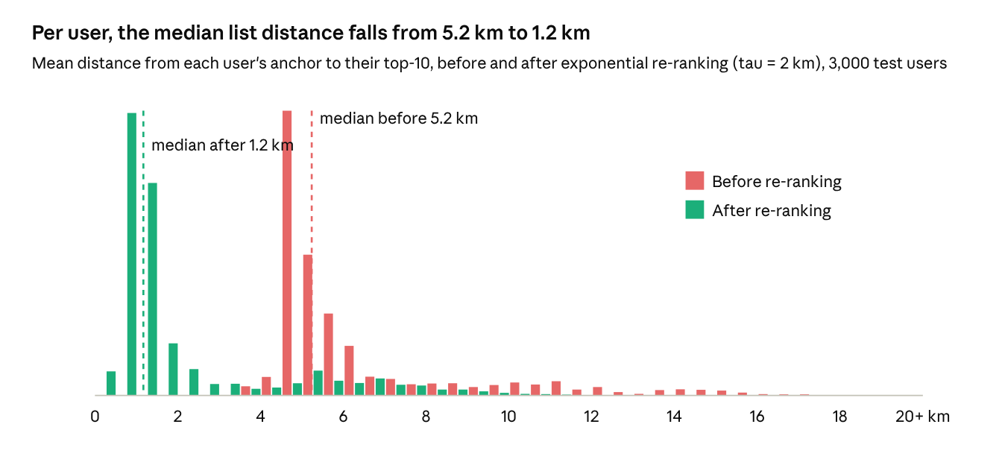
R3 · results/figdata/r3_dist_before_after.csv
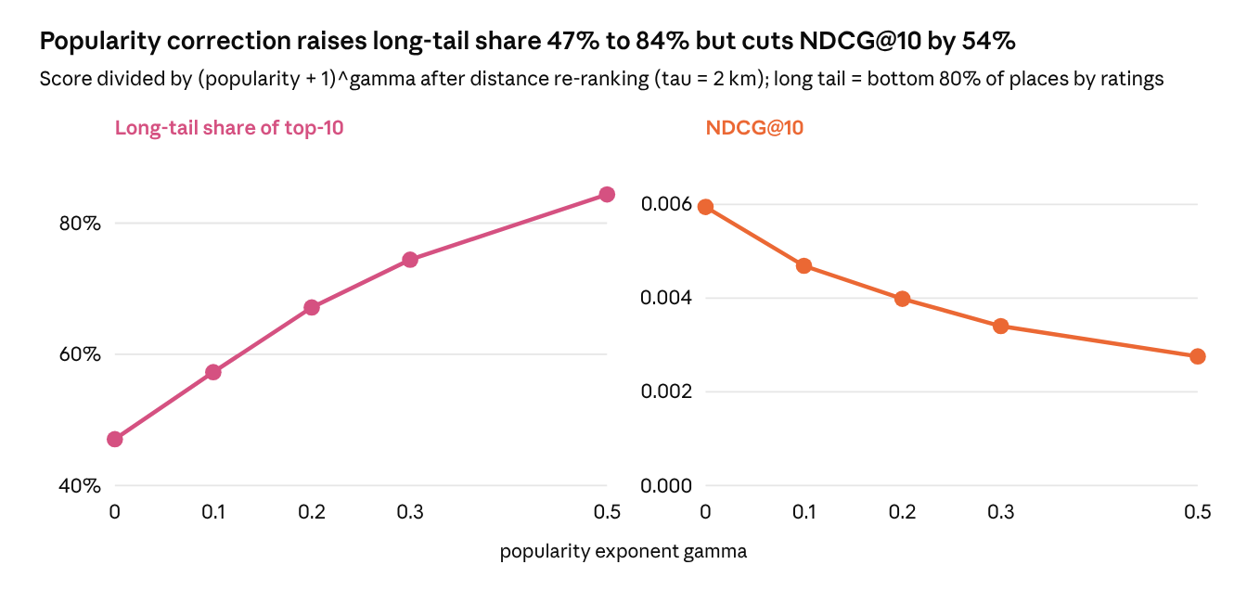
R7 · results/prototype.json popcorr
Popularity correction works as intended on long-tail share, but on this data it costs accuracy. It stays an optional knob, and gamma = 0 is the default.

9.3 Route optimization
Ordering matters even for six nearby places, and the exact solver is cheap enough to run every time. The heuristic is kept only as a comparison for RQ3.
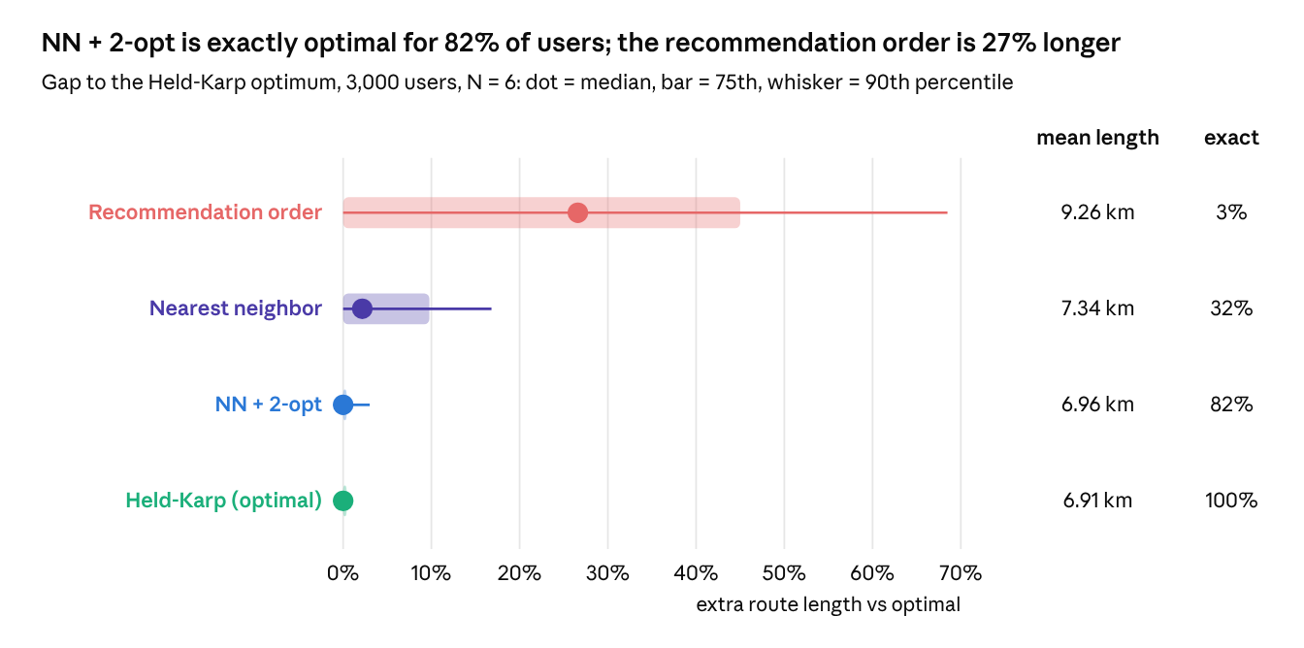
T3 · results/prototype.json route · 3,000 test users, N = 6
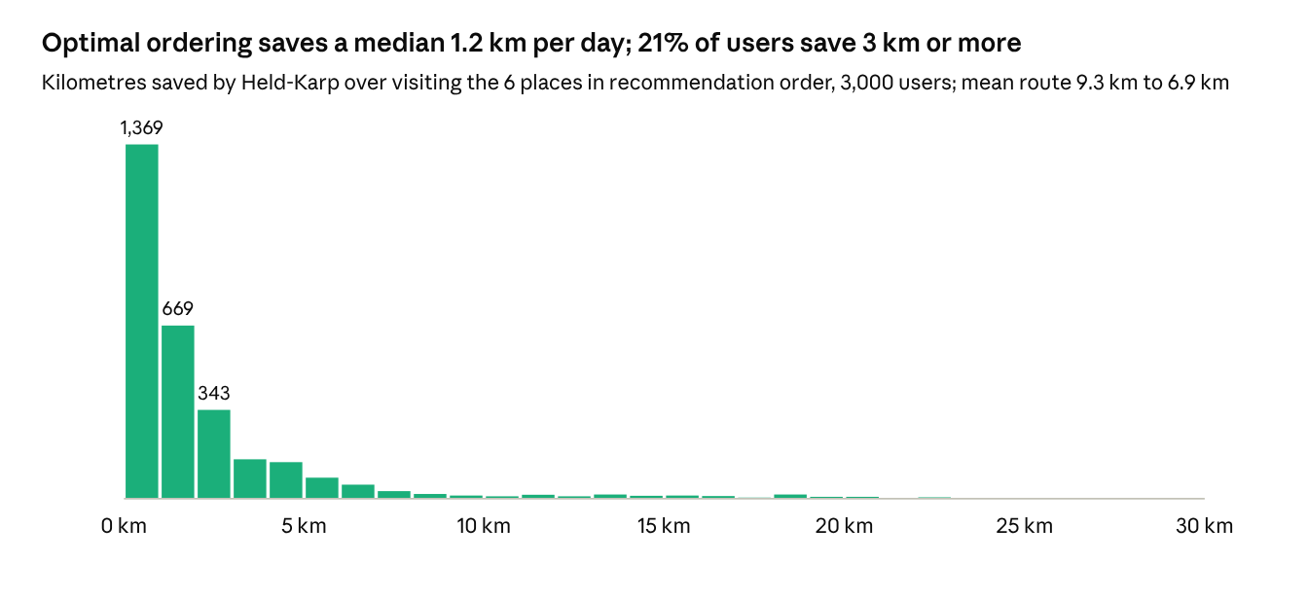
T4 · results/prototype.json route.saved_km
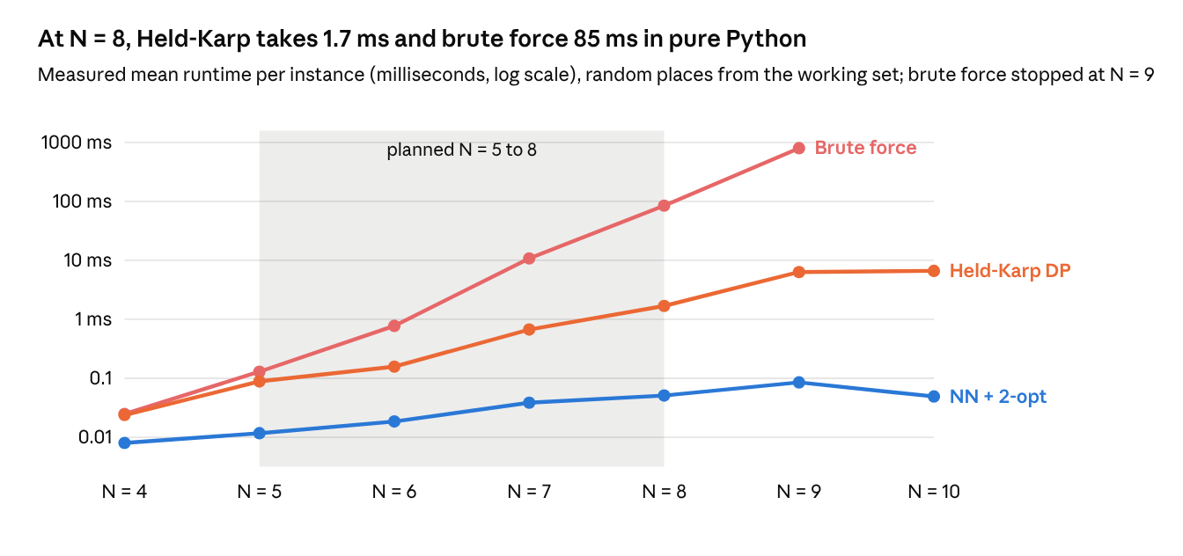
T2 · results/prototype.json timing · 10 random instances per N
The measured curves replace the operation-count preview in Section 7.3: Held-Karp stays under 7 ms up to N = 10, while brute force is already 0.8 s at N = 9.

9.4 Worked example: one user through the pipeline
One test user with 45 training ratings shows all three stages: how a rating is predicted, how distance changes the list, and how the day route is ordered. src/prototype.py picks this user automatically as the case where re-ranking and route ordering both change the most.
Stage 1, rating prediction. The hybrid trusts MF with weight alpha = 45 / (45 + 100) = 0.31 and CBF with 0.69.
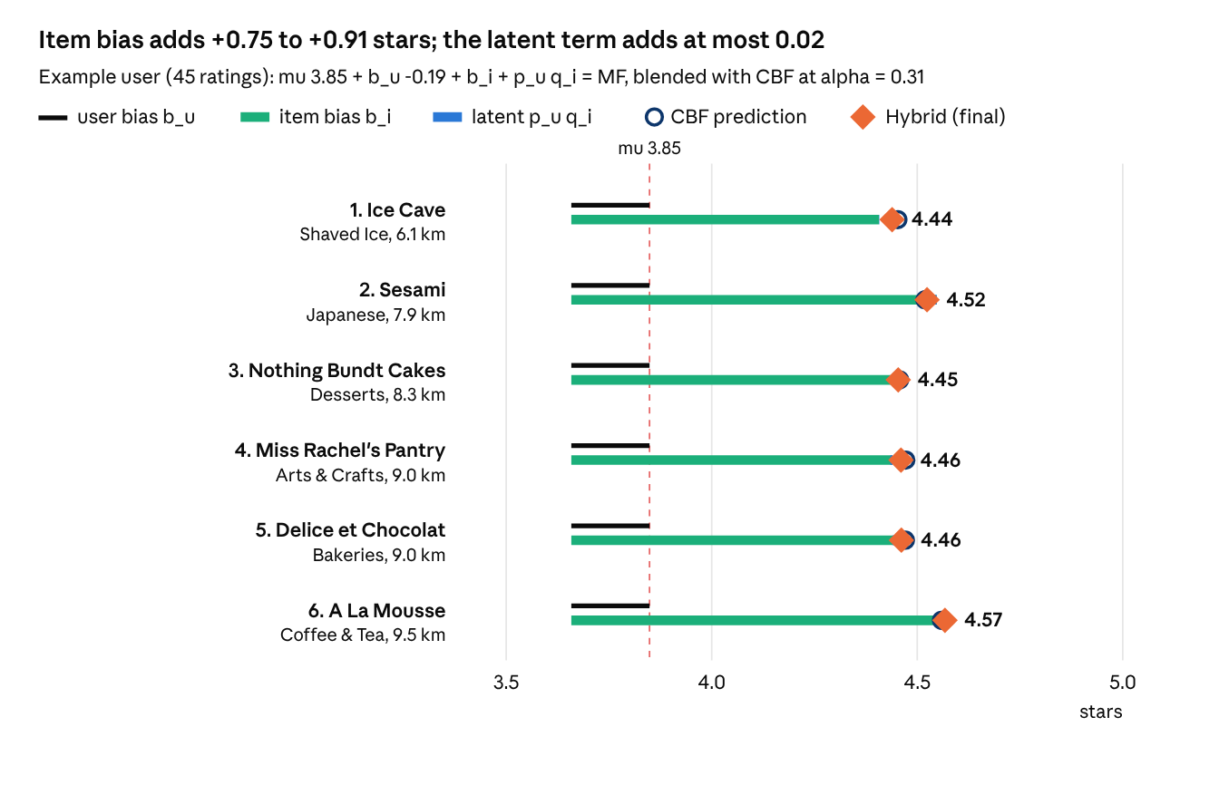
X1 · results/figdata/x_lists.csv · example test user, final 6 places
Stage 2, distance re-ranking. Before re-ranking, all ten places are 10 to 21 km from where this user usually eats. After it, the list moves to 6 to 10 km while predicted ratings drop only from the 4.57 to 4.70 range to 4.41 to 4.57.
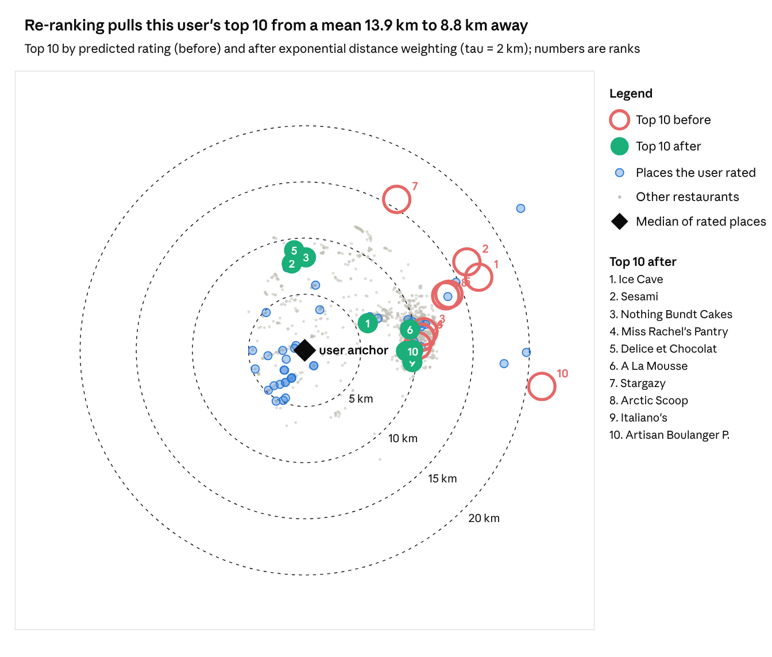
X2 · results/figdata/x_lists.csv, x_train.csv, x_background.csv
Stage 3, route ordering. The six top places are visited from the anchor in three orders.
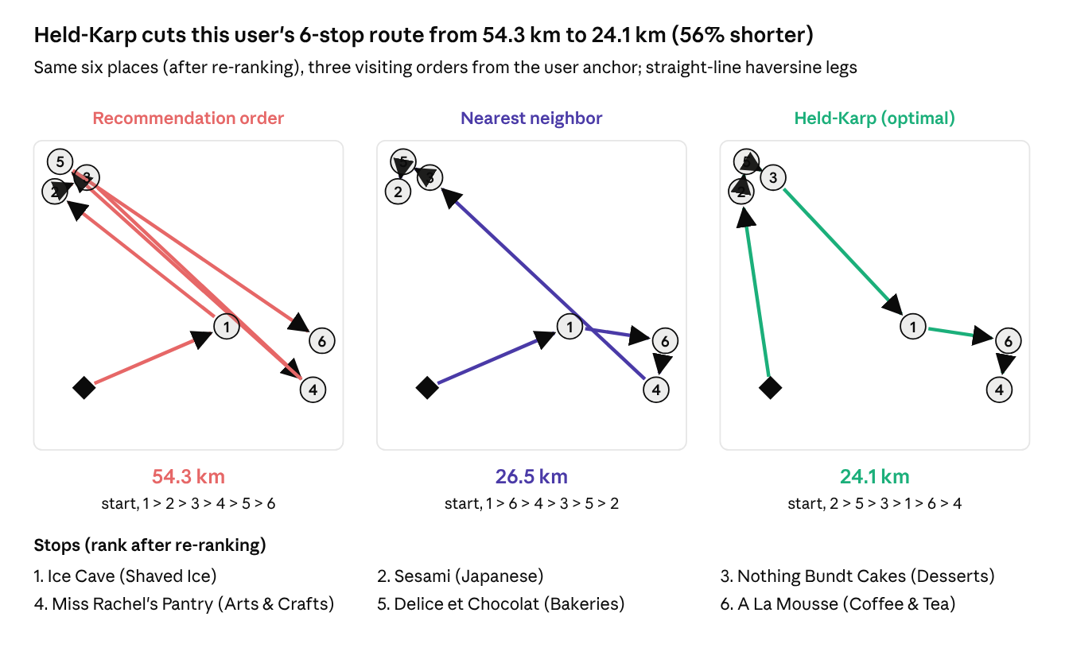
X3 · results/figdata/x_lists.csv · route orders from results/prototype.json example

9.5 Model comparison and hyperparameter search
The first run searched 107 configurations across nine grids, always choosing on the validation set and reporting the test set once. Bias, MF, CBF and Hybrid land within 0.002 test RMSE of each other while Item-kNN trails at 1.142. MF and CBF both pick the strongest regularization in their grids, a sign that the data supports little structure beyond the biases.
Model or stage | Searched (configurations) | Best setting | Validation RMSE | Test RMSE | NDCG@10 | Figure
Global mean | none (1) | - | - | 1.190 | - | V1
Popularity | none (1) | - | - | - | 0.0335 | V3
Bias | lambda in {1, 5, 10, 25} (4) | lambda = 5 | 1.0428 | 1.051 | 0.0017 | H1
Item-kNN | similarity x 3, k in {10, 20, 40, 80} (12); beta = 25 fixed | cosine, k = 80 | 1.1400 | 1.142 | not ranked | M1
MF (SGD) | f in {10, 20, 50, 100} x lambda in {0.01, 0.02, 0.05, 0.1} (16); eta = 0.01 fixed | f = 10, lambda = 0.1, 15 epochs | 1.0438 | 1.052 | 0.0016 | M3, M4
CBF (ridge) | lambda_c in {0.3, 1, 3, 10, 30} (5) | lambda_c = 30 | 1.0426 | 1.051 | 0.0018 | H1
Hybrid, fixed alpha | alpha in {0, 0.1, …, 1} (11) | alpha = 0.1 | 1.0441 | - | - | H1
Hybrid, adaptive alpha(n_u) | kappa in {0.5, …, 100} (9) | kappa = 100 | 1.0426 | 1.051 | 0.0017 | H1
Hybrid + distance re-ranking | decay x 4, tau 0.5 to 1000 km (40) | exponential, tau = 2 km | - | - | 0.0059 | R1, R2
Popularity correction | gamma in {0, 0.1, 0.2, 0.3, 0.5} (5) | gamma = 0 | - | - | 0.0059 | R7
MMR diversity | lambda_m in {1, 0.9, 0.8, 0.7, 0.5} (5) | lambda_m = 1 | - | - | see H2 | H2
Route ordering | 4 algorithms | Held-Karp (exact, 1.7 ms at N = 8) | - | - | - | T2, T3
Two grids in Section 5 were fixed in this run and are next on the list: the MF learning rate eta (planned 0.002 to 0.01) and the kNN shrinkage beta (planned 0, 25, 100).
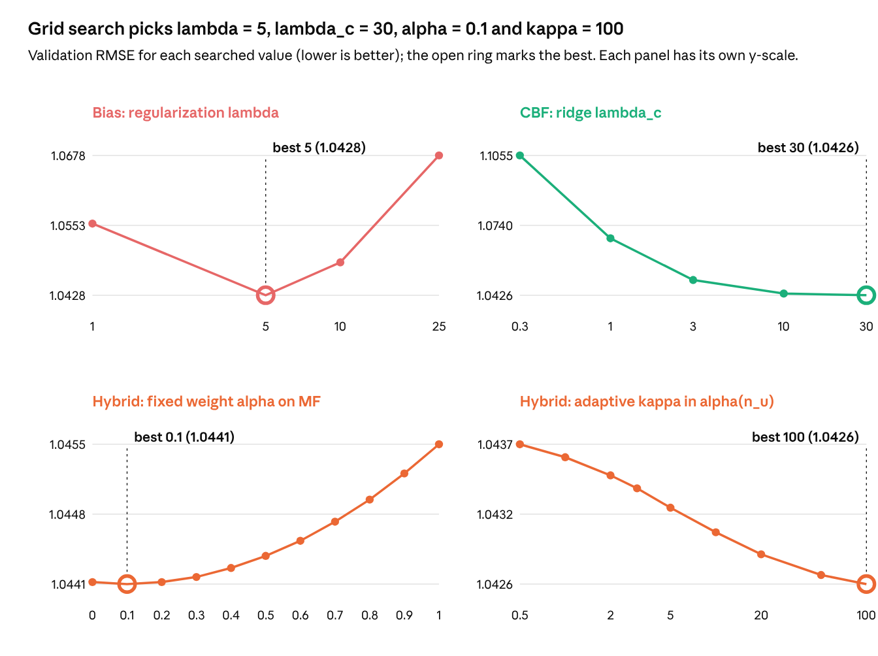
H1 · results/prototype.json bias_grid, cbf_grid, alpha_curve, kappa_curve · validation set
The alpha and kappa curves are almost flat (a spread of 0.0014 and 0.0011 RMSE), so the blend weight barely matters in this run; the CBF and Bias curves are where tuning pays.
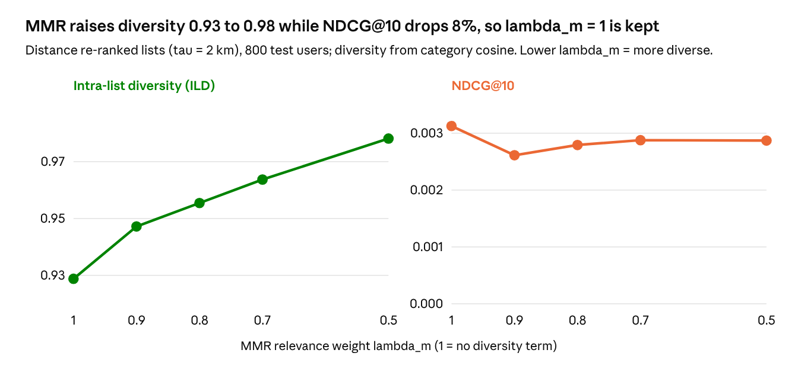
H2 · results/prototype.json mmr · 800 test users

10. Scope and open decisions
The plan lists 49 figures: 14 EDA (E), 5 preprocessing (P), 9 model (M), 7 re-ranking (R), 5 routing (T) and 9 evaluation (V). 31 of them are already drawn from real data in this proposal (E1 to E13, P1 to P5, M1, M3, M4, R1 to R3, R7, T2 to T4, V1, V3, V5), plus the three worked-example figures X1 to X3. The final report should feature E8, E13, V1, V5, R2, T3 and X1 to X3; the rest go to an appendix.
Priority | Work | Figures
Required | Preprocessing, baselines, Item-kNN, MF, CBF, Hybrid, distance re-ranking | E1-E14, P1-P5, M1-M9, R1-R5, V1-V9
If time allows | Route optimization (N up to 8, brute force and Held-Karp) | T1, T2, T4
Stretch | Diversity, popularity correction, opening hours, NN + 2-opt comparison | R6, R7, T3, T5
Open decisions:
- Confirm the city: Philadelphia restaurants (proposed) or New Orleans.
- Confirm k for k-core (5 proposed) after E13.
- Set radius R for the city scope after E6.
- Choose random or temporal split as the main protocol.
- Team size and role split.

