Module Name: Web Development (Introduction)
Module Code: WEDE5020
Full Name: Mojapelo Rebecca
Student Number:ST10523809

TABLE OF CONTENTS
- Organisation Overview
- Website Goals and Objectives
- Current Website Analysis
- Proposed Website Features and Functionality
- Design and User Experience
- Technical Requirements
- Timeline and Milestones
- Budget
- References
- Sitemap

1. Organisation Overview
Name: GlowLab Beauty
Brief History: GlowLab Beauty is a small, proudly South African skincare brand that was launched two years ago. It started as a small home-based business by a skincare enthusiast who wanted to create products that were free from harsh chemicals. Today, GlowLab has grown into a beloved local brand known for its natural, cruelty-free serums and moisturizers.
Mission Statement: To make high-quality, natural skincare simple, safe, and accessible for everyone, without compromising on effectiveness or harming the planet.
Vision Statement: To empower every individual to embrace their natural skin and feel confident in their own glow, by providing education and products that truly work.
Target Audience: Our target audience is primarily women and men between the ages of 20 and 45, who are conscious about the ingredients they put on their skin. They are health-aware, value sustainability, and are looking for affordable luxury skincare solutions.

2. Website Goals and Objectives
Specific Goals:
The primary goal of this project is to build a professional, user-friendly website that acts as the main digital storefront for GlowLab Beauty.
- Goal 1: To increase online product enquiries by 20% over the next 6 months.
- Goal 2: To establish GlowLab's credibility as a professional skincare expert, moving beyond just being a "social media page."
- Goal 3: To provide a seamless and informative experience where customers can easily learn about the products and contact the brand for personalized advice.
Key Performance Indicators (KPIs): To measure the success of the website, we will track the following metrics:
- Monthly Traffic: The number of unique visitors coming to the site.
- Enquiry Form Submissions: The number of successful form submissions from the enquiry page.
- Bounce Rate: The percentage of visitors who leave after viewing only one page (we want this to be low, under 50%).
- Time on Page: How long visitors spend reading the "About Us" and "Products" pages.

3. Current Website Analysis
Strengths (What is working well):
Currently, GlowLab relies heavily on Instagram. Their strength is a strong visual aesthetic and an engaged community of followers who love seeing new product photos.
Weaknesses (What needs fixing):
- Lack of a Central Hub: There is no official website. All product information is scattered across Instagram posts and stories, making it hard for new customers to find clear, consolidated information.
- Hard to Buy/Enquire: There is no dedicated enquiry system. Customers have to send Direct Messages, which get lost easily.
- No Brand Authority: Without a professional website, the brand looks less legitimate compared to large corporate skincare companies.
Areas for Improvement: By building this website, we will solve all of these weaknesses. The website will be the "single source of truth" for all product details, pricing, and brand values. It will move the brand from a "social media shop" to a proper business with a professional online presence.

4. Proposed Website Features and Functionality
We plan to build a 5-page website to ensure the brand is fully represented.
- Homepage (index.html): This will feature a stunning hero image (a glowing model or beautiful product shot), a catchy headline ("Your Skin Deserves the Glow"), a "Shop Now" button, and a section highlighting the top 3 best-selling products.
- About Us (about.html): This page will tell the story of how GlowLab started, explain the mission and vision, and feature a "Meet the Founder" section to build a personal connection with the customer.
- Our Products (products.html): This page will act as a product catalog. It will list each serum and moisturizer with a photo, a short description, and the price.
- Skincare Enquiry (enquiry.html): This page will feature a form where customers can ask for personalized skincare advice. They can select their skin type (oily, dry, combination) and ask a question. Once they submit the form, they will receive a response confirming that the skincare expert will get back to them within 24 hours.
- Contact Us (contact.html): This page will feature the brand's main studio address in Cape Town, a second stockist location in Johannesburg, an interactive map showing both locations, and a separate contact form for general business inquiries.site
5. Design and User Experience
Overall Design Aesthetic: We want the website to feel "clean, airy, and spa-like." It should be visually calming and relaxing, just like a high-end skincare clinic. We will use a minimalist design approach with plenty of white space so that the focus is purely on the beautiful product photos.
Colour Scheme:
- Primary Background: Pure White (#FFFFFF)
- Main Accent: Soft Pastel Pink (#F8E8E8) – This feels feminine, gentle, and soothing.
- Secondary Accent: Warm Gold (#D4AF37) – This will be used for buttons and borders to give a sense of "luxury" and quality.
- Text: Dark Slate Grey (#333333) – To keep it readable, professional, and easy on the eyes.
Typography:
- Headings: We will use "Playfair Display" – a beautiful, elegant serif font that feels high-end.
- Body Text: We will use "Open Sans" – a clean, modern sans-serif font that is extremely easy to read on all devices.
- Font Hierarchy: H1 will be large and bold; H2 will be slightly smaller; paragraphs will be kept to a readable size of 16px.
User Experience (UX) Considerations:
- Simple Navigation: The menu will be placed at the top of every page. The links will be clear so the user never gets lost.
- Mobile Friendly: The layout will adapt perfectly to a mobile phone, with the menu collapsing into a "hamburger" icon.
- Call-to-Action (CTA) Buttons: We will use the warm gold color for buttons like "Get Started" or "Send Enquiry" to make it obvious to the user what they need to click next.
Low-Fidelity Wireframes:
Below is a low-fidelity wireframe sketch showing the general layout of the Homepage, Products Page, and Contact Page.
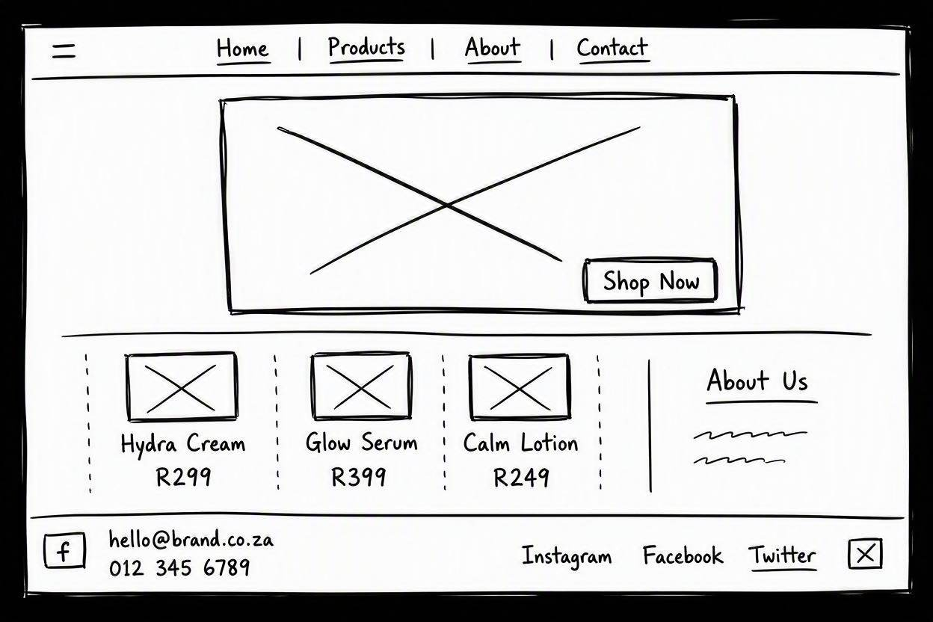

About
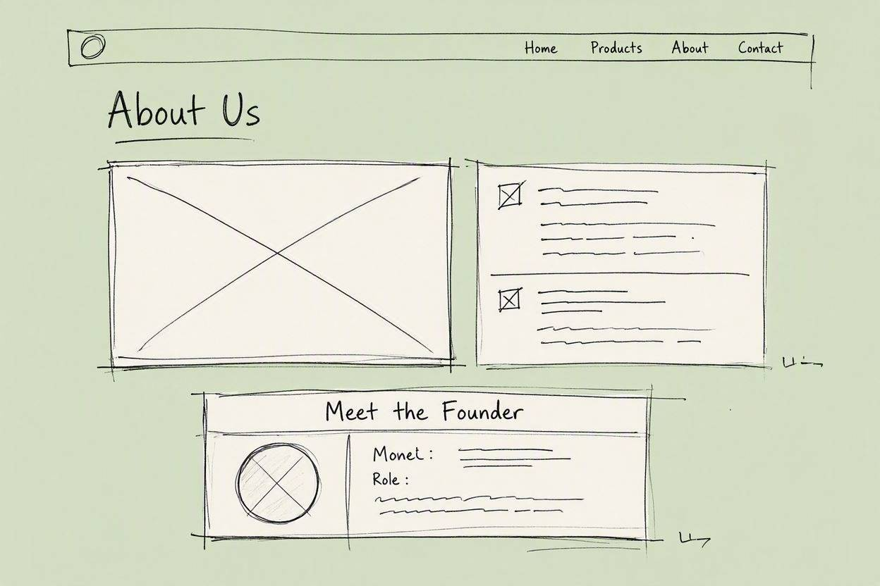
6. Technical Requirements
- Programming Languages: We will use standard HTML5 for the page structure, CSS3 for all the styling and layout, and JavaScript (Vanilla) for the form validation and interactive features.
- Hosting and Domain: We will deploy the final website on a free hosting platform like Netlify or GitHub Pages. We will purchase a custom domain name (e.g., www.glowlabbeauty.co.za) to make it look even more professional.
- Version Control: The entire project will be tracked using Git and pushed to a private GitHub repository. This ensures we have a history of every change made and can easily fix any mistakes.

7. Timeline and Milestones
To stay organized, I will break the project down into three main phases, following the assignment instructions.
- Phase 1 (Part 1) – Building the Foundation (Weeks 1 & 2):
  - Submit two proposals for approval.
  - Research content and gather free images from Unsplash.
  - Write the HTML code for all 5 pages and create the folder structure.
  - Set up the GitHub repository and push the initial code.
- Phase 2 (Part 2) – Designing the Visuals (Weeks 3 & 4):
  - Create the external CSS file (style.css).
  - Apply the colour scheme, typography, and layout using Flexbox/Grid for desktop.
  - Use media queries to make the site responsive for tablets and mobile phones.
  - Update the GitHub repository with the new CSS changes.
- Phase 3 (Part 3) – Adding Functionality and SEO (Weeks 5 & 6):
  - Write JavaScript to validate the forms on the Enquiry and Contact pages.
  - Add an interactive gallery/lightbox for the product images.
  - Optimize the site for SEO (add title tags, meta descriptions, alt text for images).
  - Deploy the live website to Netlify.

8. Budget
Since this is a web development assignment project, we will focus on a very low-budget approach. The following is a realistic estimate of what it would cost to get this site live in the real world:
Item | Cost
Domain Name (e.g., .co.za) | R150.00 (One-time annual fee)
Web Hosting (Netlify/GitHub Pages) | R0.00 (Free tier is sufficient)
Stock Images (Unsplash / Pexels) | R0.00 (Free to use)
Total Estimated Budget | R150.00
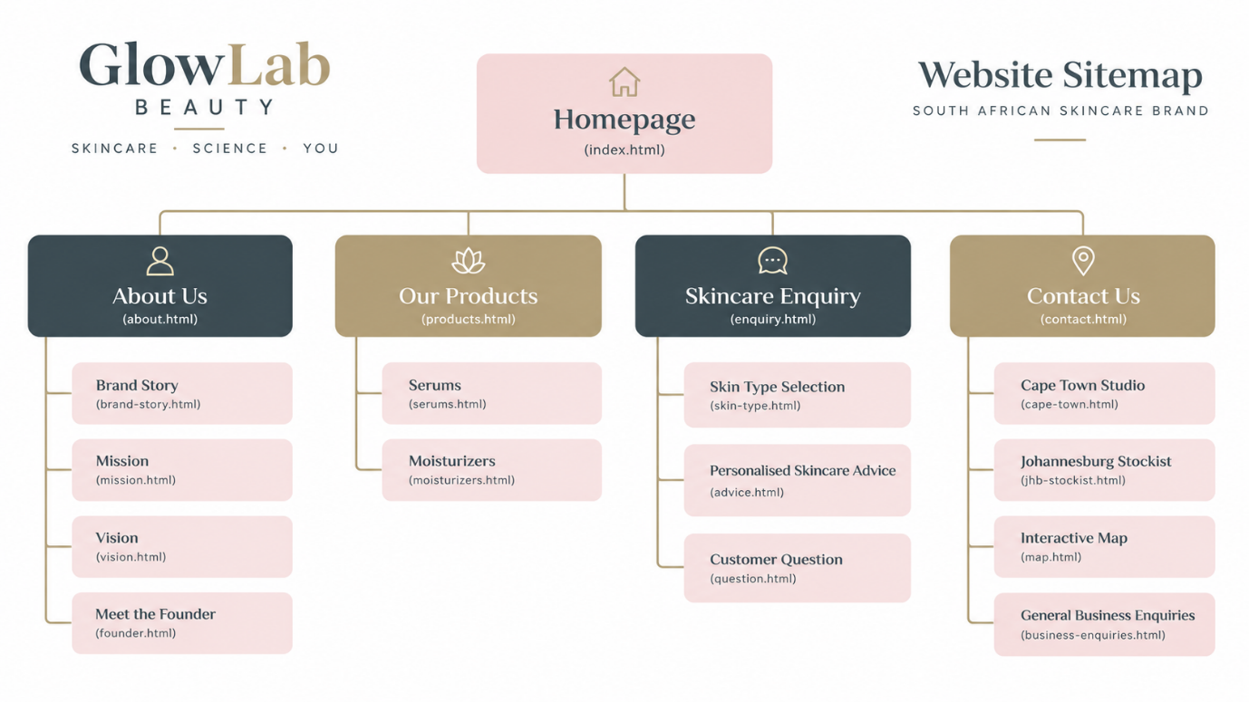
9. References
GlowLab Beauty is a fictional entity created for the purpose of this assignment. All content, logos, and branding are hypothetical and were created solely for educational use.
However, I have researched various web development techniques and resources to ensure I build the website correctly:
- W3Schools. (2026). HTML Semantic Elements. [Online]. Available at: https://www.w3schools.com/html/html5_semantic_elements.asp (Accessed: 10 August 2026).
- MDN Web Docs. (2026). Responsive Design. [Online]. Available at: https://developer.mozilla.org/en-US/docs/Learn/CSS/CSS_layout/Responsive_Design (Accessed: 10 August 2026).
- Unsplash. (2026). Free High-Resolution Skincare Images. [Online]. Available at: https://unsplash.com/s/photos/skincare (Accessed: 10 August 2026).
- The Independent Institute of Education. (2026). WEDE5020 Module Guide. IIE.

WEDE5020
WEB DEVELOPMENT (INTRODUCTION)
WEBSITE DEVELOPMENT PROPOSAL 2
Organisation: LM Wear

TABLE OF CONTENTS
- Organisation Overview
- Website Goals and Objectives
- Current Website Analysis
- Proposed Website Features and Functionality
- Design and User Experience
- Technical Requirements
- Timeline and Milestones
- Budget
- References
- ORGANISATION OVERVIEW
- Sitemap
Name: LM Wear
Brief History:
LM Wear is a modern South African clothing brand focused on providing stylish, comfortable and affordable fashion for young adults. The brand offers a range of everyday clothing designed for customers who want to express their individual style while maintaining a clean and modern appearance.
LM Wear was established with the goal of creating a clothing brand that combines fashion, comfort and accessibility. The business aims to build a strong identity through its clothing collections and online presence.
Mission Statement:
To provide stylish, comfortable and affordable clothing that allows customers to express their personal style with confidence.
Vision Statement:
To become a recognised South African clothing brand with a strong online presence and a reputation for quality, modern and accessible fashion.
Target Audience:
The primary target audience is young adults between the ages of 18 and 35. This includes students, young professionals and fashion-conscious customers who are interested in affordable casual and streetwear clothing.
The target audience values:
• Affordable fashion
• Modern clothing styles
• Comfortable everyday wear
• Easy online access to product information
• Attractive and simple website designs
• Convenient ways to enquire about products
- WEBSITE GOALS AND OBJECTIVES
Specific Goals:
The primary goal of this project is to develop a professional, responsive and user-friendly website that acts as the main digital platform for LM Wear.
Goal 1:
Increase online product enquiries by 20% within six months of launching the website.
Goal 2:
Establish LM Wear as a professional clothing brand by providing customers with a central online platform containing product information, prices and brand information.
Goal 3:
Provide customers with an easy and informative browsing experience where they can view clothing products, learn about the brand and contact LM Wear.
Key Performance Indicators (KPIs):
The success of the website will be measured using the following indicators:
• Monthly website visitors
• Number of product enquiries
• Number of contact form submissions
• Average time spent on the website
• Number of products viewed
• Website bounce rate
• Mobile and desktop usability
- CURRENT WEBSITE ANALYSIS
Strengths:
LM Wear has the potential to attract customers through visually appealing clothing, strong branding and social media marketing. Clothing is highly visual, which means product photography can be used effectively to attract customers.
The brand can also use social media platforms to promote new clothing collections, special offers and product launches.
Weaknesses:
• Lack of a central website: Product information may be difficult to access if customers rely only on social media platforms.
• Limited product information: Customers need a clear location where they can view product names, descriptions, prices and images.
• Difficult enquiries: Customers may need to use direct messages to ask about products, sizes or availability.
• Limited brand credibility: A professional website can make LM Wear appear more established and trustworthy.
• Poor information organisation: Products, brand information and contact details can become difficult to find when they are spread across different social media posts.
Areas for Improvement:
The proposed website will provide LM Wear with a central online platform where customers can access product information, learn about the brand and submit enquiries.
The website will organise the brand's information into clear sections and provide a consistent visual identity across all pages.
- PROPOSED WEBSITE FEATURES AND FUNCTIONALITY
A five-page website will be developed for LM Wear.
Homepage (index.html):
The homepage will introduce visitors to LM Wear and create a strong first impression.
It will include:
• A large hero image featuring LM Wear clothing
• A short brand introduction
• A headline such as "Wear Your Identity"
• A "Shop Collection" call-to-action button
• Featured products
• A short section introducing the latest collection
• Links to the Products, About and Contact pages
About Us (about.html):
The About Us page will provide information about LM Wear and its identity.
It will include:
• The history of LM Wear
• Mission statement
• Vision statement
• Brand values
• Information about the founder
• Images representing the LM Wear brand
Our Products (products.html):
The Products page will act as the main clothing catalogue.
Each product will contain:
• Product image
• Product name
• Product description
• Available category
• Price in South African Rand
• Product enquiry button
Product categories may include:
• T-shirts
• Hoodies
• Jackets
• Jeans
• Caps
• Tracksuits
Product images will be displayed in an organised gallery so that customers can easily browse the available clothing.
Enquiries (enquiry.html):
The Enquiries page will allow customers to submit questions about LM Wear products.
The form will allow customers to provide:
• Full name
• Email address
• Product of interest
• Clothing size
• Enquiry type
• Message
JavaScript validation will be used to ensure that required information is entered correctly.
After submitting the form, the customer will receive a confirmation message indicating that LM Wear has received the enquiry.
Contact Us (contact.html):
The Contact page will provide customers with ways to communicate with LM Wear.
It will include:
• Business contact details
• Email address
• Telephone number
• Business location
• Contact form
• Social media links
• Google Maps location
- DESIGN AND USER EXPERIENCE
Overall Design Aesthetic:
The LM Wear website will use a modern, clean and fashion-focused design.
The design will focus on large clothing images, clear product information and simple navigation. The layout will avoid unnecessary elements so that customers can focus on the clothing and brand.
Colour Scheme:
• Primary Background: Black (#000000)
• Secondary Background: White (#FFFFFF)
• Main Accent: Dark Red (#8B0000)
• Secondary Accent: Light Grey (#F2F2F2)
• Text: Dark Grey (#222222)
Black and white will create a strong fashion-focused appearance, while dark red will be used selectively for buttons, highlights and important elements.
Typography:
Headings:
Montserrat will be used for headings because it provides a bold and modern appearance suitable for a clothing brand.
Body Text:
Open Sans will be used for body text because it is clear and easy to read across desktop and mobile devices.
Font hierarchy will be maintained using different font sizes and weights for headings, subheadings and paragraphs.
User Experience Considerations:
Simple Navigation:
The navigation menu will appear at the top of every page. The links will clearly identify the main sections of the website.
Mobile Friendly:
The website will be responsive and adapt to smartphones, tablets and desktop computers. On smaller screens, the navigation menu will collapse into a hamburger menu.
Call-to-Action Buttons:
Clear buttons such as "Shop Collection", "View Products" and "Send Enquiry" will guide visitors through the website.
Product Gallery:
Products will be displayed using a clean gallery layout with large images and clear pricing.
Accessibility:
Images will include descriptive alt text. Text will have sufficient contrast against backgrounds, and navigation will remain clear and consistent across the website.
Low-Fidelity Wireframes:
Low-fidelity wireframes will be created for the Homepage, Products page and Contact page before development begins. These wireframes will show the basic positioning of the navigation, images, headings, product cards, forms and buttons.
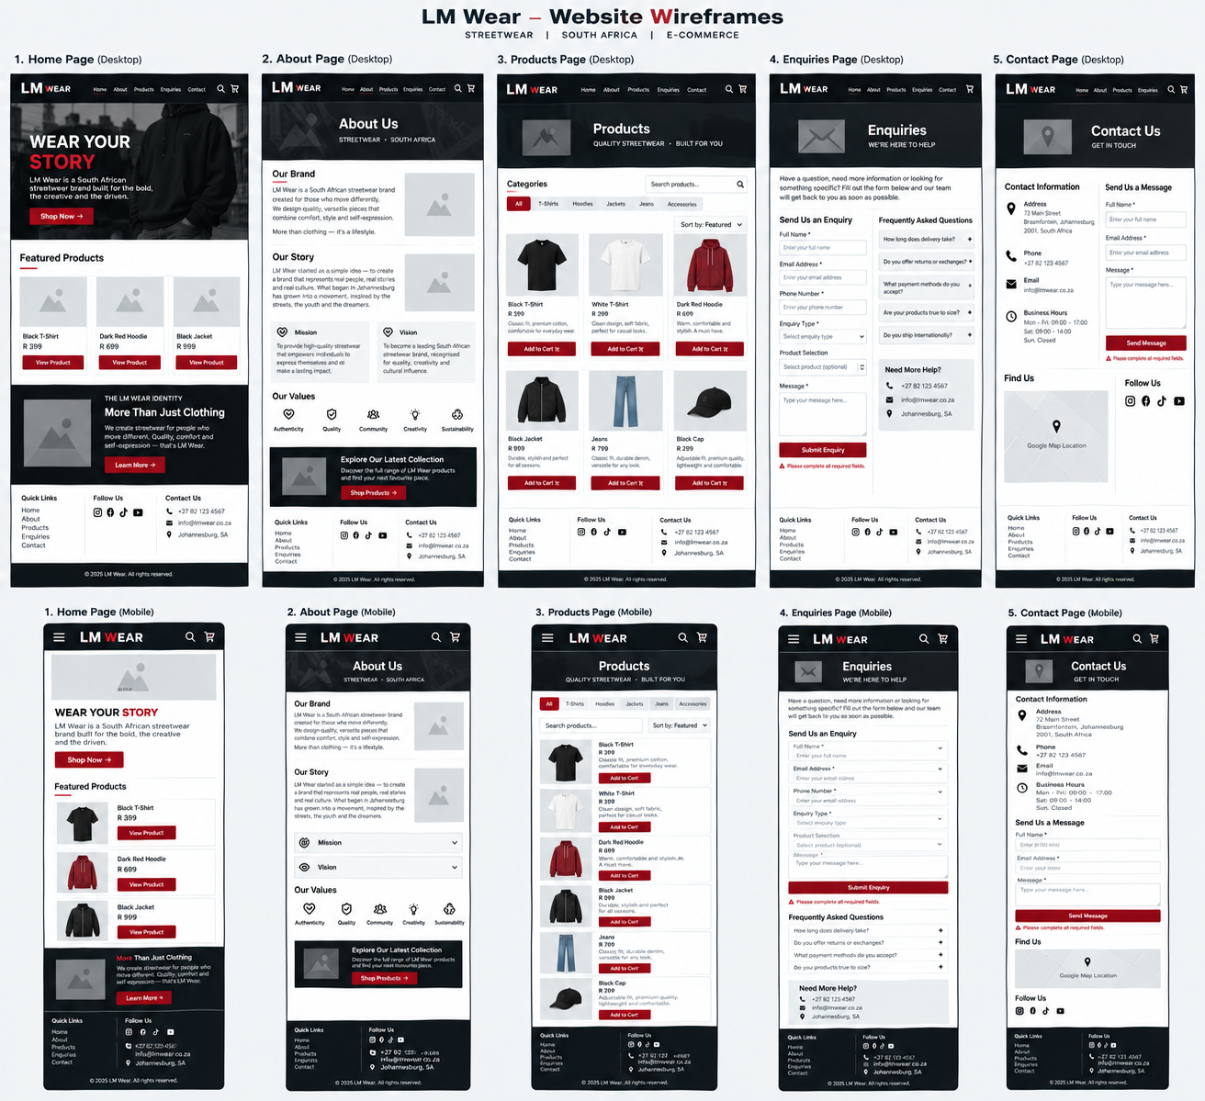
- TECHNICAL REQUIREMENTS
Programming Languages:
The website will use:
• HTML5 for the structure of the website
• CSS3 for styling, layout and responsive design
• JavaScript for form validation and interactive features
Hosting and Domain:
The final website will be deployed using a free hosting platform such as Netlify or GitHub Pages.
A custom domain could be purchased in the future to improve the professional appearance of the business website.
Version Control:
Git and GitHub will be used to maintain the project files and track changes made during development.
Folder Structure:
The project will contain organised folders for:
• HTML pages
• CSS files
• JavaScript files
• Images
• Other website assets
The external CSS file will be used throughout the website rather than placing large amounts of styling directly inside the HTML pages.
- TIMELINE AND MILESTONES
Phase 1: Part 1, Building the Foundation, Weeks 1 and 2
• Submit proposals for approval
• Research LM Wear and its target audience
• Gather suitable clothing images
• Create the website folder structure
• Develop all five HTML pages
• Add navigation between pages
• Add initial website content
• Set up the GitHub repository
• Push the initial HTML project to GitHub
Phase 2: Part 2, Designing the Website, Weeks 3 and 4
• Create the external style.css file
• Apply the LM Wear colour scheme
• Apply typography
• Create product cards and galleries
• Use Flexbox and Grid for page layouts
• Add responsive design
• Create the mobile navigation
• Test the website on different screen sizes
• Update the GitHub repository
Phase 3: Part 3, Functionality and SEO, Weeks 5 and 6
• Add JavaScript form validation
• Add interactive product gallery/lightbox
• Add interactive website elements where appropriate
• Add SEO-friendly title tags
• Add meta descriptions
• Add descriptive image alt text
• Create robots.txt
• Create sitemap.xml
• Test all website links and forms
• Deploy the completed website to Netlify
- BUDGET
The project will use a low-cost approach because it is being developed as an academic web development project.
Item | Estimated Cost
Domain Name | R150.00 per year
Web Hosting | R0.00
Stock Images | R0.00
Development Software | R0.00
GitHub Repository | R0.00
Total Estimated Budget | R150.00
9.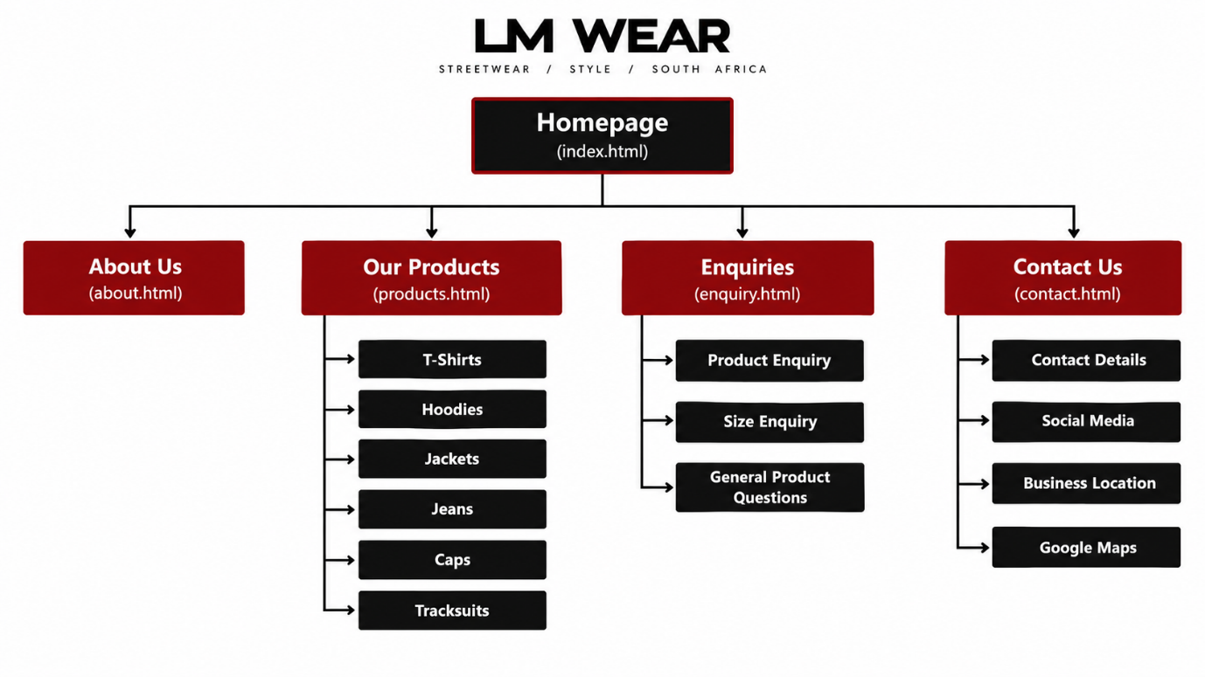
10.REFERENCES
LM Wear is a fictional clothing brand created for the purpose of this academic assignment. The organisation, branding, products and business information are hypothetical and intended for educational use.
The following resources will be used to support the development of the website:
MDN Web Docs. (2026). HTML: HyperText Markup Language. [Online]. Available at: https://developer.mozilla.org/en-US/docs/Web/HTML (Accessed: 7 September 2026).
MDN Web Docs. (2026). CSS: Cascading Style Sheets. [Online]. Available at: https://developer.mozilla.org/en-US/docs/Web/CSS (Accessed: 7 September 2026).
MDN Web Docs. (2026). JavaScript. [Online]. Available at: https://developer.mozilla.org/en-US/docs/Web/JavaScript (Accessed: 7 September 2026).
W3Schools. (2026). HTML Tutorial. [Online]. Available at: https://www.w3schools.com/html/ (Accessed: 7 September 2026).
W3Schools. (2026). CSS Responsive Web Design. [Online]. Available at: https://www.w3schools.com/css/css_rwd_intro.asp (Accessed: 7 September 2026).
The Independent Institute of Education. (2026). WEDE5020 Module Guide. IIE.

