1. Usecase

|  |
| --- |
|  |

1. Database Diagram

|  |
| --- |
|  |

1. Screen shot

3.1 Show product in page home

|  |
| --- |
|  |

* Database

|  |
| --- |
|  |

* 1. Invoice

|  |
| --- |
|  |

DB

|  |
| --- |
|  |

* 1. Login

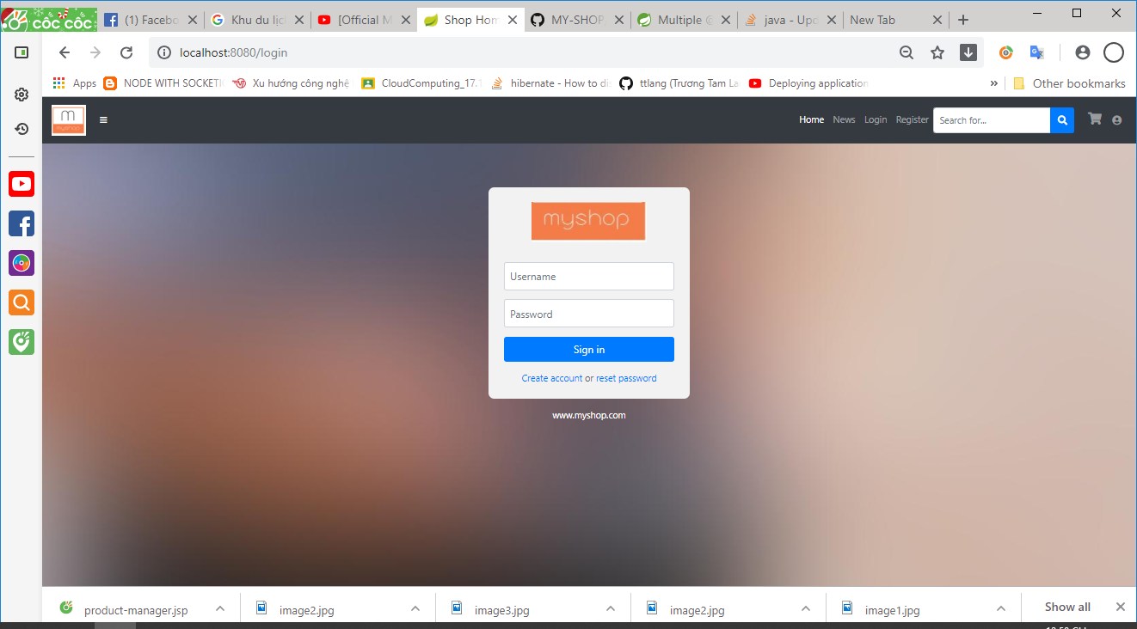

|  |
| --- |
|  |

3.4. Information Account

