

**Project Report Document**

**TEAM 06 PRESENT**

| **JS1802 - Team 01** | |
| --- | --- |
| **Members** | Le Thanh Binh - SE173315 (Leader)  Nguyen Tran Khanh Ha - SE173344  Nguyen Thanh Phong - SE173313  Luu Thien An - SE173297  Le Thu An - SE172257 |
| **Supervisor** | Ms. Nguyen Thi Cam Huong |

– HCM, July 2024–

**Table of Contents**

[I.](https://docs.google.com/document/d/1CoY8v8nMYhtVPQLMNMuduPz99kIHwI8k/edit#heading=h.gjdgxs) Overview 3

1. Introduction 3

2. Project Information 3

II. Software Requirement Specification 4

1. Use case diagram 4

2. Functional Requirements 4

3. Screen Flows 7

a. Admin 7

b. Staff 8

c. Manager 9

4. Business Rule 10

III. Software Design Specification 11

1. Database 11

2. Class Diagram 12

a. Bonus point 12

b. Staff dashboard 12

c. Add product 13

d. Sell / Purchase orders 14

# **I. Overview**

## **1. Introduction**

The Jewelry Sale Management System is an innovative software solution designed to streamline and modernize the process of selling jewelry in retail environments. This system aims to replace traditional paper-based methods and manual entry processes with efficient digital tools, enhancing the overall customer experience and optimizing business operations.

Our system will cater to jewelry retailers operating in various settings, from standalone boutiques to larger chain stores. By automating inventory management, sales tracking, and customer interactions, it promises to increase productivity, reduce errors, and ultimately drive revenue growth for businesses in the jewelry industry.

With the evolving landscape of retail and technology, our system is expected to adapt and grow over time. Future releases may integrate with online sales platforms, customer relationship management tools, and payment processing services to provide a seamless and comprehensive solution for jewelry retailers.

Now, let's visualize the context of our Jewelry Sale Management System with a context diagram.

## **2. Project Information**

Project name: Jewelry System sales at the store

Software Type: Web application PC

**Supervisor**

| **Full Name** | **Email** | **Title** |
| --- | --- | --- |
| Nguyen Thi Cam Huong | HuongNTC2@fe.edu.vn | Lecturer |

**Members**

| **Full Name** | **Student ID** | **Email** | **Title** |
| --- | --- | --- | --- |
| Lưu Thiên Ân | SE173297 | anltse173297@fpt.edu.vn | Member |
| Lê Thanh Bình | SE173315 | binhltse173315@fpt.edu.vn | Leader |
| Lê Thu An | SE172257 | anltse172257@fpt.edu.vn | Member |
| Nguyễn Trần Khánh Hà | SE173344 | hantkse173344@fpt.edu.vn | Member |
| Nguyễn Thành Phong | SE173313 | phongntse173313@fpt.edu.vn | Member |

# **I. Software Requirement Specification**

## **1. Use case diagram**

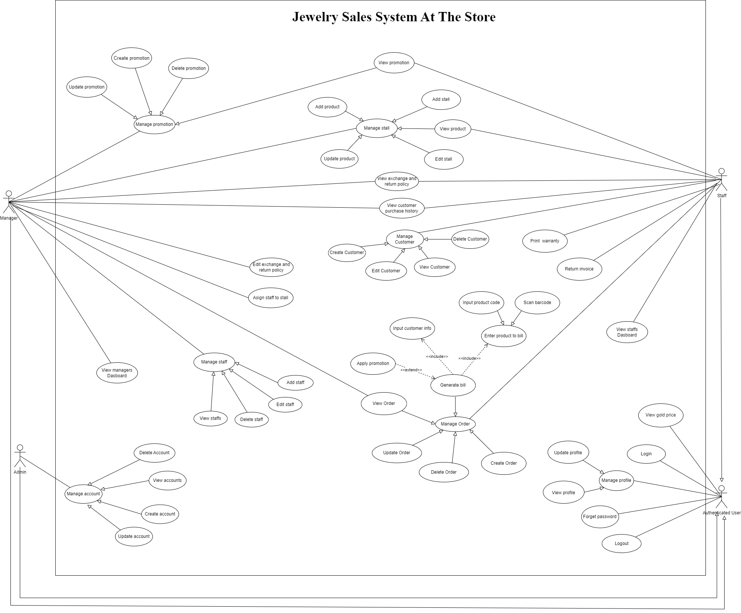

## **2. Functional Requirements**

### **Manager Functional Requirements and Descriptions**

* **Manage Promotions**
  + **Create promotion**: Ability to add new promotions to the system.
  + **Update promotion**: Modify existing promotions.
  + **Delete promotion**: Remove promotions that are no longer valid.
  + **View promotion**: See the list and details of all active promotions.
* **Manage Products**
  + **Add product**: Add new products to the inventory.
  + **Update product**: Edit details of existing products.
  + **View product**: Access and view product information.
* **Manage Staff**
  + **Add staff**: Register new staff members.
  + **Edit staff**: Update staff information.
  + **Delete staff**: Remove staff from the system.
  + **View staff**: Access and view staff details.
* **Manage Customers**
  + **Create customer**: Register new customers.
  + **Edit customer**: Update customer information.
  + **Delete customer**: Remove customer records.
  + **View customer**: Access and view customer details.
  + **View customer purchase history**: See the purchase history of customers.
* **Manage Orders**
  + **Create order**: Create new orders.
  + **Update order**: Modify existing orders.
  + **Delete order**: Cancel orders.
  + **View order**: Access and view order details.
  + **Apply promotion**: Apply promotions to orders.
  + **Input customer info**: Enter customer information for orders.
  + **Generate bill**: Produce bills for orders.
* **Other Functions**
  + **View manager's dashboard**: Access a summary view of the store’s performance.
  + **Edit exchange and return policy**: Modify policies regarding exchanges and returns.
  + **Assign staff to stall**: Allocate staff to specific stalls.
  + **View exchange and return policy**: See the current exchange and return policies.
  + **Manage stalls**: Oversee stall-related activities.
    - **Add stall**: Create new stalls.
    - **Edit stall**: Update stall information.
    - **View stall**: Access and view stall details.

### **Staff Functional Requirements and Descriptions**

1. **Manage Orders**
   * **Create order**: Initiate new customer orders.
   * **Update order**: Edit existing orders.
   * **Delete order**: Remove orders from the system.
   * **View order**: See details of orders.
   * **Apply promotion**: Add promotions to orders.
   * **Input product code**: Enter product codes for billing.
   * **Scan barcode**: Use barcode scanner for products.
   * **Enter product to bill**: Add products to the bill.
   * **Input customer info**: Enter customer details for billing.
   * **Generate bill**: Create the final bill for customers.
2. **Manage Promotions**
   * **View promotion**: Access and view current promotions.
3. **View Information**
   * **View gold price**: See the current price of gold.
   * **View customer's purchase history**: Access customer purchase records.
   * **View staff's dashboard**: View a summary of staff activities and performance.
4. **Other Functions**
   * **Print warranty**: Print warranty documents for products.
   * **Return invoice**: Process returned invoices.
   * **Login**: Access the system.
   * **Logout**: Exit the system.
   * **Update profile**: Edit personal profile information.
   * **View profile**: View personal profile details.
   * **Manage profile**: Oversee profile settings.
   * **Forgot password**: Recover lost passwords.

### **Admin Functional Requirements and Descriptions**

1. **Manage Accounts**
   * **Create account**: Add new user accounts.
   * **Update account**: Edit existing user accounts.
   * **Delete account**: Remove user accounts.
   * **View accounts**: Access and view account details.
2. **Other Functions**
   * **Manage profile**: Oversee user profile settings.
   * **Update profile**: Edit user profile information.

## **3. Screen Flows**

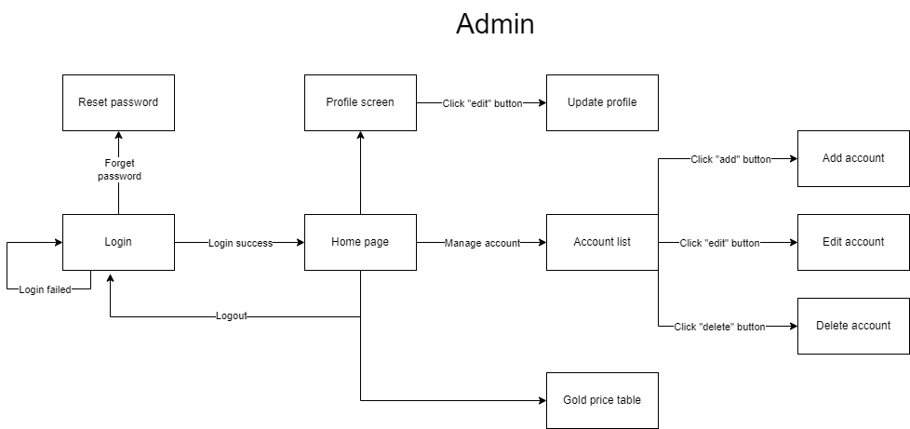

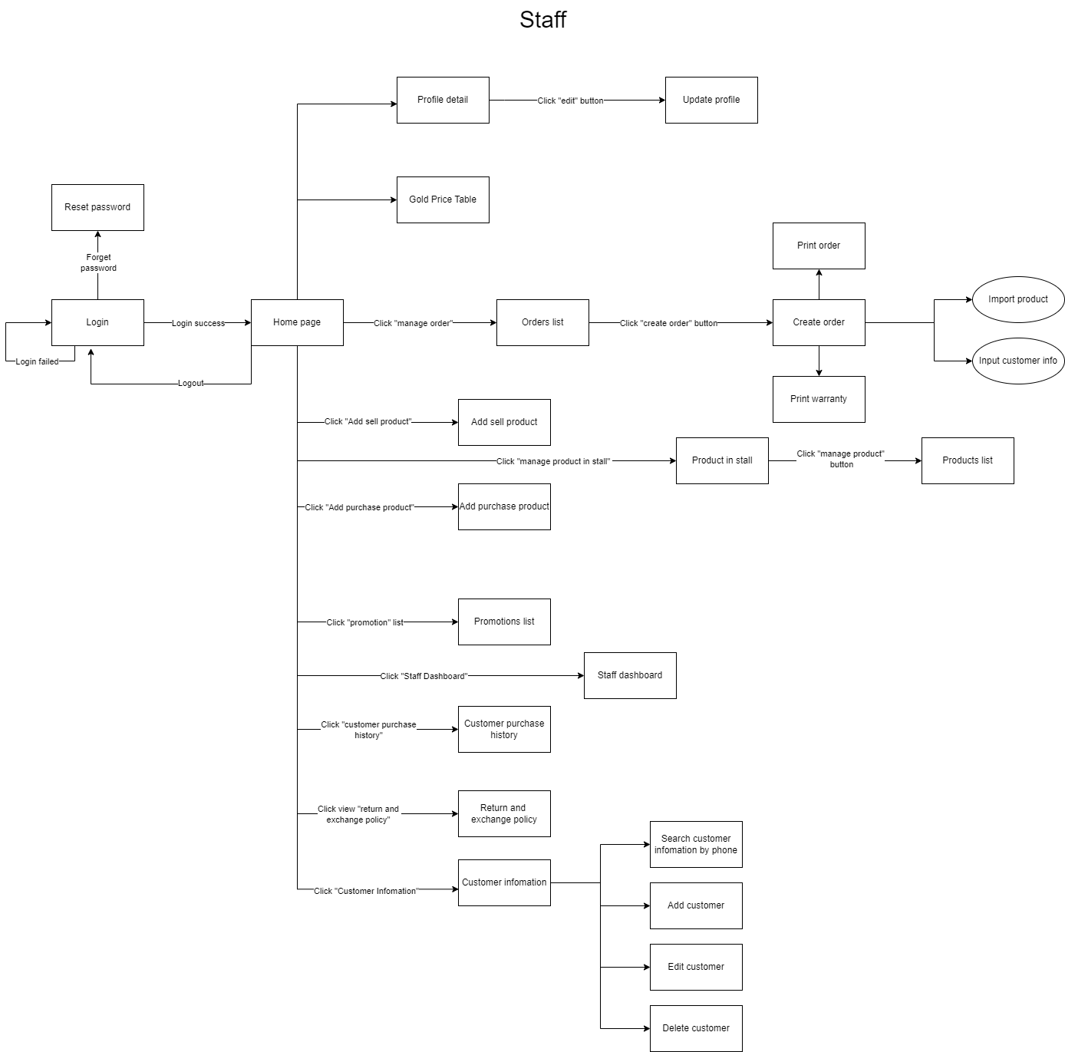

## 

## 

## 

## 

## 

## 

## 

## 

## **4. Business Rules:**

| **ID** | **Features** | **Description** |
| --- | --- | --- |
| 1 | Sales Order Creation | Sales orders can be created at the sales counter by scanning the barcode or manually entering the item code. The software should generate and print sales invoices for the customers. |
| 2 | Item Pricing | Selling Price = Cost Price of the product * Markup Rate. Cost Price = (Current Gold Price * Product Weight) + Labor Cost + Stone Cost. |
| 3 | Warranty Card | The software should support the printing of warranty slips for jewelry items sold. |
| 4 | Promotion Handling | The software must manage the company’s promotional programs during sales transactions. Customers may receive additional discounts under special customer loyalty policies, which must be confirmed by a manager before the salesperson can apply the discount. |
| 5 | Discount Calculation | Invoice Discount = Promotional Period Discount (if any) + Customer Loyalty Discount (if any). |
| 6 | Buyback Order Creation | The software should allow for the creation of buyback orders at the sales counter and generate buyback invoices for customers. |
| 7 | Buyback Pricing | For Jewelry with Regular Stones: Only the actual gold weight is considered for buyback. For Precious Stones: The store buys back at a predefined system rate (e.g., 70% of the original sale price). Gold Buyback Price follows the current market gold price. |
| 8 | Invoice Retrieval | The software should support searching and retrieving previous sales invoices for buyback processing. |
| 9 | Gold Price Display | The software should display the current gold prices on the store’s television screens. |
| 10 | Loyalty Points | The software must manage and accumulate loyalty points for customers based on their purchases. |
| 11 | Sales Tracking | The software should track sales for each employee and counter. It should manage and report the revenue generated by each counter and each employee. |
| 12 | Return and Exchange Policies | The software must allow for the declaration and management of jewelry return and exchange policies. |
| 13 | Product and Price Management | The software should support the declaration of products available at each counter. It must manage and update the price list of goods. |
| 14 | Dashboard Statistics | The software should provide a dashboard with statistical summaries and visualizations for management oversight. |

# **I. Software Design Specification**

## **1. Database**

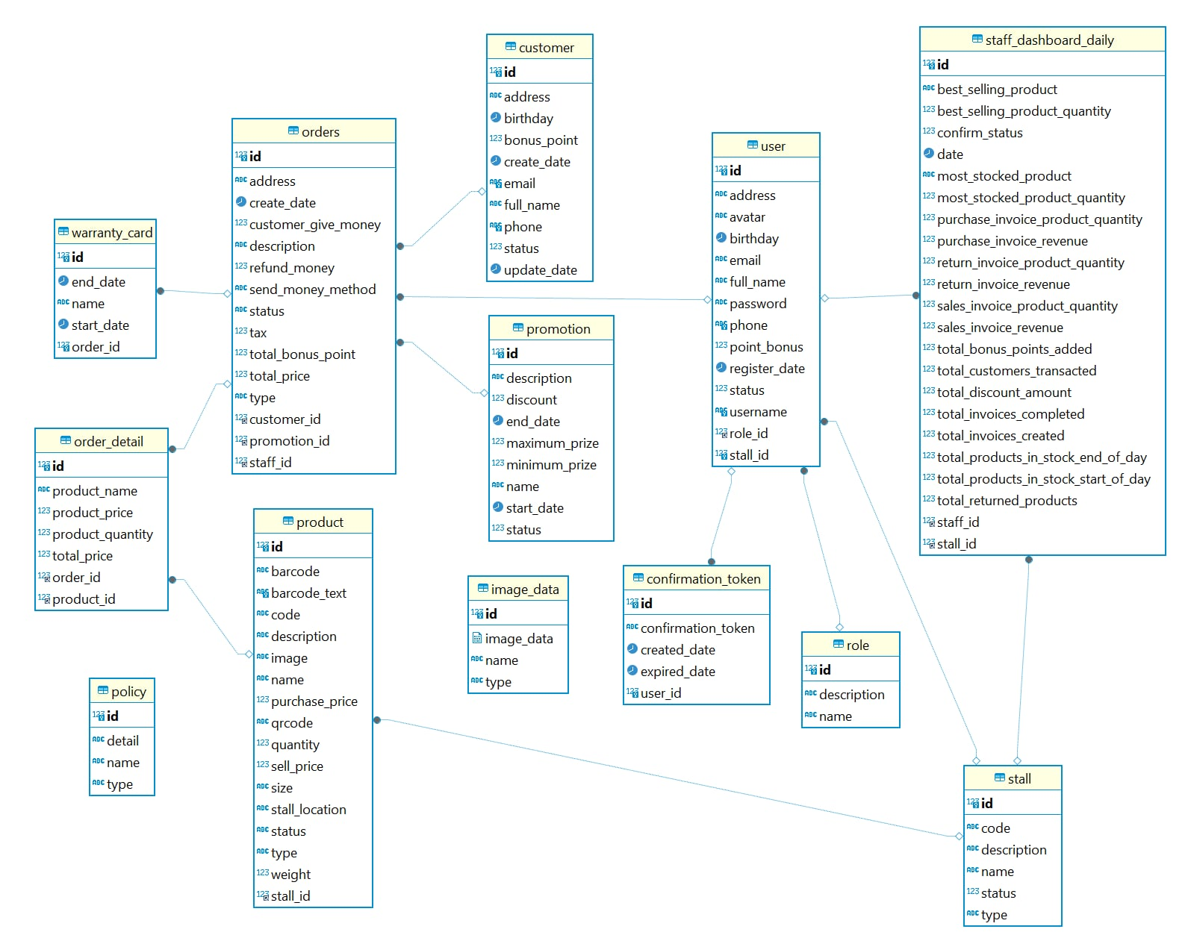

## 

#### **2. Class diagram**

#### **Bonus Point**

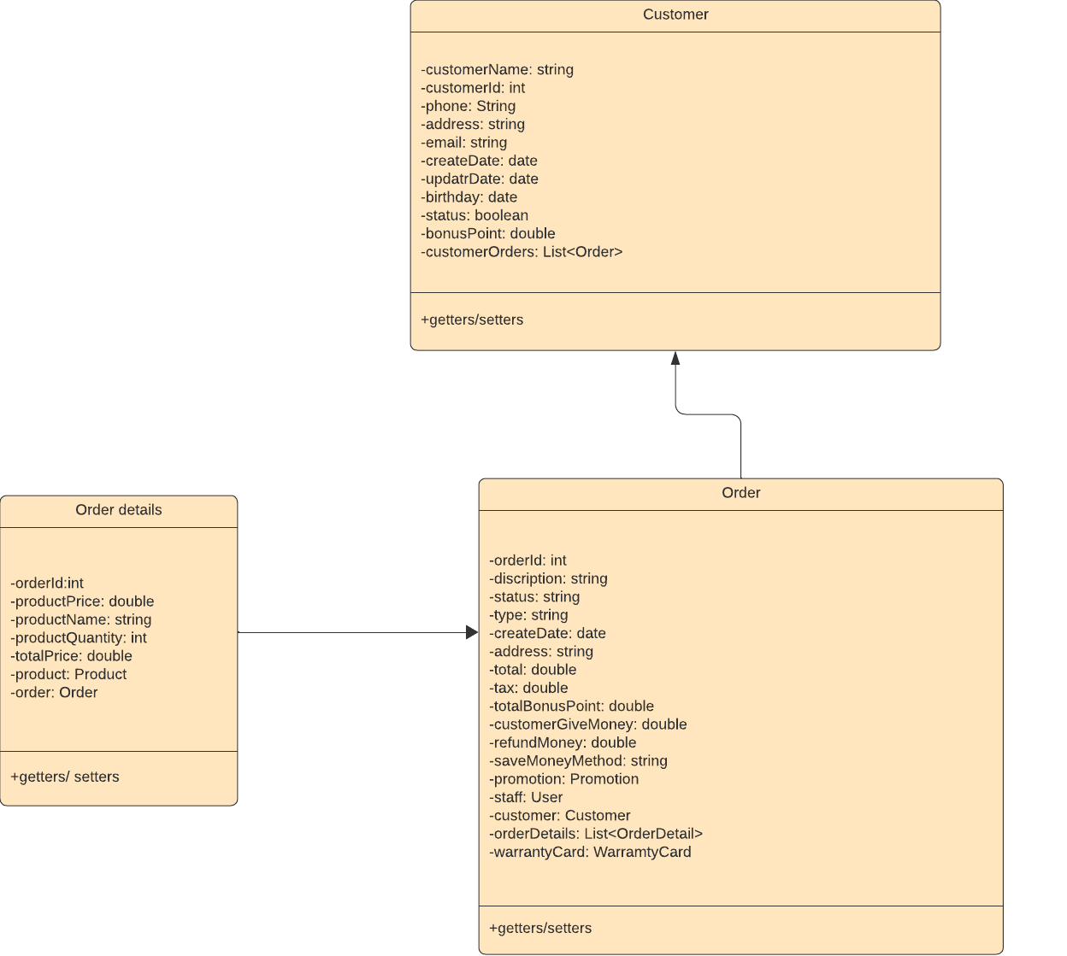

#### **Staff dashboard**

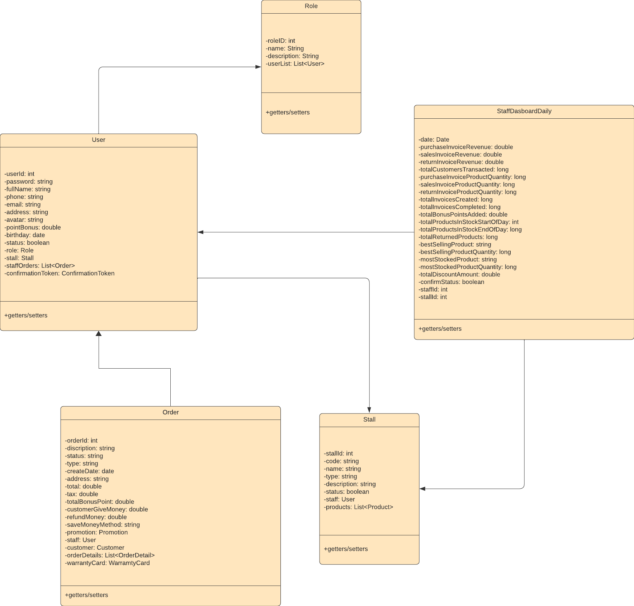

#### 

#### **Add product**

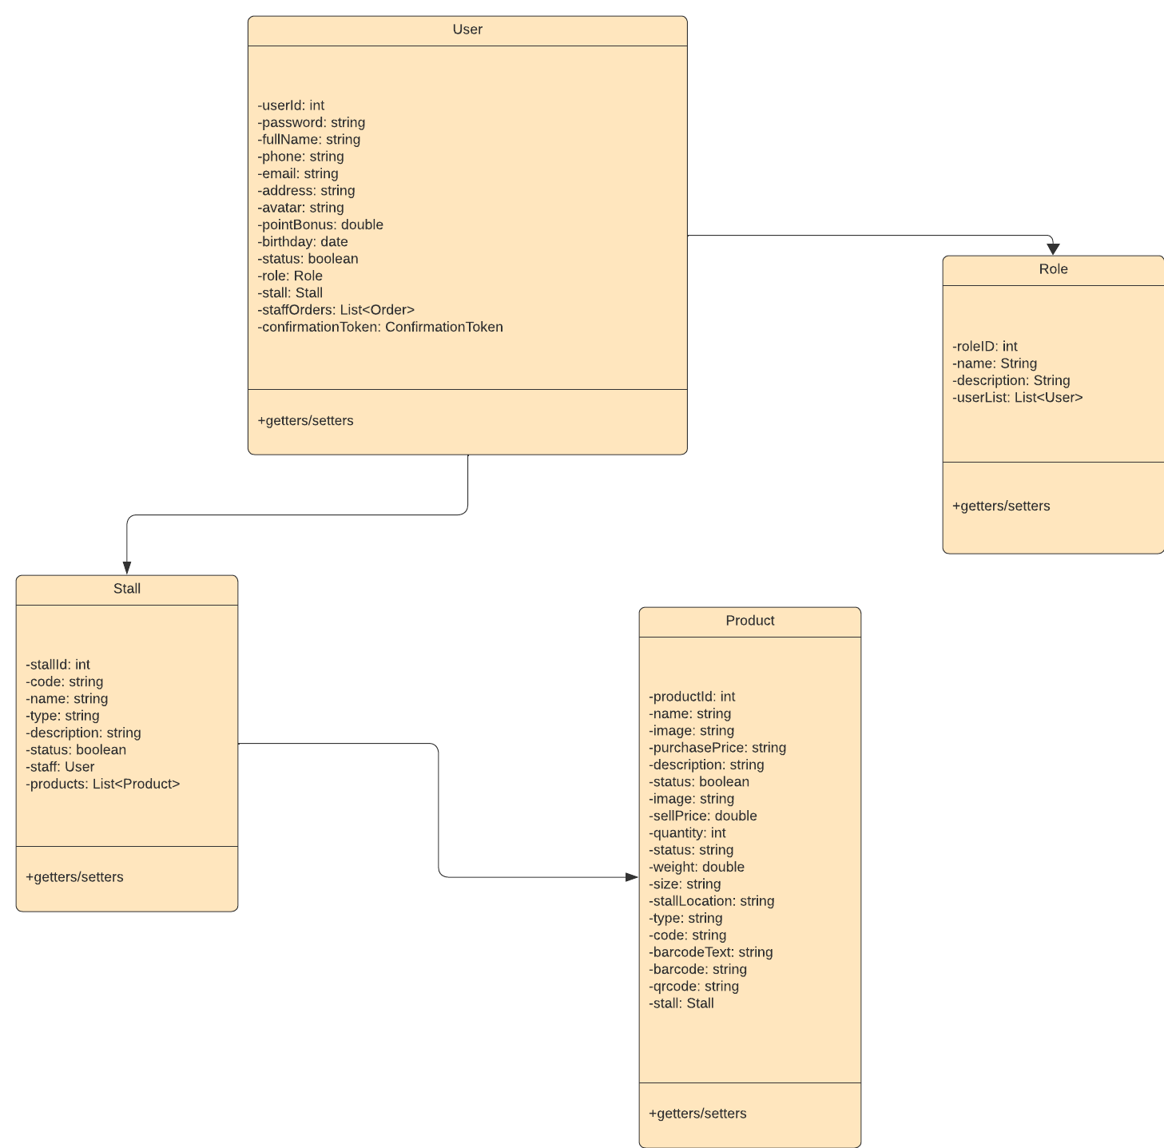

1. **Sell / Purchase order**

