EMBEDDED LINUX SYSTEMS
ASSIGNMENT 01 REPORT
How to Write a Device Driver
ioctl Interface | Misc Device | Driver Analysis | ARMv7 Target
Student | Le Tien Thanh
Student ID | SE_201799
Target | ARMv7-A / QEMU vexpress-a9
Kernel | Linux 5.15.0
Date | 13 October 2026
Implemented and tested on QEMU with ARMv7 kernel modules.

Report structure
Section | Content
1 | Objective and test environment
2 | System architecture
3 | Task 1: ioctl character driver
4 | Task 2: misc counter driver
5 | Character, block and network driver comparison
6 | Design choices
7 | Test results and logs
8 | Debugging note
9 | Theory questions
10 | Final verification and references
This report records the design decisions and the test evidence for two kernel modules: asgn1_driver and counter_driver. The implementation was cross-compiled for ARMv7 and executed in QEMU. The screenshots in this report are taken from the actual source code and terminal output used during the assignment.

1. Objective and test environment
The assignment contains two driver implementations. Task 1 is a character driver with a custom ioctl interface. Task 2 is a misc device that behaves as a simple integer counter. I kept the two drivers independent so that each interface can be tested separately.
Item | Configuration
Host | Ubuntu Linux
Target architecture | ARMv7-A (armv7l)
Machine | QEMU vexpress-a9, Cortex-A9
Kernel | Linux 5.15.0
Cross compiler | arm-linux-gnueabihf-gcc
Root filesystem | BusyBox initramfs
Task 1 device | /dev/asgn1, major 241
Task 2 device | /dev/counter, misc major 10
The Task 1 userspace ioctl helper was compiled as a static ARM EABI5 executable and copied to /usr/bin/test_ioctl in the initramfs. This was needed because the minimal BusyBox image does not provide a command for the custom ioctl numbers used by the driver.

2. System architecture
Both device nodes are accessed from userspace through normal system calls and the VFS. /dev/asgn1 is connected to asgn1_driver through file_operations, where read(), write() and unlocked_ioctl() operate on the internal buffer, mode and statistics. /dev/counter is connected to counter_driver through its file_operations; the current value is stored in atomic_t and the statistics are exposed through /proc/counter_info. For ioctl, the path is userspace ioctl() -> VFS -> unlocked_ioctl() -> copy_to_user()/copy_from_user() -> userspace.

3. Task 1: ioctl character driver

3.1 ioctl definitions
The ioctl interface is defined in a separate header file, asgn1_ioctl.h. I used magic value 'A' and command numbers 1 to 4. The statistics structure contains open_count, write_count, read_count, buffer_len and last_write_size.
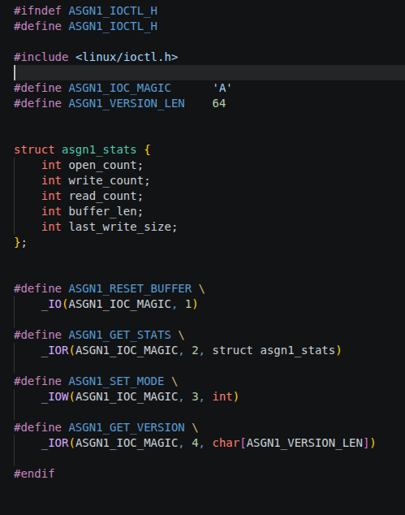
Figure 2. Actual asgn1_ioctl.h used for Task 1.
RESET_BUFFER uses _IO because it has no argument. GET_STATS and GET_VERSION return data to userspace with _IOR. SET_MODE receives an integer from userspace with _IOW. The version buffer is limited to 64 bytes.

3.2 ioctl handler and synchronization
The ioctl switch handles all four commands. Buffer state and counters are protected by asgn1_mutex. GET_STATS copies a local struct to userspace with copy_to_user(). SET_MODE reads the requested mode with copy_from_user() and rejects values other than 0 or 1. Unsupported commands return -ENOTTY.
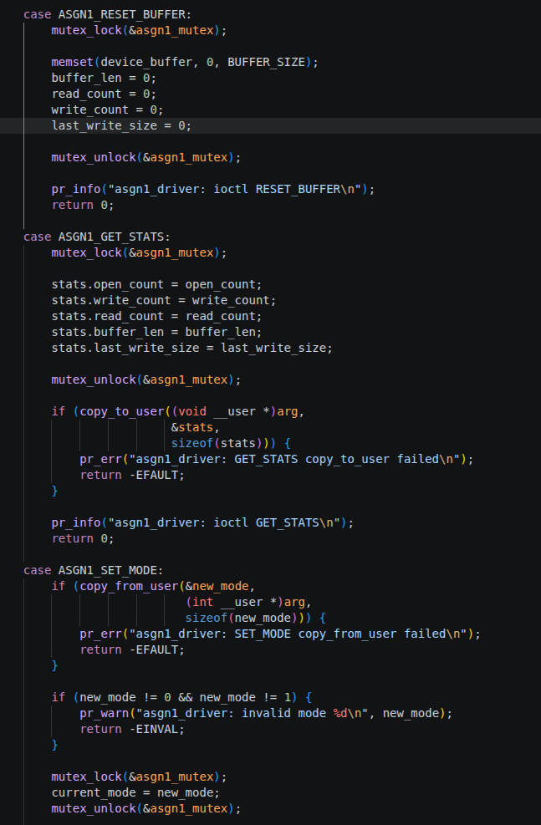 | 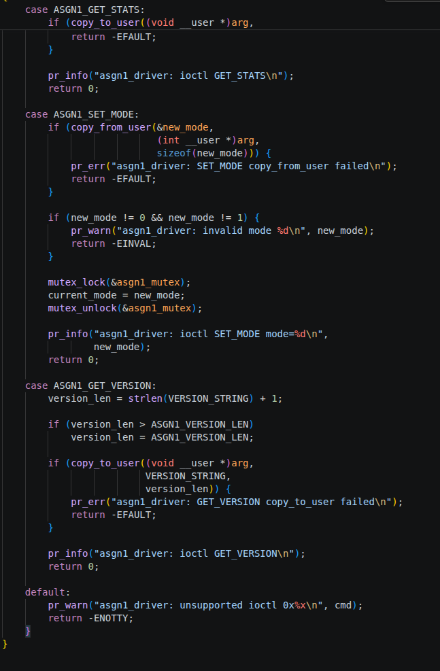
Figure 3. RESET_BUFFER, GET_STATS, SET_MODE, GET_VERSION and default -ENOTTY handling.

3.3 file_operations and module registration
Task 1 uses register_chrdev() with major 241. The file_operations structure connects open, release, read, write and unlocked_ioctl to the driver functions. class_create() and device_create() create /dev/asgn1. The exit function destroys the device and class before unregistering the character driver.
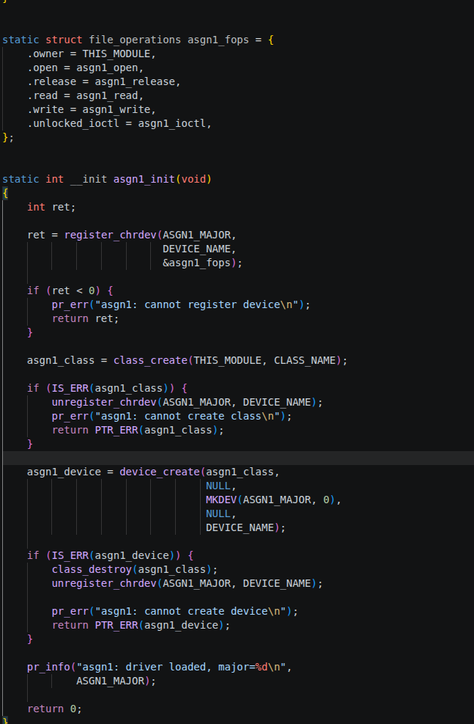 | 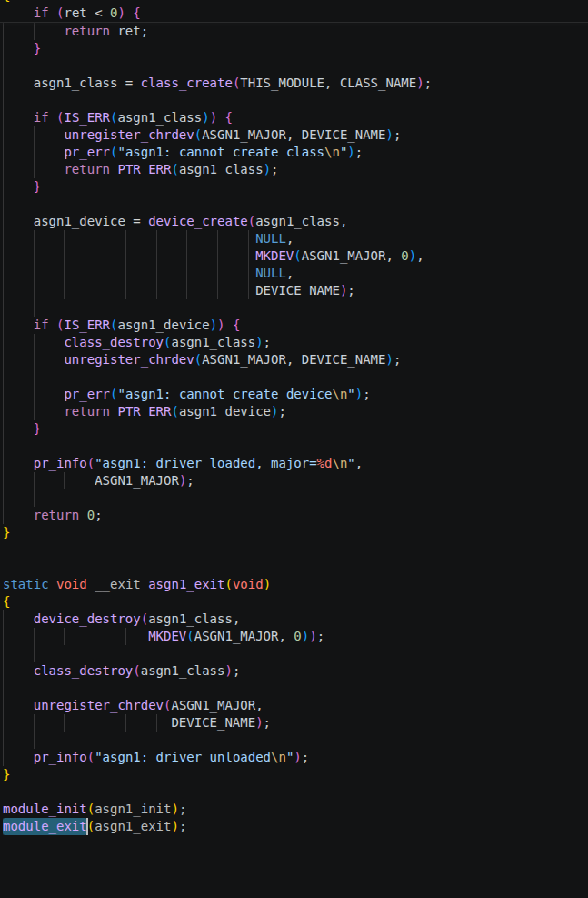
Figure 4. file_operations, register_chrdev(), device_create() and cleanup code.
Mode 0 stores the prefix [KERNEL] before user data. Mode 1 stores the original bytes. Mode 1 is the default after module load. RESET_BUFFER clears the internal buffer and resets read_count, write_count and last_write_size; open_count is intentionally not reset.

4. Task 2: misc counter driver

4.1 read and write behavior
The counter is stored in atomic_t. counter_read() first checks *ppos. On the first read it formats the current counter as text, copies it to userspace, advances the file position, then increments both counter and read_count. A second read on the same file returns 0, which gives userspace an EOF condition.
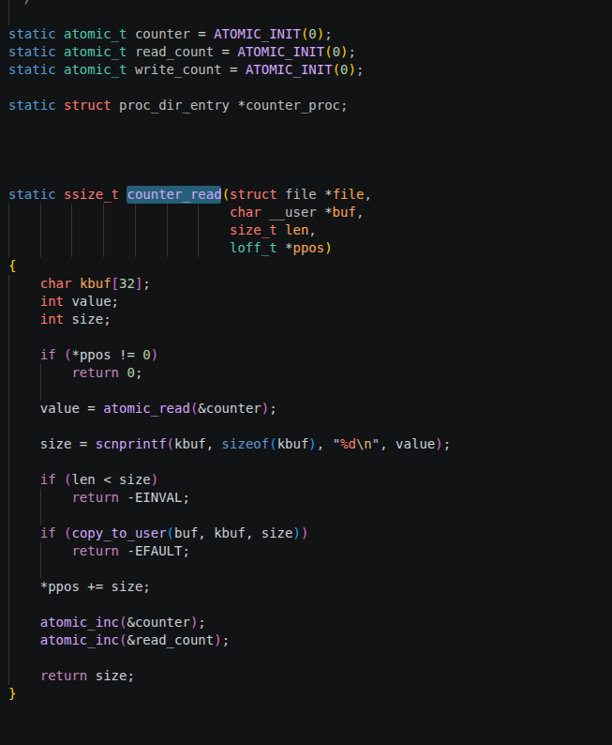 | 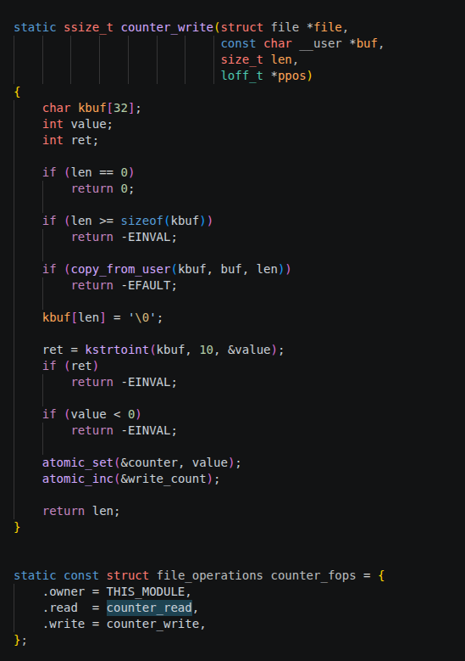
Figure 5. Actual counter_read() and counter_write() implementation.
counter_write() copies the ASCII input into a local buffer, converts it with kstrtoint(), rejects negative values, then writes the value with atomic_set(). A valid write increments write_count. Therefore echo 100 sets the next read to 100, while echo 0 resets the counter.

4.2 misc device and procfs interface
The misc device uses MISC_DYNAMIC_MINOR and the name counter. This produces /dev/counter under misc major 10. /proc/counter_info is created with proc_create() and reports the current counter, total reads and total writes.
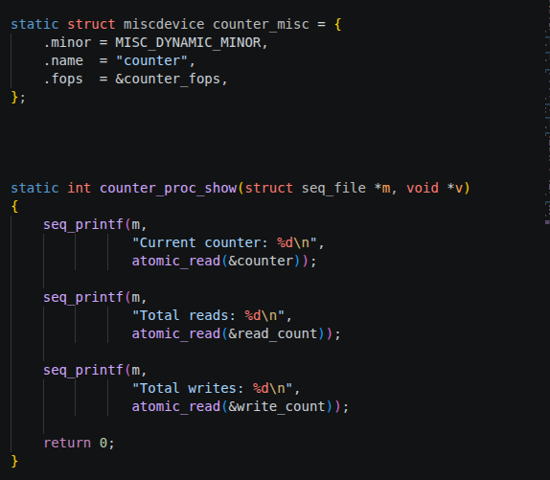 | 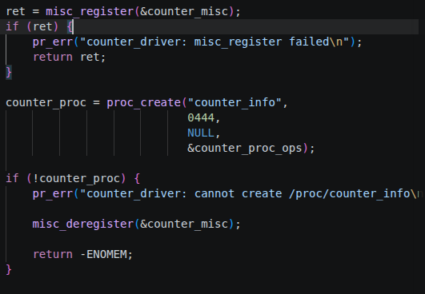
Figure 6. miscdevice registration data and /proc/counter_info creation.
The init path registers the misc device before creating procfs. If proc_create() fails, the misc device is deregistered before returning the error. The normal exit path removes procfs and deregisters the misc device.

5. Character, block and network driver comparison
Type | Kernel interface | Transfer unit | Buffering path | Embedded example | When I would use it
Character | file_operations | Byte stream | Driver-specific buffers; optional VFS buffering depending on file type | UART, GPIO control, simple sensor interface | Small control/status interfaces or sequential byte I/O
Block | block_device_operations + block layer | Sector/block | BIO/request queue, blk-mq and page cache for filesystems | eMMC, SD card, SATA/SSD | Random-access storage exposed as sectors
Network | net_device_ops + networking stack | Packet/frame | sk_buff queues, qdisc and protocol stack | Ethernet MAC, Wi-Fi interface | Packet transmission and reception through sockets
Design example 1: a UART-like device that sends configuration bytes is naturally a character device because userspace reads and writes a stream. Design example 2: an eMMC device should use the block layer because filesystems expect sector-based random access. An Ethernet controller is registered as a network device because packets are handled by the networking stack rather than normal read()/write() on a device file.

6. Design choices

6.1 register_chrdev() compared with misc_register()
I used register_chrdev() in Task 1 because the assignment requires a normal character driver with a selected major number. It gives direct control over the major number and the device creation path, but class creation, device creation and cleanup are more manual. Task 2 is a small single-purpose device, so misc_register() removes most of that setup. The misc framework uses major 10 and can allocate a minor number automatically with MISC_DYNAMIC_MINOR.

6.2 Why atomic_t is used in Task 2
The counter can be accessed by more than one execution context. A normal expression such as counter++ is a read-modify-write sequence. Two CPUs can read the same old value and both write the same incremented value, losing one update. atomic_inc() performs the update atomically, while atomic_read() and atomic_set() keep the counter operations consistent with the selected representation.

6.3 ioctl magic number and command fields
ASGN1_IOC_MAGIC is the character 'A'. The command number is the second argument of _IO/_IOR/_IOW, so _IOC_NR() returns 1 for RESET_BUFFER, 2 for GET_STATS, 3 for SET_MODE and 4 for GET_VERSION. On this ARMv7 target, int is 4 bytes. Therefore _IOC_SIZE() is 0 for RESET_BUFFER, 20 bytes for the five-int stats structure, 4 bytes for SET_MODE and 64 bytes for GET_VERSION. The direction bits also tell the kernel/userspace ABI whether data is expected to move into or out of the driver.

7. Test results and logs

7.1 Task 1 automated test
The final test_asgn1.sh loads the module, checks /dev/asgn1, calls all four ioctl commands, verifies both modes, checks RESET_BUFFER, unloads the module and prints the related dmesg lines. The final result was 18 passes and 0 failures.
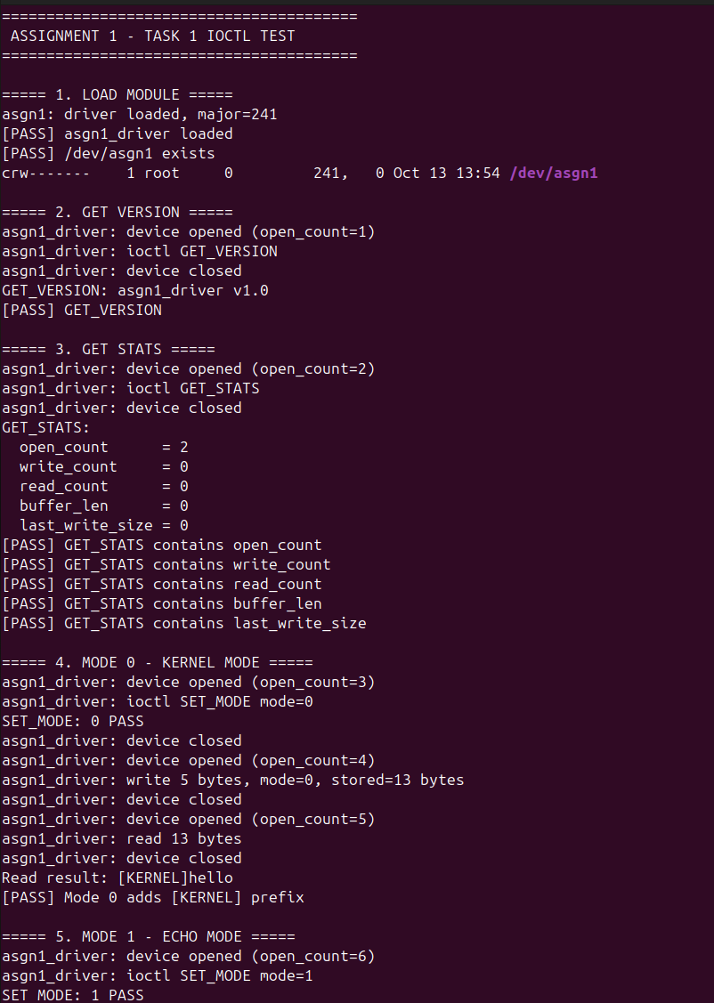 | 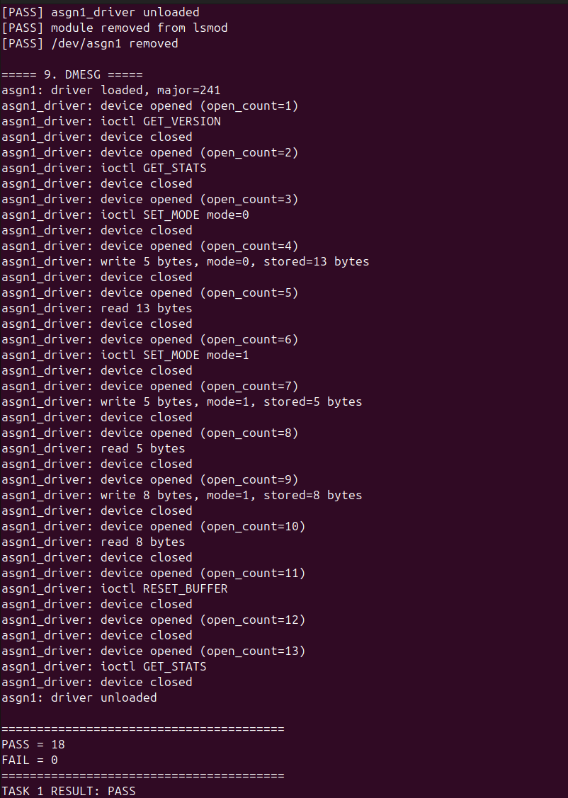
Figure 7. Task 1 automated test output. Final result: PASS = 18, FAIL = 0.

7.2 Task 2 automated test
The Task 2 script checks misc registration, /dev/counter and /proc/counter_info, the 0/1/2 read sequence, write 100, reset 0, invalid negative/text input, cleanup and dmesg. The final result was 15 passes and 0 failures.
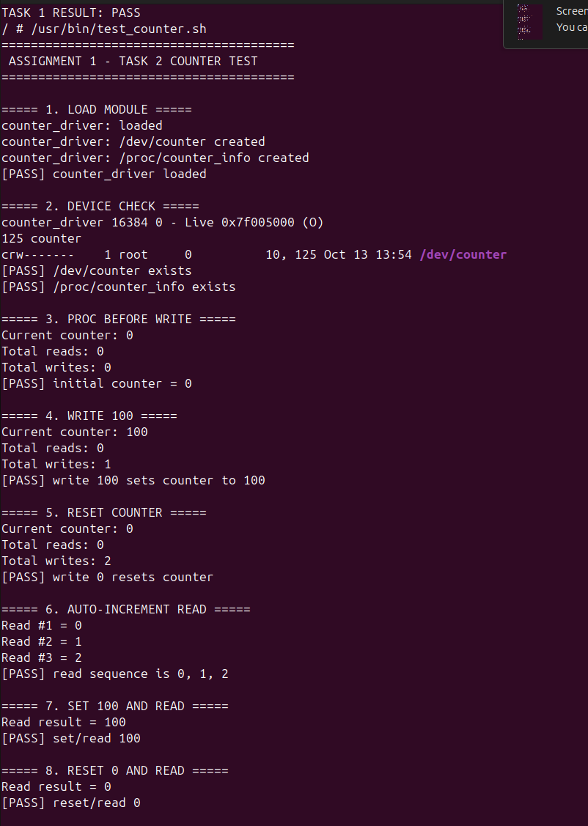 | 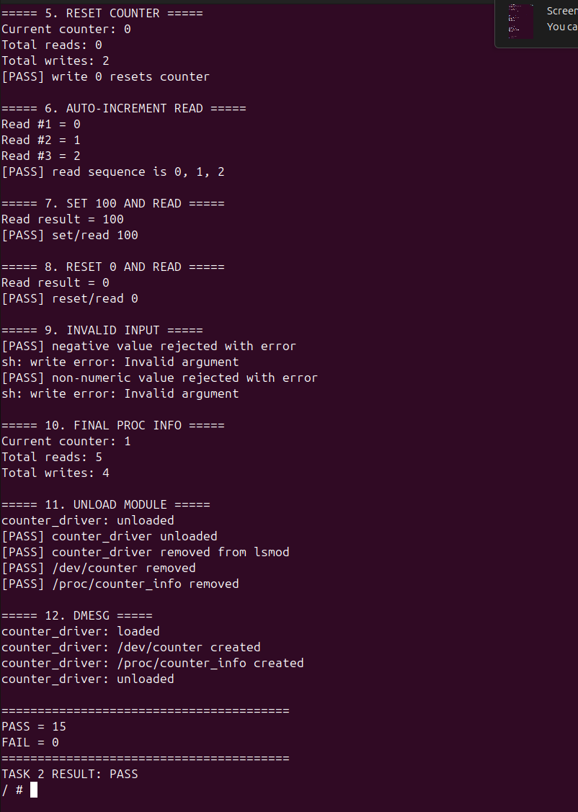
Figure 8. Task 2 automated test output. Final result: PASS = 15, FAIL = 0.

7.3 procfs statistics at three points
The assignment asks for /proc/counter_info at three different times. I reloaded the module to start from a clean state. Before write the values were 0/0/0. After echo 100, the current counter was 100 and writes was 1. After echo 0, the counter returned to 0 and writes became 2.
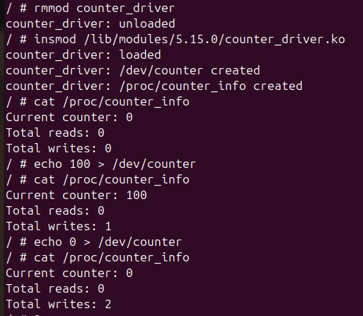
Figure 9. /proc/counter_info before write, after write 100, and after reset 0.

7.4 Saved log files
The final submission logs were extracted from the captured QEMU session. test_asgn1_output.txt contains 145 lines, test_counter_output.txt contains 77 lines, and dmesg_full.txt contains 233 lines. The two test logs end with PASS and zero failures, while dmesg_full.txt contains load, ioctl, read/write and unload messages from both drivers.
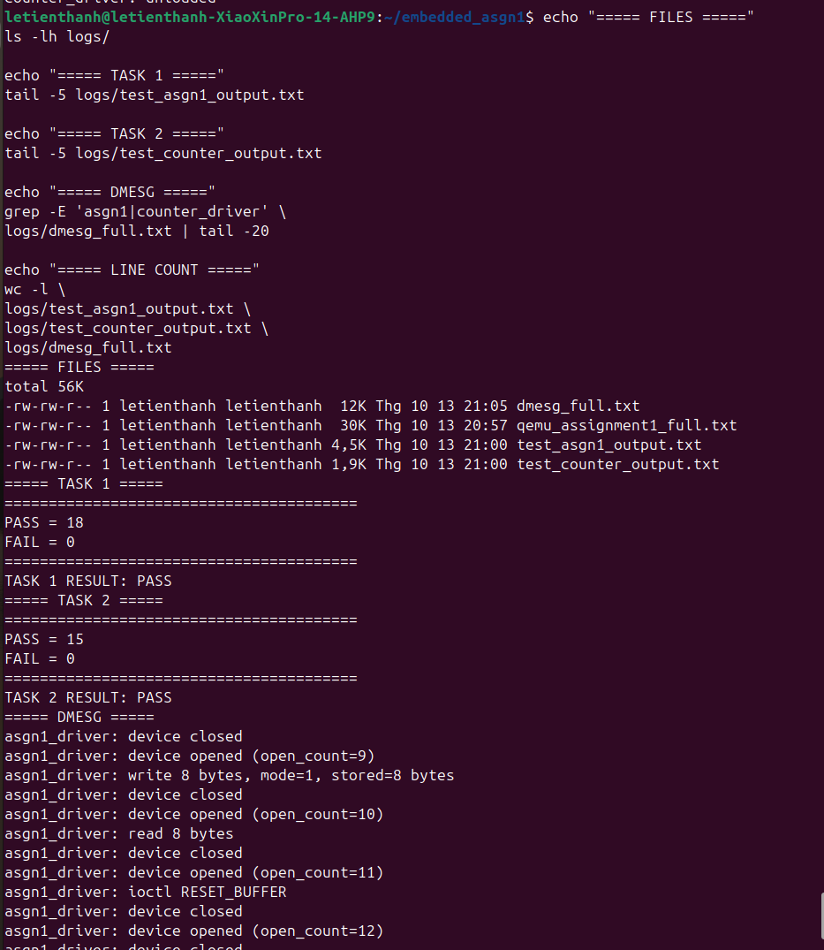
Figure 10. Final log verification on the host system.
Required log files in the submission: logs/test_asgn1_output.txt, logs/test_counter_output.txt and logs/dmesg_full.txt. The raw qemu_assignment1_full.txt file is only a working capture and is not required by the assignment structure.

8. Debugging note
One integration problem appeared during Task 1 testing: the driver loaded correctly, but the initial test_asgn1.sh file was empty and the BusyBox root filesystem did not contain a userspace program that could issue the custom ioctl commands. The kernel module itself could not be fully tested with shell commands alone.
I fixed this by creating a small userspace helper named test_ioctl, compiling it with arm-linux-gnueabihf-gcc -static, verifying that it was an ARM EABI5 executable on the host, and copying it to /usr/bin in the initramfs. After repacking the initramfs, the helper could call GET_VERSION, GET_STATS, SET_MODE and RESET_BUFFER from QEMU. The shell test then used this helper for the automated checks.

9. Theory questions

9.1 Module reference counting
A loadable module must not be removed while kernel code still uses it. A module reference can be acquired explicitly with try_module_get()/module_get-style logic and released with module_put(). For device files, setting .owner = THIS_MODULE in file_operations lets the file-operation path hold the module while the file is in use. If the reference count is non-zero, a normal rmmod fails because the module is busy. A forced unload is possible only when the kernel supports forced module unload and the administrator uses the force option. It is unsafe because executing code or callbacks may still refer to memory that has been removed.

9.2 Why copy_to_user() is required
The pointer passed to an ioctl comes from userspace and cannot be treated like a normal kernel pointer. The target page may be unmapped, read-only, outside the process address range, or may fault while the copy is being made. copy_to_user() and copy_from_user() are the kernel interfaces for these accesses. They perform the required access checks and use fault-safe user-memory handling. A raw memcpy() to a user virtual address can turn a bad userspace pointer into a kernel fault instead of returning an error such as -EFAULT.

9.3 MTD compared with a normal block device
The block layer presents storage as sectors that can be read or written through a block request path. Raw flash has different rules. NAND and NOR flash may require erase-before-write, eraseblock management, bad-block handling, ECC and out-of-band data. Linux exposes these raw flash characteristics through the MTD subsystem. Raw SPI NOR or raw NAND is a typical MTD case. An SD card or eMMC device normally appears as a block device because its controller hides the raw flash management and presents sectors.

9.4 Why counter_read() checks *ppos
cat keeps calling read() until read returns 0. If counter_read() ignored *ppos and returned a number every time, cat would continue reading and the driver would keep incrementing the counter. In this driver, the first call copies one line and advances *ppos by the number of bytes returned. The next call sees a non-zero file position and returns 0. That 0 is the EOF condition that stops cat.

10. Final verification and references
The final QEMU tests completed without functional failures: Task 1 reported 18 PASS and 0 FAIL, while Task 2 reported 15 PASS and 0 FAIL. The submission logs include test_asgn1_output.txt, test_counter_output.txt and dmesg_full.txt.

References
- ASSIGNMENT-01, Embedded Linux Systems, "How to Write a Device Driver" (course assignment sheet).
- Linux Kernel Documentation 5.15, Driver Basics: https://docs.kernel.org/5.15/driver-api/basics.html
- Linux Kernel Documentation, Miscellaneous Devices: https://docs.kernel.org/driver-api/misc_devices.html
- Linux Kernel Documentation, Memory Technology Device (MTD) and NAND driver API: https://docs.kernel.org/driver-api/mtdnand.html
- Linux Device Drivers, 3rd Edition, Corbet, Rubini and Kroah-Hartman.
- Linux man pages: ioctl(2), open(2), read(2), write(2).

