Name: Thanh Tam Le

Email: lethanhtam1604@gmail.com

Position: iOS Developer

**ASTRO ASSIGNMENT**

1. Application Development Environment

* IDE: Xcode 8.3.2
* Language: Swift 3
* No Need library

1. Architecture Pattern

* 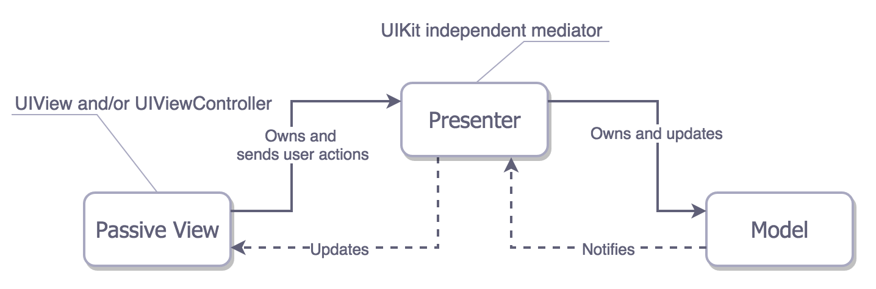I used MVP design pattern to resolve massive view controller instead of MVC traditional pattern in iOS.

1. Multiple Languages

* Used Localization in iOS

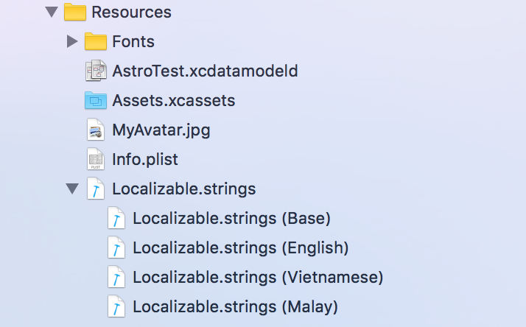

1. Swiftlint

* I used this library to refactor code, setup some rules in coding such as naming variables, function names, maximum number of lines in a class, enforce Swift style and conventions.

1. Auto Layout

* Used Auto Layout to design User of Interface for supporting multiple device.

1. CoreData

I used coredate to save favouite list

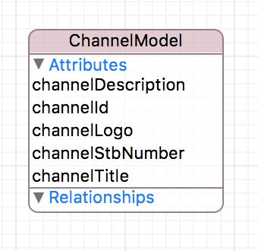

1. UserDefaults

It helps me to save some variables on local device.

1. UICollectionViewLayout

I used it for UIColectionView custom layout to display grib TV Guide

1. Module

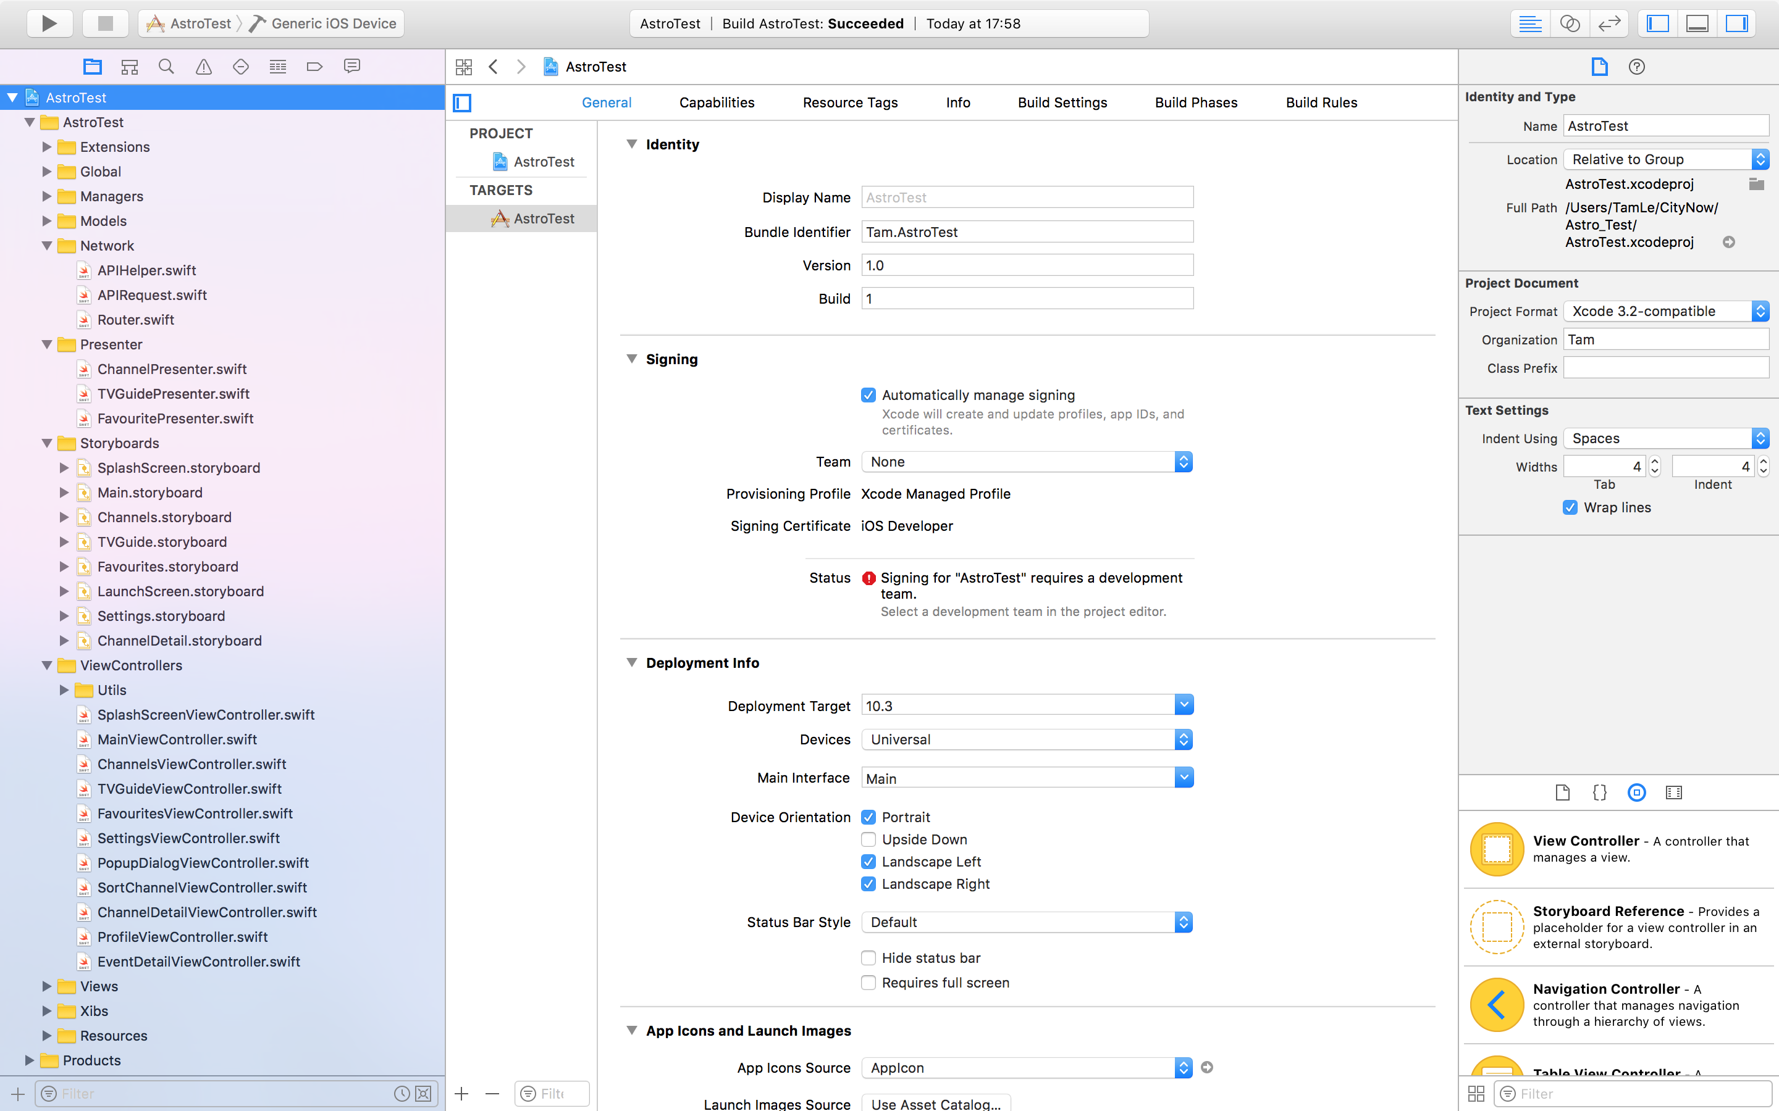

* Managers: To manage local database
* Network: It is classes to request API from server
* Models: Model objects encapsulate the data specific to an application and define the logic and computation that manipulate and process that data
* Presenter: It contains business logic for each controller.
* Storyboards: It is divided into multiple storyboard to help other developer maintain UI in the future
* ViewControllers: It contains controllers of UI
* View: It contains custom view cell
* Xibs: It contains custom cell xib file
* Resources: Fonts, Assets, Localizable.strings, etc

1. Screenshots

I completed assignment with level 1 and 2

1. Splash screen

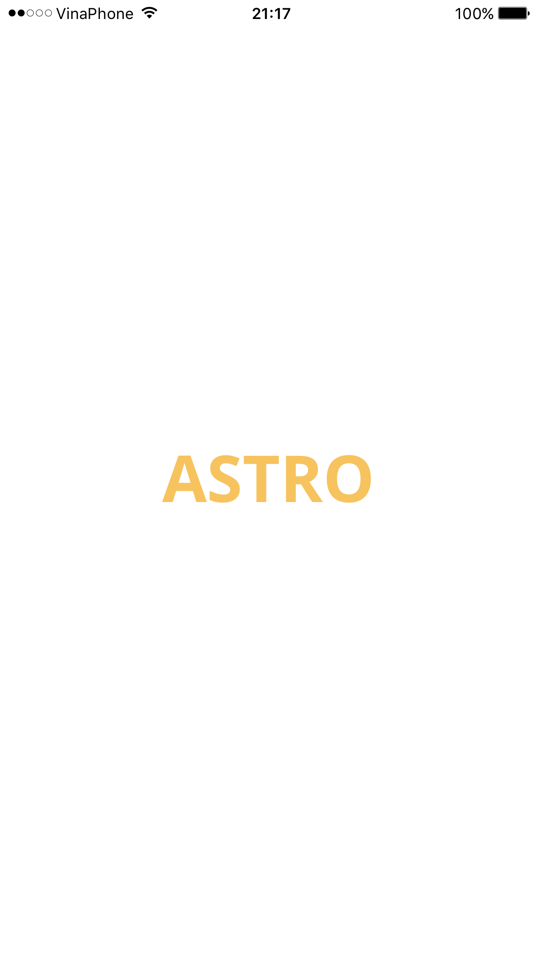

1. Channel List and Search for Channels

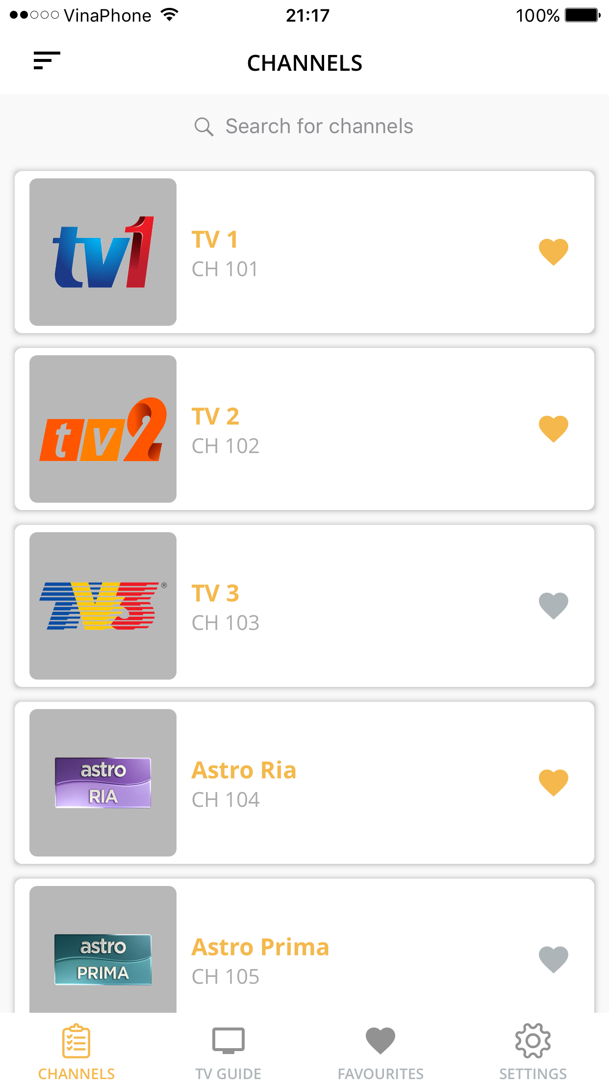 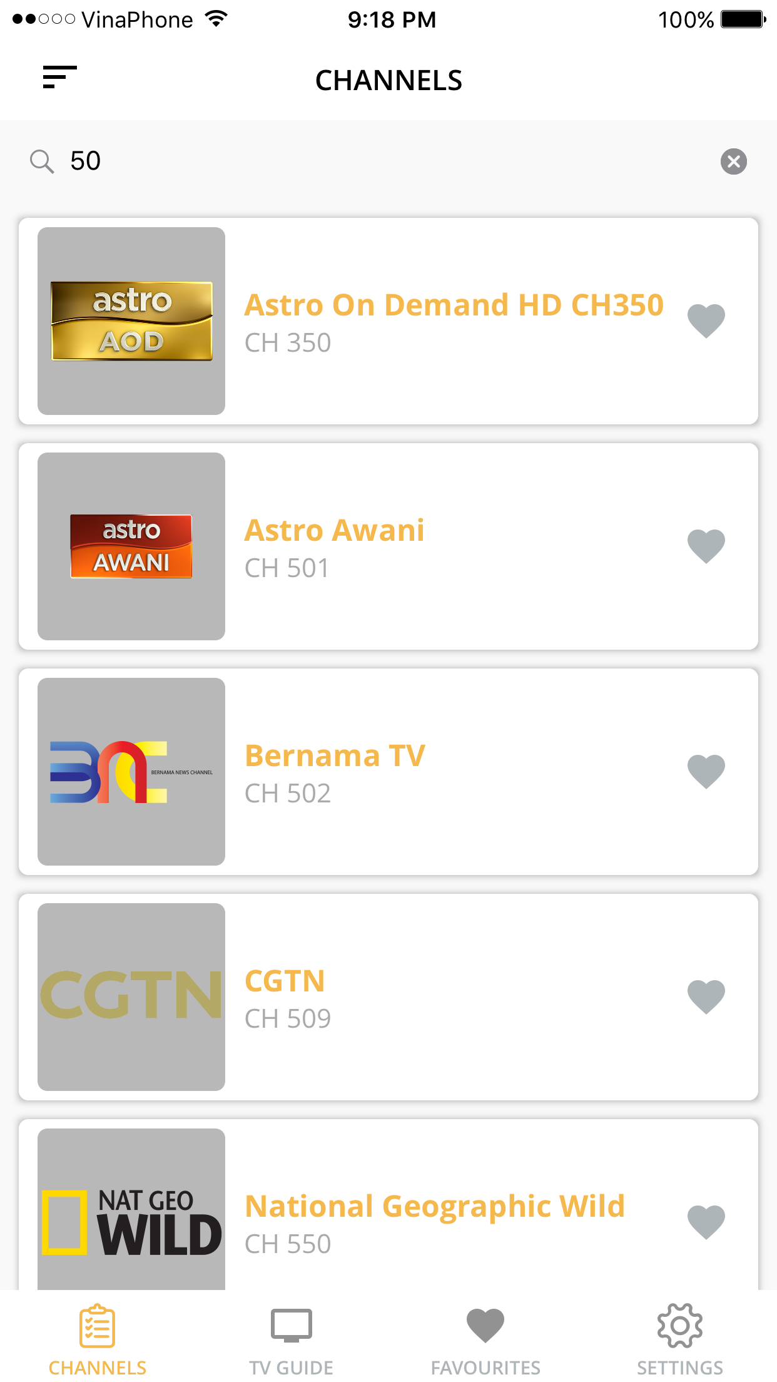



1. Channel Detail

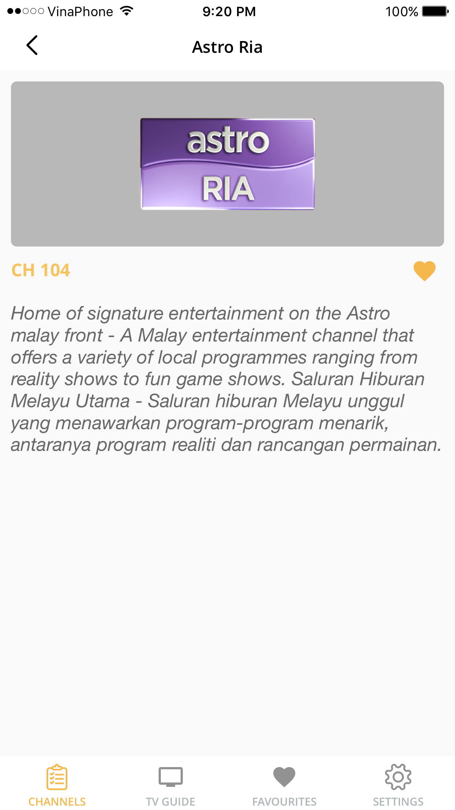

1. Sort for Channels

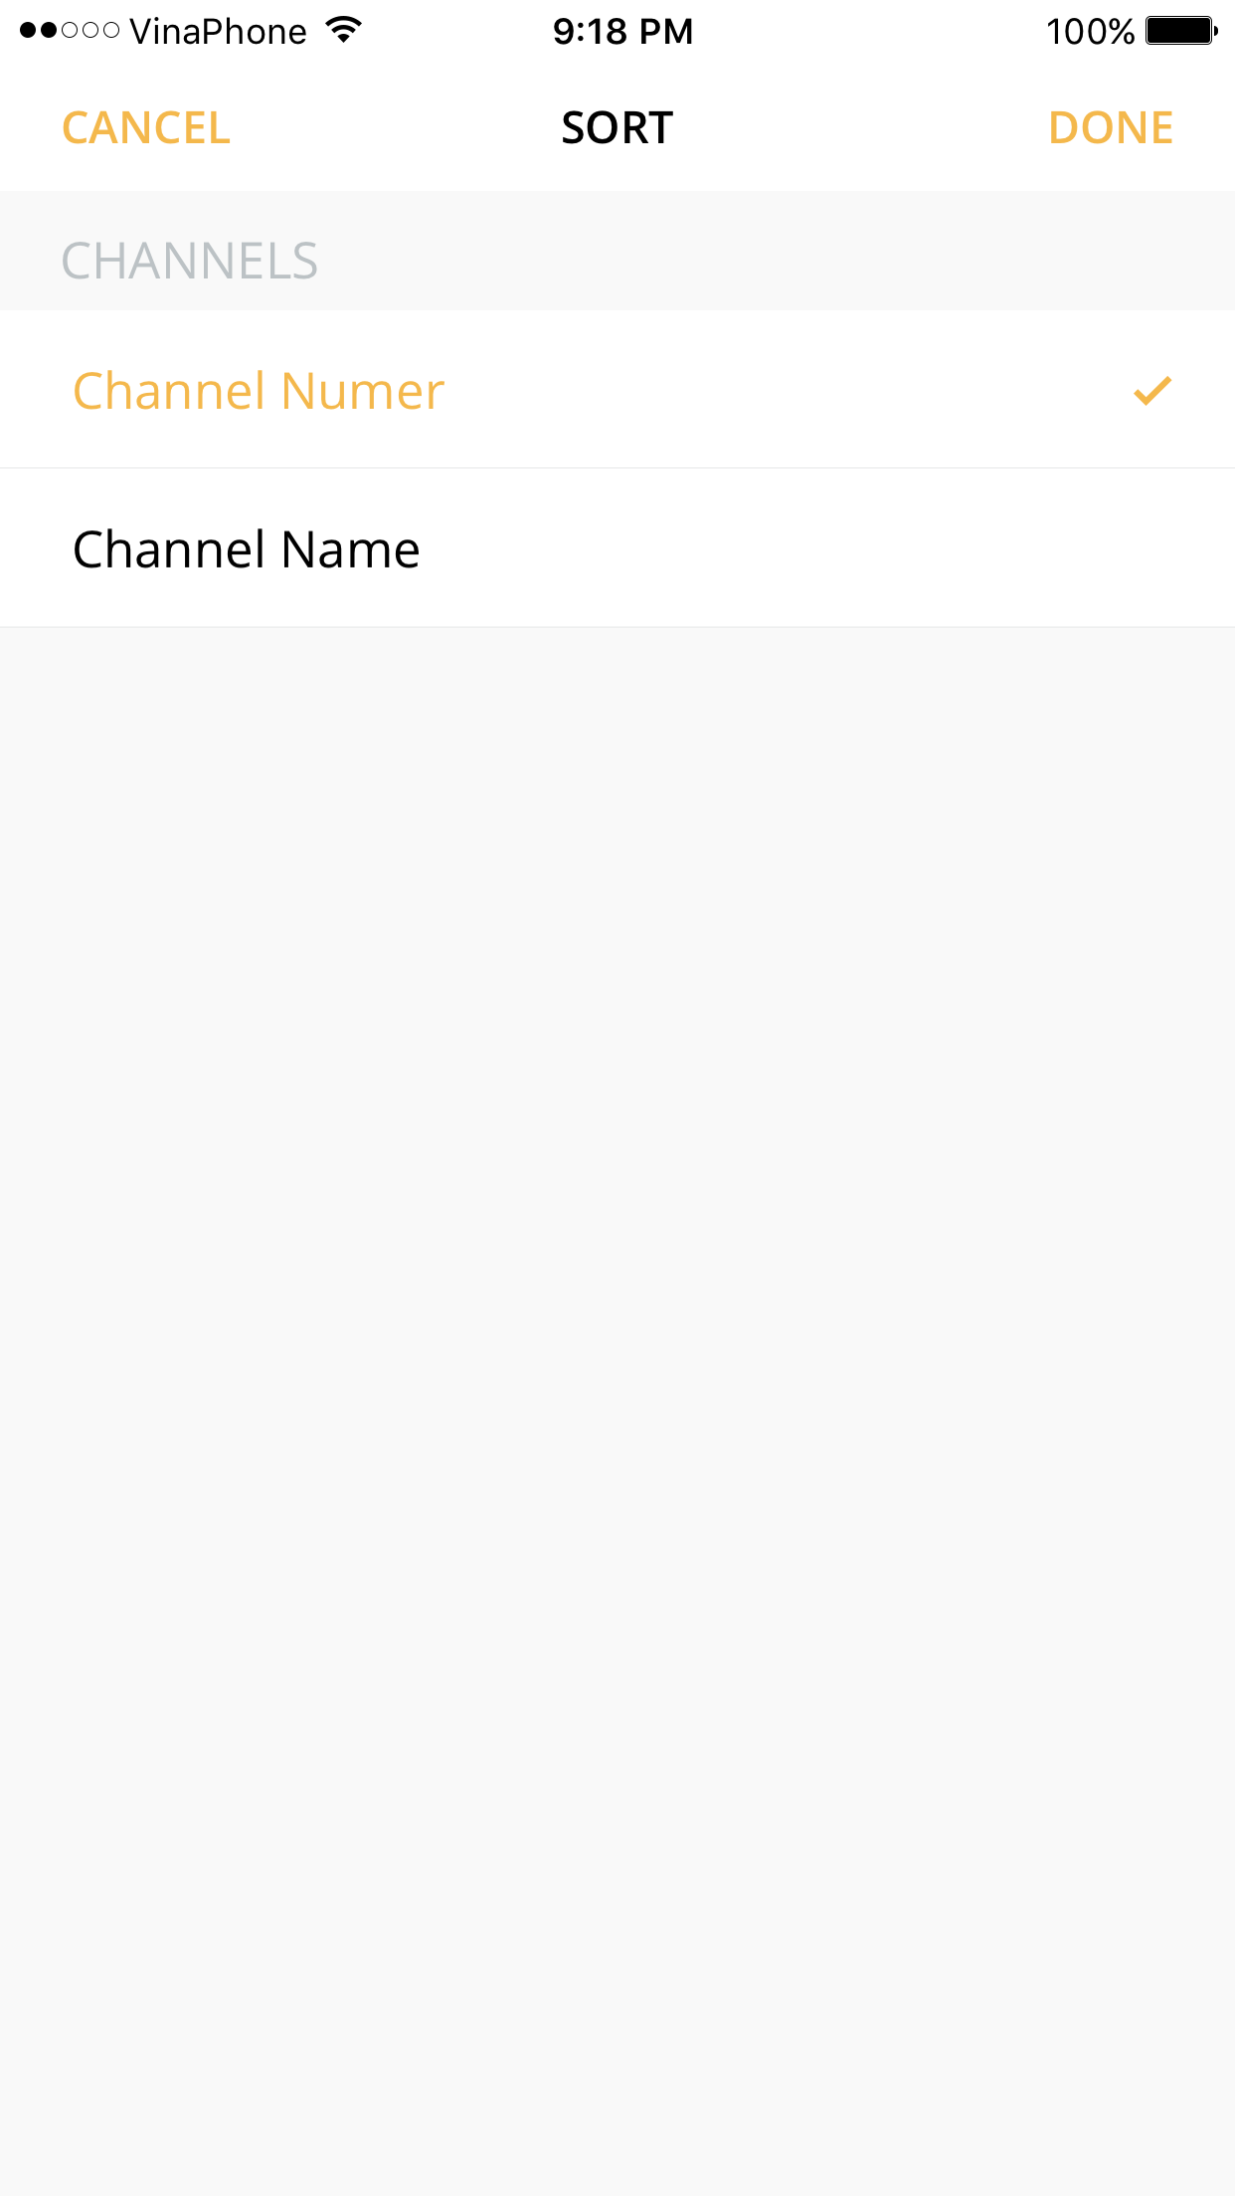

1. Favourite List

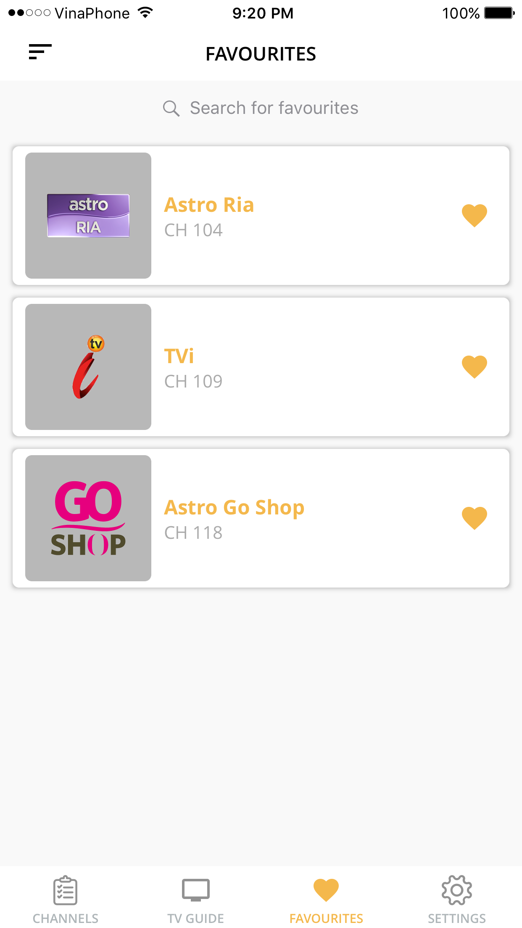

1. TV Guide

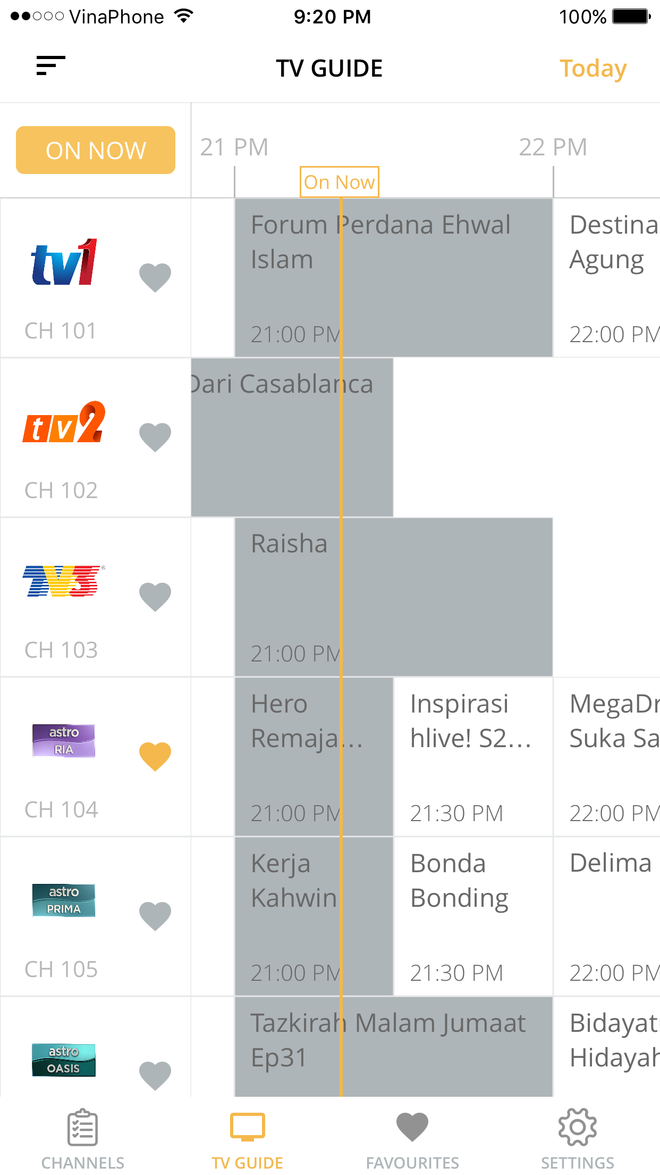

1. Event Detail

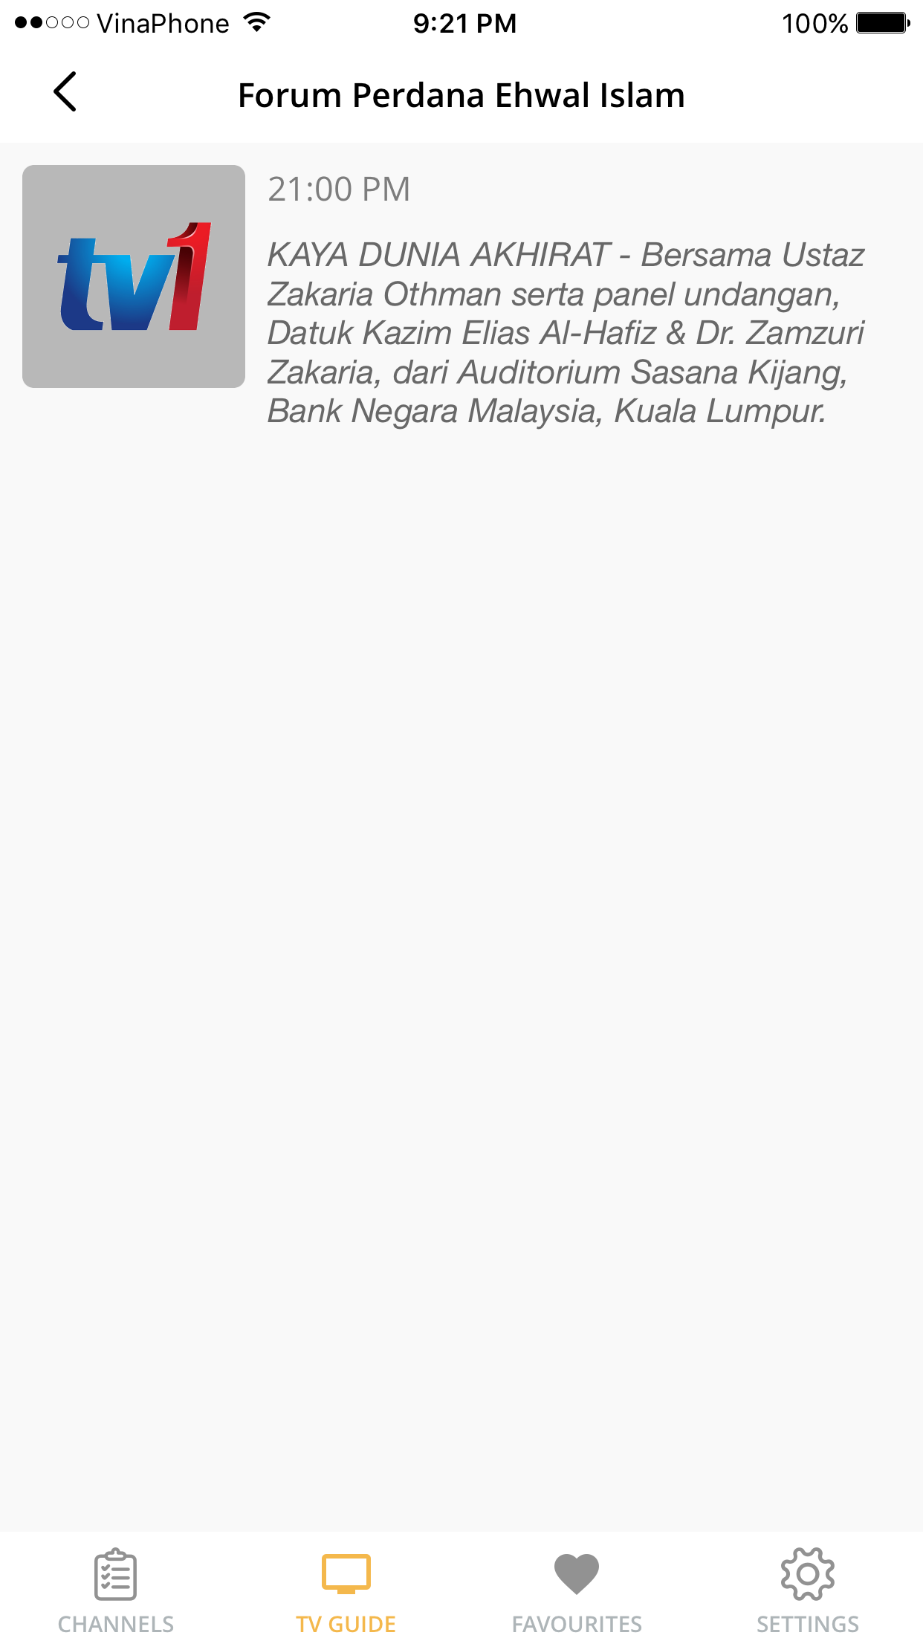

1. Settings (Future)

