Exercise 1. Changing Working Time

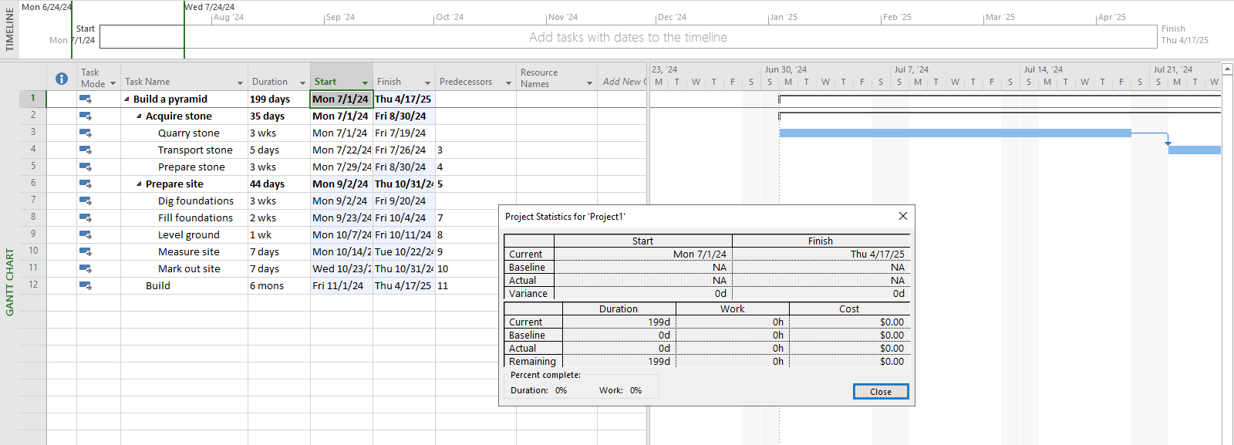

Exercise 2. Changing Working Time

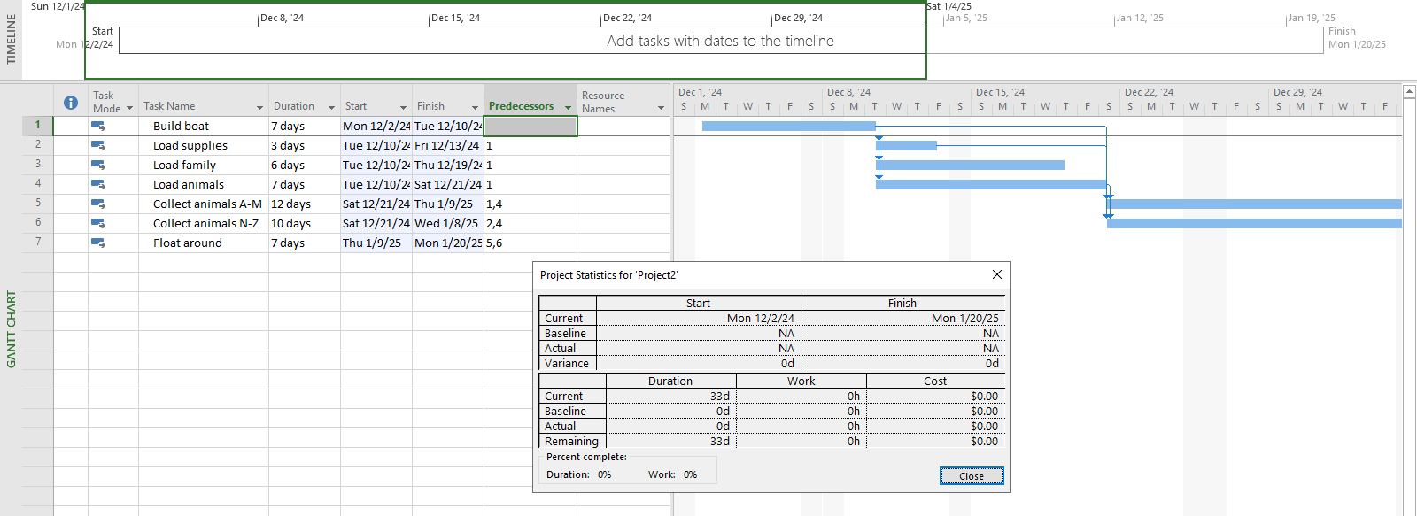

Exercise 3. Part Time - creating new calendar

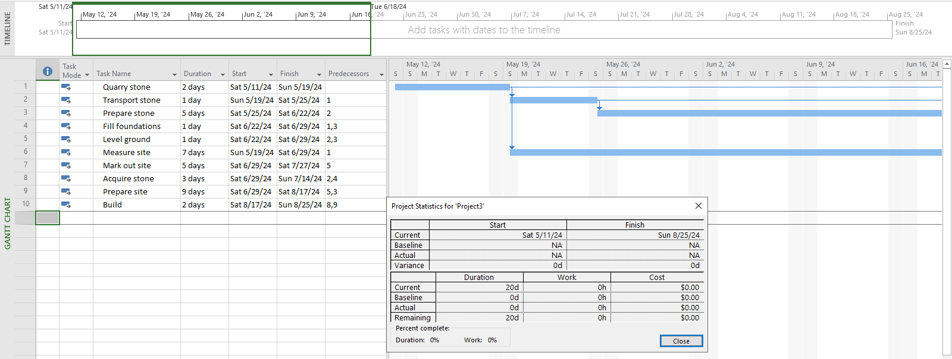

Exercise 4. Changing Working Time

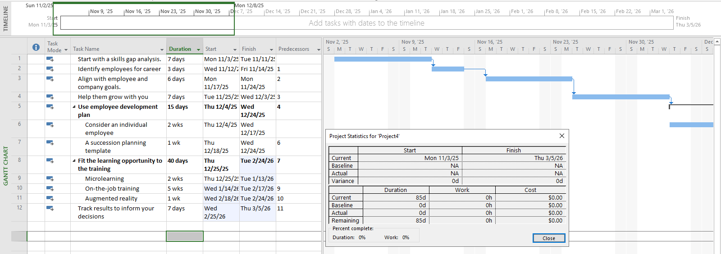

Exercise 5. Create the private Time for a project

