**Exercise 1. Changing Working Time (Start Date 1/11/2024)**

- Display the Project Information.

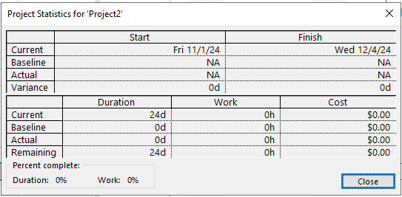

- Project Timeline



- Gantt Chart

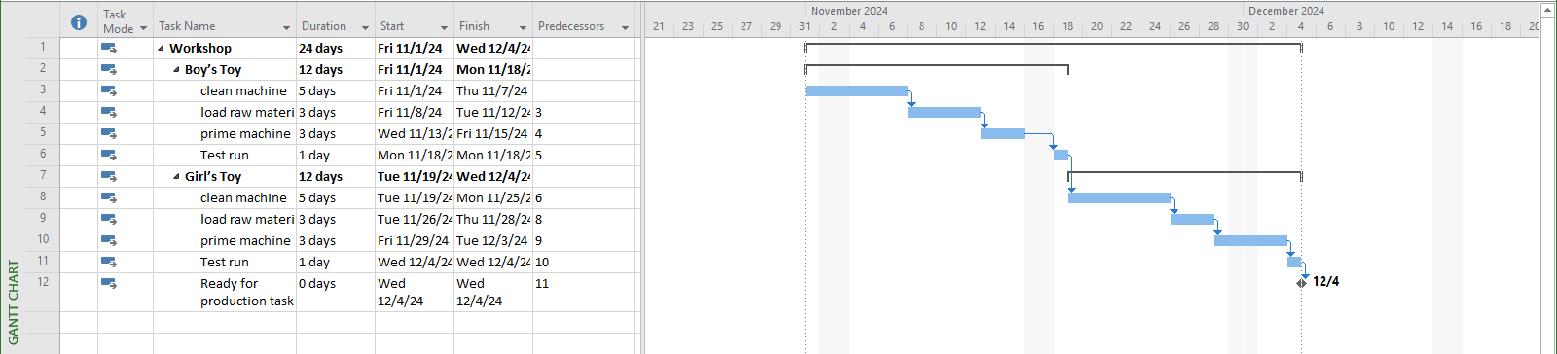

- View CP



- Total Slack

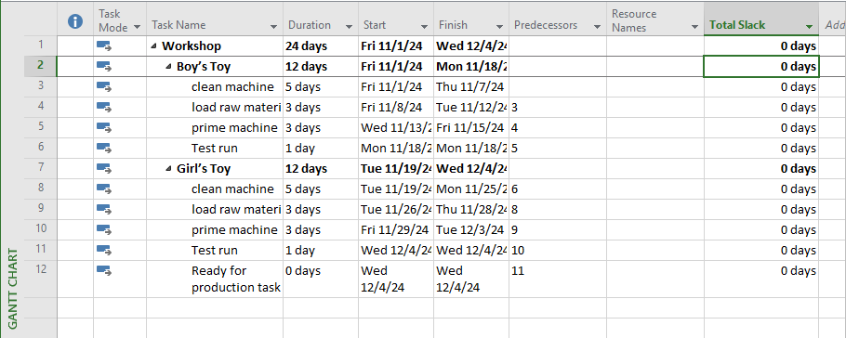

**Exercise 2. Changing Working Time (Start Date 1/11/2024)**

- Display the Project Information

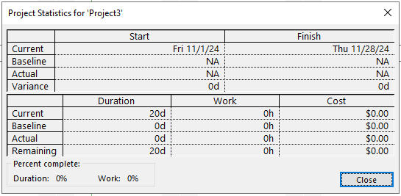

- Project Timeline



- Gantt Chart

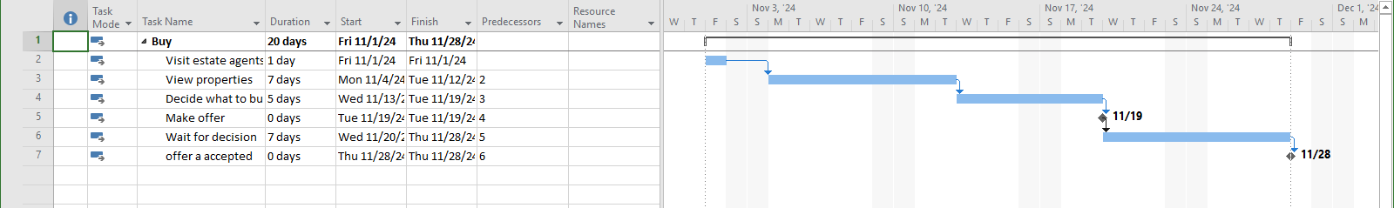

- View CP



- Total Slack

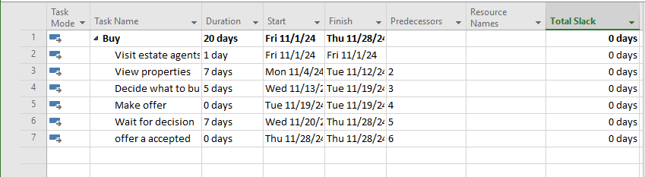

**Exercise 3. Scheduling – Task dependencies**

- Display the Project Information.

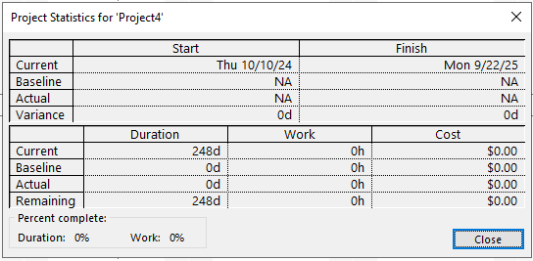

- Time Line



- Gantt Chart

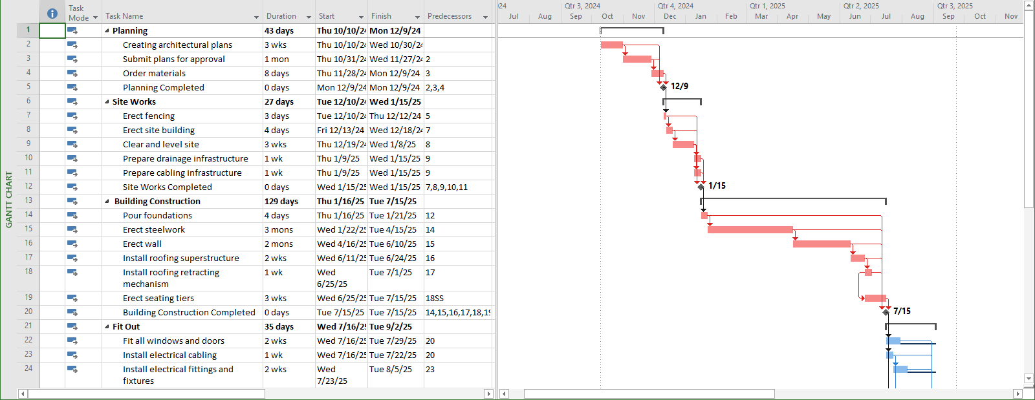

- View CP

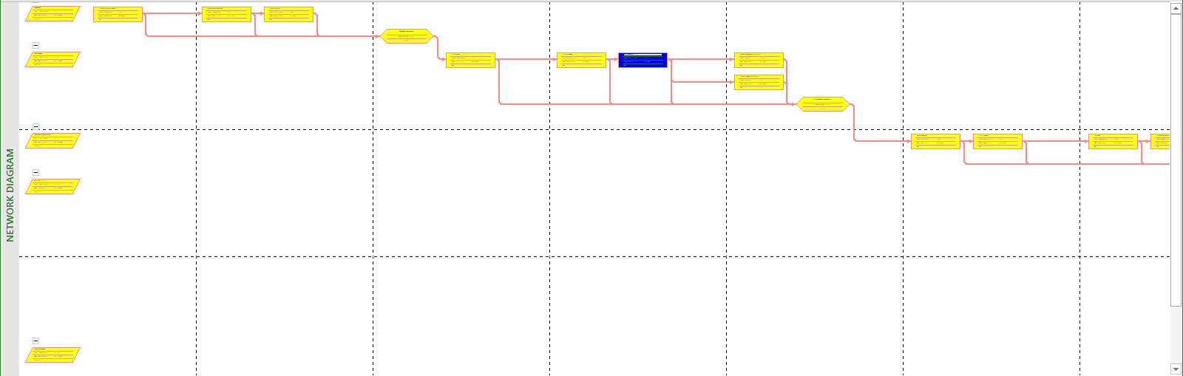

- Total Slack

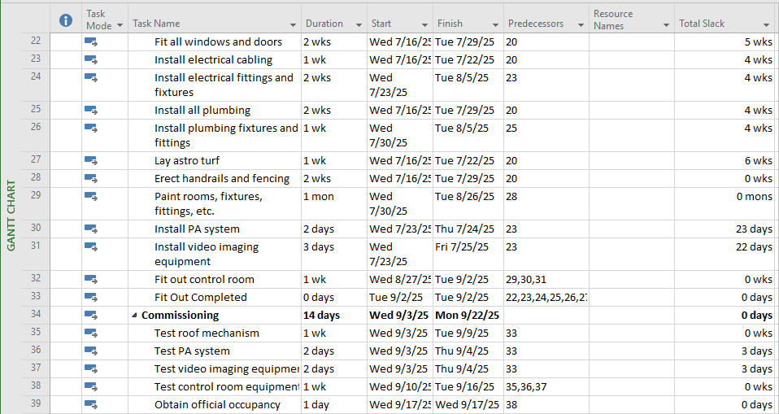

- Late Start, Late Finish, Total Slack

