REPORT

LAB 2 : MI CARD

***Student name: Le Thi Dan Lien***

***Student ID: 21IT622***

***Student email: lienltd.21it@vku.udn.vn***

# **Introduction**

* Briefly describe the purpose of the lab report.

The objective of this lab is to gain an understanding of the fundamental components that constitute Flutter's UI, as well as to incorporate supplementary elements like font libraries and images. Through practical exercises, participants will explore the integration of these elements to create visually appealing and functional user interfaces.

* Provide background information on your mobile app.

App Name: Mi Card

Purpose: MiCard is designed to simplify the process of creating personalized business cards with a beautiful and user-friendly interface. By leveraging Flutter Widgets, it offers flexibility and optimal performance across various platforms. Its purpose is to empower users to effortlessly design their own business cards while delivering an aesthetically pleasing experience.

# **Objectives**

* State the objectives of the lab.

The lab aims to equip participants with essential skills and knowledge required to set up a Flutter development environment, create projects, utilize basic elements like Scaffold, manage dependencies using the Pubspec file, and incorporate icons into Flutter applications. Through hands-on exercises and demonstrations, participants will gain practical experience in Flutter app development fundamentals.

# **Methodology**

* Describe the methodology used in the lab.

The methodology used in the lab about programming with Flutter involves a combination of theoretical explanations, practical demonstrations, and hands-on exercises to ensure participants grasp the concepts effectively.

* Explain how your app was developed.

# **Results**

* Present the results of the lab.
* Include screenshots of the app.

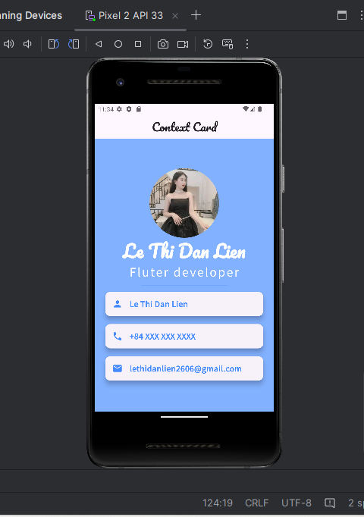

# **Discussion**

* Discuss the results obtained.

Understanding of Flutter Environment Setup:

Project Creation and Structure:

Understanding of Scaffold Widget:

Working with Pubspec File:

Integration of Icons:

Quality of Lab Report Documentation:

Feedback and Improvement Opportunities:

# **Conclusion**

* Summarize the main findings of the lab.

Strong understanding and utilization of the Scaffold widget for app layout.

Effective management of dependencies and assets using the Pubspec file.

High-quality documentation providing clear instructions and explanations.

* Provide recommendations for future work.

Explore advanced Flutter topics like state management and animation.

Assign real-world projects for practical application of skills.

Encourage collaborative group projects for teamwork experience.

Provide continuous learning resources and encourage self-study.