**Họ và Tên:** Lê Thị Đan Liên

**Lớp:** 21SE4

**Lớp học phần :** [Phát triển ứng dụng di động đa nền tảng (5)](https://classroom.google.com/c/NzA0MDgzODQyMzY2)

**Mã SV:** 21IT622

**LAB 1: I AM RICH**

1. **I Am Rich Structure**

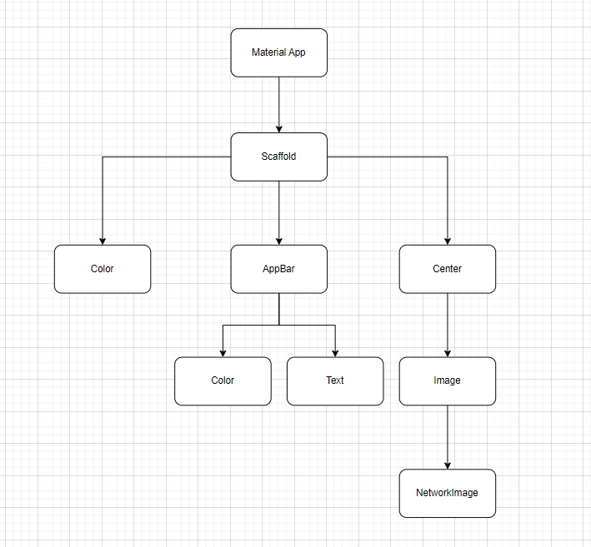

1. **Creating a New Flutter Project from Scratch:** 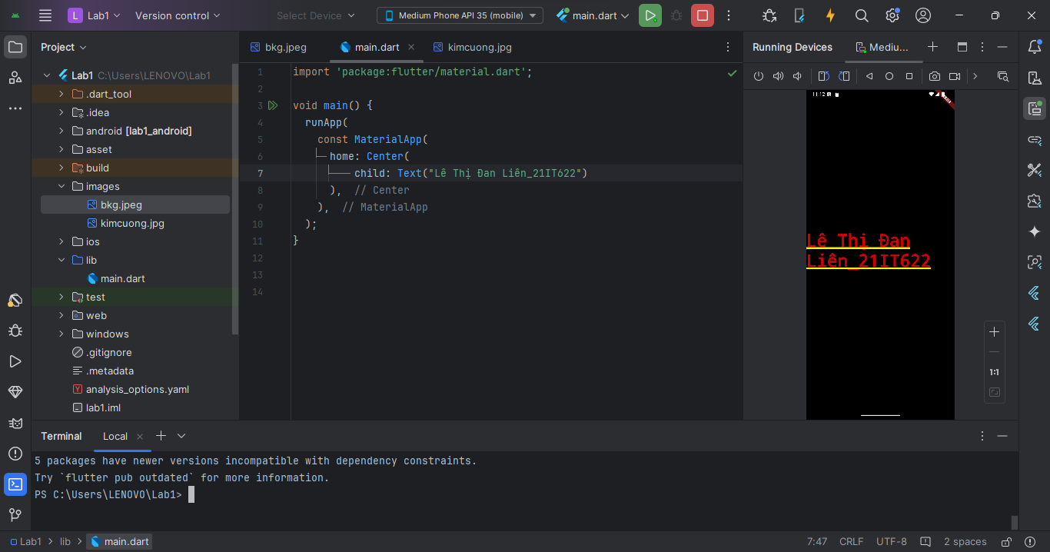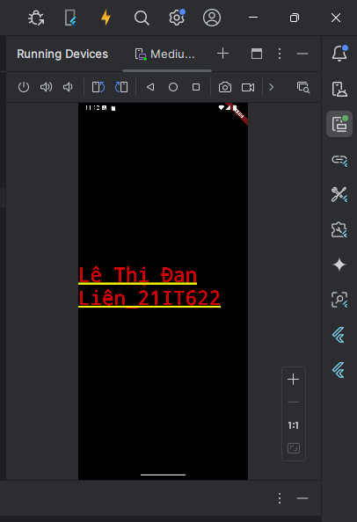
2. **Scaffolding a Flutter App**

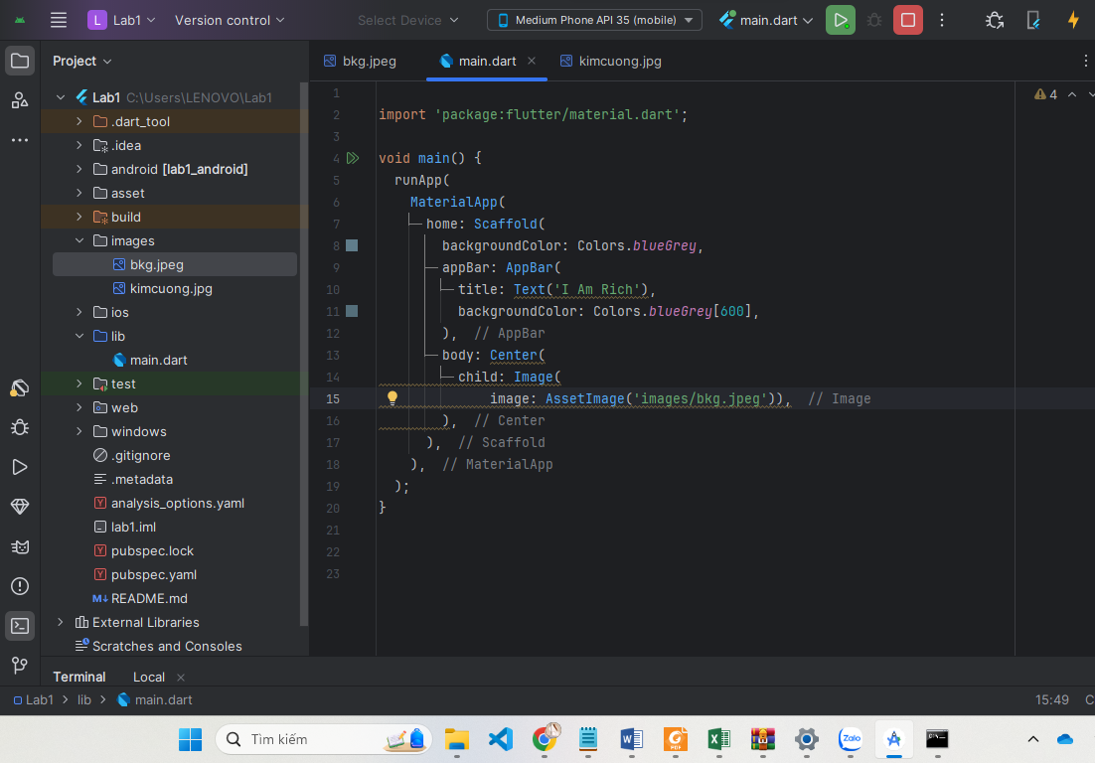

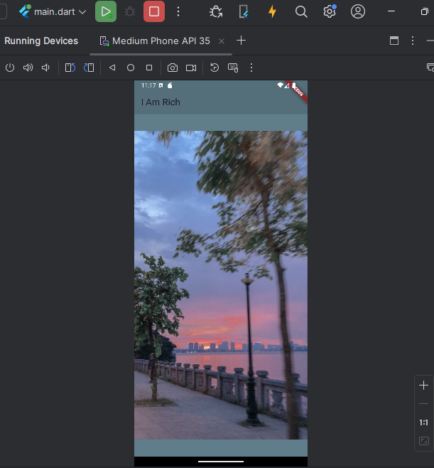

**4. Working with Assets in Flutter & the Pubspec file**

* Repair the file pubspec.yaml

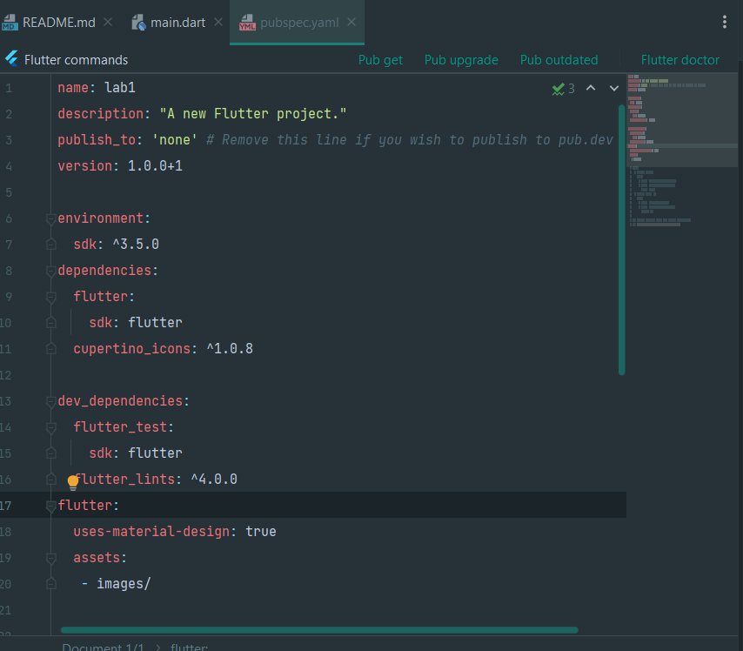

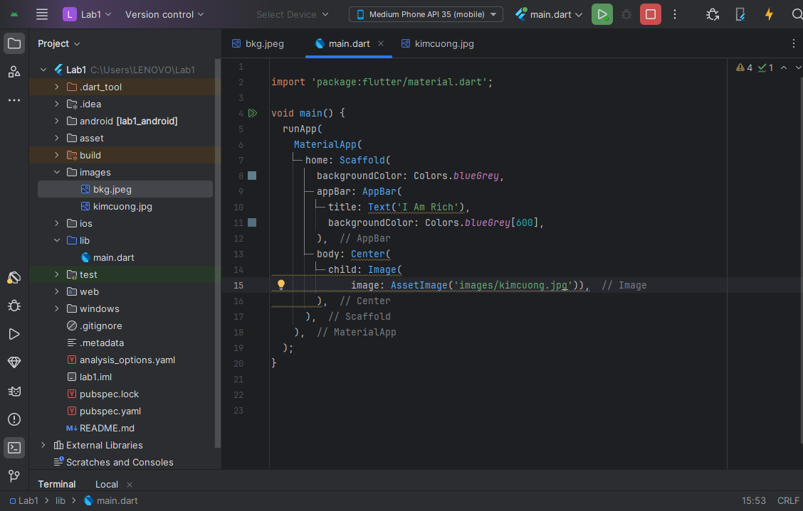

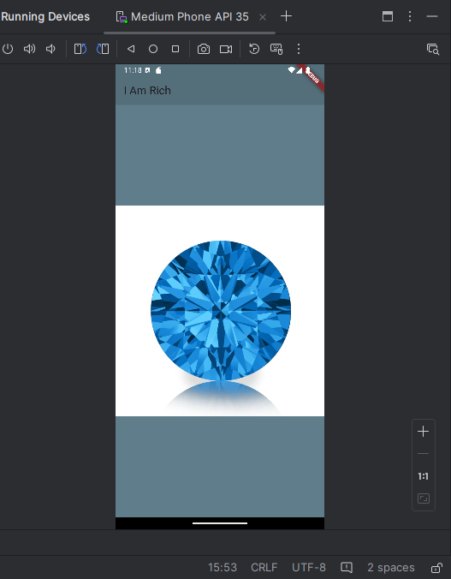

**5. How to Add App Icons to the iOS and Android Apps**

* ***Setup the config file:***

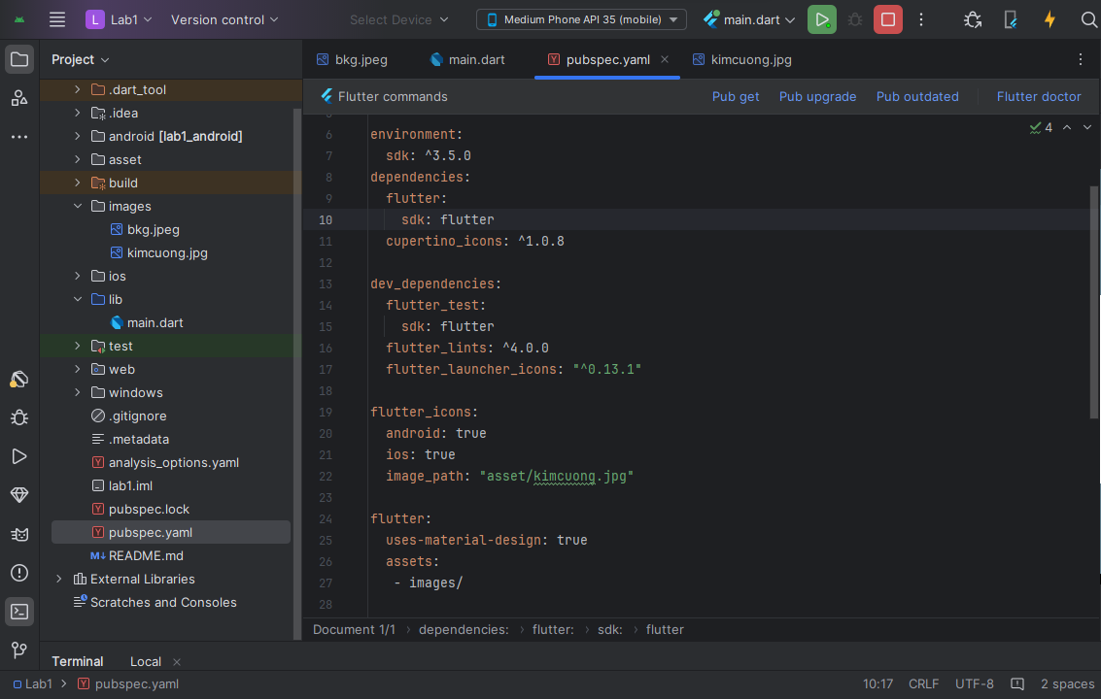

* ***Run the package***
* After setting up the configuration, all that is left to do is run the package.
  + flutter pub get
  + flutter pub run flutter_launcher_icons

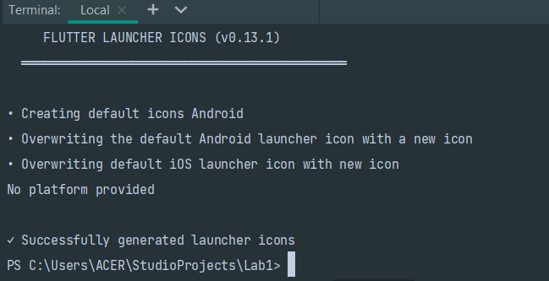

* Run app:

