

Commerce & Business Administration Faculty

Course CSIS 3540 – Client Server Systems – Winter 2019

**Term Project**

Meeting Management Application

Instructor: Michael Hrybyk

Project Team Number: 04

Team Leader: Thien Toan Le – 300293232

~~Team Member: Rajdeep Sachar – 300261238~~

1. **Project Description:**

This application will help:

* + - Managing the meetings of employees in a company.
    - Coordinating the utilization of meeting rooms.

Meetings have become the norm in today workplace. With a proper managing system, employees can plan their workday accordingly.

Another problem that this project is trying to solve is the conflicts between groups that might happen when using a limited number of meeting rooms. For example, after initialized an important meeting, the whole project goes to the planned meeting room just to realize it being used by another group. This application’s second purpose is to solve the conflict by being a centralized managing system for meeting rooms in a company.

Using the Meeting Management application, an employee can:

* + - See self’s meeting schedule.
    - Check availability of meeting rooms when planning for the upcoming meeting.
    - Create a meeting, reserve a meeting room and invite others to the meeting.
    - Manage owned created meeting.

This application can be used in companies in different kinds of businesses.

Managing users isn’t in the scope for now. Most businesses would already have their dedicated user management. When integrating into a company ecosystem, the USER table can be replaced, and the Login Screen can be extended to connect with the company’s authentication system.

1. **Project Model:**

There will be 3 user roles: regular user, manager and admin

A regular user can:

* See self’s meeting schedule (past, present and future)

A manager can:

* Do everything a regular user can.
* Check meeting rooms availability.
* Reserve meeting room and create meeting.
* Invite others to the meeting.
* Update created upcoming meetings.

An admin can:

* + - Everything a manager can.
    - Manage groups (list, add, update, disable)
    - Manage meeting rooms (list, add, disable)

1. **User Interface:**
   1. **Login screen:**

User will enter username in this screen to login.

* 1. **Main screen:**

This screen contains many sub-screens for each functionality, which are contained in separated tabs.

Based on the role associates with the logged in user, the number of tabs will differ:

* + - Manage Meetings tab: show self’s meeting schedule, available for all. Also allow adding new meetings and updating future meetings, available for managers and admins.
    - Meeting Rooms tab: allow managing meeting rooms. Available for managers (limited to listing meeting rooms only) and admins.
    - Groups tab: allow managing groups. Available for admins only.
    - Import / Export XML tab: allow import and export database using xml file. Available for admins only.

1. **Database Model:**

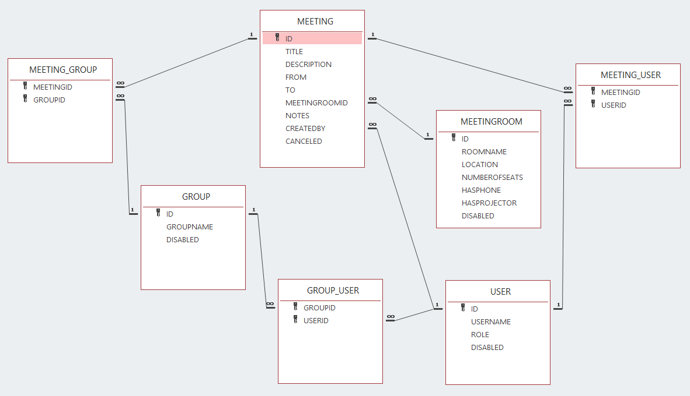

Figure 1 - Entity Relationship Diagram

* + - USER: storing users and their roles. The application will use username for login and role for display. Password management will be left for future enhancement.
    - GROUP: represent a group of users, can be project or department.
    - GROUP_USER: associate entity between USER and GROUP.
    - MEETINGROOM: storing meeting rooms information.
    - MEETING: storing meetings information. Has foreign key to MEETINGROOM.
    - MEETING_USER: associate entity between MEETING and USER. Represent users being invited to meetings.
    - MEETING_GROUP: associate entity between MEETING and GROUP. Represent groups being invited to meetings. Shortcut for organizers to invite multiple users indirectly through groups.

1. **Project Plan:**

|  |  |  |  |  |
| --- | --- | --- | --- | --- |
| **ID** | **Task Description** | **Owner** | **Predecessor** | **Status** |
| 1 | Proposal (scope, process, database design, screens design, plan) | Toan |  | Done |
| 2 | Coordinating and reporting | Toan |  | Done |
| 3 | Database project | Toan | 1 | Done |
| 4 | Project for Seed data | Toan | 3 | Done |
| 5 | Initialize and Structure Main Project | Toan | 1 | Done |
| 6.1 | Implement Login Screen | Toan | 3, 5 | Done |
| 6.2 | Implement Main Screen tabs | Toan | 3, 5 | Done |
| 6.3 | Implement Meetings tab | Toan | 3, 5 | Done |
| 6.4 | Implement Meeting Rooms tab | Toan | 3, 5 | Done |
| 6.5 | Implement Groups tab | Toan | 3, 5 | Done |
| 6.6 | Implement Import / Export XML tab | Toan | 3, 5 | Done |
| 7 | Integration Test | Toan | 6 | Done |

*\*Note: Implementation tasks are consisted of user interface, logic and unit test.*