

Commerce & Business Administration Faculty

Course CSIS 3280 – Web Based Scripting – Winter 2019

**Group Project**

MyMDB

A simple clone of IMDB

Instructor: Rahim Virani

Group Members:

Toan Thien Le – 300293232

Tung Lam Trinh – 300267601

Trevor Fawcett - 300291654

Table of Contents

**I.** **Project Description** 2

**1.** **Project Overview:** 2

**2.** **Entities:** 2

**a.** **Movie:** (Responsible members: Trevor and Toan) 2

**b.** **User:** (Responsible member: Toan) 2

**c.** **Review:** (Responsible members: Lam and Toan) 2

**3.** **Project Structure:** 2

**a.** **Front-end:** 2

**b.** **Web service (RestAPI, Mappers and PDO):** 2

**II.** **Entity Relational Diagram** 3

**III.** **Meeting Minutes** 3

**IV.** **Installation Manual** 5

**1.** **Project Files:** 5

**2.** **Setup MySQL database:** 5

**3.** **Setup Apache Server alias:** 5

**4.** **Access the MyMDB website:** 5

**V.** **User Manual:** 6

**1.** **Authentication page:** 6

**2.** **Home page:** 6

**3.** **Movie List page:** 6

**4.** **Movie Detail page:** 6

**5.** **Add / Edit Movie page:** 6

**6.** **User Detail page:** 6

**VI.** **References** 7

1. **Project Description**
   1. **Project Overview:**

This project will be simple version of IMDB website.

User will be able to:

* + - Register and Login / Logout
    - View, Search, Add, Update movies
    - See a movie detail and Leave review or Delete review on a movie
    - View statistic of movies, users and reviews on Home page.
    - View self-activity statistic on User Detail page.
  1. **Entities:**
     + - 1. **Movie:** (Responsible members: Trevor and Toan)
  2. **User:** (Responsible member: Toan)
  3. **Review:** (Responsible members: Lam and Toan)
  4. **Project Structure:**

**Front-end:**

The webpages that users interact to. It handles user actions, validates, and then make corresponding HTTP calls to RestAPI; finally shows the result to users on screen.

**Web service (RestAPI, Mappers and PDO):**

Handle HTTP calls from Front-end. Based on the requested operation, it will interact with MySQL database (CRUD operations) through Mappers and PDO.

1. **Entity Relational Diagram**

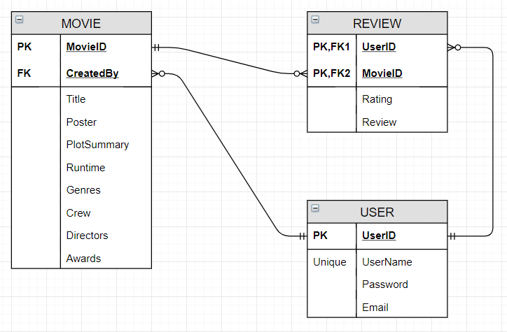

Figure 1 - Entities Relational Diagram

1. **Meeting Minutes**

|  |  |  |  |  |
| --- | --- | --- | --- | --- |
| Date | Name | Work Done | What is going well | What is not going well |
| 3/28/2019 | All | - Decide on the theme and entities |  |  |
| - Complete the project proposal |  |  |
| - Setup a Github repo |  |  |
|  | | | | |
| 3/31/2019 | Toan | - Created templates and rough design | - Everything went smoothly very similar to lab |  |
| - Create project structure |  |
| - Authenticate functionality |  |
| Trevor | - Finished MyMDB_Database.sql |  |
| - Finished Movie.class.php |  |
| - Finished MovieMapper.class.php |  |
| - Finished MovieRestAPI.php |  |
| Lam | - Report’s layout |  |
|  | | | | |
| 4/1/2019 | Trevor | - Retrieve and Show movies |  |  |
| - Search movies |  |  |
| Toan | - Fix sql script and classes setters |  |  |
| - Add movie functionality |  |  |
| Lam | - SQL script and Entity class for Review |  |  |
|  | | | | |
| 4/2/2019 | Trevor | - ERD diagram for the report |  | - This was painful to  create using Draw.IO |
| - Integration test |  |  |
| Toan | - View movie detail and update movie |  |  |
| - Redesign movies list from table to rows of movie cards |  |  |
| - View and Add review |  |  |
| - Get movie’s average rating and number of reviews |  |  |
| - Statistic on Home page |  |  |
| - Statistic on User Detail page |  |  |
| - Format codes and add comments |  |  |
| Lam | - Integration test |  |  |
|  | | | | |
| 4/3/2019 | Trevor | - Integration Test |  |  |
| - Create and Assemble seed data |  |  |
| - Meeting Minutes section of the report |  |  |
| - Redesign add review form |  |  |
| Toan | - Add Delete review option on page |  |  |
| - Compile the final report |  |  |
| Lam | - Integration test |  |  |
| - Create seed data |  |  |

1. **Installation Manual**
   1. **Project Files:**
      * Unzip MyMDB.zip for a folder containing all the project files. Or go to <https://github.com/lethien/MyMDB> for the whole project.
      * Go inside this folder, you should see the main controller file **MyMDB.php**. This will be called the **[Project Root Folder]**.

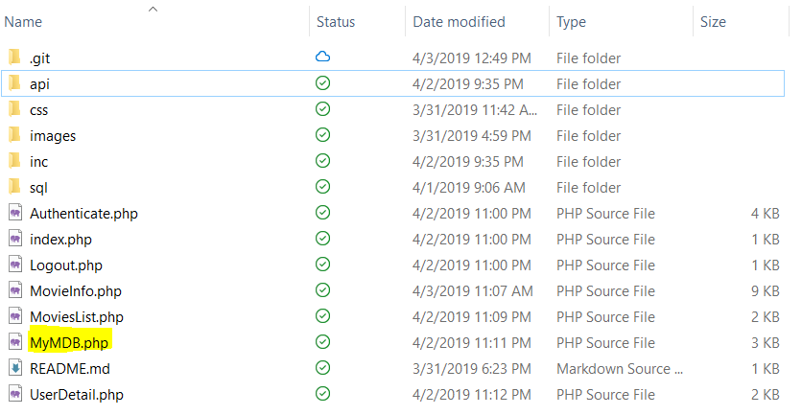

* 1. **Setup MySQL database:**
     + MySQL database should be on the same machine that the Apache Server is on, username should be ‘root’ and password should be ‘’.
     + Create the database MyMDB and the three tables by running the script sql/MyMDB_Database.sql.
     + If your MySQL setup is different, change the configuration in inc/config.inc.php.
     + (Optional) Seed data by running sql/MyMDB_Seed_Data.sql.
  2. **Setup Apache Server alias:**
     + Create an alias called ‘MyMDB’ that points to **[Project Root Folder].** Port should be the standard http port 80.
     + If your Apache Server configuration is different, change the configuration for API_URL in inc/config.inc.php.

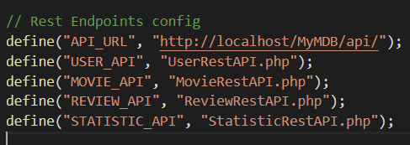

* 1. **Access the MyMDB website:**
     + Use <http://localhost/MyMDB>.

1. **User Manual:**
   1. **Authentication page:**
      * MyMDB requires user to login. If user hasn’t logged in, system will redirect user to Authentication page.
      * User can choose to login or register. If success, user will be logged in and redirected to Home page.
   2. **Home page:**
      * Show MyMDB statistic on number of movies, users and reviews. Also show top rating movies and top reviewed movies.
      * MyMDB provides a navigation bar on top that is available every page. User can choose to show all movies or search for specific ones, user will be then transferred to Movie List page.
   3. **Movie List page:**
      * Show List of Movies. Each movie will be displayed in a card with basic information.
      * User can click on a movie’s title to go to Movie Detail page.
      * User can choose Add Movie to go to Add Movie page.
   4. **Movie Detail page:**
      * Show the requested Movie’s full information.
      * At the bottom, user can add or see their review on that movie. If user already added a review on that movie, user can choose Delete Review to remove that review and then add a new one.
      * User can choose Edit Movie link to go to Edit Movie page.
   5. **Add / Edit Movie page:**
      * Provide a form to add a new movie or edit an existing one.
      * If user want stop editing, click on the Cancel Edit to discard all changes and go back Movie Detail page.
   6. **User Detail page:**
      * Show user’s information.
      * Show statistic on current user’s activity (number of created movies, number of reviews and favorite movies)
2. **References**

Gamache, D. (n.d.). *Skeleton: Responsive CSS Boilerplate*. Retrieved from Skeleton: http://getskeleton.com/

IMDB. (n.d.). *IMDb: Ratings and Reviews for New Movies and TV Shows*. Retrieved from IMDB: https://www.imdb.com/

Stack Overflow. (n.d.). *Stack Overflow*. Retrieved from Stack Overflow: https://stackoverflow.com/

Virani, R. (2019). Example Code, Labs and Assignments. *CSIS3280 - Douglas College*.