*General Points*

* Use the course material located at:
  + [Whirlwind Tour of Python](https://github.com/jakevdp/WhirlwindTourOfPython)
* Assignment 05 can be completed using previously covered material and content from the following chapters:
  + 00-Introduction *through* 10-Iterators
* After completing requirements, test to ensure all cells run correctly in the .ipynb file.
* Include appropriate markdown cells to identify the requirements below by number. See this [example.](https://austincode.com/coursecontent/itse1302/requirements-example.png)
* Produce an .html file that shows the .ipynb after a successful test run. o by File | Download as | HTML (.html) .
* Test the .html file by opening it in a browser and ensure the content is produced correctly from the run in Jupyter Notebook.
* Submit BOTH the .ipynb and .html files to the appropriate link in

Blackboard | Assignments. Submit the files individually (via a multi-select).

However, if your browser posts an error for the .html file, submit it as a .zip.

* Submit any additional files required to complete the assignment.



(*Ensure all Requirements are complete*)

1. Using Jupyter Notebook (or similar tool), create a file named:

• assignment-05.ipynb

1. Add an H1 markdown cell: “This is Assignment 05 - <yournamehere>”. See example at link above.
2. Include appropriate markdown cells to identify the requirements below by number. See example at link above.
3. Demonstrate the following arithmetic operations in a cell:
   * + addition
     + subtraction
     + multiplication
     + true division
     + floor division
     + exponentiation
4. Demonstrate the following comparison operations in a cell:
   * + ==
     + !=
     + < , >
     + <= , >=
5. Use a text editor like Notepad++ (or an IDE of your choice) to create a file named operators.py with the same arithmetic and comparison operations as Requirements 4 & 5. Include appropriate print statements. In assignment-05.ipynb, include a cell running operators.py.

Hint: Use one of these to execute operators.py in Jupyter Notebooks.

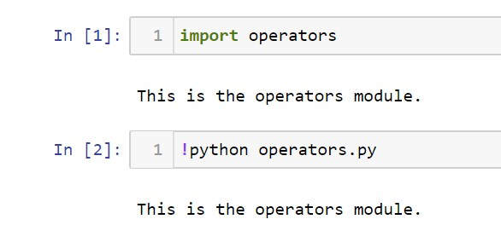

The second version is a little easier to work with due to the server caching of the import operation. More on both techniques as we progress through the course.

1. In a cell, use Python to:
   * + Include appropriate comments in your code.
     + Create two lists, list_1 and list_2.
     + Populate each list with 10 arbitrary numbers, some even and some odd in each list.
     + Create two more lists, list_even and list_odd.
     + Programmatically populate list_even with the even numbers from list_1 and list_2.
     + Programmatically populate list_odd with the odd numbers from list_1 and list_2.
     + Print list_even and list_odd.
2. Demonstrate the use of the method is_integer() to test if numbers qualify as integers.
3. Demonstrate the following Boolean, Identity, and Membership operations in a cell:
   * + and
     + or
     + not
     + is
     + is not
     + in
     + not in
     + Object Identity

i. Hint: use hex(id(x)) to show object address in hexadecimal.

1. Demonstrate *variable precision* in a cell.
2. Demonstrate the following string operations in a cell:
   * + len
     + upper()
     + capitalize()
     + concatenation
     + multi-concatenation
     + access of individual characters
3. Use markdown to include a statement at the end of assignment-05.ipynb explaining your experiences with Assignment 05. Make this authentic (minimum of 2-3 sentences).

TEST – TEST – TEST your .ipynb file to ensure all requirements are met.

Produce an .html file from a successful run of the .ipynb file. Ensure that the .html is produced correctly by opening it in a browser.

* + Use the list above as a confirmation checklist.
  + Not meeting all requirements = 0 points for the assignment.