Marine Services and Ship Repair in Vietnam – About HMS Haiphong Marine Services
HMS – Haiphong Marine Services is one of the pioneering companies in marine services and ship repair in Vietnam, headquartered in Hai Phong – the largest maritime gateway in northern Vietnam. The company provides comprehensive solutions in ship repair, dry dock services in Vietnam, marine supplies, lashing services, and underwater works.
With a team of trained engineers, technical experts, and modern repair workshops, HMS supports ship owners, managers, and operators at all major ports and anchorages nationwide, ensuring safe, efficient, and internationally compliant technical services.

Why Choose HMS – Haiphong Marine Services in Vietnam
In the context of a steadily growing global ship repair market, ship owners and operators demand higher standards in technical quality, efficiency, and cost-effectiveness.
HMS meets these requirements by:
- Ensuring fast completion times, helping vessels return to operation quickly.
- Delivering high-quality technical work through internationally certified engineers and modern workshops.
- Offering competitive pricing while maintaining operational efficiency.
- Providing nationwide coverage with emergency support available at every port and anchorage.
- Building trust through responsibility, safety, and long-term commitment to clients.
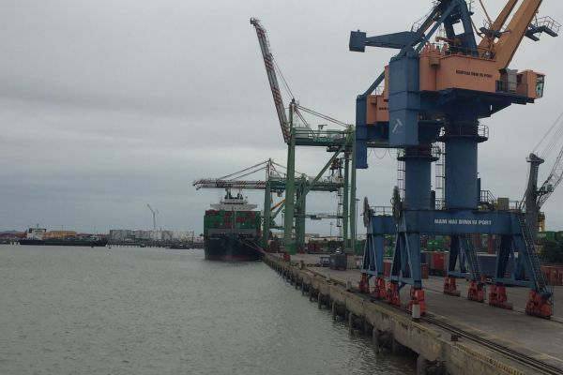
Cargo vessel at Hai Phong Port – HMS provides nationwide marine services and ship repair in Vietnam

About HMS – Haiphong Marine Services
HMS aims to become a leading provider of marine services and ship repair in Vietnam while expanding its capabilities to meet international standards. The company’s long-term objectives focus on sustainable growth, adoption of modern technology, and the delivery of high-quality services to optimize vessel operations.
HMS is committed to providing safe, reliable, and timely technical solutions for vessel maintenance, repair, and dry dock services. We work closely with ship owners and operators to ensure vessels operate smoothly, comply with international classification standards, and minimize downtime.
At HMS, we are committed to:
- Fast delivery service, reducing repair cycles.
- On-time completion, maintaining progress and quality.
- Reasonable pricing, optimizing client budgets.
- Highly experienced engineers and specialists trained and certified internationally.
- A strong sense of responsibility, placing client safety and interests first.
With its solid foundation and proven track record, HMS continues to play a vital role in the maritime industry, serving as a reliable partner for ship repair, dry docking, and marine services in Vietnam.

Services Offered by HMS – Haiphong Marine Services
HMS provides comprehensive solutions for vessels, including repair, maintenance, supply of materials, and fabrication. Services are delivered by professional engineers and technicians under standardized processes, complying with international classification standards (IACS, DNV, ABS, LR, VR, ClassNK).

1. Marine Services
HMS offers a full range of Marine Services to support stable operations and compliance:
- Dry Dock & Floating Dock Services:
  - Hull structure repairs and replacement of AH36/DH36/EH36 steel plates.
  - Welding and quality inspection with WPS certified by ClassNK, LR, ABS.
  - Safe and efficient service minimizing vessel downtime.
- Underwater Services:
  - Hull cleaning, inspection of propellers, shafts, rudders, and speed logs.
  - Non-Destructive Testing (NDT) underwater inspections.
  - Professional divers with modern equipment, ensuring safety for both vessel and personnel.
- Lashing & Cargo Securing Services:
  - Lashing/unlashing for all types of cargo vessels: container, bulk, oil, and LPG/LNG.
  - Ensures cargo is secured properly, reducing risks during transportation and complying with international classification standards.
- LSA / FFE Annual Inspection:
  - Inspection and maintenance of Lifesaving Appliances (LSA) and Fire Fighting Equipment (FFE).
  - Compliant with IMO regulations and international classification requirements.
- Load Test Services:
  - Load testing of lifting equipment, cranes, and winch systems.
  - Ensures safety, reliability, and operational compliance.
- Navigation & Communication Equipment:
- Inspection and calibration of radar, GPS, AIS, VHF, and GMDSS systems.
- Troubleshooting and repair ensuring IMO/SOLAS compliance.
- Handled by certified marine electronics engineers.
- Ultrasonic Hatch Cover Testing:
- Class-approved ultrasonic testing for hatch cover watertightness.
- Detects leaks and ensures cargo protection during voyage.
- Meets IACS and P&I Club requirements.
- Inspection & Certification Services:
- Hull, machinery, and safety system inspections for Class renewal.
- Coordination with VR, ABS, DNV, LR, and ClassNK.
- Technical reporting to maintain vessel certification compliance.
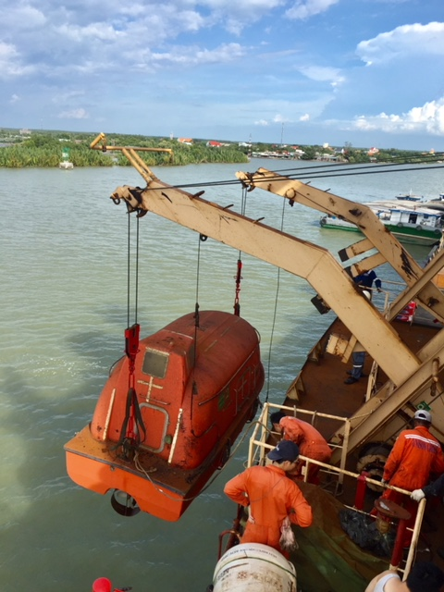

2. Marine Supplies & Fabrication
HMS is a trusted partner for marine supplies and spare parts, as well as fabrication and new construction:
- Marine Supplies & Spare Parts:
  - Provides a wide range of marine equipment: engines, electrical systems, auxiliary machinery, lifesaving and firefighting equipment.
  - Ensures certified origin, quality, and compatibility with international classification standards.
  - Offers consultancy on selecting the right spare parts for durability and performance.
- Fabrication & New Construction:
  - Fabrication of steel structures, marine equipment, cranes, and container fittings.
  - Refurbishment, upgrades, or complete replacement of vessel equipment to optimize efficiency and safety.
  - Uses CNC technology, automated welding, and modern equipment for high precision.
- Design & Engineering Services:
  - Structural design, vessel modification, and conversion according to client requirements.
  - Technical consultancy, planning repair and upgrading solutions efficiently.
  - Utilizes modern marine engineering software to provide effective, cost- and time-saving solutions.
By combining Marine Services and Marine Supplies & Fabrication, HMS delivers end-to-end solutions for vessel owners and operators, from maintenance, repair, lashing, and dry docking to spare parts supply and equipment fabrication, all in compliance with international standards.
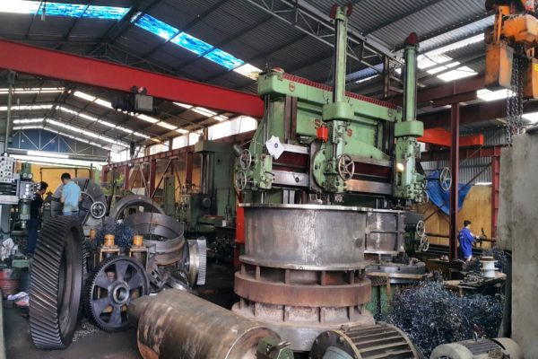

3. Ship Repair & Maintenance

HMS performs comprehensive repair and maintenance for all vessel types: container, bulk, oil, LPG/LNG, and specialized ships:
- Hull, cabin, deck, propulsion, and electrical-hydraulic system repair.
- Routine maintenance and emergency repairs.
- Work executed under international classification standards, ensuring safety, quality, and operational efficiency.
- Vessel modification or conversion for improved transport capacity or functional changes.
All ship repair services are conducted by internationally certified engineers in modern workshops, ensuring short repair cycles, high precision, and reasonable costs.
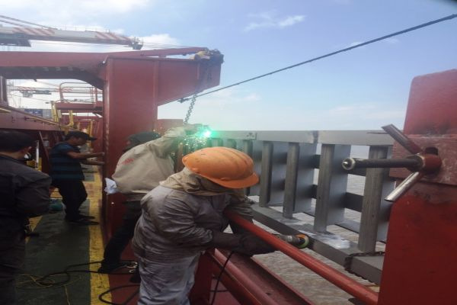
Contact us immediately with information below when you need ship repair services or any other marine service.

Geographic Coverage – Ports & Anchorages in Vietnam
HMS serves most major ports and anchorages nationwide.
Key ports: Hai Phong, Cai Lan, Hon Gai, Cam Pha, Nghi Son, Cua Lo, Son Duong, Dung Quat, Quy Nhon, Van Phong, Vinh Tan, Da Nang, Cai Mep – Thi Vai, Phu My, Vung Tau.
Anchorages: Ha Long, Hon Gai, Cam Pha, Cua Lo, Son Duong, Vung Ang, Da Nang, Van Phong, Dung Quat, Cai Mep – Thi Vai, Vung Tau.
HMS provides full services at these locations, including ship repair, dry docking, underwater works, material supply, classification inspection, LSA/FFE inspection, and lashing services. Nationwide coverage enables rapid response to emergency requests and minimizes vessel downtime.
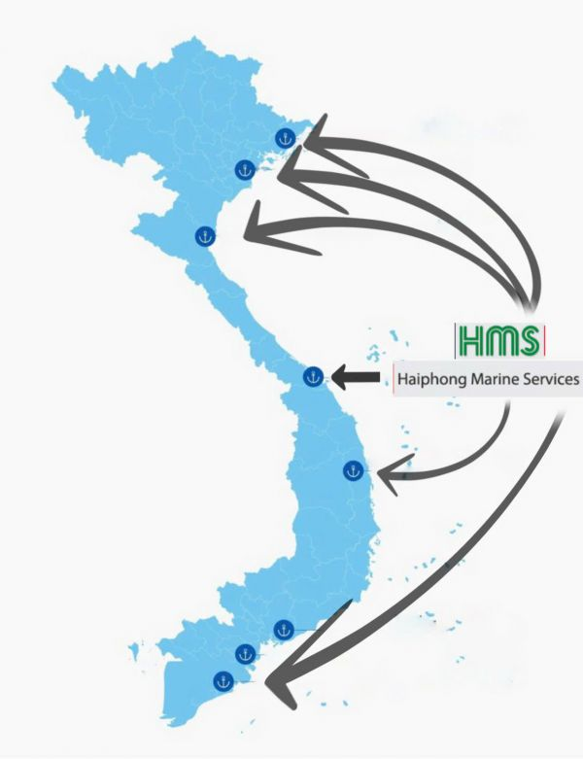

Certificates & Accreditations
HMS is recognized by multiple international classification societies: ClassNK, LR, ABS, DNV, and Vietnam Register (VR).
Approval Scope examples:
Classification Society | Approval Scope
ClassNK | WPS for AH36 steel plates; welders 1G–4G (AH36)
LR | WPS for AH36 steel plates, verified by mechanical & NDT tests
ABS | WPS for AH36/DH36/EH36 plates; welders 1G–4G (plate) & 6G (pipe)
HMS also applies ISO 9001 for quality management, ensuring transparent, safe, and stable processes from project intake to completion.

Commitment to Safety & Environment
HMS prioritizes labor safety and marine environmental protection:
- Regular training, risk control, and full PPE for all personnel.
- Compliance with IMO and MARPOL standards.
- Eco-friendly procedures for hull cleaning, sludge treatment, and waste management.
The philosophy “Safety and Sustainability First” guides HMS toward reliable technical services and sustainable development.

Case Study

1. Load Test Services – M/V LAURA D
Client: Ship Owner/Operator of M/V LAURA D
Location: Cam Pha Anchorage, Vietnam
Date: 28 March 2025
Service Provider: HMS – Haiphong Marine Services
Background
M/V LAURA D required annual statutory load tests for its provision and bunker cranes to meet IMO and class standards.
Scope of Work
HMS engineers carried out:
- Operation and overload tests on PS & STB’d provision cranes.
- Operation and overload tests on PS & STB’d bunker cranes under working conditions.
- Verification using calibrated test weights and wireless indicators, in line with class requirements.
Execution & Results
All cranes were tested under normal and overload conditions, confirming safe working limits and structural integrity. Full documentation, photo evidence, and certificates were provided.
Outcome
- All cranes passed, confirming compliance with IMO and class rules.
- Vessel readiness ensured with minimal downtime.
- Client satisfied with HMS’s fast, professional, and class-approved service.
This demonstrates HMS’s capability in load test services, ensuring safe, compliant, and efficient vessel operations.
See more our other projects.
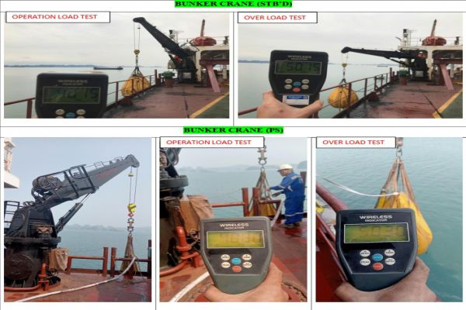
HMS engineers conducting crane load test services with certified equipment at Cam Pha Anchorage, Vietnam

Clients & Partners
HMS is a reliable partner for numerous ship owners, international shipping lines, maritime agents, and logistics companies in the Asia-Pacific region.
Representative clients:
- Ship owners and managers from Japan, Korea, Singapore, Greece, and Europe.
- Major shipping corporations such as Maersk, MSC, HDC, ZIM, regularly using ship repair, dry docking, and underwater services.
- Maritime agents and logistics companies for material supply, equipment, and emergency technical support.
- Classification societies and inspection organizations collaborating on safety certification and surveys.

Capabilities & Strengths
HMS possesses:
- A team of skilled engineers and experts trained and certified internationally.
- Modern repair workshops with CNC machines, automated welding, lathes, milling machines, lifting systems, and testing equipment.
- Experience across container ships, bulk carriers, oil tankers, LPG/LNG vessels, and specialized ships.
- Operational principles: Safety – Accuracy – Timeliness.
- 24/7 emergency support, deployable to any port or anchorage nationwide.

Frequently Asked Questions (FAQ)
1. What services does HMS provide?
HMS offers a full range of marine services, including ship repair, dry dock services in Vietnam, floating dock solutions, underwater works, lashing & cargo securing, LSA/FFE inspection, load testing, and marine supplies.
2. Where does HMS operate?
Headquartered in Hai Phong, HMS supports ship owners and operators at all major ports and anchorages across Vietnam, ensuring nationwide ship repair and marine services.
3. Does HMS comply with international standards?
Yes. All services are carried out under the requirements of IMO, MARPOL, IACS classification societies (VR, DNV, ABS, LR, ClassNK, etc.), ensuring safe, efficient, and class-certified technical solutions.
4. Who are HMS’s clients and partners?
HMS works with leading ship owners, managers, and shipping lines worldwide, including Maersk, MSC, HDC, ZIM, as well as classification societies, maritime agents, and logistics providers.
5. What makes HMS different from other providers?
HMS combines over three decades of technical expertise with a team of class-certified engineers, modern workshops, and nationwide facilities, delivering reliable, time-efficient, and internationally compliant marine services.

Contact us:
Contact HMS today for class-certified ship repair and nationwide marine services in Vietnam – available 24/7.
Haiphong Marine Services Co. Ltd
Address: 27/633 Thien Loi street - Le Chan District - Hai Phong City
Email: info@haiphongmarine.com
Phone number: +84 947 739 556 - HOTLINE: +84 947 739 556
Website: http://haiphongmarine.com

