Drydock Services in Vietnam – Nationwide Ship Repair by HMS
HMS – Haiphong Marine Services provides professional drydock services in Vietnam for all types of vessels that require inspection, maintenance, or repair at any port or anchorage nationwide

Why Dry Docking Is Essential for Ship Repair and Vessel Maintenance
Dry docking is not only a mandatory requirement by international classification societies but also a strategic process for vessel servicing and operational performance. Key benefits include:
1. Enhanced Maritime Safety
- Controlled surveys of hull, propulsion system, ballast tanks, steel structures, and welds.
- Early detection of cracks, corrosion, and hidden defects minimizes the risk of failures at sea.
2. Optimized Performance and Fuel Efficiency
- Hull cleaning, corrosion treatment, and propulsion system alignment reduce hydrodynamic resistance.
- Lower drag results in measurable energy savings and reduced emissions.
3. Regulatory and Environmental Alignment
- All restoration and evaluation work follow SOLAS, MARPOL, and rules issued by IACS, Vietnam Register (VR), ABS, DNV, ClassNK, and Lloyd’s Register.
- Application of IMO-compliant protective coatings and energy-saving solutions supports green shipping initiatives.
4. Asset Protection and Preventive Care
- Scheduled dry docking extends vessel lifespan, maintains commercial value for charter or resale, and avoids costly downtime.
- Preventive measures reduce emergency corrective works and support continuous fleet operations.
5. Comprehensive Drydock Services in Vietnam
- HMS provides integrated solutions including floating dock services, steel renewal, blasting and coating, machinery overhaul, and underwater works.
- With access to major dry dock facilities across Vietnam, HMS supports nationwide ship repair in Vietnam with class survey support and standardized procedures.
For shipowners, dry docking represents a long-term investment in safety, compliance, and vessel performance. Choosing an experienced ship repair company in Vietnam ensures consistent vessel upkeep quality and operational readiness.
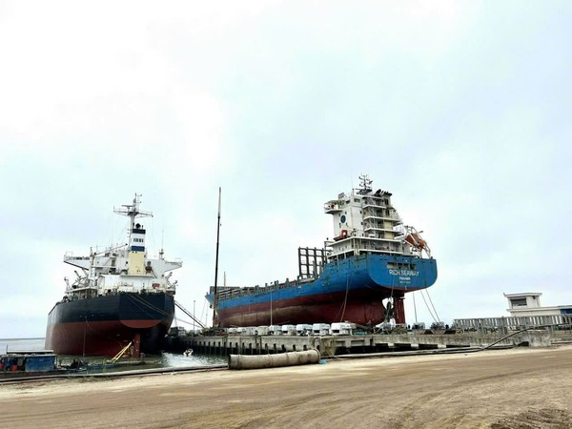
Ship Lifting and Dry Docking by HMS in Vietnam

HMS Technical Capabilities and Dry Dock Vietnam Expertise
Located near Hai Phong Port, HMS – Haiphong Marine Services provides fast, efficient, and cost-effective dry dock Vietnam solutions for both domestic and international shipowners. Its strategic location minimizes logistics costs, shortens turnaround time, and enables smooth coordination with local port authorities — a critical advantage for nationwide ship repair in Vietnam.
Certified Quality and Global Standards
- ABS, DNV, ClassNK, Lloyd’s Register, Vietnam Register (VR) – for class-approved testing and certification.
- ISO 9001 Quality Management System – ensuring quality consistency across all repair projects.
- Class survey support methods include ultrasonic thickness measurement, non-destructive testing (NDT), and pressure testing.
Advanced Technical Expertise
- Class-certified engineers and inspectors with decades of experience in hull, propulsion system, and machinery overhauls.
- Specialized equipment includes 3D laser scanning, high-capacity cranes, ultrasonic flaw detectors, and diving systems for underwater services.
- Comprehensive service scope: From hull cleaning and coating, steel renewal, and machinery overhaul to ballast water treatment retrofitting and energy-efficiency upgrades.

Scope of Dry Dock and Floating Dock Services
Our team handles every stage of vessel upkeep, from underwater inspections to full structural renewal.
1. Hull Works
- Hull cleaning and blasting: High-pressure water jetting, grit blasting, or hydro-blasting to remove marine fouling, rust, and old coatings.
- Protective and anti-fouling coatings: Application of IMO PSPC-compliant coatings to extend hull life, reduce corrosion, and optimize hydrodynamic efficiency.
- Structural check and renewal: Ultrasonic thickness measurement (UTM) for detecting steel wastage, renewal of plates, stiffeners, and weld seams under class supervision.
- Cargo holds and ballast tank renewal: Cleaning, sludge removal, protective coating, and pressure testing to prevent leaks and contamination.
- Anodes replacement: Renewal of sacrificial or impressed current anodes for long-term corrosion protection.
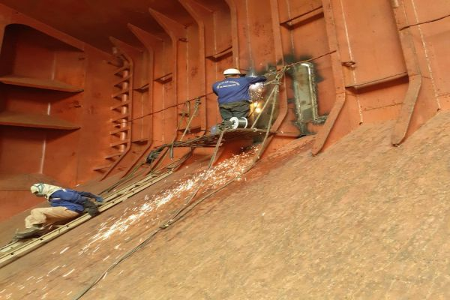
2. Underwater Systems
- Propeller overhaul: Polishing, balancing, crack inspection, and welding repairs to restore propulsion system efficiency and minimize cavitation.
- Rudder assessment and repair: Overhaul of rudder stocks, bearings, pintles, and steering gear in compliance with class standards.
- Stern gear and shaft alignment: Checking stern tube seals, bearings, and alignment to prevent vibration and leakage.
- Sea chest and gratings: Cleaning, painting, and replacement of gratings, valves, and filters to ensure optimal seawater intake.
- Underwater equipment service: Maintenance of speed logs, echo sounders, ICCP systems, and hull-mounted sensors for precise navigation and vessel monitoring.
- Marine growth removal: Barnacle and biofouling cleaning to improve hull efficiency, enhance vessel speed, and reduce fuel consumption.
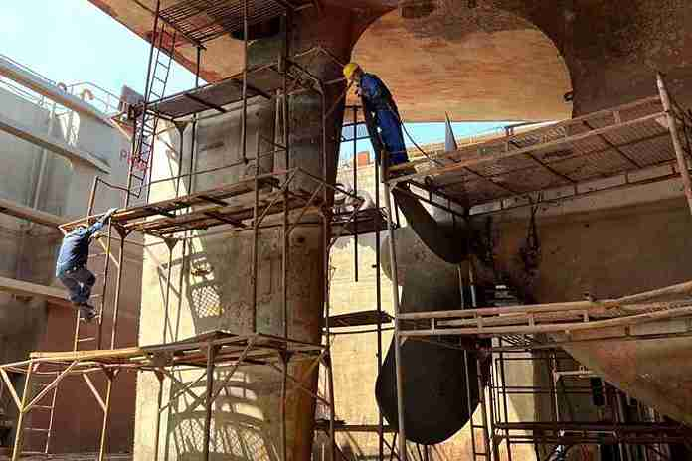
3. Engine Room Works
- Main and auxiliary engine overhaul: Inspection and repair of pistons, liners, cylinder heads, turbochargers, crankshafts, bearings, and seals.
- Fuel and lube oil system service: Calibration of fuel pumps and injectors, cleaning of purifiers, filters, and pipelines.
- Boiler and economizer maintenance: Pressure testing, tube replacement, decaling, and burner adjustments.
- Cooling and piping systems: Servicing seawater/freshwater coolers, overhauling pumps, and renewing corroded pipelines.
- Hydraulic and steering systems: Repair and testing of pumps, rams, and valves for reliable maneuvering.
- Compressed air systems: Overhaul of compressors, receivers, and safety valves.
- Electrical distribution systems: Verification of switchboards, breakers, automation, and monitoring systems with class-approved testing.
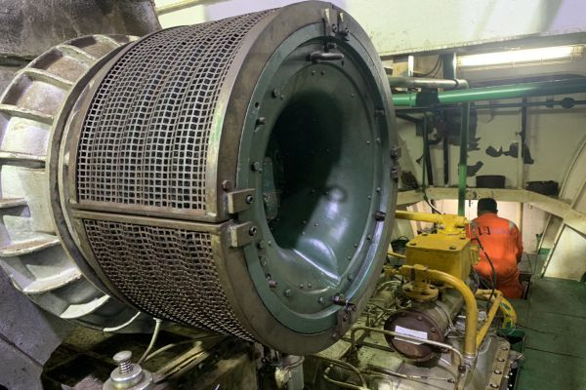
4. Deck and Navigational Equipment
- Cargo handling gear: Servicing cranes, derricks, winches, hatch covers, and mooring winches.
- Anchoring equipment: Assessment of anchors, chains, gypsies, and brake systems.
- Lifesaving appliances: Functional check of lifeboats, davits, rescue boats, life rafts, and launching systems under SOLAS compliance.
- Fire-fighting systems: Evaluation of CO₂ systems, foam extinguishers, sprinklers, hydrants, hoses, and fire detection systems.
- Navigation and communication systems: Radar Service, AIS, ECDIS, VDR/SVDR, MF/HF radios, GMDSS units, and GPS under class-certified standards.
- Deck coating and superstructure works: Protective coating for corrosion prevention, ensuring structural integrity and vessel appearance.
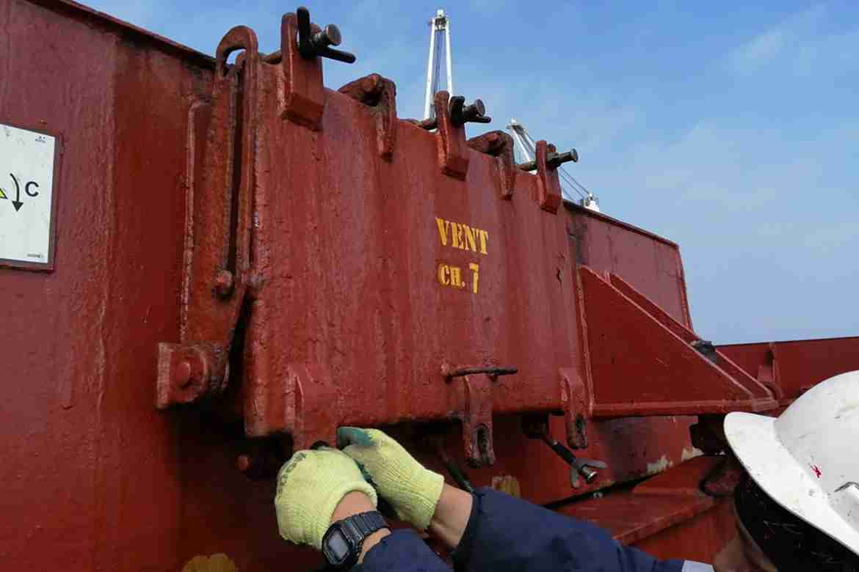
Every project follows rigorous quality assurance from material selection to final inspection, ensuring operational safety and performance. All procedures follow IMO – International Maritime Organization safety guidelines.

Case Study: Stern Gear and Propeller Repair at Pha Rung Shipyard – Haiphong
During a recent dry-docking project at Pha Rung Shipyard, Haiphong, HMS – Haiphong Marine Services performed a full overhaul of a 15,000 DWT general cargo vessel’s stern gear and propulsion system.
Scope of work included:
- Propeller inspection and polishing: Restoring surface smoothness and reducing cavitation marks.
- Rudder stock and bearing examination: Class surveyors verified clearances and wear-down readings according to LR class standards.
- Stern tube seal renewal: Aft seal rings were renewed and bonding completed under controlled dry dock conditions.
- Hull cleaning and anti-fouling coating: High-pressure washing to remove marine growth, followed by application of anti-fouling coatings.
The project was completed within seven days, minimizing off-hire time for the shipowner. Post-docking sea trials confirmed improved propulsion efficiency and reduced vibration, resulting in measurable fuel savings and smoother steering performance.
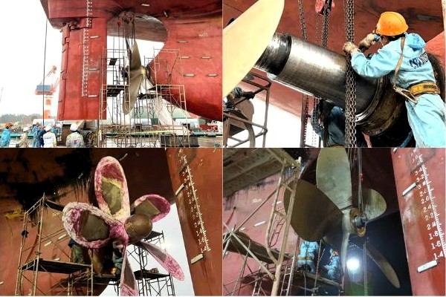
HMS engineers conducting propeller and rudder maintenance at Pha Rung dry dock, Haiphong

Benefits of Using Drydock Services in Vietnam
Choosing HMS for drydock services in Vietnam provides distinct advantages compared to regional competitors such as Singapore or China.
- Class-certified compliance: All repairs certified by VR, DNV, ABS, ClassNK, and LR, ensuring vessels remain seaworthy and compliant.
- Enhanced safety: Controlled dry dock conditions minimize operational risks, while class surveyors monitor all repair stages.
- Cost efficiency: Lower labor and operational costs in Vietnam compared to regional hubs, without compromising quality.
- Improved performance: Hull cleaning, propulsion alignment, and machinery overhauls enhance speed, fuel efficiency, and reliability.
- Nationwide ship repair coverage: HMS supports vessels at all major Vietnamese ports, including Hai Phong, Da Nang, Quy Nhon, Cai Mep, Vung Tau, and Ho Chi Minh City.
- Green and sustainable operations: HMS applies IMO-compliant coatings, ballast water treatment, and energy-saving retrofits to align with global green shipping initiatives.
- Rapid turnaround: Shorter waiting lists than larger regional shipyards, allowing owners to minimize downtime and avoid revenue loss.
These advantages make HMS a trusted partner for cost-effective, class-approved, and sustainable vessel maintenance in Vietnam.

Dry Dock and Floating Dock Facilities in Vietnam
HMS – Haiphong Marine Services, through strategic partnerships with leading shipyards, provides drydock services in Vietnam and floating dock services across all major ports, ensuring nationwide ship repair coverage.
Dock Yard Specifications
Type | Dimensions | Capacity
Dry Dock | L160m × W25m | 16000DWT
Floating Dock | L116m × W23m | 8,500 DWT
Floating Dock | L160m × W33m | 9,600 DWT
Synchro-Lift | L224m × W35m | 70,000 DWT
Representative Facilities by Port
- Haiphong: Nam Trieu Shipyard, Pha Rung Dock – Dry Dock 160m × 25m, 16,000 DWT
- Vung Tau: VARD Vung Tau – Floating Dock 160m × 33m, 9,600 DWT
- Ho Chi Minh City: Ba Son Shipyard – Synchro-Lift 224m × 35m, 70,000 DWT
- Da Nang: Song Thu Ship Repair – Dry Dock 20,000 DWT
- Dung Quat – Quang Ngai: Dung Quat Ship Repair Yard – VLCC Dry Dock
Coverage: Nationwide ship repair at all major ports & anchorages: Haiphong, Quang Ninh, Nghi Son, Quy Nhon, Phu My, Cai Mep, Da Nang, Cam Pha

Why Choose HMS – Haiphong Marine Services
- Technical expertise: Extensive experience in marine services and ship repair in Vietnam.
- Class-certified engineers: Skilled in class rules and international standards.
- Genuine OEM spare parts: All major components supplied with CO/CQ certification.
- 24/7 nationwide support: Rapid response at any port or anchorage.
- Competitive pricing: Balanced solutions between technical quality and cost efficiency.
HMS – Haiphong Marine Services stands as one of the most trusted names for marine services, dry docking, and vessel maintenance in Vietnam.

