**SOFT10101 Computer Science Programming**

**Coursework 2023**

Title: *Chess Express*

Student ID: *N1103546*

Name: *Lethiwe Mwendwa*

*Notes:*

*This is a simple outline of the project report as a guide. It is expected that you will provide more details than this in your report.*

*Text in Red italics is example text.*

**Specification**

*x*

**Design and Implementation**

**Program Flow**

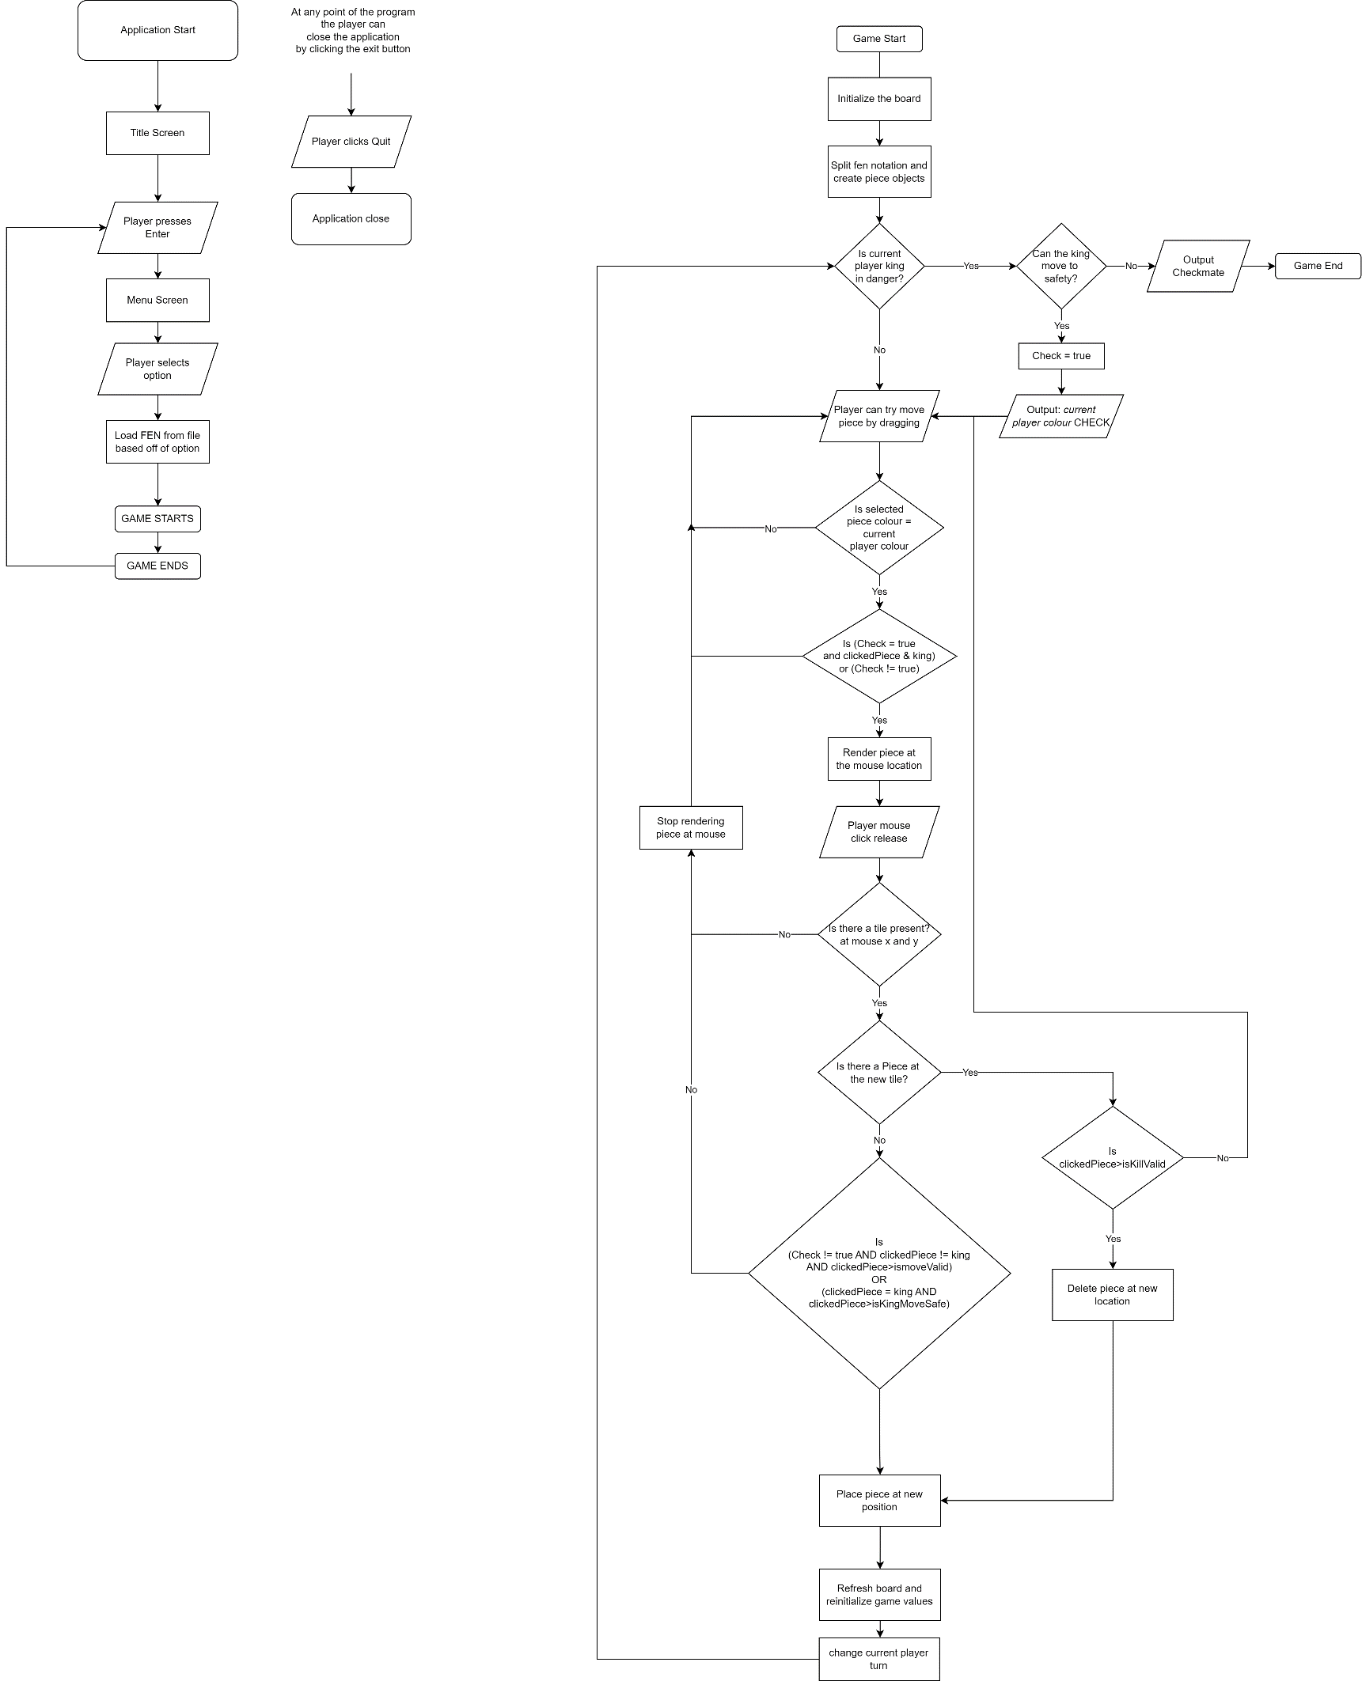

**Classes**

*This project contains three classes, as follows:*

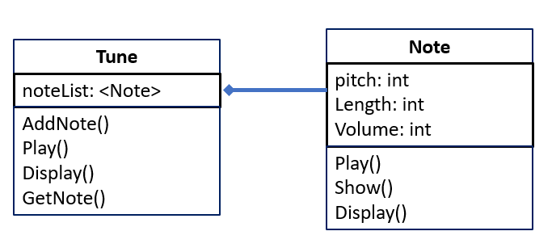

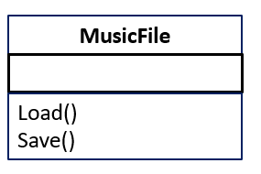

**File structure**

*X CSV files*

**Test Plan**

*The following is a text plan for the project: (examples I haven’t changed yet)*

|  |  |  |
| --- | --- | --- |
| ***Action*** | ***Test Method*** | ***Success Criteria*** |
| *Play the music* | *Press p or P* | *Music is played* |
| *Display the music* | *Press d or D* | *Music is displayed* |
| *Add a note* | *Press A or a to go to note entry routine*  *Enter values for pitch, length and volume* | *Program is able to cope with incorrect values out of range etc.*  *When completed, choosing ‘display’ shows that the note has been added* |
| *Change a note* | *Press C or c to go to next entry*  *Enter note number in track*  *Enter new note values as above* | *Program able to deal with note values out of range*  *Entry OK as above* |
| *Load tune* | *Press L or l* | *Tune loaded OK*  *When completed, choosing ‘display’ shows that the tune has been loaded* |
| *Save tune* | *Press S or s* | *Make a change to the tune and then choose Load to show that the saved file is loaded OK* |
| *Exit* | *Press e or E* | *Program ends* |

**Demo**

A ‘static’ style demo is shown in lecture slides for Lecture 12.

An video demo showing the program in action is also OK. This can be done with tools such as OSB as well as MSTeams etc.