**Lab Exercise #1**

Using the Company Database, that you have already created to execute following queries. The screen shot in your submission should include both the query syntax and query result.

Query #1: Retrieve the First name and Last name of the managers who have at least one dependent. The first name should be printed as Name and Last name as Last as well as include the name of the dependent in your result.

Query #2: For every project located in Stafford, list the name of the project and the department and last name of the department manager that controls these projects.

Drop your file file by Friday November 16, 2018 (11:55 PM). Make sure of the following before uploading your files;

1. Use your name and lab number as “File Name”. (e.g. Wyne_Lab_1).
2. Make sure before you upload the file it should include both the query and the results of the query and your name at the top. All queries should be in one file.
3. Hand written and scanned files are not acceptable and will not be graded.

Query #1: Retrieve the First name and Last name of the managers who have at least one dependent. The first name should be printed as Name and Last name as Last as well as include the name of the dependent in your result.

SELECT FNAME AS NAME, LNAME AS LAST, DEP.DEPENDENT_NAME FROM EMPLOYEE AS EMP, DEPENDENT AS DEP WHERE EMP.SUPER_SSN = DEP.ESSN;

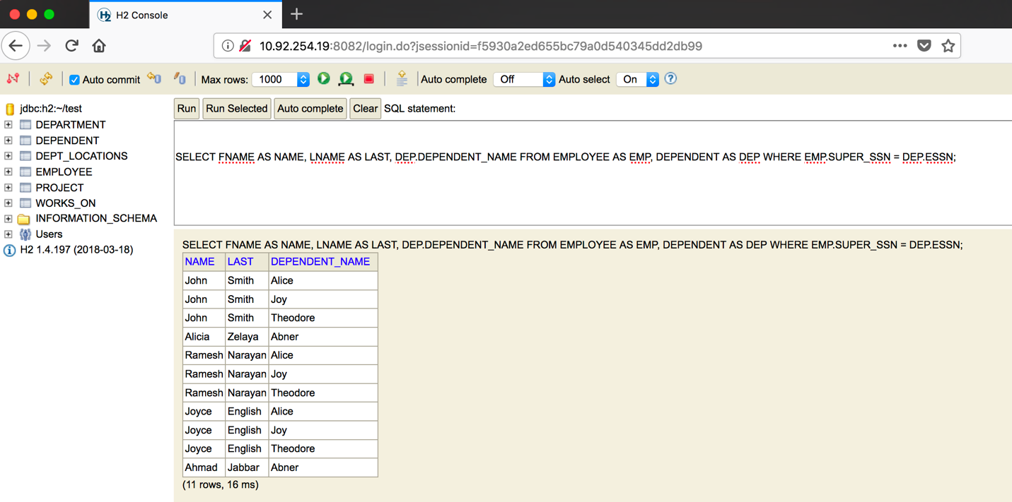

Query #2: For every project located in Stafford, list the name of the project and the department and last name of the department manager that controls these projects.

SELECT PRO.PNAME AS PROJECT_NAME, DEPT.DNAME AS DEPARTMENT_NAME, DEPT_LOC.DLOCATION AS DEPT_LOCATION, EMP.LNAME AS MANAGER_LNAME FROM EMPLOYEE AS EMP, DEPARTMENT AS DEPT, DEPT_LOCATIONS AS DEPT_LOC, PROJECT AS PRO WHERE (EMP.DNO = DEPT.DNUMBER AND EMP.DNO=DEPT_LOC.DNUMBER) AND DEPT.DNUMBER=4;

