**Lab Exercise #2**

Using the Company Database execute following query.

1. For every department located in Houston, list the name of the department and last name of the department manager. In your result also include the name of the Project controlled by this department however the project(s) is located in `Houston’.
2. Retrieve the First and Last name of all the managers who work on the project that are controlled by the department that he/she manages.

Drop your file file by Sunday, November 18, 2018 (11:55 PM). Make sure of the following before uploading your files;

1. Use your name and lab number as “File Name”. (e.g. Wyne_Lab_2).
2. Make sure before you upload the file it should include both the query and the results of the query and your name at the top. All queries should be in one file.
3. Hand written and scanned files are not acceptable and will not be graded.
4. For every department located in Houston, list the name of the department and last name of the department manager. In your result also include the name of the Project controlled by this department however the project(s) is located in `Houston’.

SELECT DEPT.DNAME AS DEPARTMENT_NAME, EMP.LNAME AS MANAGER_LNAME , DEPT_LOC.DLOCATION AS DEPT_LOCATION, PRO.PNAME AS PROJECT_NAME FROM EMPLOYEE AS EMP, DEPARTMENT AS DEPT, DEPT_LOCATIONS AS DEPT_LOC, PROJECT AS PRO WHERE (EMP.DNO = DEPT.DNUMBER AND EMP.DNO=DEPT_LOC.DNUMBER) AND DEPT.DNUMBER=1;

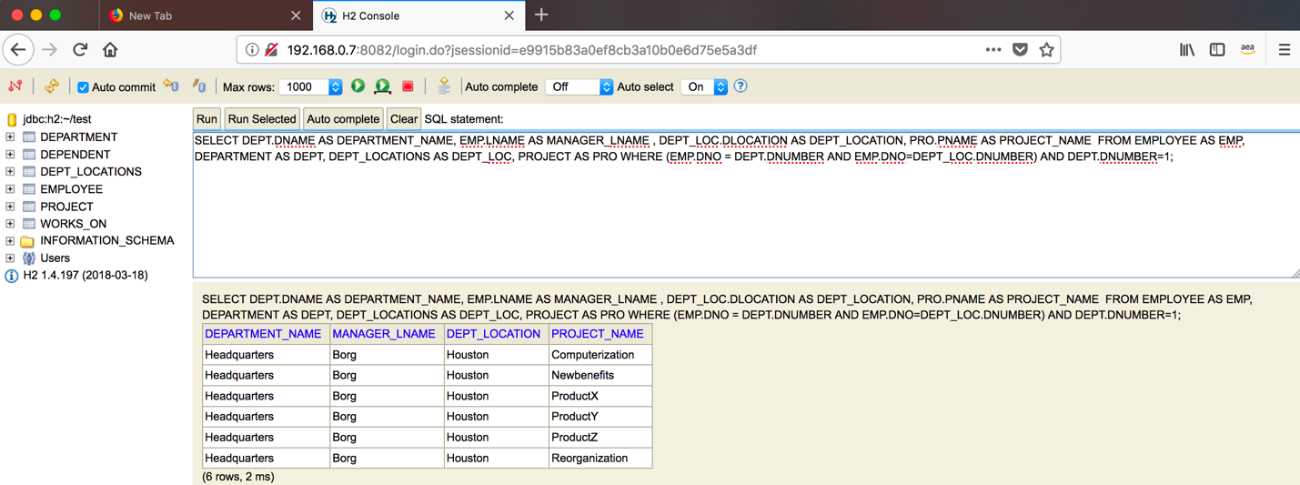

1. Retrieve the First and Last name of all the managers who work on the project that are controlled by the department that he/she manages.

SELECT DEPT.DNAME AS DEPARTMENT_NAME, EMP.LNAME AS MANAGER_LNAME , DEPT_LOC.DLOCATION AS DEPT_LOCATION, PRO.PNAME AS PROJECT_NAME FROM EMPLOYEE AS EMP, DEPARTMENT AS DEPT, DEPT_LOCATIONS AS DEPT_LOC, PROJECT AS PRO WHERE (EMP.DNO = DEPT.DNUMBER AND EMP.DNO=DEPT_LOC.DNUMBER) AND DEPT.DNUMBER>=1;

