Probability in Statistics: HW

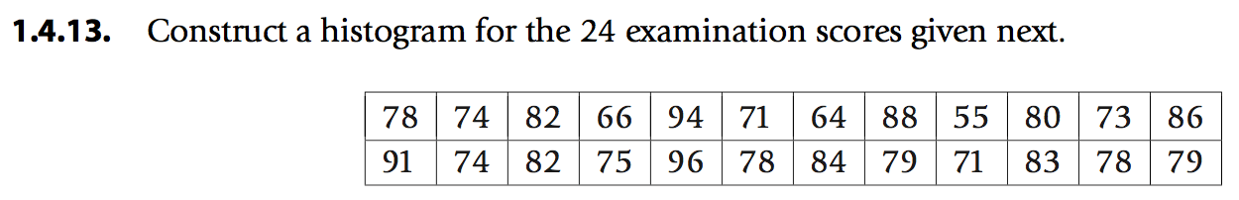

row1 <- c(78,74,82,66,94,71,64,88,55,80,73,86)

row2 <- c(91,74,82,75,96,78,84,79,71,83,78,79)

cells <- c(row1,row2)

> cells

[1] 78 74 82 66 94 71 64 88 55 80 73 86 91 74 82 75 96 78 84 79 71 83 78 79



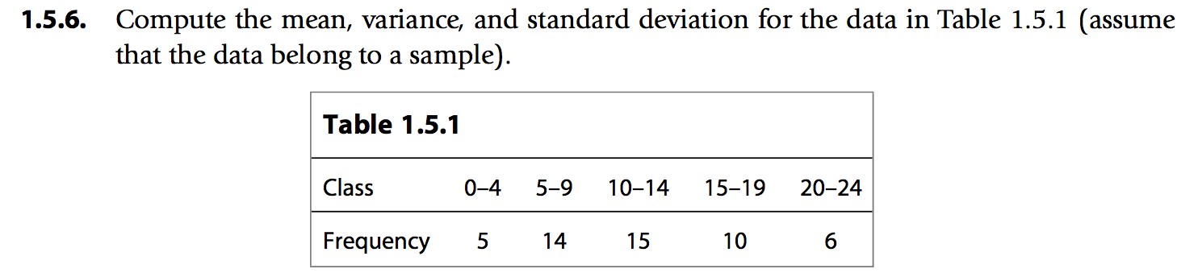

mydata = read.table("grouped_data_b.txt",1)

mydata

Class f_i m_i m_i.f_i m.2_i.f_i

1 0-4 5 2 10 20

2 5-9 14 7 98 686

3 10-14 15 12 180 2160

4 15-19 10 17 170 2890

5 20-24 6 22 132 2904

# n: 50

n <- sum(mydata$f_i)

# sample mean: 11.8

sample_mean <- ((1/n) * sum(mydata$m_i.f_i))

# sample variance: 34.65306

sample_variance <- ((sum(mydata$m.2_i.f_i)-(sample_mean^2)*n)/(n-1))

# standard deviation: 5.886685

standard_deviation <- sqrt(sample_variance)

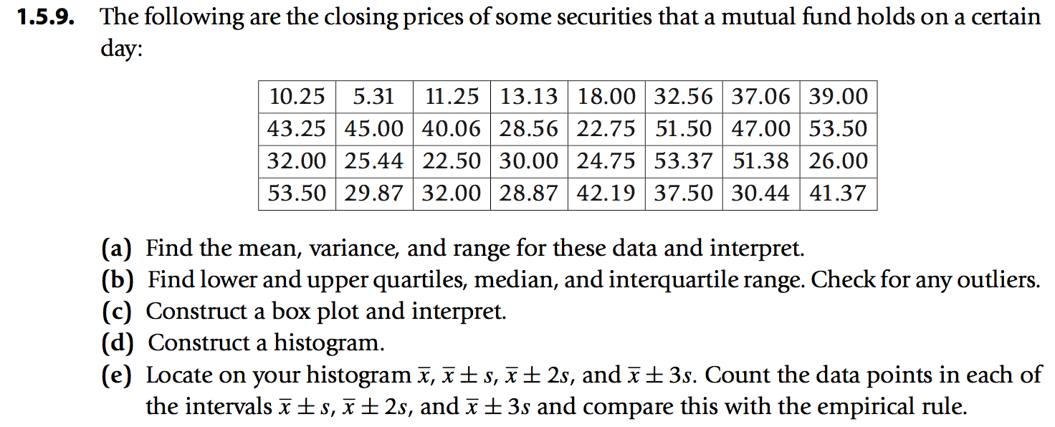

mydataprices <- read.table("closing_prices.txt",1)

prices <- c(mydataprices$col1,mydataprices$col2,mydataprices$col3,mydataprices$col4,mydataprices$col5,mydataprices$col6,mydataprices$col7,mydataprices$col8)

prices

[1] 10.25 43.25 32.00 53.50 5.31 45.00 25.44 29.87 11.25 40.06 22.50 32.00 13.13 28.56 30.00 28.87 18.00

[18] 22.75 24.75 42.19 32.56 51.50 53.37 37.50 37.06 47.00 51.38 30.44 39.00 53.50 26.00 41.37

# Mean: 33.105

mean_value<- mean(prices)

# variance: 177.043

variance_value <- var(prices)

# standard deviation: 13.30575

standard_deviation <- sd(prices)

# range: 5.31 53.50

data_range <- range(prices)

summary(prices)

#statistical summary

# Min. 1st Qu. Median Mean 3rd Qu. Max.

# 5.31 25.27 32.00 33.10 42.46 53.50

# inter quartile range: 17.1875

interquartile_range <- IQR(prices)

first_Qu <- 25.27

third_Qu <- 42.46

# Lower outlier limit: -0.51125

Lower_outlier_limit <- (first_Qu - 1.5 * interquartile_range)

# Upper outlier limit: 68.24125

Upper_outlier_limit <- (third_Qu + 1.5 * interquartile_range)



