Abstaction is a princple of object-oriented programming. It consists of removing characteristics from something, leaving only the most important ones; is to turn something complex into something simpler. The big benefit of this is to make things less complex and be more efficient.

An example of applying the principle of abstraction is programming with classes. For example, I used in my Journal program this class:

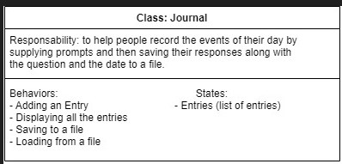

A Journal is something complex but putting it this way is simpler. I only leave the most important characteristics: responsibility (what it is a Journal), behaviors (what things should Journal do) and states (what variables should this class store).

I can translate this in a Class Diagram:

