Supplementary Information

Simultaneous Capacity Configuration and Scheduling Optimization of an Integrated Electrical Vehicle Charging Station with Photovoltaic and Battery Energy Storage System

Xiao-Jian Dong, Jia-Ni Shen, Cheng-Wu Liu, Zi-Feng Ma, Yi-Jun He∗

Department of Chemical Engineering, Shanghai Electrochemical Energy Devices Research Center, Shanghai Jiao Tong University, Shanghai 200240, China

Appendix A: Detailed parameters used in the basic scenario
Table S.1
The technical, economic, and environmental parameters of PV, BESS and transformer.
Parameters | Values | Parameters | Values | Parameters | Values
/ CNY | 31500 | / CNY | 18000 | / CNY | 0
/ CNY·kW⁻¹ | 4090 | / CNY·kWh⁻¹ | 700 | / CNY·kVA⁻¹ | 200
/ CNY·kW⁻¹ | 2400 | / CNY·kWh⁻¹ | 1000 | / CNY·kVA⁻¹ | 0
/ CNY·kW⁻¹ | 72 | / CNY·kWh⁻¹ | 30 | / CNY·kVA⁻¹ | 0
/ kgCO₂ | 20 | / kgCO₂ | 5 | / kgCO₂ | 0
/ kgCO₂·kW⁻¹ | 5 | / kgCO₂·kWh⁻¹ | 0.4 | / kgCO₂·kVA⁻¹ | 0
/ kgCO₂·kW⁻¹ | 223 | / kgCO₂·kWh⁻¹ | 1.9 | μ^{buy} / kgCO₂·kWh⁻¹ | 0.432
/ kW | 0 | / kWh | 0 | / kVA | 0
/ kW | 100000 | / kWh | 100000 | / kVA | 500
η^{dch} / % | 91 | η^{ch} / % | 91 | P^{buy,min} / kW | 0
γ^{dch,min} | 0.1 | γ^{dch,max} | 1 | P^{sell,min} / kW | 5
γ^{ch,min} | 0.1 | γ^{ch,max} | 1 | P^{sell,max} / kW | 1000
SOE^{min} / % | 5 | SOE^{max} / % | 95 | β^{sell} / CNY·kWh⁻¹ | 0
 | 3000 | r / CNY·kgCO₂⁻¹ | 0.153 | / % | 100

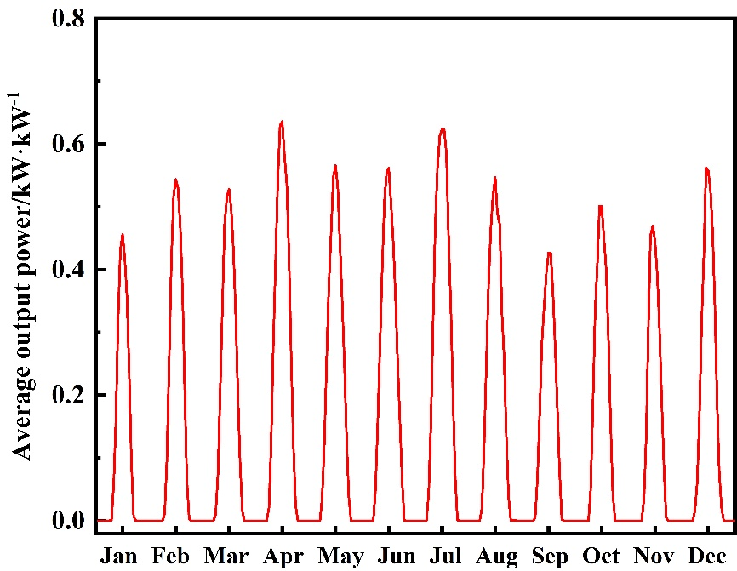
Fig. S.1. Measured average PV output power for each month.

Appendix B: Comparison of optimization results with different stochastic simulation scenarios for EV charging
The charging demand characteristics obtained by the proposed stochastic simulation for EV charging are uncertain, which might affect the optimal design of the PV/BESS integrated charging station. In this study, 100 independent stochastic simulations are firstly implemented to generate the data on the EV charging behaviors, and the simultaneous optimization is then conducted for the optimal design of PV/BESS integrated charging stations. The total annual electricity demand, NPV, optimal capacities of PV and BESS based on 100 stochastic simulations are compared in Fig. S.2.
It can be seen that there are variations in the charging demand and optimization results across different stochastic simulation experiments. The coefficient of variation (CV) is employed to quantify these differences, which represents the ratio of the standard deviation to the mean values. The CV values for the total annual electricity demand, NPV, optimal capacities of PV and BESS are 0.49%, 0.63%, 0.88%, and 4.01%. respectively. These findings indicate that the impacts of uncertainty from stochastic simulation for EV charging to optimization results are relatively small, which are not sufficient to affect the effectiveness of the proposed method.
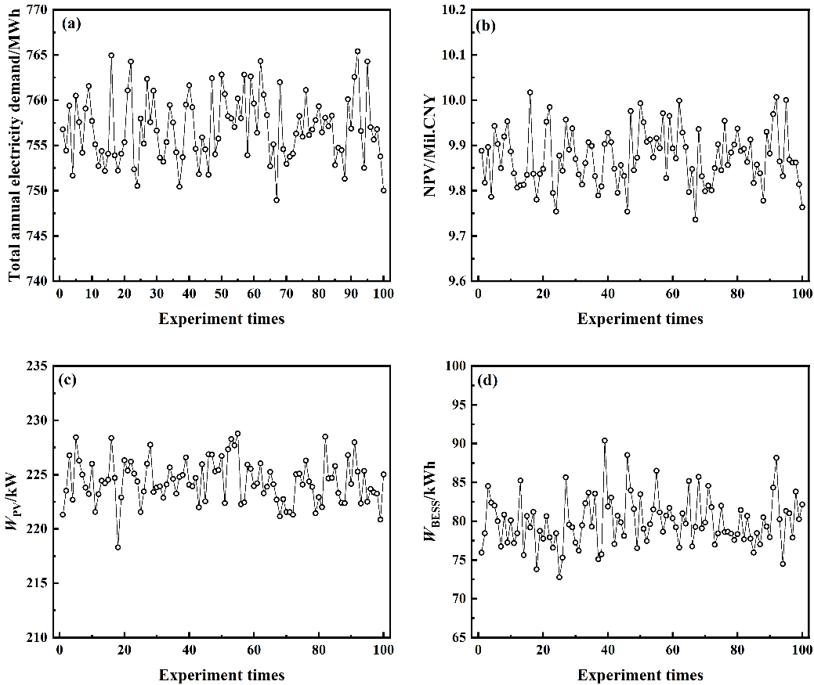
Fig. S.2. The optimization results with different stochastic simulation experiments: (a) total annual electricity demand; (b) NPV; (c) optimal capacities of PV and (d) BESS.

Appendix C: Comparison of optimization results with different scheduling scenarios
Generally, only the typical scheduling scenarios of one or some days are considered in the simultaneous optimization approaches due to the high computational cost in previous studies. However, due to the seasonal characteristics of PV generation power and time-of-use electricity price, the design results based on different scheduling scenarios might be different, which might affect the feasibility and robustness of the simultaneous optimization model.
In this study, the optimization results based on scheduling scenarios of a typical day and the whole year are compared. Firstly, based on the stochastic simulation method for EV charging behavior as shown in Section 3.1.2, the information of the EV charging behavior with 24 and 8760 hours are generated, respectively, and the process is repeated for 100 times. Next, under the above scheduling scenarios, the capacities of PV and BESS are then optimized by the proposed simultaneous capacity configuration and scheduling optimization model. Then, based on the optimal capacities of PV and BESS, the scheduling optimizations are implemented and the NPVs are compared in Fig. S.3. Note that in the scheduling scenario of a typical day, the hourly solar irradiance is the mean value of the whole year and the time-of-use price of non-summer is used.
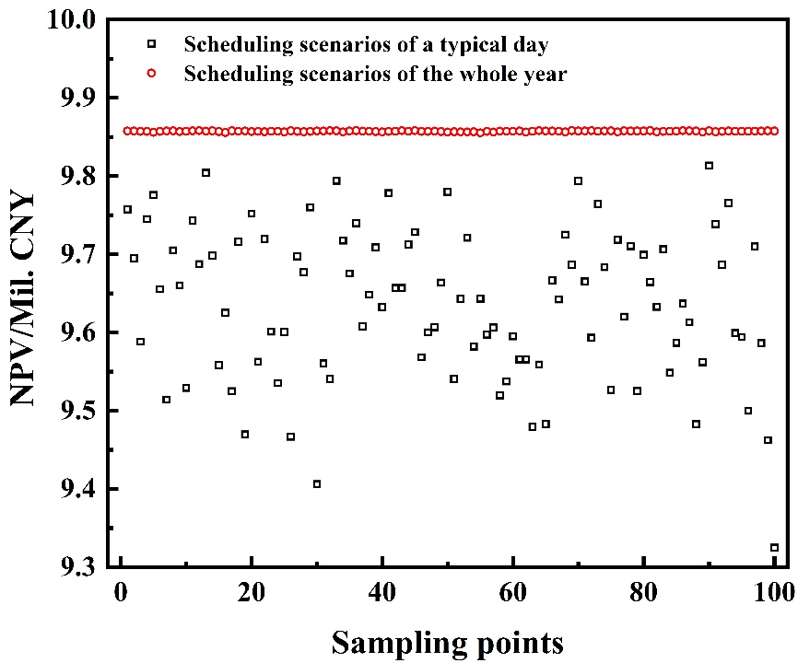
Fig. S.3. Comparison of NPVs based on different scheduling scenarios.
From Fig. S.3, it can be seen that the mean and standard deviation of NPVs based on scheduling scenarios of the whole year are 9.86 and 0.0058 Mil. CNY respectively, while those of a typical day are 9.64 and 0.096 Mil. CNY respectively. Hence, compared to the optimal designs based on scheduling scenarios of a typical day, the optimal designs based on scheduling scenarios of the whole year achieve higher economic benefit and show better robustness at different load scenarios.

Appendix D: Sensitivity analysis of key parameters

D.1 Sensitivity analysis of the on-grid price
In the basic scenario, the generation electricity of the integrated charging station is only unitized by self and the residual energy is prohibited to connect to main grid. In this section, another operating mode is considered, in which the generation electricity is allowed to connect to main grid. The optimization results with different on-grid prices are compared in Fig. S.4. The proportion of on-grid electricity in PV generation are considered in this operating mode.
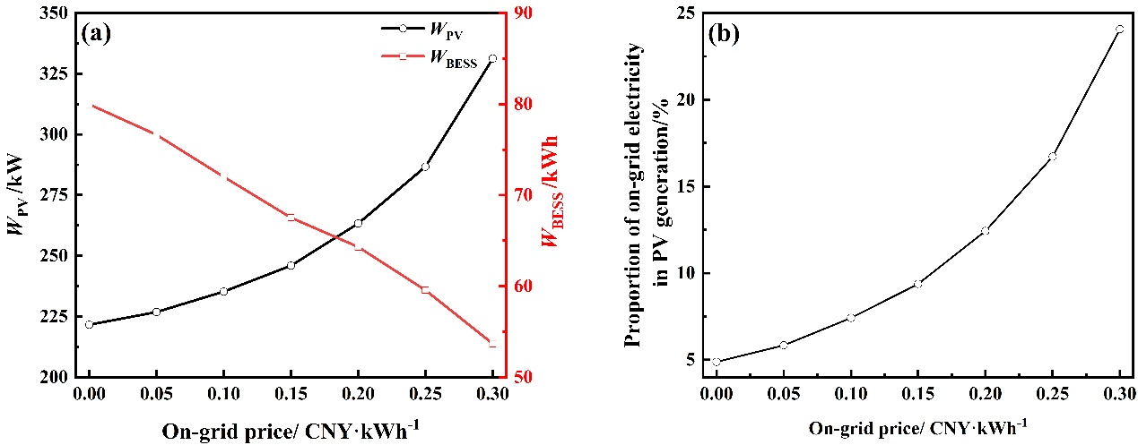
Fig. S.4. The optimization results with different on-grid prices: (a) capacities of PV and BESS; (b) proportion of on-grid electricity in PV generation.
As shown in Fig. S.4(a), with the on-grid price increasing from 0 to 0.3 CNY kWh⁻¹, the PV capacity increases from 221.61 to 331.23 kW, while the BESS capacity decreases from 79.96 to 53.68 kWh. This might because the excess PV generation electricity could be sold to the main grid, which contributes to construction of more PV system. Besides, the role of BESS to store excess generation power is replaced, resulting in the construction of fewer BESS. As shown in Fig. S.4(b), about 24.07% of the PV generation electricity is directly sold to the main gird when the on-grid price is equal to 0.35 CNY kWh⁻¹. High permeability of renewable energy might affect the stability of the main grid. Hence, the permissible on-grid power constraints should be considered in the simultaneous capacity configuration and scheduling optimization method.

D.2 Sensitivity analysis of the charging/discharging efficiency of BESS
Electricity loss of BESS might occur in both the charging and discharging process, which might not only come from the conversion of both electrical and chemical energy, but also from energy consumption of auxiliary equipment, such as air condition system , fire fighting system, battery management system, etc. The charging/discharging efficiency of BESS is always uncertain and mainly affected by the ambient temperature and the inconsistency of the batteries. The optimization results under different charging/discharging efficiencies of BESS are compared in Fig. S.5. Note that the charging and discharging efficiencies are assumed to be equal in this study.
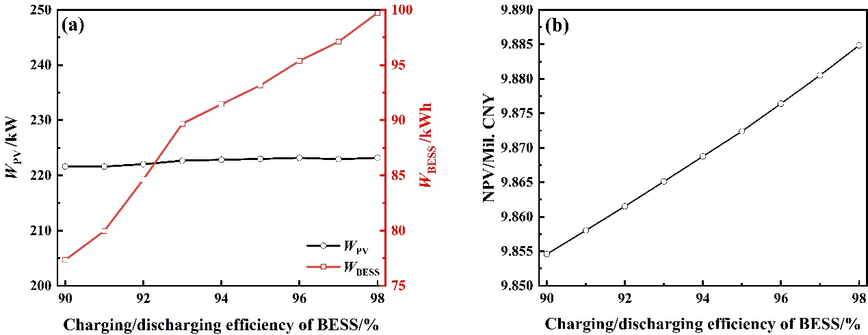
Fig. S.5. The optimization results with different conversion efficiency of BESS: (a) capacities of PV and BESS; (b) NPV.
From Fig. S.5(a), with the charging/discharging efficiencies of BESS increasing from 90% to 98%, the BESS capacity increases from 77.34 to 99.72 kWh, while the PV capacity fluctuates in the range at [221.61, 223.18] kW. This might because that higher conversion efficiencies of BESS results in lower cycle cost of BESS, and would drive capacity expansion of BESS to generate more low-cost electricity. Consequently, NPV of the integrated charging station increases from 9.855 to 9.885 Mil. CNY as shown in Fig. S.5(b). Hence, improving the charging/discharging efficiency of BESS play an important role in enhancing the comprehensive performance of the integrated charging station.

D.3 Sensitivity analysis of EV arrival time interval
The arrival time interval of EVs determines the charging power demand profile, and results in different capacity configuration and scheduling results of the integrated charging station. The optimization results with different EV arrival time intervals are compared in Fig. S.6. The x-axis represents the ratios of EV arrival time intervals to the original values in the basic scenario shown in Section 4.
From Fig. S.6(a), with arriving time intervals of EVs decreasing, the annual electricity demand of EVs increases from 398.47 to 1025.00 MWh, while NPV increases from 4.01 to 14.34 Mil. CNY. Besides, larger capacities of PV and BESS are required to cover the high electricity demand as shown in Fig. S.6(b). Note that the number of the charging piles is constant in this model, and high electricity demand might cause low charging satisfaction rate. Hence, the number of charging piles should be optimized in the scenarios with high uncertainty.
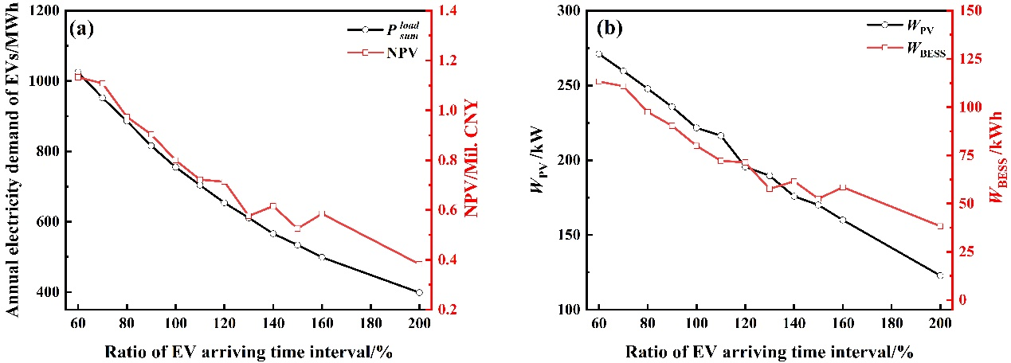
Fig. S.6. The optimization results with different EV arriving time intervals: (a) total annual electricity load and NPV; (b) capacities of PV and BESS.

D.4 Sensitivity analysis of charging electricity demand of EVs
To tackle the deficiency of the endurance mileage, EVs with larger battery capacity have attracted more attention. For integrated EV charging stations, the charging electricity demand for EVs would increase, resulting in longer residence time at the station and greater power demand for charging piles. In this study, the profiles of EV charging electricity demand with mean values ranging from 20 to 50 kWh, are generated by the stochastic simulation method as shown in Section 3.1.2. The corresponding optimization results are shown in Fig. S.7.
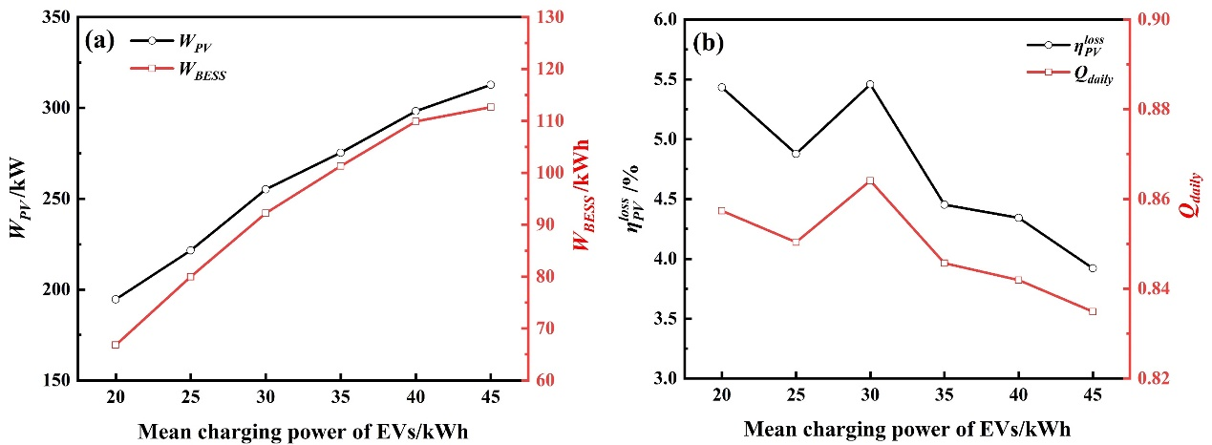
Fig. S.7. The optimization results with different mean charging power of EVs: (a) capacities of PV and BESS; (b) and .
From Fig. S.7(a), with the growth of the EV charging electricity demand, the PV capacity increases from 194.62 to 326.20 kW, while the BESS capacity increases from 66.82 to 122.62 kWh. This might because the growth of the EV charging electricity demand causes the increasing of power demand. PV and BESS with larger capacities would be constructed to cover the additional charging load. From Fig. S.7(b), with the growth of the EV charging electricity demand, the additional charging load consumes some abandoned PV power, which results in decreasing from 5.43% to 3.49%. Besides, although the charging load and design capacity are increasing, the maximum power of the charging pile remains fixed, which causes the BESS to prioritize covering the electricity demand with smaller charge and discharge depth. This results in a decrease of from 0.86 to 0.85. Hence, with the capacity of EVs increasing, it becomes necessary to design more charging piles that can charge/discharge at a high rate.

∗ Corresponding author. E-mail address: heyijun@sjtu.edu.cn (Y.-J. He).

