Logback (Spring boot)

By default, Spring use Logback as logger.

Configuration for Spring boot project:

Create Logger instance:

private static final Logger logger = LoggerFactory.getLogger(MainController.class);

*Logger and LoggerFactory used in package: org.slf4j
Usage:

logger.trace("This is TRACE");
logger.debug("This is DEBUG");
logger.info("This is INFO");
logger.warn("This is WARN");
logger.error("This is ERROR");

Log Level
Logback has 5 levels follow the critical level: TRACE, DEBUG, INFO, WARN, ERROR.

Logback default level is INFO, that mean it will print the log with level INFO and above (WARN, ERROR).

Configuration:
Some log attributes that we could configure are:

logging.config
logging.exception-conversion-word
logging.file
logging.level.*
logging.path
logging.pattern.console
logging.pattern.file
logging.pattern.level
logging.register-shutdown-hook

To change Logback configuration, go to application.properties file in Spring boot project and add:

logging.level.root = WARN

to change log level root to WARN.

logging.file=src/main/logs/myLog.log

to change location of log file.

To change logging pattern when it print in the console, use:

logging.pattern.console = %d{yyyy-MMM-dd HH:mm:ss.SSS} %-5level [%thread] %logger{15} - %msg%n

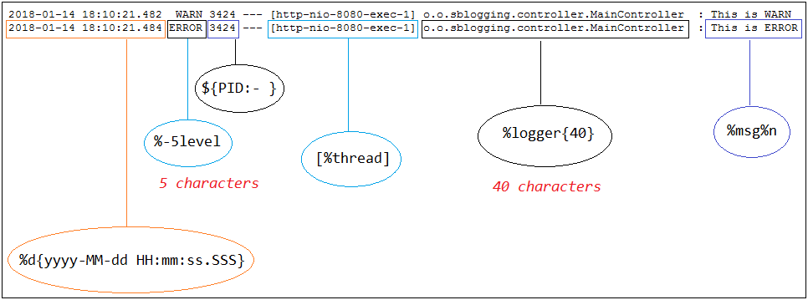
To change logging pattern when it write to log file, use:

logging.pattern.file= %d{yy-MMMM-dd HH:mm:ss:SSS} %5p %t %c{2}:%L - %m%n

External configuration

put this property in application.properties file:

configuration file is outside project.
logging.config= file:///C:/temp/logback.xml

configuration file is in project classpath:
logging.config= classpath:logback.xml

Example of XML configuration:
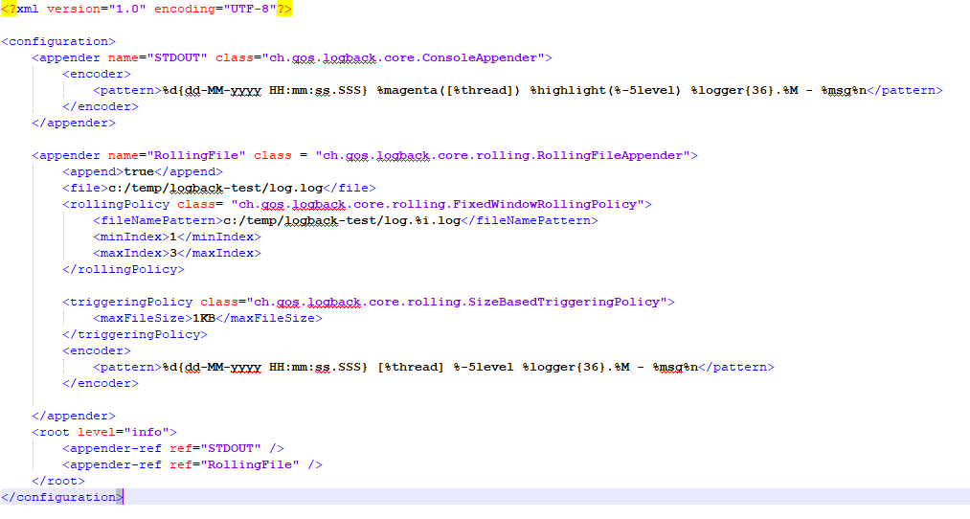
Log4j2 (Spring boot)
Because Spring use Logback by default, we need to exclude spring-boot-starter-logging and add spring-boot-starter-log4j2 dependency:

Exclude logback with:
<dependency>
<groupId>org.springframework.boot</groupId>
<artifactId>spring-boot-starter</artifactId>
<exclusions>
<exclusion>
<groupId>org.springframework.boot</groupId>
<artifactId>spring-boot-starter-logging</artifactId>
</exclusion>
</exclusions>
</dependency>
Add log4j2 dependency:
<dependency>
<groupId>org.springframework.boot</groupId>
<artifactId>spring-boot-starter-log4j2</artifactId>
</dependency>'

Spring boot will automatically configures Log4j2 if it finds a file named log4j2.xml or log4j2.json or log4j2.yaml in the classpath (usually put in src/main/resource). The order of automatic configuration see in: https://logging.apache.org/log4j/2.x/manual/configuration.html#AutomaticConfiguration

We have some simple configurations in xml file, there are: Configuration, Appender, Logger
Configuration: root element of log4j2 file
Appenders: contains list of appenders use to output the log, ex: System console, File, Database...
Some useful Appenders:

ConsoleAppender – logs messages to the System console
<Console name="Console" target="SYSTEM_OUT" follow="true">
<PatternLayout pattern="%d{yyyy-MM-dd'T'HH:mm:ss.SSSZ} %p %m%n" />
</Console>
FileAppender – writes log messages to a file

RollingFileAppender – writes the messages to a rolling log file:

<RollingFile name="RollingFile"
fileName="c:/temp/SpringBoot2App/application.log"
filePattern="c:/temp/SpringBoot2App/application-%d{yyyy-MM-dd}-%i.log">
<PatternLayout pattern="%d{yyyy-MM-dd'T'HH:mm:ss.SSSZ} %p %m%n" />
<Policies>
<SizeBasedTriggeringPolicy="19500KB" />
</Policies>
<DefaultRolloverStrategy max="1" />
</RollingFile>

JDBCAppender – uses a relational database for logs.
AsyncAppender – contains a list of other appenders and determines the logs for these to be written in a separate thread

And there is much more Appender to use, see in: https://logging.apache.org/log4j/2.x/manual/appenders.html

*About the pattern for log, use : %d [%-6p] %C{1}.%M(%F:%L) – %m%n
for best practice, it print date, class, method, source file and line, find more pattern at: https://howtodoinjava.com/log4j2/useful-conversion-pattern-examples/

Loggers: contains list of logger instances. The <Root> element is a standard logger that outputs all messages.
<Loggers>
<Logger name="tma.tft.phat.ss.controller"
additivity="false">
<AppenderRef ref="RollingFile" />
<AppenderRef ref="Console" />
</Logger>
<Root level="info">
<AppenderRef ref="Console" />
</Root>
</Loggers>

Here, the attribute additivity = "false" indicate that once an event reaches a logger with its additivity set to false the event will not be passed to any of its parent loggers, regardless of their additivity setting. If we don't set this to false, the Log in package tma.tft.phat.ss.controller may be write twice, first is by Logger "tma.tft.phat.ss.constroller", second is by Root element and we have 2 lines of log with same content.

Log Level
Log4j2 has 6 levels follow the critical level: TRACE, DEBUG, INFO, WARN, ERROR, FATAL

External configuration

put this property in application.properties file:

configuration file is outside project.
logging.config= file:///C:/temp/log4j2-spring.xml

configuration file is in project classpath:
logging.config= classpath:log4j2-spring.xml

To make Console Log have color, use this property for PatternLayout of ConsoleAppender
<Property name="LOG_PATTERN_CONSOLE">%clr{%d{yyyy-MM-dd HH:mm:ss.SSS}}{faint} %clr{%5p} %clr{${sys:PID}}{magenta} %clr{---}{faint} %clr{[%15.15t]}{faint} %clr{%-40.40c{1.}}{cyan} %clr{:}{faint} %m%n%xwEx</Property>

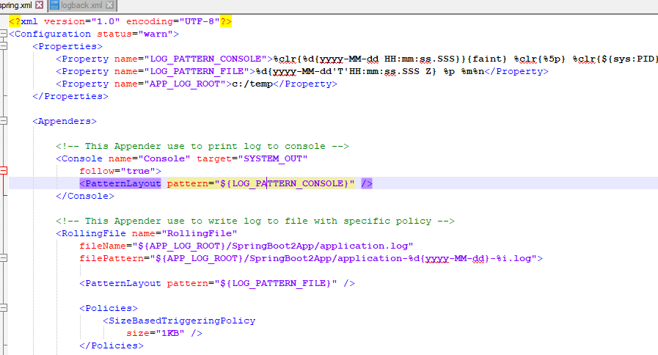

Refs:

https://o7planning.org/vi/11753/su-dung-logging-trong-spring-boot
https://logback.qos.ch/manual/appenders.html

https://stackify.com/log4j2-java/
https://www.javadevjournal.com/spring-boot/spring-boot-log4j2/
https://logging.apache.org/log4j/2.x/manual/appenders.html
https://logging.apache.org/log4j/2.x/manual/configuration.html#AutomaticConfiguration
https://howtodoinjava.com/log4j2/useful-conversion-pattern-examples/

